|  |  |  |
| --- | --- | --- |
| Taxes | | |
| Input | Process | Output |
| 1. Have them put in the amount of time in Minutes 2. Ask for the income | 1. Take the billing rate and subtract the discounted time and multiply buy the percentage and multiple by the billing rate | Put out the amount owed |

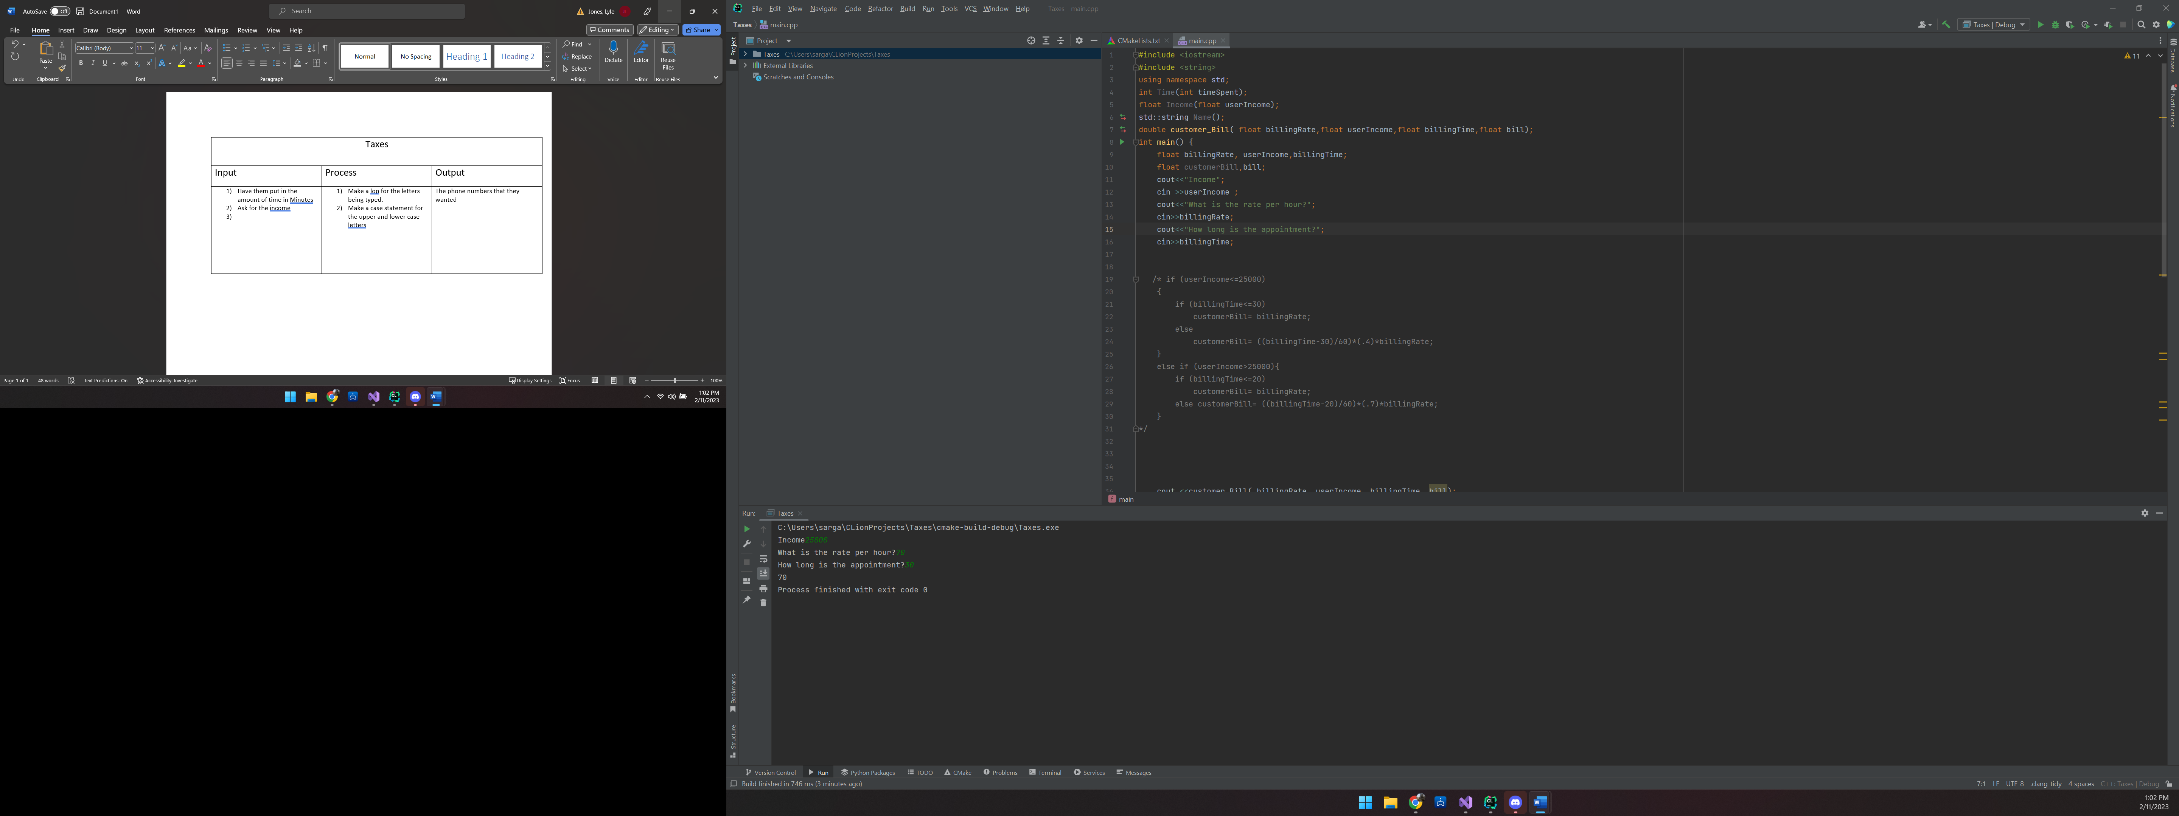

C:\Users\sarga\CLionProjects\Taxes\cmake-build-debug\Taxes.exe

Income25000

What is the rate per hour?70

How long is the appointment?30

70

Process finished with exit code 0

#include <iostream>  
#include <string>  
using namespace std;  
int Time(int timeSpent);  
float Income(float userIncome);  
std::string Name();  
double customer_Bill( float billingRate,float userIncome,float billingTime,float bill);  
int main() {  
 float billingRate, userIncome,billingTime;  
 float customerBill,bill;  
 cout<<"Income";  
 cin >>userIncome ;  
 cout<<"What is the rate per hour?";  
 cin>>billingRate;  
 cout<<"How long is the appointment?";  
 cin>>billingTime;  
  
  
 /* if (userIncome<=25000)  
 {  
 if (billingTime<=30)  
 customerBill= billingRate;  
 else  
 customerBill= ((billingTime-30)/60)*(.4)*billingRate;  
 }  
 else if (userIncome>25000){  
 if (billingTime<=20)  
 customerBill= billingRate;  
 else customerBill= ((billingTime-20)/60)*(.7)*billingRate;  
 }  
*/  
  
  
  
  
 cout <<customer_Bill( billingRate, userIncome, billingTime, bill);  
 return 0;  
}  
  
  
double customer_Bill( float billingRate,float userIncome,float billingTime,float bill)  
{  
 if (userIncome<=25000)  
 {  
 if (billingTime<=30)  
 bill=billingRate;  
  
 else  
 bill=((billingTime-30)/60)*(.4)*billingRate;  
 return bill;  
 }  
 else if (userIncome>25000){  
 if (billingTime<=20)  
 bill=billingRate;  
  
 else  
 bill=((billingTime-20)/60)*(.7)*billingRate;  
 return bill;  
 }  
}  
  
std::string Name(){  
 std::string customerName;  
 return customerName;  
}

|  |  |  |
| --- | --- | --- |
| Vowel counter | | |
| Input | Process | Output |
| 1)Have the user input a word | Have the program count the number of Vowels and out put that number | The number of Vowels |

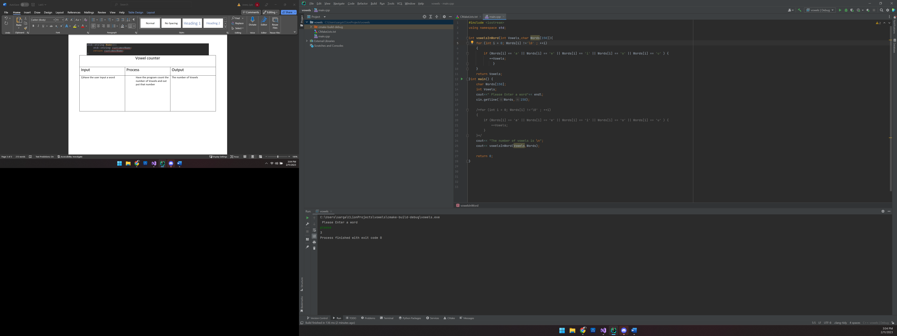

C:\Users\sarga\CLionProjects\vowels\cmake-build-debug\vowels.exe

Please Enter a word

Hello There

The number of vowels is

4

Process finished with exit code 0

#include <iostream>  
using namespace std;  
  
int vowelsInWord(int Vowels,char Words[150]){  
 for (int i = 0; Words[i] !='\0' ; ++i)  
 {  
 if (Words[i] == 'a' || Words[i] == 'e' || Words[i] == 'i' || Words[i] == 'o' || Words[i] == 'u' ) {  
 ++Vowels;  
 }  
 }  
 return Vowels;  
}int main() {  
 char Words[150];  
 int Vowels;  
 cout<<" Please Enter a word"<< endl;  
 cin.getline(Words,150);  
  
 /*for (int i = 0; Words[i] !='\0' ; ++i)  
 {  
 if (Words[i] == 'a' || Words[i] == 'e' || Words[i] == 'i' || Words[i] == 'o' || Words[i] == 'u' ) {  
 ++Vowels;  
 }  
 }*/  
 cout<< "The number of vowels is \n";  
 cout<< vowelsInWord(Vowels,Words);  
  
 return 0;  
}

|  |  |  |
| --- | --- | --- |
| Inflation Rate | | |
| Input | Process | Output |
| 1)Have the user input the current price of an item  Have them put in the price of the same item from 2 years ago | Take the ending cost subtracting starting cost then from that number divide the starting cost | Put out what the inflation rate is and whether it has gone up or down |

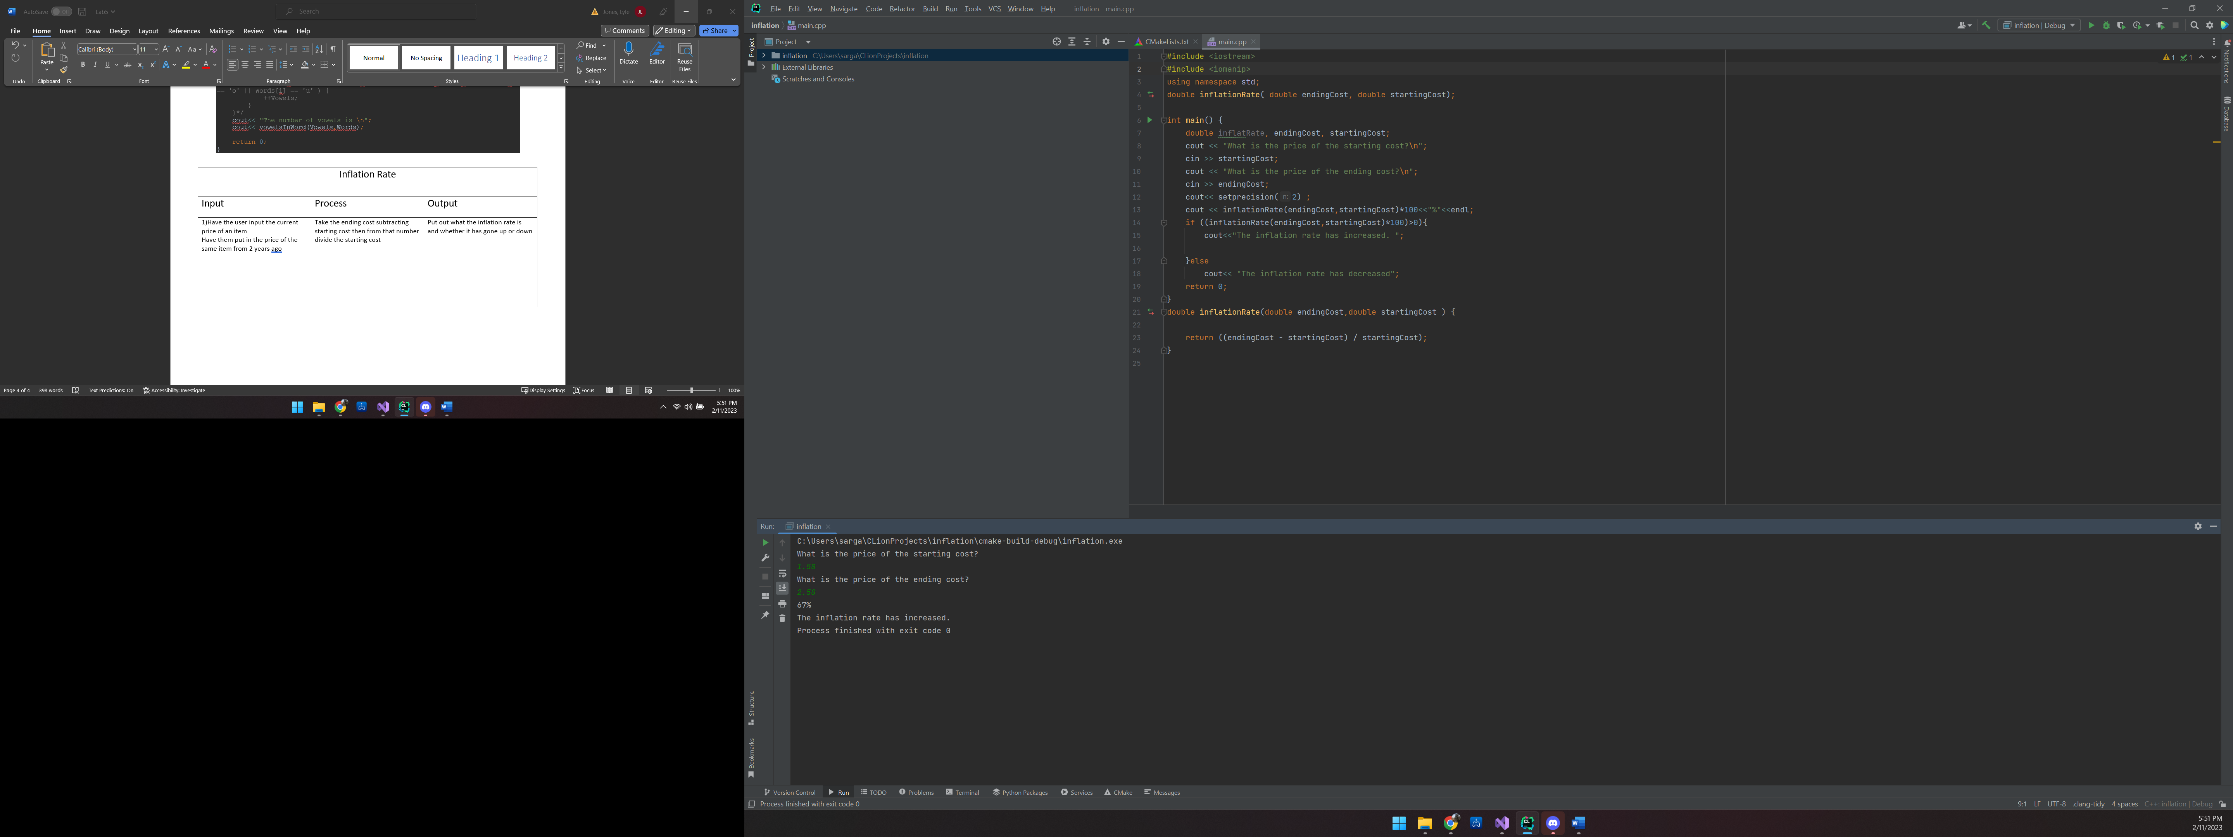C:\Users\sarga\CLionProjects\inflation\cmake-build-debug\inflation.exe

What is the price of the starting cost?

1.50

What is the price of the ending cost?

2.50

67%

The inflation rate has increased.

Process finished with exit code 0

#include <iostream>  
#include <iomanip>  
using namespace std;  
double inflationRate( double endingCost, double startingCost);  
  
int main() {  
 double inflatRate, endingCost, startingCost;  
 cout << "What is the price of the starting cost?\n";  
 cin >> startingCost;  
 cout << "What is the price of the ending cost?\n";  
 cin >> endingCost;  
 cout<< setprecision(2) ;  
 cout << inflationRate(endingCost,startingCost)*100<<"%"<<endl;  
 if ((inflationRate(endingCost,startingCost)*100)>0){  
 cout<<"The inflation rate has increased. ";  
  
 }else  
 cout<< "The inflation rate has decreased";  
 return 0;  
}  
double inflationRate(double endingCost,double startingCost ) {  
  
 return ((endingCost - startingCost) / startingCost);  
}

|  |  |  |
| --- | --- | --- |
| Random Number | | |
| Input | Process | Output |
| 1)Have the user input the current price of an item  Have them put in the price of the same item from 2 years ago | Take the ending cost subtracting starting cost then from that number divide the starting cost | Put out what the inflation rate is and whether it has gone up or down |

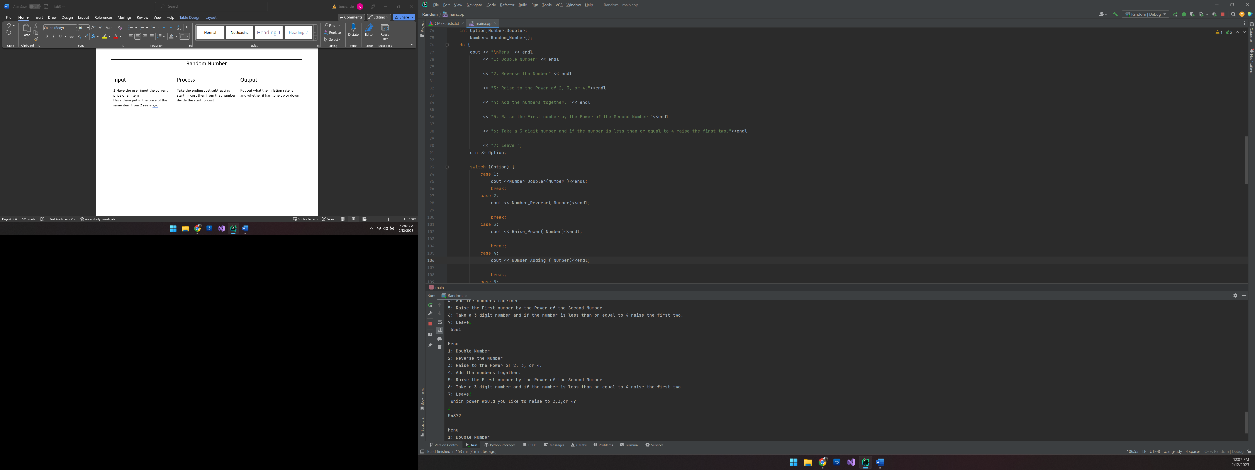

4: Add the numbers together.

5: Raise the First number by the Power of the Second Number

6: Take a 3 digit number and if the number is less than or equal to 4 raise the first two.

7: Leave5

6561

Menu

1: Double Number

2: Reverse the Number

3: Raise to the Power of 2, 3, or 4.

4: Add the numbers together.

5: Raise the First number by the Power of the Second Number

6: Take a 3 digit number and if the number is less than or equal to 4 raise the first two.

7: Leave3

Which power would you like to raise to 2,3,or 4?

3

54872

#include <iostream>  
#include<cstdlib>  
#include <ctime>  
#include <cmath>  
  
int Doubler;  
using namespace std;  
  
  
/*int Random_Number(int New_Number);  
int Number_Doubler(int New_Number,int Doubler);  
int Raise_Power(int New_Number,int Power_Raise);  
int Number_Reverse(int New_Number,int Reversed_Number);  
int Number_Adding (int New_Number,int Added);  
int Number_Raising(int New_Number,int Raised_Number);  
}*/  
int Random_Number(){  
 srand(time(NULL));  
 int New_Number;  
 New_Number = ((rand()% 99) + 1);  
 return New_Number;  
}  
int Number_Doubler(int New_Number){  
 int Doubler =New_Number*2;  
 return Doubler;  
}  
  
int Raise_Power(int New_Number){  
 int Power_Raise, Option2;  
 cout<<"Which power would you like to raise to 2,3,or 4?\n";  
 cin>>Option2;  
 switch (Option2) {  
 case 2: Power_Raise= ::pow(New_Number, 2 );  
 break;  
  
 case 3: Power_Raise= ::pow(New_Number, 3 );  
 break;  
 case 4: Power_Raise= ::pow(New_Number, 4 );  
 break;  
 }  
 return Power_Raise;  
}  
  
int Number_Reverse(int New_Number){  
 int Reversed_Number = 0, Remainder;  
 while(New_Number != 0) {  
 Remainder = New_Number % 10;  
 Reversed_Number = Reversed_Number * 10 + Remainder;  
 New_Number /= 10;  
 }  
 return Reversed_Number;  
}  
  
int Number_Adding (int New_Number){  
 int Added, Remainder;  
 while (New_Number>0){  
 Remainder=New_Number%10;  
 Added=Added+Remainder;  
 New_Number=New_Number/10;  
 }  
 return Added;  
}  
  
int Number_Raising(int New_Number){  
 int First_Number, Second_Number,Raised_Number;  
 First_Number= New_Number / 10;  
 Second_Number= New_Number % 10;  
 Raised_Number= ::pow(First_Number,Second_Number);  
 return Raised_Number;  
  
}  
  
int main() {  
 int Option,Number,Doubler;  
 Number= Random_Number();  
 do {  
 cout << "\nMenu" << endl  
 << "1: Double Number" << endl  
  
 << "2: Reverse the Number" << endl  
  
 << "3: Raise to the Power of 2, 3, or 4."<<endl  
  
 << "4: Add the numbers together. "<< endl  
  
 << "5: Raise the First number by the Power of the Second Number "<<endl  
  
 << "6: Take a 3 digit number and if the number is less than or equal to 4 raise the first two."<<endl  
  
 << "7: Leave ";  
 cin >> Option;  
  
 switch (Option) {  
 case 1:  
 cout <<Number_Doubler(Number )<<endl;  
 break;  
 case 2:  
 cout << Number_Reverse( Number)<<endl;  
  
 break;  
 case 3:  
 cout << Raise_Power( Number)<<endl;  
  
 break;  
 case 4:  
 cout << Number_Adding ( Number)<<endl;  
  
 break;  
 case 5:  
 cout << Number_Raising( Number)<<endl;  
 break;  
  
 case 6:  
 cout << " ";  
  
 break;  
 }  
 }while(Option<6);  
 return 0;  
}  
/*  
int Random_Number(){  
 srand(time(NULL));  
 int New_Number = ((rand()% 99) + 1);  
 return New_Number;  
}  
int Number_Doubler(int New_Number){  
 int Doubler =New_Number*New_Number;  
 return Doubler;  
}  
  
int Raise_Power(int New_Number){  
 int Power_Raise, Option2;  
 cout<<"Which power would you like to raise to 2,3,or 4?\n";  
 cin>>Option2;  
 switch (Option2) {  
 case 2: Power_Raise= ::pow(New_Number, 2 );  
 break;  
  
 case 3: Power_Raise= ::pow(New_Number, 3 );  
 break;  
 case 4: Power_Raise= ::pow(New_Number, 4 );  
 break;  
 }  
 return Power_Raise;  
}  
  
int Number_Reverse(int New_Number){  
 int Reversed_Number = 0, Remainder;  
 while(New_Number != 0) {  
 Remainder = New_Number % 10;  
 Reversed_Number = Reversed_Number * 10 + Remainder;  
 New_Number /= 10;  
 }  
 return Reversed_Number;  
}  
  
int Number_Adding (int New_Number){  
 int Added, Remainder;  
 while (New_Number>0){  
 Remainder=New_Number%10;  
 Added=Added+Remainder;  
 New_Number=New_Number/10;  
 }  
 return Added;  
}  
  
int Number_Raising(int New_Number){  
 int First_Number, Second_Number,Raised_Number;  
 First_Number= New_Number / 10;  
 Second_Number= New_Number % 10;  
 Raised_Number= ::pow(First_Number,Second_Number);  
 return Raised_Number;  
  
}*/

|  |  |  |
| --- | --- | --- |
| Random Number | | |
| Input | Process | Output |
| 1)Have the user input the current price of an item  Have them put in the price of the same item from 2 years ago | Take the ending cost subtracting starting cost then from that number divide the starting cost | Put out what the inflation rate is and whether it has gone up or down |