|  |  |  |
| --- | --- | --- |
| Pay | | |
| Input | Process | Output |
| 1)enter the amount paid per hour  2) Enter the amount of time worked | Take time worked and multiple it by the amount paid | Show gross pay |

What is the pay rate of the employee?27

Enter 1 first to put in the employees hours.

Enter 2 second to enter the employees rate of pay

Enter 3 third to get the gross pay

Enter 4 to Leave3

$1080

#include <iostream>  
using namespace std;  
  
  
float getHoursWorked();  
float getPayRate();  
float CalsGross(int PayRate, int HoursWorked);  
  
  
int main() {  
 int Menu,Pay,Hours;  
 do {  
 cout<<"Enter 1 first to put in the employees hours.\n"  
 <<"Enter 2 second to enter the employees rate of pay\n"  
 <<"Enter 3 third to get the gross pay\n"  
 <<"Enter 4 to Leave";  
 cin>>Menu;  
 switch (Menu) {  
 case 1:  
 Pay=getHoursWorked();  
 break;  
 case 2:  
 Hours=getPayRate();  
 break;  
 case 3:  
 cout<<"$"<< CalsGross(Pay,Hours)<<endl;  
 break;  
 }  
  
 }while (Menu<4);  
 return 0;  
}  
  
float getHoursWorked(){  
 float HoursWorked;  
 cout<<"How many hours did you work?";  
 cin>>HoursWorked;  
 return HoursWorked;  
}  
float getPayRate(){  
 float PayRate;  
 cout<<"What is the pay rate of the employee?";  
 cin>>PayRate;  
 return PayRate;  
}  
  
float CalsGross(int PayRate, int HoursWorked){  
 float GrossPay=PayRate*HoursWorked;  
 return GrossPay;  
}

|  |  |  |
| --- | --- | --- |
| Insurance | | |
| Input | Process | Output |
| 1)enter the how many dependents they have  2) Enter the amount of time worked | Take time worked and multiple it by the amount paid | Show gross pay |

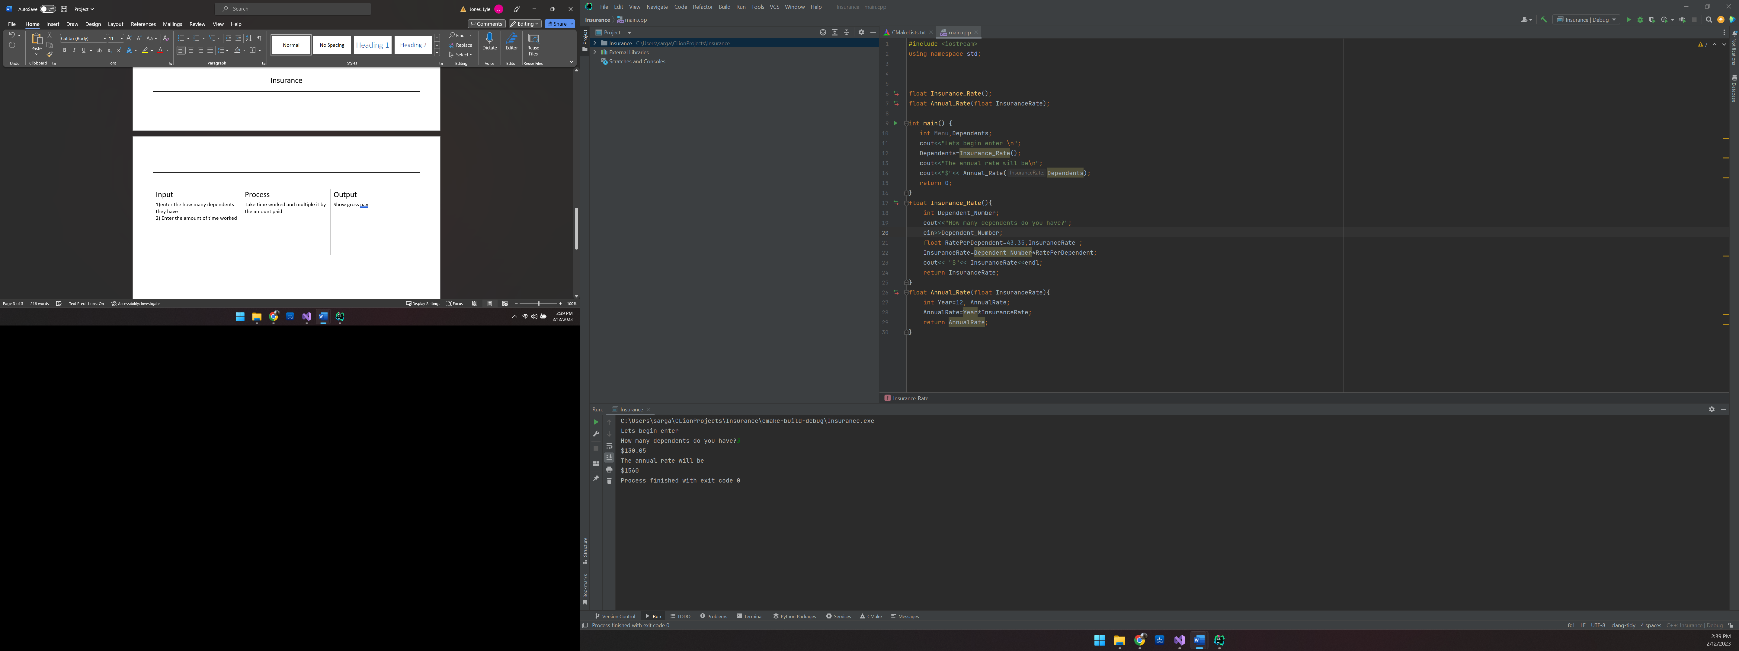

C:\Users\sarga\CLionProjects\Insurance\cmake-build-debug\Insurance.exe

Lets begin enter

How many dependents do you have?3

$130.05

The annual rate will be

$1560

Process finished with exit code 0

#include <iostream>  
using namespace std;  
  
  
  
float Insurance_Rate();  
float Annual_Rate(float InsuranceRate);  
  
int main() {  
 int Menu,Dependents;  
 cout<<"Lets begin enter \n";  
 Dependents=Insurance_Rate();  
 cout<<"The annual rate will be\n";  
 cout<<"$"<< Annual_Rate(Dependents);  
 return 0;  
}  
float Insurance_Rate(){  
 int Dependent_Number;  
 cout<<"How many dependents do you have?";  
 cin>>Dependent_Number;  
 float RatePerDependent=43.35,InsuranceRate ;  
 InsuranceRate=Dependent_Number*RatePerDependent;  
 cout<< "$"<< InsuranceRate<<endl;  
 return InsuranceRate;  
}  
float Annual_Rate(float InsuranceRate){  
 int Year=12, AnnualRate;  
 AnnualRate=Year*InsuranceRate;  
 return AnnualRate;  
}

|  |  |  |
| --- | --- | --- |
| Vacation | | |
| Input | Process | Output |
| 1)enter the number of years worked | Take the amount of years work and out put the days of vacation | Show the days of vacation |

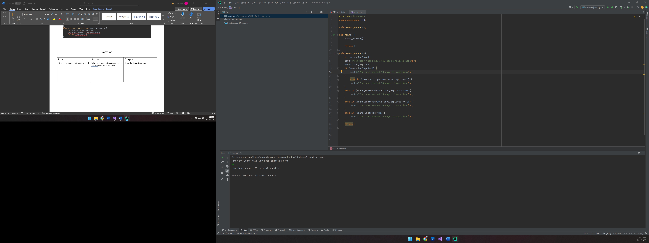

C:\Users\sarga\CLionProjects\vacation\cmake-build-debug\vacation.exe

How many years have you been employed here

99

You have earned 25 days of vacation.

Process finished with exit code 0

#include <iostream>  
using namespace std;  
  
void Years_Worked();  
  
int main() {  
 Years_Worked();  
  
 return 0;  
}  
void Years_Worked(){  
 int Years_Employed;  
 cout<<"How many years have you been employed here\n";  
 cin>>Years_Employed;  
 if (Years_Employed==0) {  
 cout<<"You have earned 10 days of vacation.\n";  
 }  
 else if (Years_Employed>0&&Years_Employed<5) {  
 cout<<"You have earned 10 days of vacation.\n";  
 }  
 else if (Years_Employed>=5&&Years_Employed<=10) {  
 cout<<"You have earned 15 days of vacation.\n";  
 }  
 else if (Years_Employed>10&&Years_Employed <= 20) {  
 cout<<"You have earned 20 days of vacation.\n";  
 }  
 else if (Years_Employed>=21) {  
 cout<<"You have earned 25 days of vacation.\n";  
 }  
 return ;  
 }