JANE.M DESIGNS
Fashion Brand Turnaround Playbook
90-day strategy, operating model, campaigns, pricing, sales process and execution tracker
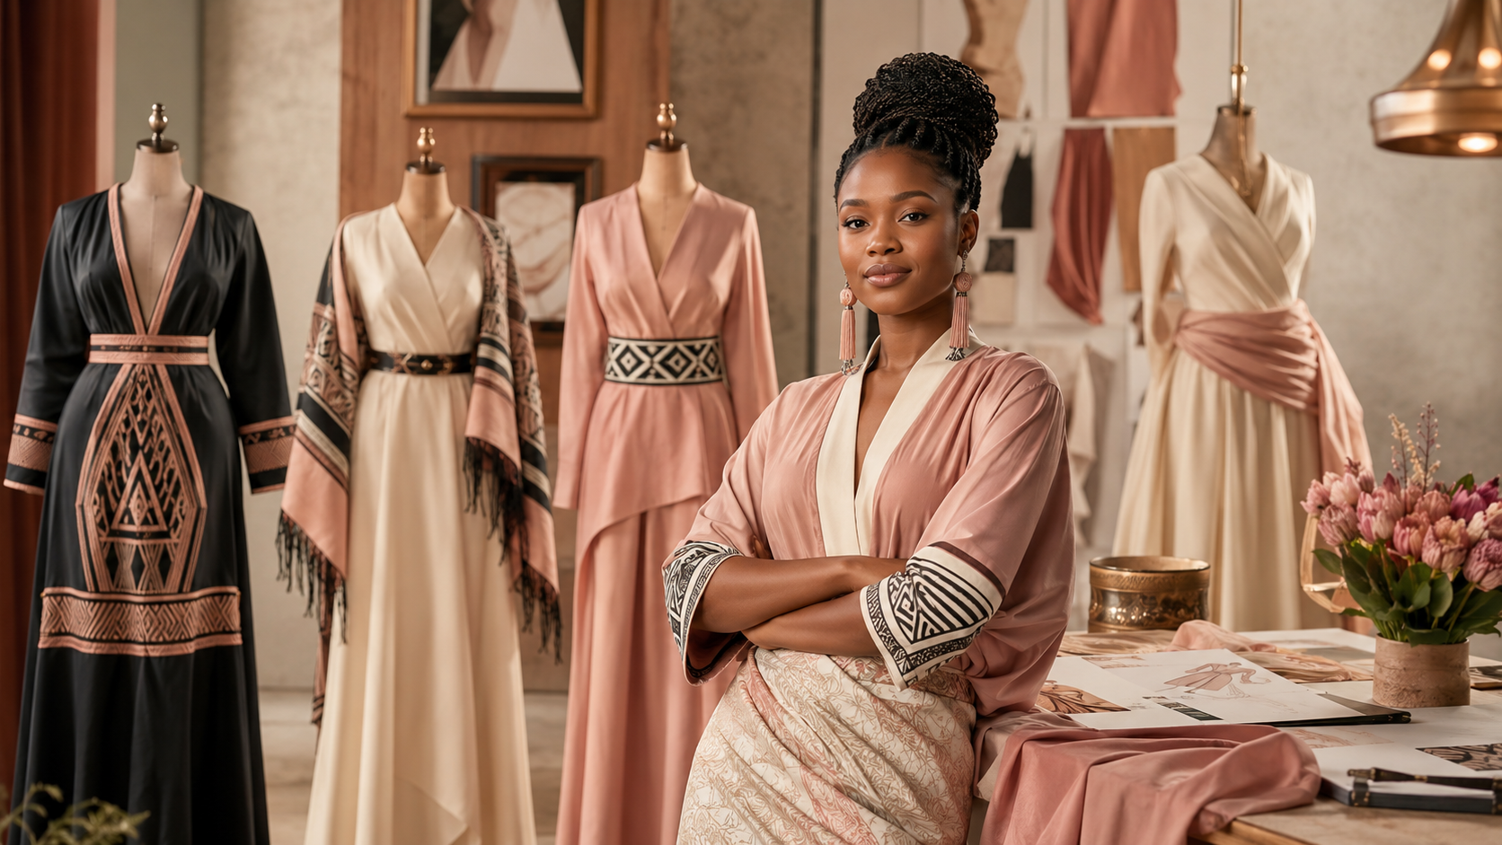
Turnaround thesis
Jane.M must move from a talent-led creative presence to a commercially disciplined fashion business: clear offers, visible prices, WhatsApp sales office, proof, campaign rhythm, deposits and weekly KPI control.

1. Strategic objective
In 90 days, convert Jane.M from a content-led fashion page into a visible, trusted, order-generating women’s apparel business with clear offers, repeatable campaigns and predictable weekly sales activity.
Metric | 90-day target
Qualified inquiries | 20-40 per week
Paid orders | 5-10 per week
Quote-to-deposit conversion | 30%+
Average order value | M900+
Late deliveries | 0
Referral orders | 2+ per week

2. Positioning
Brand promise
Elegant, feminine, made-to-measure outfits for Basotho women who want to look special without looking ordinary.
Brand lane | Meaning
Elegant | Premium finish and graceful silhouettes, not random sewing.
Feminine | Designs that make women feel beautiful and confident.
Event-ready | Graduations, weddings, church, work events and bridal parties.
Custom but accessible | Made-to-measure, but packaged into clear tiers and lead times.

3. Offer architecture
Signature line | Target customer | Commercial role
Graduation Belle | Graduates and families | Immediate campaign opportunity
Wedding Guest Queen | Women attending weddings/lobola | High-volume seasonal line
Sunday Best / Church Lady | Church and event women | Stable monthly orders
Office Elegance Set | Professional women | Repeatable capsule line
Seshoeshoe Modern Muse | Heritage-conscious buyers | Differentiation line

4. Pricing and deposits
Tier | Price range | Includes
Simple | M450-M750 | Standard fabric, clean finish, limited changes
Premium | M800-M1,500 | Better fabric, lining, fitting and detail
Luxe | M1,800-M4,500+ | Statement pieces, priority production, premium finish
Ready-to-wear | M250-M650 | Pre-made, no custom changes

Order type | Deposit policy
Normal custom | 60% deposit, balance before collection
Rush order | 80% deposit, balance before collection
Bridal/group | 50% deposit, 30% after fitting, 20% before delivery
Ready-to-wear | 100% upfront

5. Target market priorities
Segment | Need | Message
Graduates | Unique and memorable look | Your graduation look should be remembered.
Wedding guests | Stand out respectfully | Never basic at a wedding.
Bridesmaids | Coordinated looks and deadline control | Beautiful bridal party looks without stress.
Church women | Modest elegance | Elegant outfits for women of grace.
Professional women | Polished wardrobe | Workwear that still feels feminine.
Diaspora Basotho | Cultural-modern pieces | Modern Basotho elegance, wherever you are.

6. Sales funnel and WhatsApp operating model
The buying path should be simple: Content -> Inquiry -> Catalogue -> Quote -> Deposit -> Measurements -> Fitting -> Delivery -> Testimonial -> Referral.
WhatsApp feature | Configuration
Catalogue | Signature pieces with price-from ranges
Quick replies | Pricing, lead time, measurements, deposit policy
Labels | New lead, quoted, deposit paid, production, fitting, collected
Auto greeting | Ask for event date, outfit type, colour, budget and inspiration
Broadcasts | Past clients, prospects, graduation campaign, wedding season

7. Campaign plan
Campaign | Offer | Execution
Graduated Designer, Dressing Graduates | Graduation dresses from M650 | Use her graduation story, friends discount, photographer partners
Never Basic at a Wedding | Wedding guest dresses from M850 | Reels, client proof, wedding season countdowns
Sunday Best Elegance | Church/event outfits | Monthly drop before salary weekends
Corporate Woman Capsule | 3-piece workwear capsule | Target banks, telecoms, NGOs, government and universities

8. Partnership playbook
Partner | Action | Commission
Photographers | Refer graduation/event clients | 5-10% on paid deposits
Makeup artists | Dress + makeup bundle | 5-10% on paid deposits
Salons | Display lookbook / QR card | Referral incentive
Wedding planners | Bridal party package | 5-10% on paid deposits
Universities | Student ambassador or pop-up | Discount or commission
Women groups | Showcase church/corporate line | Group discount

9. Operations and quality control
Control area | Standard
Capacity | Define weekly slots for simple, premium, group and rush orders
Order control | No cutting without deposit and signed order form
Fitting | Book fitting date at deposit stage
Quality gate | Fit, seams, lining, pressing, packaging and final photo
Admin | Separate inquiries/follow-ups from sewing work
Delivery | Balance paid before handover

10. 90-day roadmap
Phase | Focus | Deliverables
Days 1-7 | Commercial reset | Brand bio, price guide, catalogue, WhatsApp setup, testimonials
Days 8-30 | First campaign | Graduation launch, ad test, referral partners, daily CTAs
Days 31-60 | Scale proof | Wedding campaign, influencers, pop-up, client testimonials
Days 61-90 | Systemise | Ready-to-wear drop, corporate capsule, production dashboard

11. First 7-day checklist
- Choose final brand name and bio
- Create 5 signature designs
- Publish price guide with “from” pricing
- Set WhatsApp Business catalogue and quick replies
- Collect 10 testimonials/photos
- Post graduation campaign announcement
- Contact 10 referral partners
- Run first M300-M500 boosted post
- Start inquiry / quote / deposit tracker
- Hold first weekly KPI review

12. Weekly management routine
Day | Routine
Monday | Review previous week: inquiries, quotes, deposits, delivery issues
Tuesday | Follow up all unpaid quotes
Wednesday | Post client proof or transformation
Thursday | Push price/package post
Friday | Campaign CTA and urgency post
Saturday | Collect testimonials and pickup photos
Sunday | Plan next week’s content and production schedule

