**CMSC203 Assignment 0**

Class: CMSC203 CRN 47501

 Program: Assignment 0

Instructor: Prof. G. Grinberg

 Summary of Description: Setting up Eclipse, GitHub, JDK, JUnit, and JavaFX

 Due Date: 06/12/2022

 Integrity Pledge: I pledge that I have completed the programming assignment independently.

 I have not copied the code from a student or any source.

**Part1: Setup GitHub:** Provide the screen shots of your GitHub account with Assignment 0 file is uploaded on GitHub:

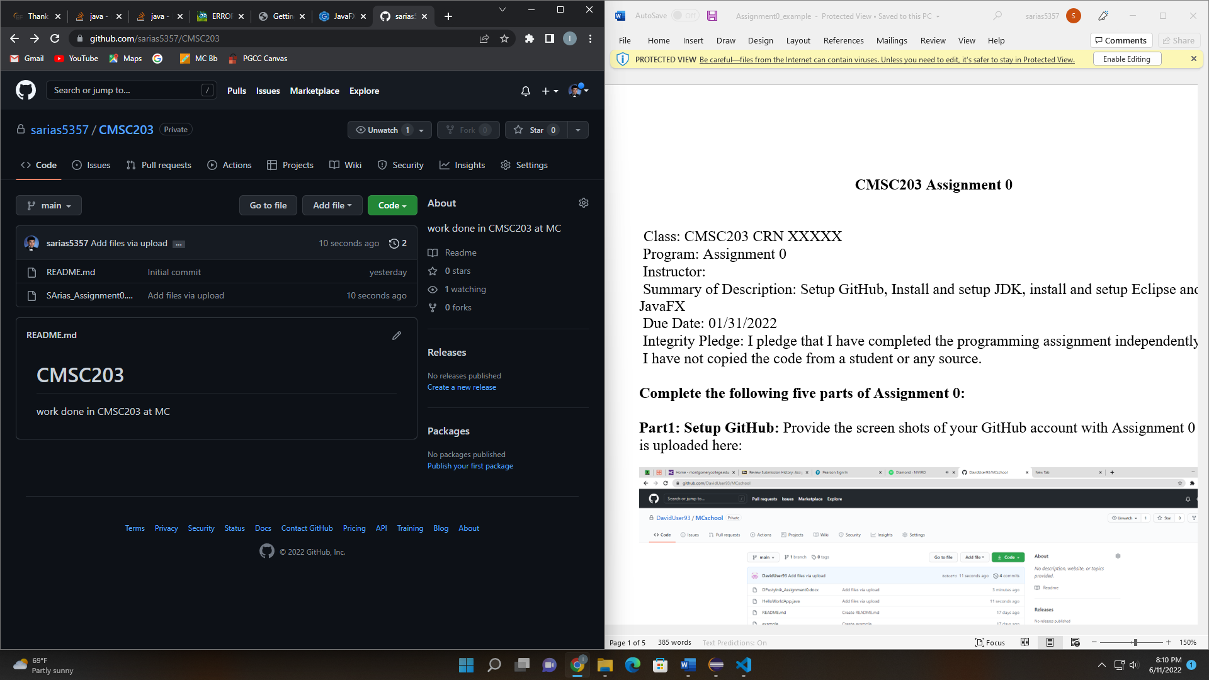

**Part 2 -Install JDK, Test java Application from Command Line**

Provide the screen shots from Step 1 and 2 here:

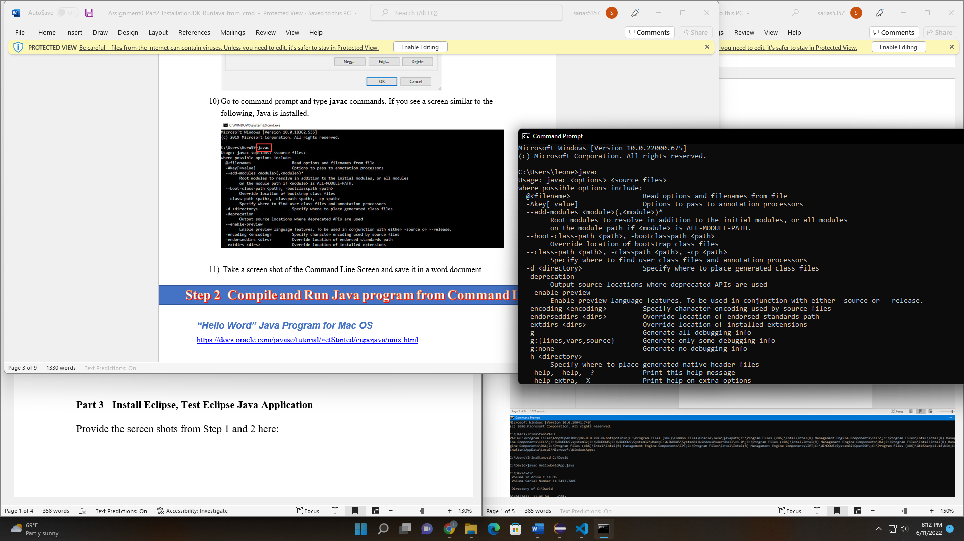

**Part 3 - Install Eclipse, Test Eclipse Java Application**

Provide the screen shots from Step 1 and 2 here:

**Already had eclipse installed**

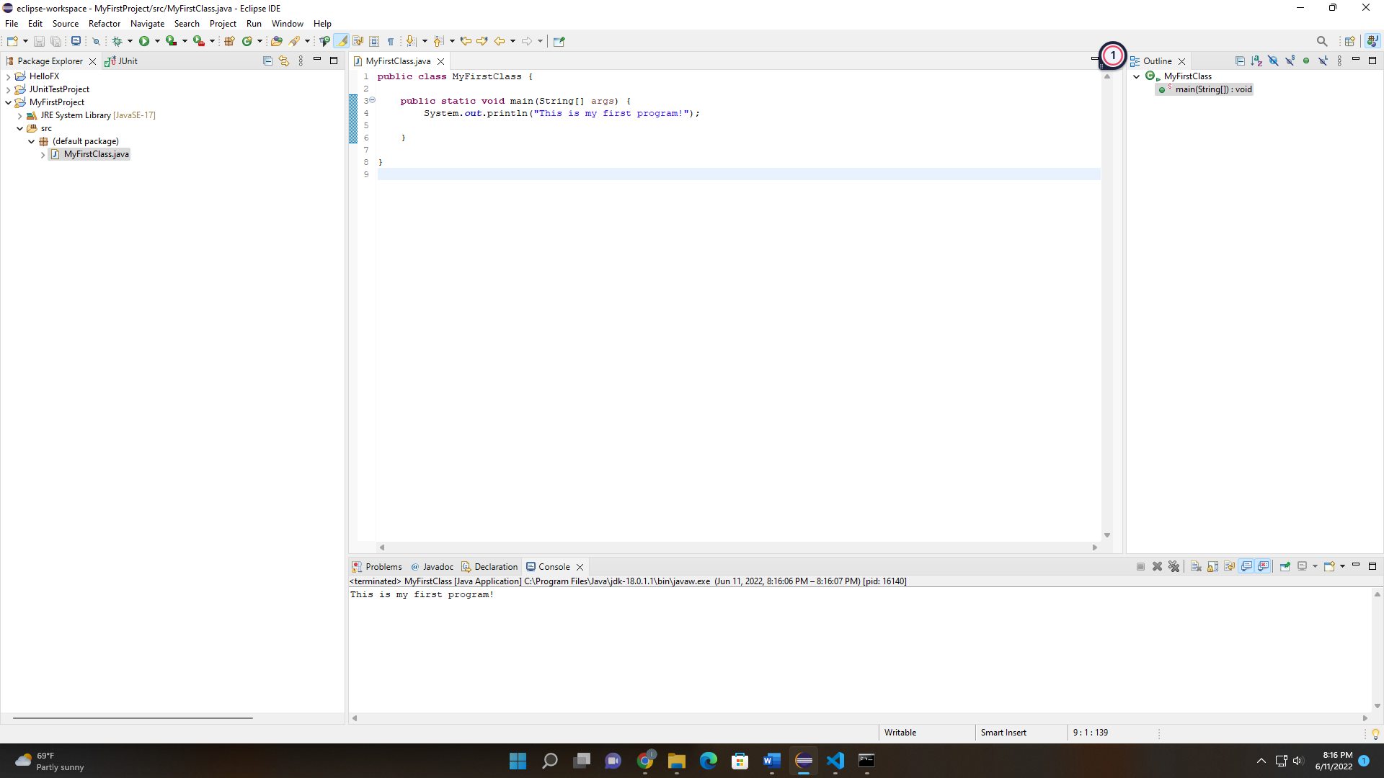

**Part 5 - Install, Setup, and Test JavaFX Application.**

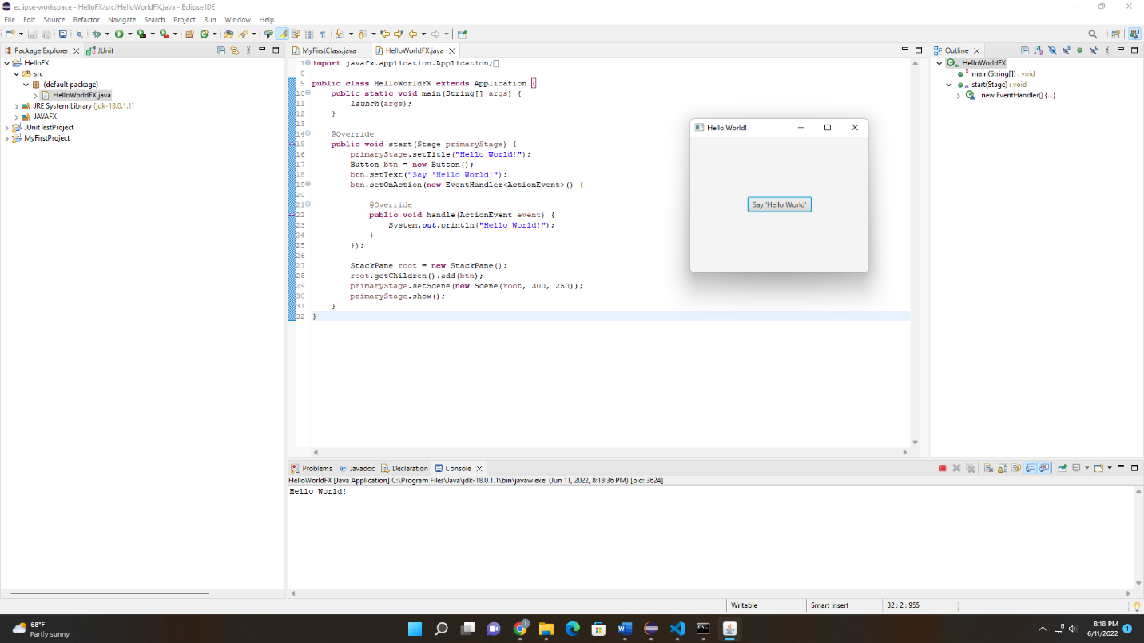

**Lessons Learned** <Provide answers to the questions listed below>**:**

Write about your Learning Experience, highlighting your lessons learned and learning experience from working on this assignment.

**The assignment was fairly easy however I struggled a lot with the Path/CLASSPATH variables. For some reason, my JDK/JRE files were not appearing in my Program Files. After a restart of my computer and a reinstall, I got it to work. I also learned a bit about JavaFX since I do not have any experience in it. It seems like it could be useful!**

What have you learned?

**I learned how to run Junit tests and how to create a JavaFX program**

What did you struggle with?

**I struggled with the environmental variables and setting up the JUnit test classes. I did not understand how the methods were supposed to be implemented but eventually I understood.**

What parts of this assignment were you successful with, and what parts (if any) were you not successful with?

**I was successful with creating the JavaFX program and figuring out how to add libraries in Eclipse.**

Provide any additional resources/links/videos you used to while working on this assignment.

**<https://docs.oracle.com/javase/tutorial/essential/environment/paths.html>**

**Check List:** <Provide answers to the column Y/N or N/A >**:**

|  |  |  |  |
| --- | --- | --- | --- |
| **#** |  | **Y/N** | **Comments** |
|  | **Assignment files:** |  |  |
|  | * FirstInitialLastName_Assignment0.docx/pdf | **Yes or No** | **Y** |
|  | * Source java files | **Yes or No** | **Y** |
|  | **Program compiles** | **Yes or No** | **Y** |
|  | **Program runs with desired outputs related to a Test Plan** | **Yes or No** | **Y** |
|  | **Documentation file: Screenshots of** |  |  |
|  | * Part1: Setup GitHub | **Yes or No** | **Y** |
|  | * Part 2 -Install JDK, Test java Application from Command Line | **Yes or No** | **Y** |
|  | * Part 3 - Install Eclipse, Test Eclipse Java Application | **Yes or No or N/A** | **Y** |
|  | * Part 4 - Install, Setup, Test Junit Program | **Yes or No or N/A** | **Y** |
|  | * Part 5 - Install, Setup, and Test JavaFX Application. | **Yes or No or N/A** | **Y** |
|  | * Lessons Learned | **Yes or No** | **Y** |
|  | * Checklist is completed and included in the Documentation | **Yes or No** | Y |