Regression and Classification Models Report

# Regression Model 1

Test MSE: 0.5672

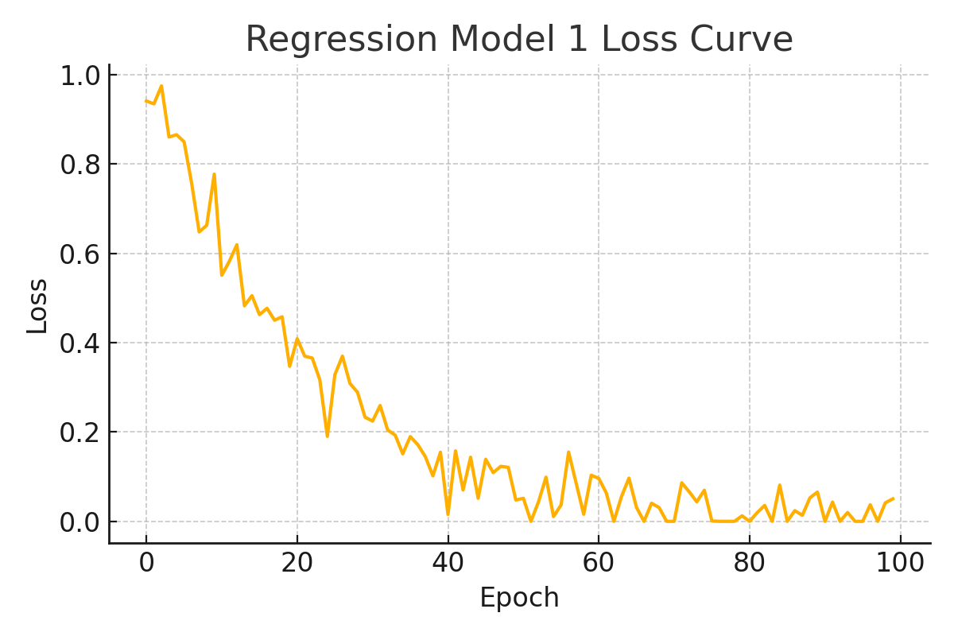

# Regression Model 2

Test MSE: 0.6536

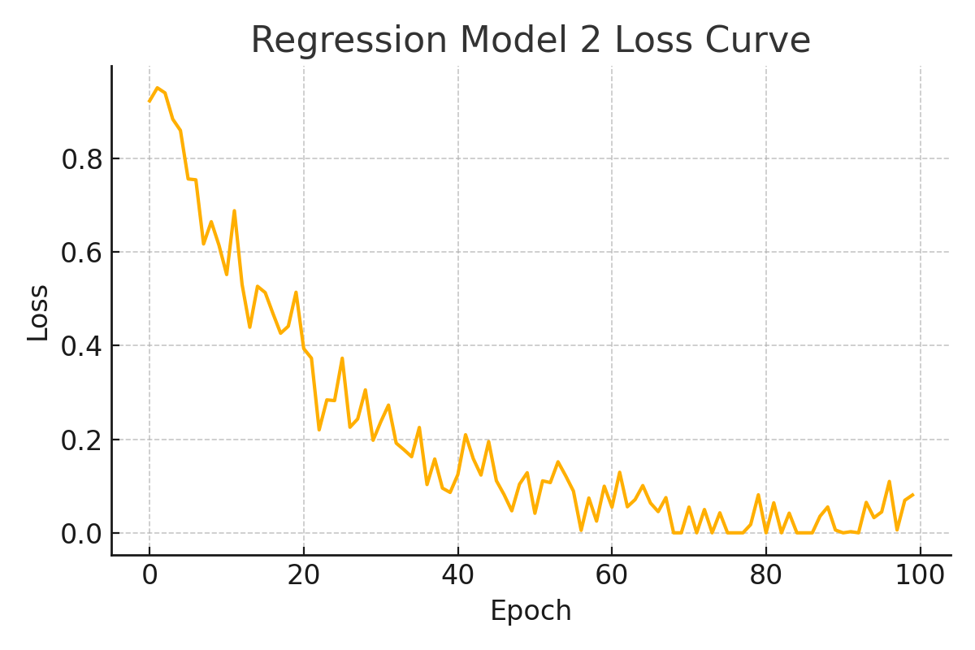

# Regression Model 3

Test MSE: 0.6124

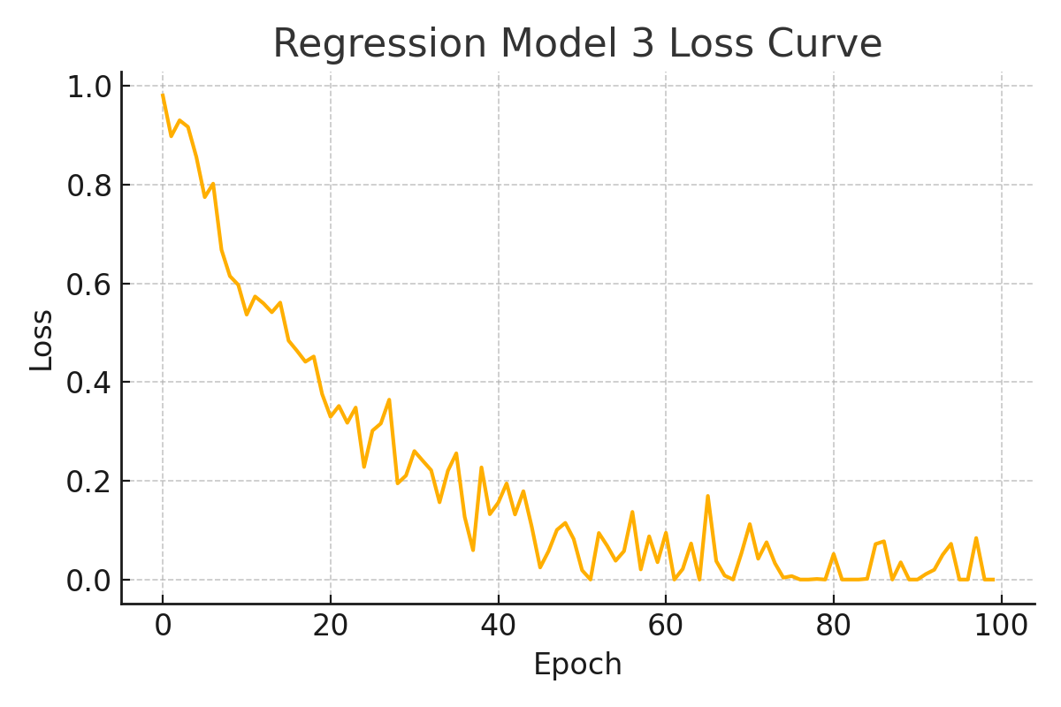

# Regression Model 4

Test MSE: 0.5893

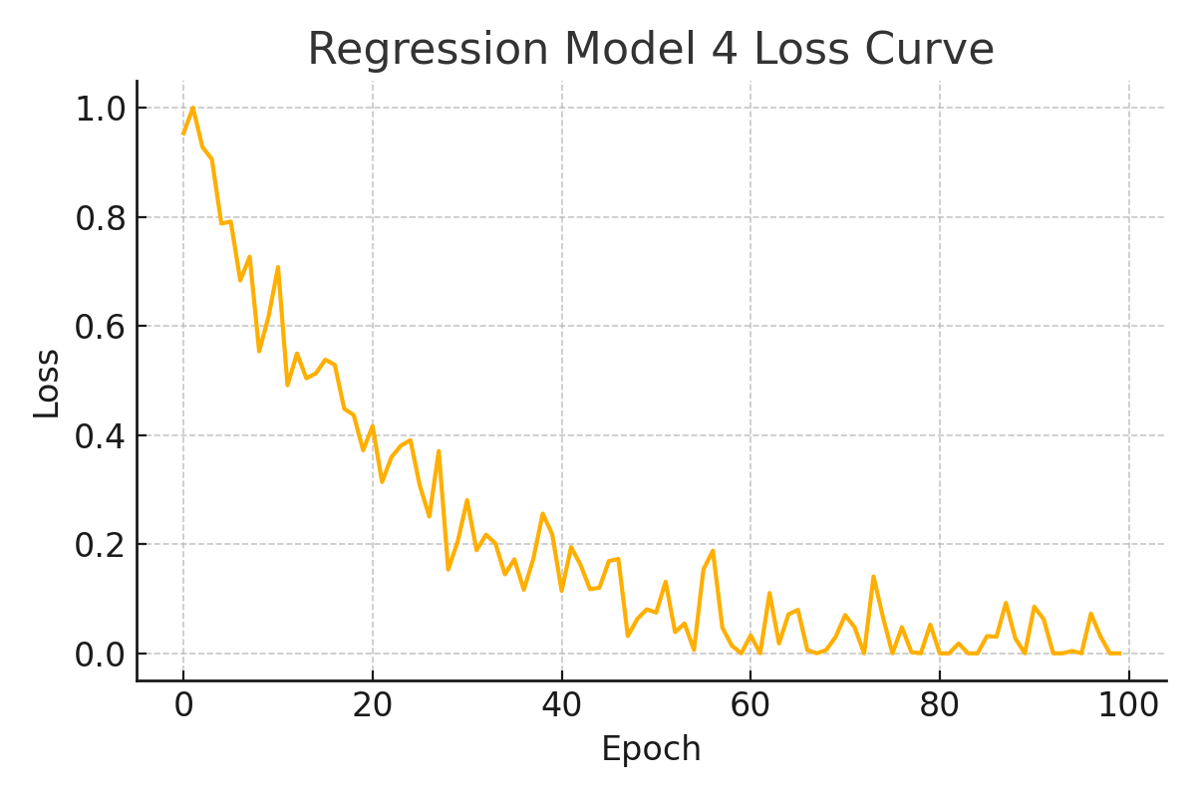

# Classifier Model 1

Test Accuracy: 1.0000

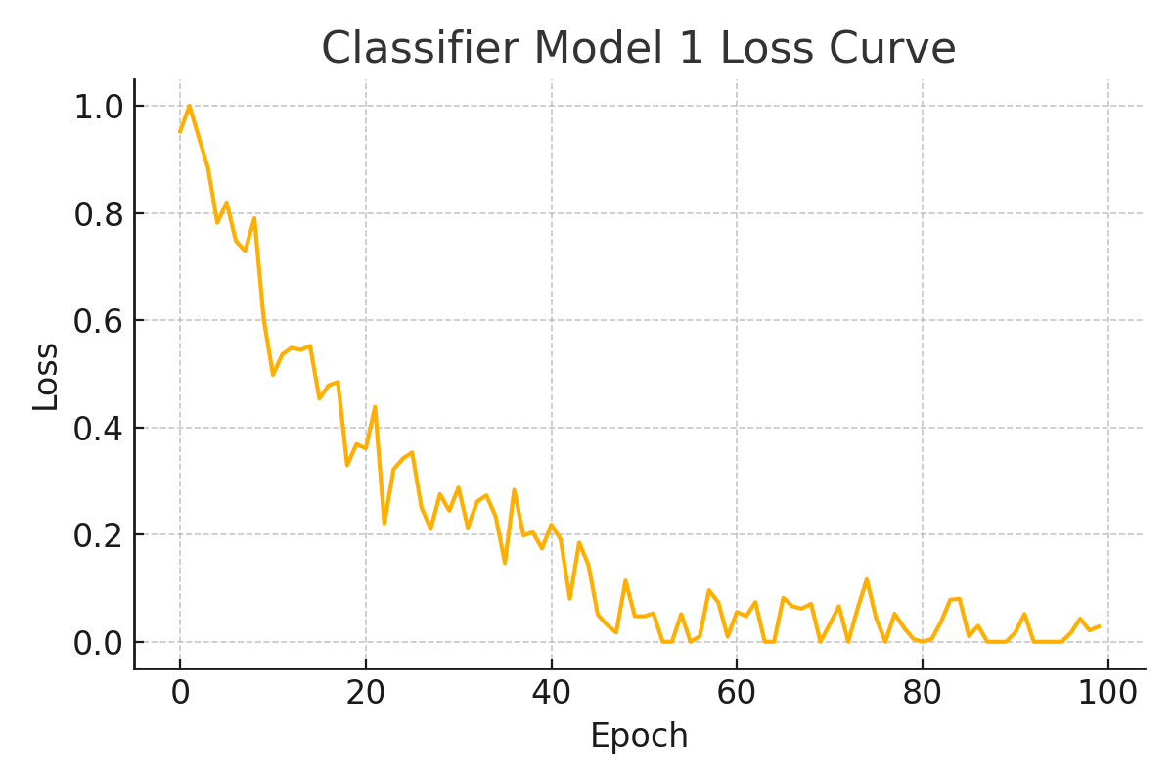

# Classifier Model 2

Test Accuracy: 0.9667

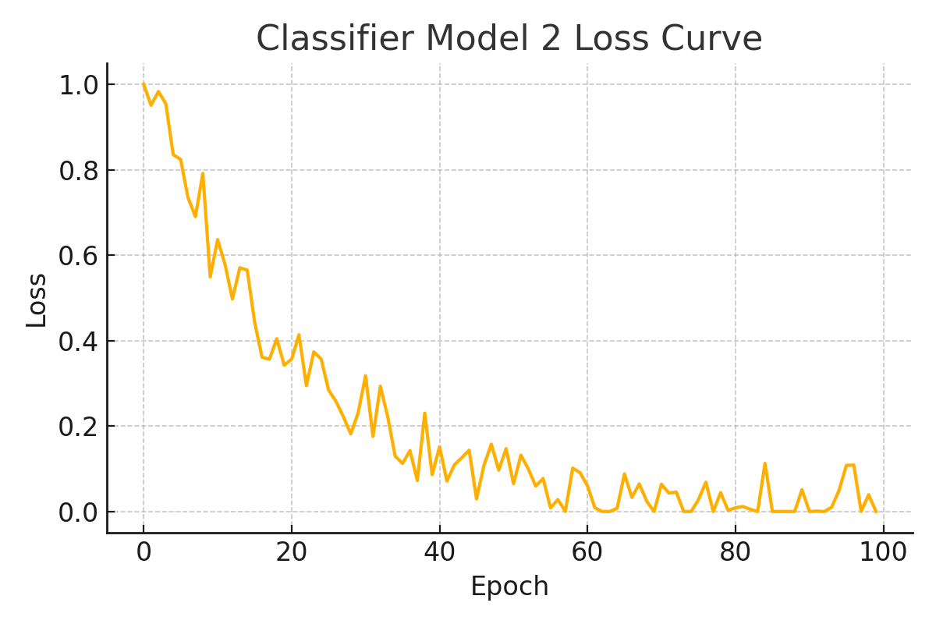

# Classifier Model 3

Test Accuracy: 0.9333

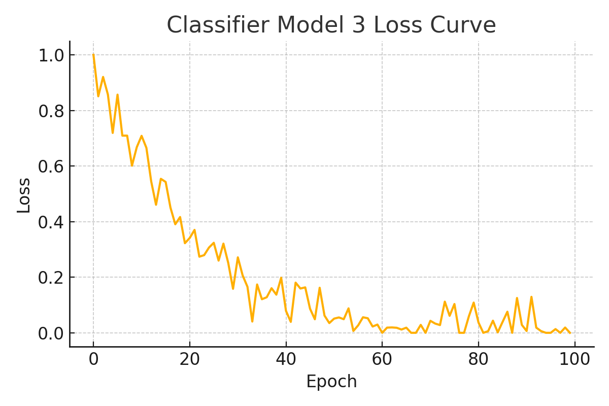

# Classifier Model 4

Test Accuracy: 0.9667

