**Curriculum Vitae** 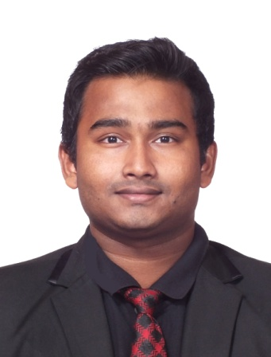

**MD. ARIFUL ISLAM**

New world Petaling Jaya Hotel Paradigm, 1 Jalan SS7/26A

Kelana Jaya, 47301 petaling Jaya Selongor Darul Ehsan, Malaysia.

Email: Arifbd789@gmail.com, Mob: +60 1128434912

**OBJECTIVE**

To develop my career as a professional in a dynamic & growing environment through my personal abilities, gained skills, knowledge, education for long term mutual benefit.

**STRENGTH**

* Effective communication skill.
* Capable to adopt new protocols & any environment.
* Positive & flexible attitude.
* Capability to communicating with people effectively.
* Having good analytical & judgmental skills.
* Accept responsibility and do it honestly.

**EDUCATIONAL QUALIFICATION**

* Title (1) : Diploma ( On Job training )
* Organized by : Innovative International College

Unit902, LVL 9, Mutiara Majestic Jalan Othman, Seksyen

3,46000 Selangor.

* Subject : Hotel Management
* Year : Studying (10 December 2015 to 2018)

* Title(2) : Higher Secondary Certificate Examination (HSC)
* Conducted by : Board of Intermediate and Secondary Education, Dhaka
* Organized by : Dania college

Jatrabari, Dhaka-1236

Mobile: 7542591, 7552525 , Fax: 7552525

Email: daniacollege85@gmail.com

Web: www.daniacollege.edu.bd

* Year : 13 May,2011 to 03 August,2013
* Group : Business Studies .
* GPA : 5.00 out of 5.00

* Title(3) : Secondary Certificate Examination (SSC)
* Conducted by : Board of Intermediate and Secondary Education, Dhaka.
* Organized by : Bamoil Ideal High School & College,

Bamoil, Sarulia. Sarulia.. P.C. 1361,  Demra, Dhaka.

Bamoil Bazar Main Road, 1204 Dhaka

http://www.bamoil.ideal.school.com

* Year : 01 January 2001 to12 May,2011.
* Group : Business Studies .
* GPA : 4.69 out of 5.00

**SKILLS**

**Computer Skill:**

* MS Word, MS Excel, MS Access, MS PowerPoint
* Bangla & English typing
* E-mail, Internet Browsing, Front Desk PMS Hotel Software.

**Communication Skills**

* Good communication skill in Bangla as mother tongue.
* English-Fluent and also well at Hindi language .

**JOB EXPERIENCE**

1 ) I have 10 month work experience as a **'waiter'** as a part-timer in Manmaru Homemade Udon Restaurant , Mid valley , Malaysia

2 ) I have 1 year work experience as a **'Room attentent'** in housekeeping in Lexis suits hotel Penang, Malaysia.

3 ) I am doing front Office training in New World Petaling Jaya Hotel, Malaysia.

**INTEREST AND ACTIVITIES**

Reading Newspapers & Magazines, Enjoy different culture, Traveling & Photography, Meeting new people & making friends, Listening Music, Net Browsing, adventure, Do presentation .

**PERSONAL PROFILE**

* Date of Birth : 20-10-1996
* Place of birth : Dhaka
* Father’s Name : Md. Anwar Hossain
* Mother’s Name : Mina Begum
* Present Address : House No-07 ,word No-07, Lane No-03, Village: Bamoil, Post.: Sarulia,

P.S: Demra, Dist: Dhaka

* Permanent Address :EastAngrapara,Ramganj, Lakshmipur
* Religion : Islam
* Marital Status : Unmarried
* Height : 5' 5"
* Blood Group : B+
* Nationality : Bangladeshi.

MOHAMMED ARIFUL ISLAM 20 MARCH,2018

|  |  |  |
| --- | --- | --- |
| Signature |  | Date: |