Hi Sharon,

Congratulations on taking the first steps to coming closer to your dreams!

If I can be of any help, just let me know. Bob has told me a little about your situation.

You will love it here in the good ol’ USA.

Hope you take these comments as constructive criticism.

Your resume looks fine and these are suggestions, but not necessary.

* 1. Overall, your resume looks good.
     + The personal sheet (pg 2) & the class sheet (pg 3) are not necessary.
     + You should enhance your main resume by adding more detail, making your work history stronger, increasing your resume to 2 pages.
  2. CONTACT INFO: ask yourself if a potential US employer will be able to reach you easily at your phone number. Sometimes calling out of the county is difficult. Also, will you be ready to arrange an interview & travel out of the country.
  3. PROFESSIONAL PROFILE: Add the job title you are seeking bold & at the top. Also, add how many years of experience you have here. Maybe you have 15 years construction experience & 8 years of safety management experience.

Example:

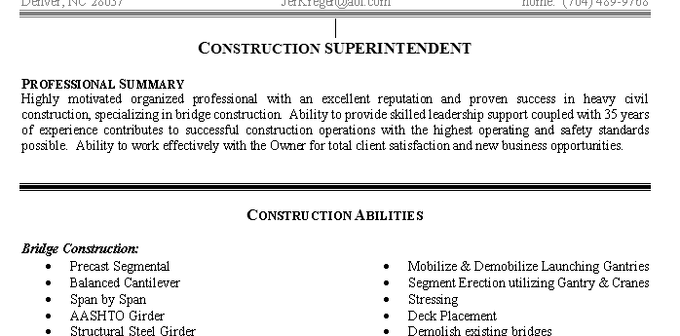

* 1. EDUCATION: This section might look better moved under your profile. Add location of schools & year graduated. Is that 4 different schools? If you are currently working on a degree, add ‘undergraduate studies’ at xyz University.
  2. WORK HISTORY: add more detail… similar to attached job search.

The job you are currently working on must be huge. It may be worth adding detail about how big & where the job is. Also on your resume, move the current job date to the right & swap 2012-current. For example:

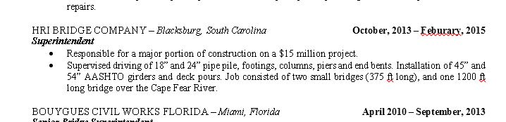

* 1. CLASSES: Replace ‘Related courses’ & add your certificates if you have any. For example:
* CPR AED & First Aid Certification, issued 2/2/2013
* Bloodborne Pathogens Certification, issued 2/2/2013
* OSHA 30 hour Safety Certification
* OSHA 10 Hour Safety Certification
* Crane Institute Rigging & Hoisting Certification
* Crane Signal Training Course, issued 1/15/2011
* Mobile Crane Safety Training Certification
* Confined Space Training Course, issued 1/15/2011
* Fall Protection Training, issued 3/12/2011
* Registered Flagger, expiration date 12/18/2017

MISCELLANEOUS:

Website to search for jobs:

<https://www.indeed.com/q-Construction-Safety-jobs.html>

Here are a few good Heavy Civil Construction companies:

Balfour Beatty

Lane

Traylor Brothers

Flatiron Crowder

Bylthe Construction

**EXAMPLE OF A JOB POSTING IN NY.**

**Credentials:**OSHA 10/30 & Scaffold, Site Safety Manager Certification (SSM), Certified Safety Professional (CSP), or other relevant credentials (Preferred) Responsibilities include:

* Monitoring the implementation of Safety and Health policies, procedures, and Safety related programs of contractors currently working at PANYNJ - La Guardia.
* Monitors job sites for adherence to client's safety practices and policies. Identify potential OSHA violations, liability issues, and risk exposures.
* Perform safety compliance monitoring and write up reports stating observations and recommendations that may help our client reduce construction site risk to employees.

**Anticipated work load:**Initial "ramp up" period 40 hours on site, then two site visits per month with two corresponding reports.

**ESSENTIAL FUNCTIONS:**

* Monitor the development of safety and health policies, practices and procedures in compliance with governmental regulations including Federal, State, and Local laws and regulations, including, but not limited to OSHA.
* Provide guidance and best practices to personnel regarding facility specific issues relative to safety, environmental, and health programs and practices.
* Provide leadership and guidance to site production management, supervision and employees.
* Act as a contact for job sites regarding matters involving safety, environmental, and health.
* Inspect all worksites by visual observation to observe and report on potential violations of occupational safety, company policy, NAVSEA Standard Items, and OSHA.
* Document violations identified through electronic media and distribute to responsible parties and management personnel.
* Investigate occupational accidents and injuries to determine the cause of the accidents/injuries and ensure all required investigation forms are completed and submitted on time.
* Distribute and post safety awareness information.
* Perform other duties as assigned by supervisor.

**QUALIFICATIONS:**

* Minimum five years experience in construction safety industry, ten or more years of construction experience preferred; however, will accept qualified candidates with less experience.
* Strong verbal, written, analytical, and persuasive skills and the ability to interact effectively with all levels of employees and management.
* Ability to discuss standard safety policy and procedures, and oversee team of site safety professionals.
* Knowledge of occupational hazards and safety precautions applicable to a variety of construction industry worksites.
* Ability to communicate effectively, both written and oral.
* Proficient knowledge of MS Word, Outlook, and Excel.
* Must have reliable transportation, a valid drivers license, current auto insurance, computer with printer and scanner.
* Must be able to pass drug test, government background check, and obtain SWAC clearance (www.secureworker.com).
* Available to be on-site as needed. Must be reliable, able to work remotely, independently and able to meet due dates.EOE/AA/M/F/Disability/Vet