Cv

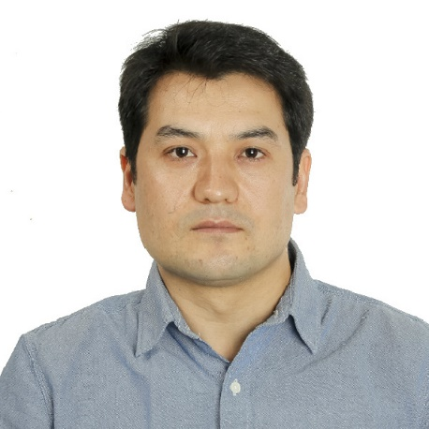

**Name:** Dilshod Sharipov

**Adress:** Sorögatan 15

16441,Kista,Stockholm

**Telephone:** 0730701980

**Epost:** sharipoff2013@yandex.com

**Degree:**

University:

-Tashkent State Technical University (bachelors degree In Management and Administration)

-Faculty: Economy-Engineering

-Field of Study: Management

- Study Period:1999-2003

College:

-Uzbek-Turkish Foreign Languages College (translator and computer sciences)

-Study Period:1995-1999

**Job Skills:**

**-Driver in Homefleetgroup AB (Transport and Logistic)**

-Date of start: 2016-

-Electrician in ” BARQI MONTAJ NALADKA” Company

-Work Period:2008-2016

Living in Sweden for 2 years

-Other skills :

Driving License (Swedish category B)

Driving License (Uzbek category B.C)

Computer Knowledge

Foreign Languages: English,Swedish