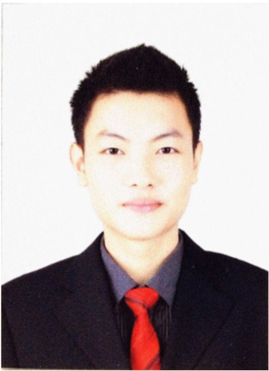**FRANKIE SIOK YI REN**

[**FRANKIESIOK1227@ICLOUD.COM**](mailto:FRANKIESIOK@ICLOUD.COM)

**TEL :+6590554647**

**6A WHAMPOA DRIVE**

**327713**

**SINGAPORE**

**OBJECTIVE**

**Vigilant and proactive chef with 5 year of experience in assisting kitchen operation and performing kitchen management tasks.** **Self motivated and quality-driven individual with a strong commitment to prepare exceptional cuisine ,maintain safe and efficient kitchen environment. Demonstrated passion for motivating culinary team to deliver truly spectacular results. Highly skilled in creating menu specials while ensuring that all stations are set before service time. Track record of maintaining cleanliness and sanitation of kitchen.**

**Skill**

* **Fluent in English, chinese and Bahasa Malaysia**
* **Ability to work positively in fast-paced environment**
* **Ability to perform well under high-pressure situations**
* **Creative mind in culinary**
* **Strong desire to learn**

**Chef De Partie**

**• Prepare western cuisine and Asian cuisine   
• Ensure that all stations are set appropriately  
• Process and store food items  
• Make sure that all kitchen staff is aware of standards and protocols  
• Manage rotation of food items in chillers  
• Ensure kitchen and worse area’s cleanliness  
• Maintain and ensure the quality of prepared and raw items**

**• Unload supplies and ensure that inventory and stock levels are maintained**

**EDUCATION**

**Malaysia Education Certificate 2013 (SPM)**

Graduated Malaysia Education Certificate with science stream students and pass for 9 credit