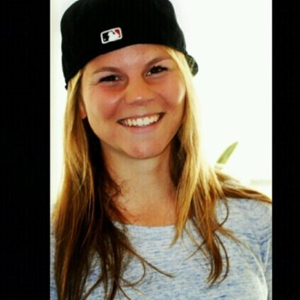Personal information:

Name: Daphne Steensma

Street: 2698 Woodbine Drive

Zip: BC V7R 2R8

City: North Vancouver

Date of Birth: 01-12-1994

Phone number: 604-816-9337

E-mail: [daphnedionne@hotmail.com](mailto:daphnedionne@hotmail.com)

Nationality: Dutch

Speaks English and Dutch

Educations/diploma’s:

2007-2012 Haarlemmermeerlyceum: Havo, Diploma Highschool.

2012 -2016: Hogeschool van Amsterdam, Food and Dietetics. (Propedeuse in first year) Bachelor Diploma

Februari 2015 - juli 2015: Minor Personal Trainer, certified NSCA-PT

2016: Diploma Sports and Exercise Nutrition – Shaw Academy

Workexperience:

March 2018 till May 2018- Hostess at Grouse Mountain Altitude Bistro

July 2017 till June 28th- Working as a fulltime live-in nanny in North Vancouver, 3 kids (6,8 and 10yrs)

November 2016 till now: Writer for the Fastball Magazine about Food and proper Exercise for baseball and softball players

December 2015 till November 2016: Work on board with Run for Life to run the New York Marathon with 39 other runners and make it the best life experience ever.

March 2015 till Juli 2015: gym Shape all-in Amsterdam (internship, teaching lessons and personal training)

August 2014 till June 2017: Lunchroom Meneer Frans (Waitress and barmaid) (during lunch and working on events/party’s at night)

September 2013 till August 2014 : Restaurant Chocoase in combination with a small club for the nights (Waitress and barmaid)

October 2012 till October 2013: East Coast Café Hoofddorp (Waitress and preparing lunch)

May 2012 till September 2012: ZorgSamen (Home Care; cleaner)

May 2010 till May 2012: Toys XL (cashier)

Extracurricular activities:

I have my own Vegan facebook page about healthy food and vegan lifestyle tips. I do a lot for the community and for the environment in my free time.

Besides babysitting a few kids occasionally, I also babysitted two little boys (2 and 4 years old) almost fulltime for a few months. I coached kids with sports and I love to work with kids.

I love being healthy and help people around me getting a healthy lifestyle. Cooking together and help them getting more active are things in life I love to do.

I help my father with his company Boom Experience! and National Baseball and Softball Clinic, by helping with organizing events and coaching young baseball/softball players.

I also help people with a healthy lifestyle by providing them a healthy diet or/and by helping them in exercising.

Characteristics:

I love it to work with different people and to be social with guests of the restaurant (or any place where I work). I’ve been working for years in restaurants and bars, so I know how to work hard and fast under pressure. I enjoy working and that is why I’m always giving more than 100% during my job. I’ve also worked in a gym in Amsterdam, wich was a really good experience to work with people. My biggest passion is to work with food and people, making people fit and healthy so they can live life to the fullest.

I’m really sportive and love to train outdoors, in 2016 I ran the New York Marathon at the age of 21. I love it to try new sports, but my favorite sports are softball, running and fitness.

I’m a person who can be really outgoing and social, but I can also enjoy reading a book in the woods or at the beach by myself. I’ve been travelling solo in South-east Asia so I know how to be by myself and how to meet new people.