**CHINAY NEL**

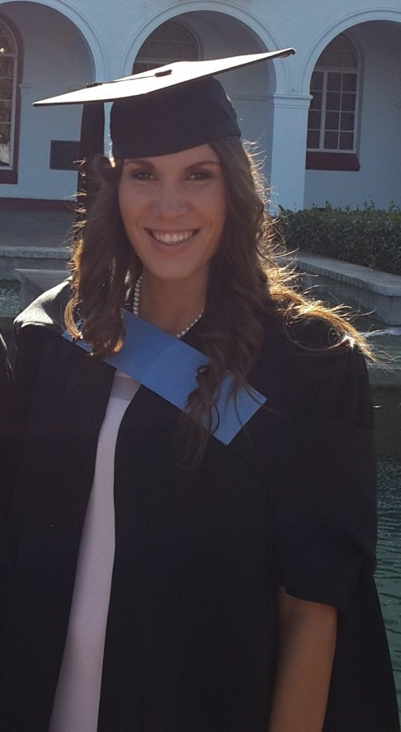

**CURRICULUM VITAE**

|  |
| --- |
| **Index**   1. **PERSONAL INFORMATION** 2. **PERSONAL PROFILE** 3. **ACADEMIC BACKGROUND** 4. **EXTRA MURAL ACTIVITIES** 5. **WORK EXPERIENCE** 6. **REFERENCES** |

1. **PERSONAL INFORMATION:**

**Surname:** Nel **Name:** Chinay

**Address:** Dixon Ave **Postal address** PO Box 3132

Estienne 12 Montana Park

Witbank 0159

1035

**Telephone:** 0792913896 **Licence:** Code 8

**Identity number:** 9209220325086 **Sex:** Female

**Marital Status:** Single **Nationality:** SA Burger

**Birthdate:** 22 September 1992 **Race:**  White

**E-mail address:** [nelchinay@yahoo.com](mailto:nelchinay@yahoo.com) **SACE:** 12279158

**Languages:**

|  |  |  |  |
| --- | --- | --- | --- |
|  | **Speak** | **Read** | **Write** |
| Afrikaans | Very good | Very good | Very good |
| English | Good | Good | Good |

1. **PERSONAL PROFILE:**

I am a confident and hard working person with strong moral values. I believe that as a teacher it is part of my job to set a good example for learners. The fact that I am a well-organized person and good with working in a team, will help me to fit in with the school environment and also to adapt and engage in the daily tasks that is expected of me.

1. **ACADEMIC BACKGROUND:**

**Higher Education:**

I am currently a teacher in my first year of education. I completed my B. Ed degree at the North West University (Pukke) in the Intermediate and Senior Phase and received my degree 4 March 2015. I specialize in Mathematics and Life Orientation, but I am teaching Mathematics and English First Additional Language.

**Secondary Education:**

I matriculated in 2010 at High school Montana

Subjects in matric: Afrikaans

English

Mathematical Literacy

Life Orientation

Consumer Studies

Business Studies

Visual Arts

**COURSES:**

As an education student at the North West University during the completion of my degree, I also attended a beginners Netball coaching course in 2011. I attended Land Service course in 2012 and passed and received a certificate in 2013 for First Aid Level 1.

I also did my Netball grading in the beginning of 2015.

**ACADEMIC PEFORMANCE:**

In 2013 I was chosen to become part of the Golden Key International Honour Society on academic merit for being part of the top 15% students of the university.   
At school I also participated in Consumer Studies Olympiad and received certificates for passing in 2009 and 2010. I also took part in the World Knowledge Olympiad in 2009.

1. **EXTRA MURAL ACTIVITIES:**

**CULTURE:**

At school I participated in drama and received certificates for participation in the Youth festival in 2008 and 2009   
In 2008 to 2010 I also participated in the Pierneef Youth Festival and received certificates.

**COMMUNITY SERVICES:**

In 2011, I became involved with the AKSA committee which stands for social inclusion, diversity and unity on the North West campus. By being part of this committee in my first year I learned to see unity and diversity as a positive aspect of functioning in a group.

As a member of Kasteel Dames Koshuis I became part of the SJGD committee in 2011 and 2012. SJGD is the university's registered charity. As a member of this committee, we had to help with activities such as giving food to the less fortunate. The SJGD (Student Rag Community Service) is in cooperation with RAG (Reach Sacrifice for charity) and they assist people that are in need within the immediate community in the North West Province.

**INTERESTS AND HOBBIES:**

In my spare time I enjoy being peaceful and calm. I love drawing and reading. I am passionate about cooking and baking and I also enjoy being outdoor and exercising.

1. **WORK EXPEIENCE:**

During my time as a student, I observed in classes of teachers since 2011. They also allowed me to take full responsibility for their classes. I was responsible for lessons and small administrative tasks.

I also have experience as a teacher for six months at the school where I am currently employed.

1. **REFERENCES:**

**School principal:** Mr Sakkie Jacobs (High school Montana) 012 548 0160

**Drama teacher:** Mrs Gerda Wessels 012 567 5374

083 316 0015