**CURRICULUM VITAE – NEIL KIRSTEN**

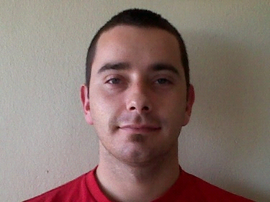

**PERSONAL INFORMATION:**

**Name:** Neil-Pierre Kirsten

**Maritial Status:** Married

**Dependants:** 1 Child

**Date of Birth:** 18/01/1984

**Identity Number:** 8401185155084

**Passport Numbers:** M00133027 **/** A04377842

**Languages:** Afrikaans (first language); English (second language)

**Drivers License:** Code B

**CONTACT DETAILS:**

**Address:** 2 Meerlust Park, Meerlust Road, Oak Glen, Bellville, 7530

**Cell:** 078 380 0446

**Email:** neilkirsten@gmail.com

**ACADEMIC QUALIFICATIONS:**

**Tygerberg Hoërskool:** Afrikaans

English

Mathematics

Business Economics

Woodwork

Accounting

* **Courses and Training Completed:**

1. 5 Day Offshore Survival, H.U.E.T., Fire Fighting and First Aid Course
2. SAMSA Seafarer Medical
3. SAQCC – Fire Service
4. SRI – International Fire Training (Co2 systems, R200 Systems, Inertec, Kitchen Shield)
5. Sea Safe (Life Raft)
6. Sanghai (Life Raft)
7. Julong (Life Raft)
8. Various Auto Trader Sales Training and Implementation of new products
9. Plumbing (Completed to N2) (Westlake College)
10. Honeywell – Fenzy SCBA maintenance & Service
11. CMAS-ISA – Compressor operator
12. OMITC – BT- Boat Transfer

**Characteristics:**

I am a hard worker, ambitious, spontaneous, friendly, neat, diligent person as well as a good leader. I am also able to work with people from all races and cultures.

**EMPLOYMENT HISTORY:**

**August 2017 to Date:**

Currently I’m employed by Nova Marine Services, where I’m a Fire technician and Life Raft technician. I do services on all types of vessels around the world, from fishing vessels to oil rigs. Offshore and land based services. I’ve been in the marine industry for 4 years before starting with Nova marine.

**1998 to Date:**

Lifeboat Technician

Fire Technician

Life Raft Technician

Salesman

Restaurant Manager

Bar Manager

Bar tender / Waiter

**References**

Carl Roodt Bosss Marine (+27) 84 701 2345

Pamela Brown Auto Trader (021) 914 9190

Louis Pareira Silver Creek & Saratoga Spur (021) 930 3018

Steven Gerber Barbaroozos (+27)82 650 0067