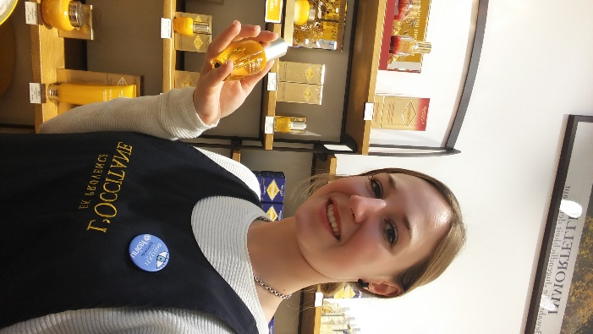Damaris Kiser

Born: February 08. 1992 (26) in Sarnen, OW, Switzerland

Nationality: Swiss

**Experiences**

Regular Schooling of Switzerland (9 years)

2008-2012 Apprenticeship as a druggist at Drogerie Parfümerie Bühlmann, Sarnen

2012-2013 Travelling Canada and America

2013-2014 working as a druggist at Drogerie Bühlmann 40%

2013-2017 Homeopathic College SHI, Zug

2014-2016 working as a Beauty Advisor at L’Occitane Boutique Zug

2015-2017 working as a druggist at the SHI college drugstore, Zug

2017-today working as a Beauty Advisor at L’Occitane Boutique Zug

2017-today working as a homeopath at Praxis for classical Homeopathy Kurt Lustenberger, Luzern