# How to deploy a .war file

1. Login Tomcat server as admin and deploy from here:



1. After deployment finishes, IT department will see my service at the top of the list.



1. Go to “AGT Group Exercise\Released“ folder and copy FileAnalyzer.jar, paste it to the C:/ .

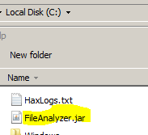

1. Click on ‘/FileOperation’ and it will forward to the welcome page.



1. Click button “Access Web Service Click Here” . It forwards you :

http://localhost:4040/FileOperation/data/fileoperation

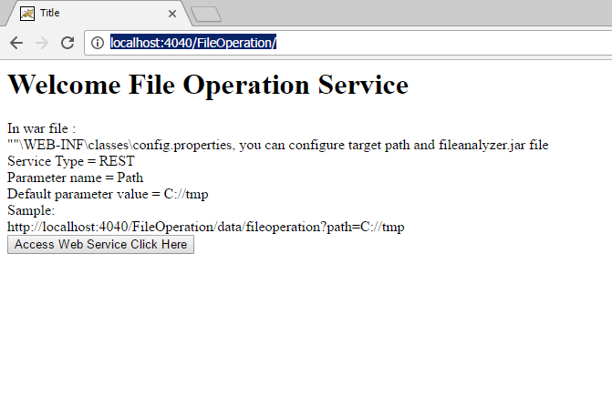

1. The user will be able to see the output as a JSON.

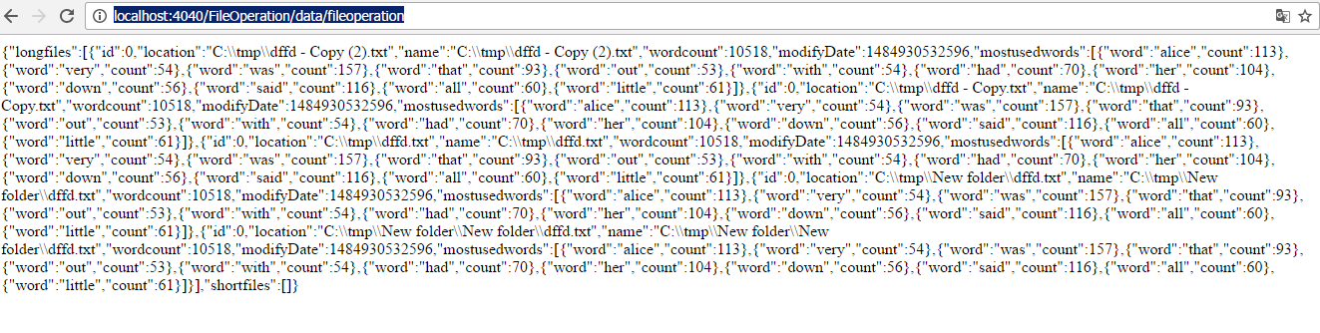

**How to use it on client side**

1. If the user leaves the path empty. The service will search the C:/tmp folder.

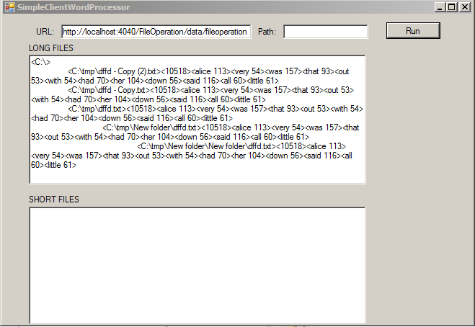

1. The screenshot with provided path information.

