

Immersion Day

VPC Hands-On Lab
  - Getting Started with Virtual Private Cloud

Virtual Private Cloud (VPC) Overview
Amazon Virtual Private Cloud (Amazon VPC) lets you provision a logically isolated section of the AWS Cloud where you can launch AWS resources in a virtual network that you define. You have complete control over your virtual networking environment, including selection of your own IP address range, creation of subnets, and configuration of route tables and network gateways. You can use both IPv4 and IPv6 in your VPC for secure and easy access to resources and applications.

In this lab, you will learn how to set up a VPC with public and private subnets. You will also learn about AWS networking concepts such as Elastic IPs, NAT Gateways, and Flow Logs.

Navigate to the VPC Dashboard
To get started, let’s take a look at the VPC Dashboard.
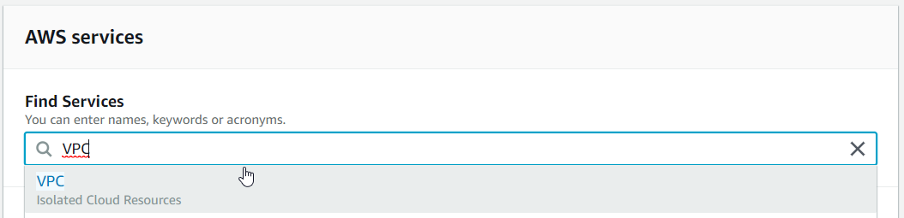
In every region, a default VPC has already been created for you. So, even if you haven’t created anything in your account yet, you will see some VPC resources already there.
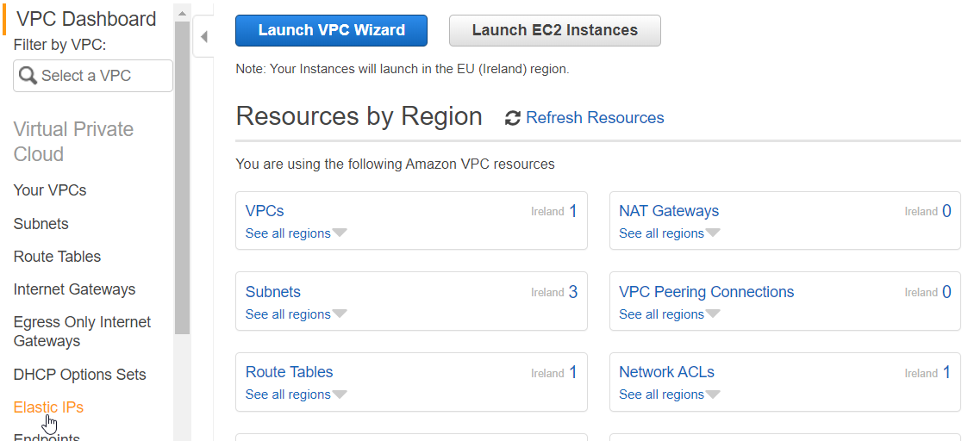In this lab, we will be using the VPC Wizard to create a VPC with private and public subnets pre-configured. Once you’re more familiar with AWS networking, you can create VPCs and subnets without the Wizard to create custom networking configurations.

During the VPC wizard set up, you will need to specify an Elastic IP Address (EIP). An Elastic IP is a static public IPv4 address that you can attach to AWS resources, such as EC2 instances and NAT Gateways. Elastic IPs are required for NAT Gateways.

To create one, go to Elastic IPs in the sidebar.
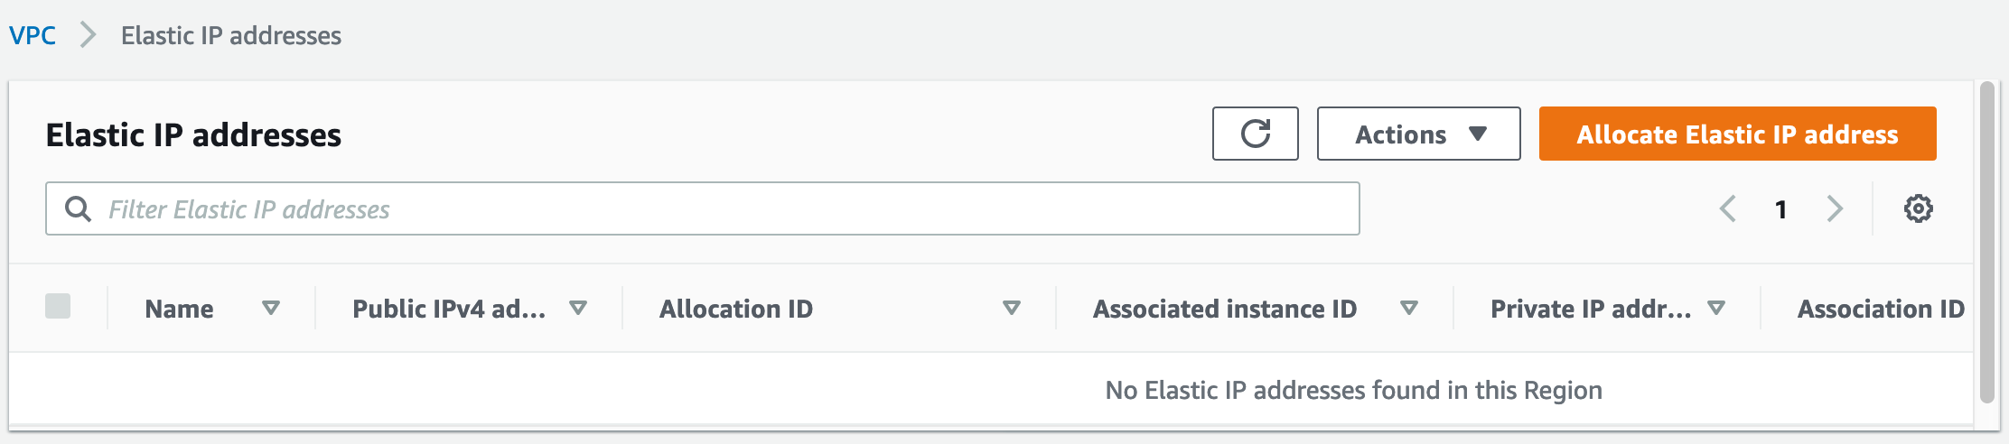
Press Allocate Elastic IP address, choose Amazon's pool of IPv4 addresses and click on Allocate. Your Elastic IP will now be listed on console.
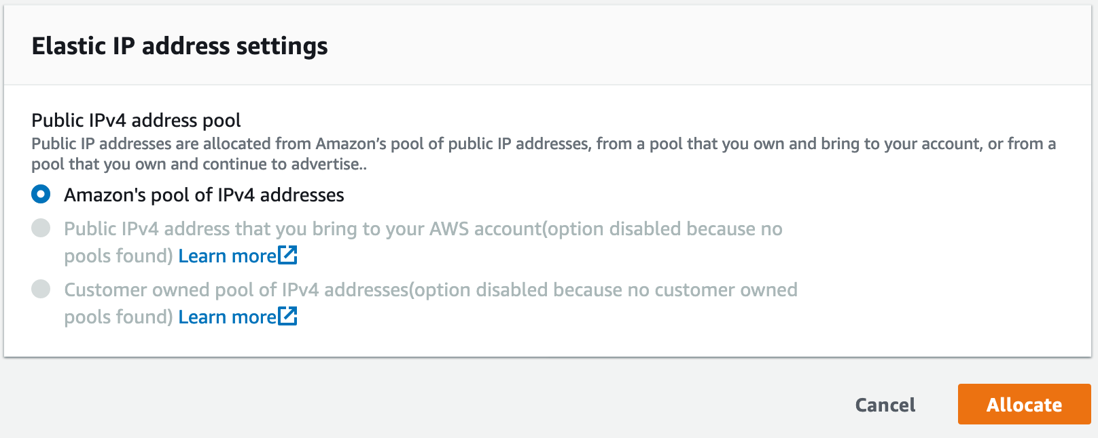

Now click on VPC Dashboard in the top left corner to go back to the main VPC page and click on Launch VPC Wizard to start the VPC Wizard

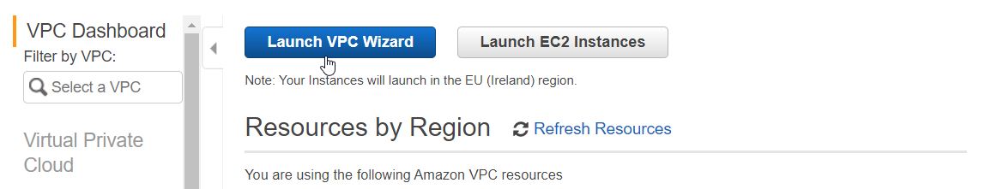
Select ‘VPC with Public and Private Subnets’ and click Select.
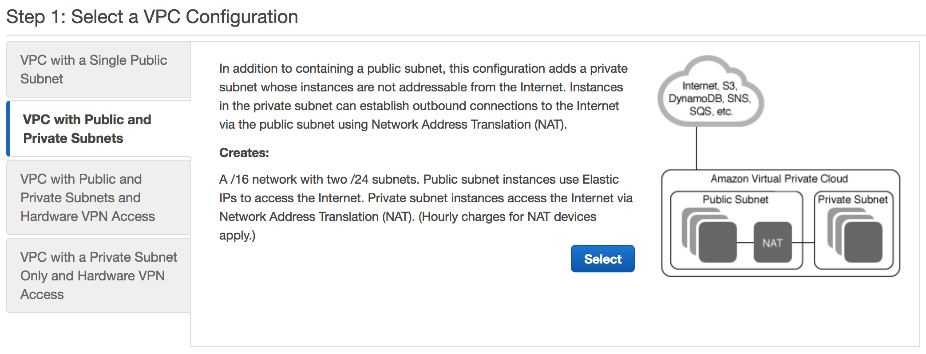
This option will create a VPC with a /16 CIDR block and two subnets with /24 CIDR blocks which have 256 total IP addresses each. In each subnet, AWS reserves 5 IP addresses. In this case, that leaves you 251 IP addresses per subnet. Fill in the VPC name (shown as “test” here) and select your Elastic IP Allocation ID from the drop-down. For this lab, we will leave the rest of the default configuration as is.
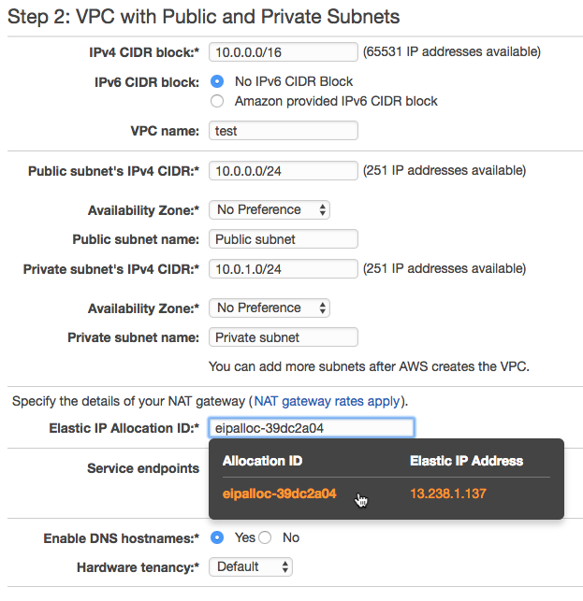
This Elastic IP will be used to create a Network Address Translation (NAT) gateway for the private subnet. NAT gateway is a managed, highly scalable NAT service that gives your resources access to the internet but doesn’t allow anyone on the Internet access to your resources. NAT is helpful for when a resource needs to pull down updates from the Internet but should not be publicly accessible.

Click on Create VPC. This step will take a couple minutes. Once your VPC has been created, click OK.

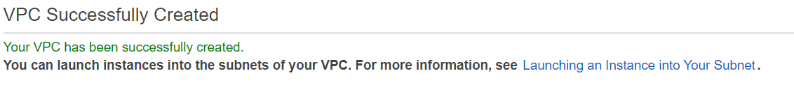
Wow! It only took you a few minutes to set up an entire virtual private network, including subnets for public and private resources, route tables, and a scalable NAT service.

What the VPC Wizard Created
Let’s walk through the VPC Console and explain each component that the wizard created.

From the last step, you should now be on the Your VPCs dashboard looking at all of your VPCs in this region. Select the VPC that you just created by selecting the checkbox to the left of the VPC name, and look at the Description tab. If you can’t see everything in the pane, you can pull the pane up by dragging on the pane’s top line.

In the Description tab, you can see the Route Table for your VPC. Any subnets in the VPC that do not have a route table directly associated with it will use this route table by default. To explore this further, click on the Route table link.

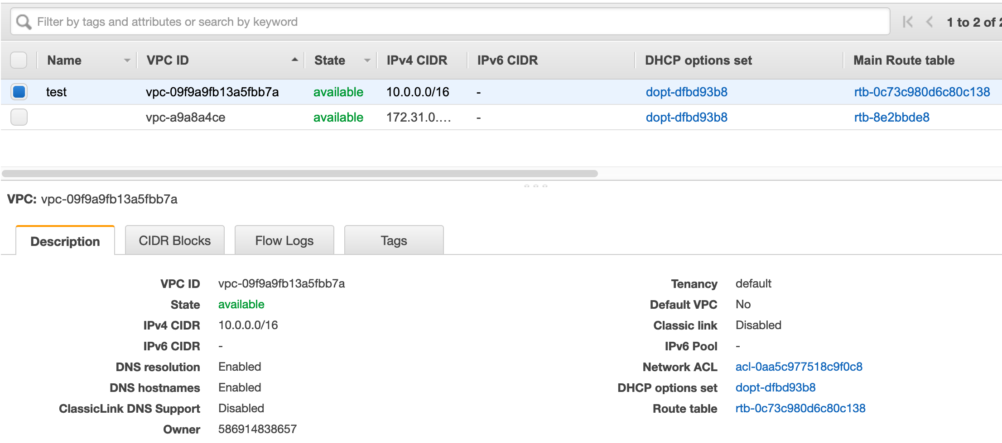

You are now in the Route Tables dashboard, filtered on the main route table of the VPC you just created. That means that there should be only one route table shown. Select this route table and click on the Subnet Associations tab.
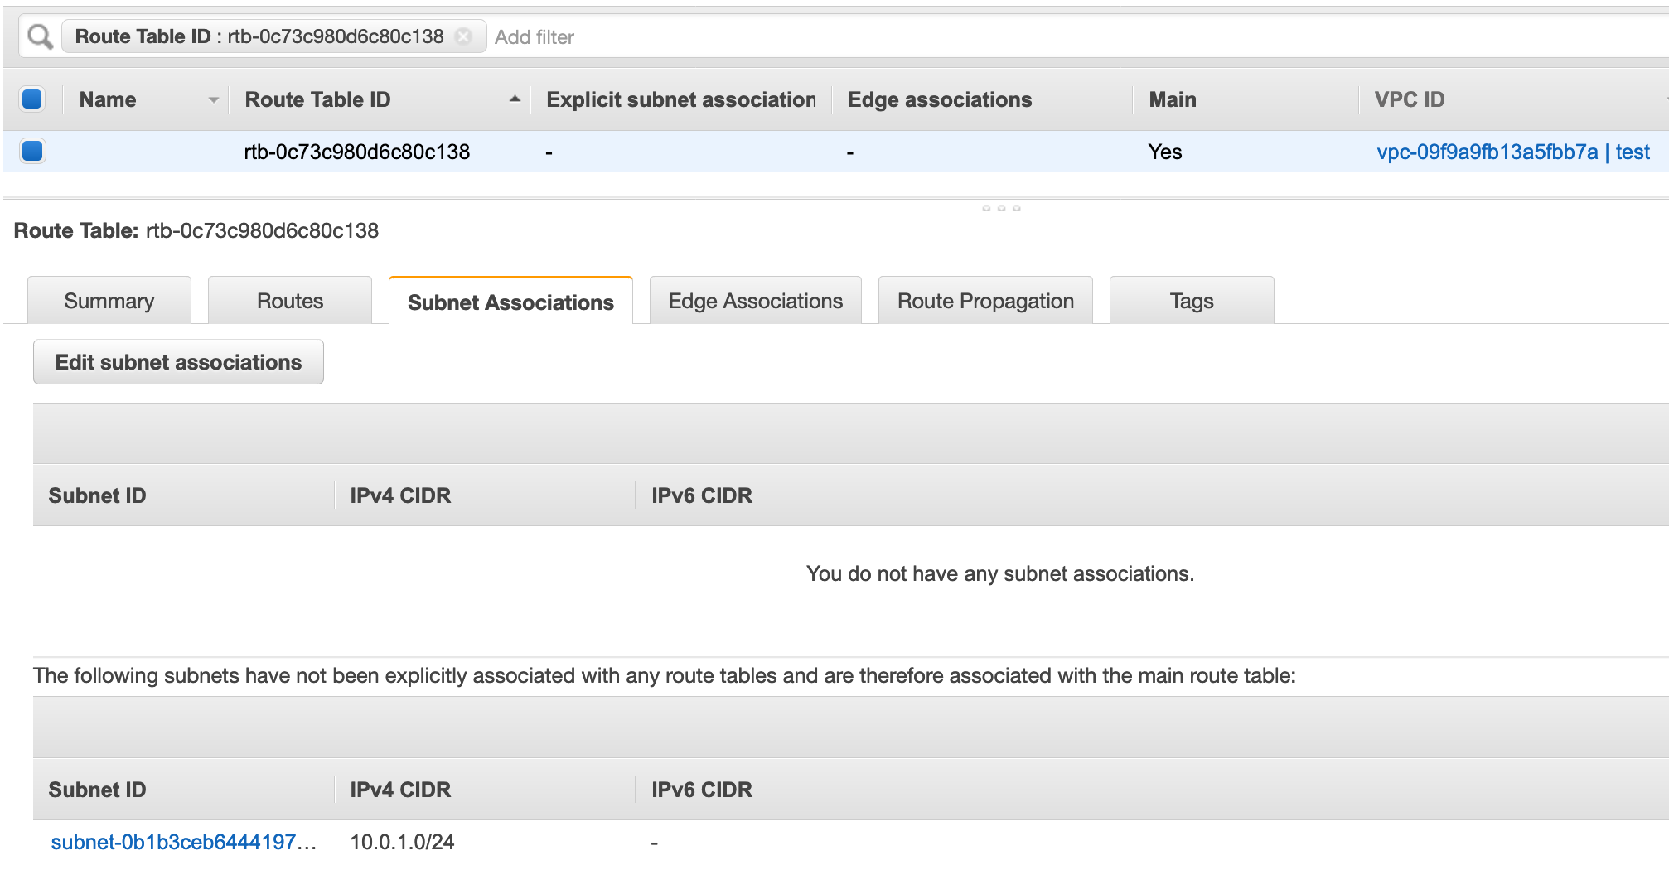

You can see that there are no explicit subnet associations on this route table. However, since this is the main route table for the VPC, there is one subnet implicitly associated. It’s the Private subnet of the VPC. What makes a subnet public or private? We can find out by looking at the routes in this table. Click on the Routes tab.

In the Routes tab, look at the Target column. You’ll see one local route which every route table has. This ensures that resources within the VPC can talk to each other. This route cannot be modified.

You will also see a route to the NAT gateway that the wizard created. Remember that a NAT gateway gives Internet access to resources which are not publicly accessible. Because the resources in this subnet are not publicly accessible, this is considered a private subnet.
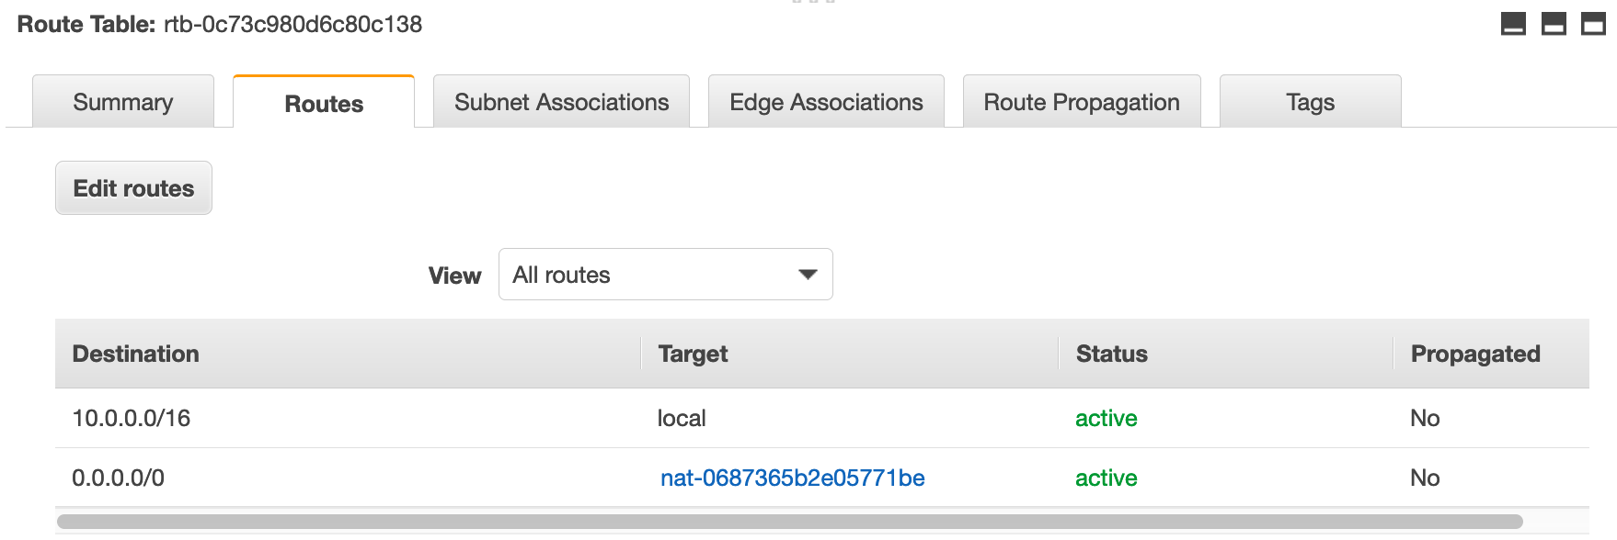

Now let’s find out what makes a subnet public. First, get rid of the filter on this view. To do this, click the “x” in the search bar at the top of the page.
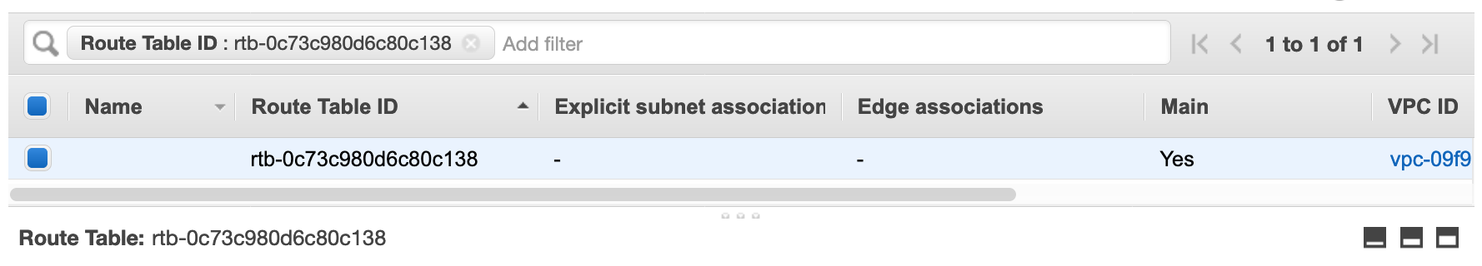
You are now looking at all of the route tables in this region. Your dashboard should look something like the screenshot below.

Select the other route table in your VPC (check VPC ID column for name with “test”) which is not the main route table (check Main column for No). In the Routes tab, you’ll see a route to an Internet Gateway (IGW). IGWs are another managed and scalable service like the NAT Gateway except that it allows access from the Internet to your resources in the VPC, making your resources publicly accessible.
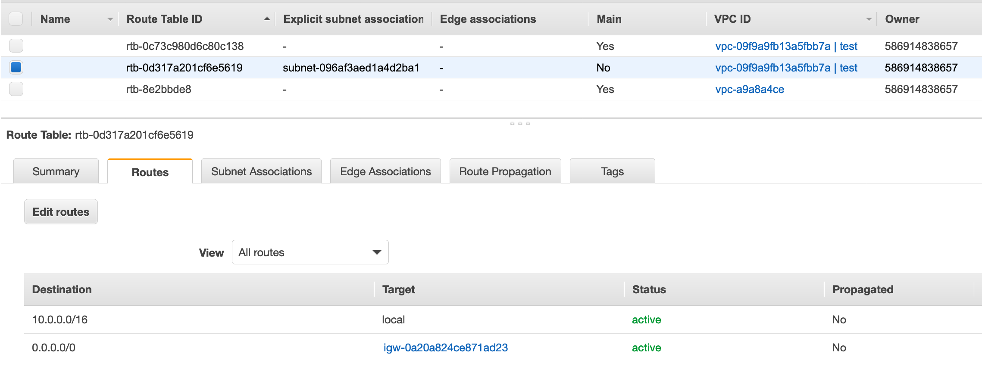

There is a reason why this route table is not the main route table. It is best practice for your VPC’s main route table to not have a route to an IGW so that subnets are private by default and only public if specified.

Go to the Subnet Associations tab and confirm that it is the Public subnet which is associated with this route table. Click on the Public subnet link.

Note: If you don't see the link "Public subnet", you likely need to expand the "Subnet ID" column by left-clicking the column divider and dragging to the right.

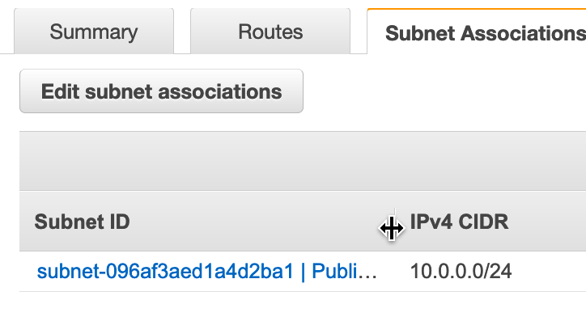

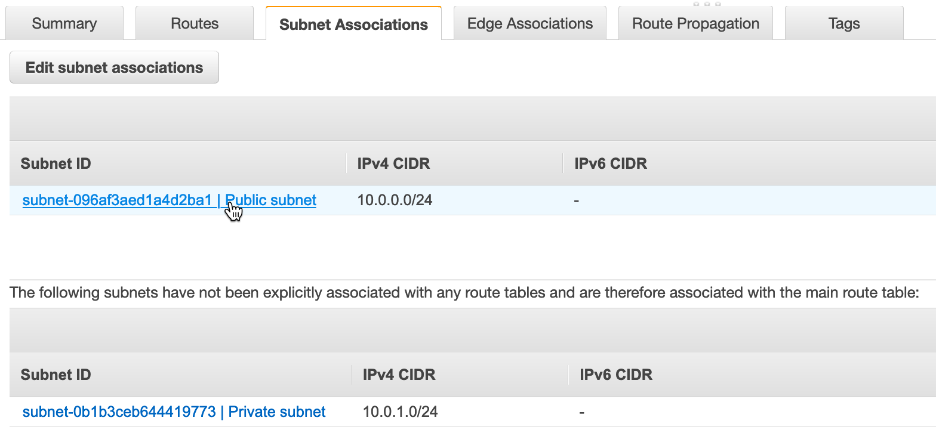
Look at the Description tab. You’ll notice a Network Access Control List (Network ACL) link. NACLs are virtual stateless firewalls at the subnet layer. This wizard used the default NACL (created automatically with the VPC) for both subnets. Similar to the main route table, the default NACL is implicitly associated with all subnets in a VPC unless another NACL is directly associated with that subnet.

Go to the Network ACL tab to look at the default NACL rules. Rules are evaluated in order from lowest to highest. If the traffic doesn’t match any rules, the * rule is applied, and the traffic is denied. Default NACLs allow all inbound and outbound traffic, as shown below, unless customized.
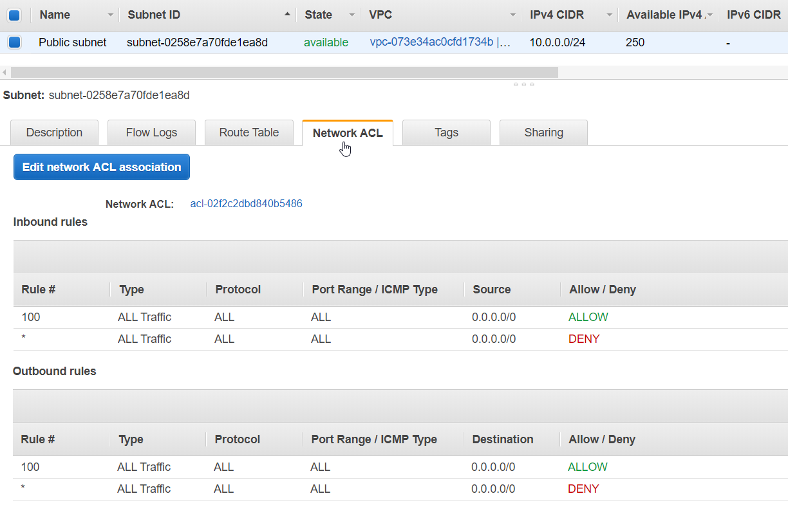

Allowing all traffic in and out of your subnets is not a best practice. However, it is possible to achieve better security with this default NACL by also leveraging Security Groups.

Security Groups are virtual stateful firewalls at the resource (EC2 instance) level. It is best practice to implement necessary firewall rules with Security Groups first and only adding rules to NACLs as necessary. For instance, you can explicitly deny traffic from specific IPs with NACLs but not with Security Groups. We will explore Security Groups more in the next section.

We have now gone through the basics of AWS VPC networking. You should now understand how routing works within a VPC, what makes a subnet public or private, and how to secure your resources at the subnet and resource levels.

Create a Public EC2 Instance
In this section, you will spin up an EC2 instance in the Public subnet of your VPC.
To get started, go to the Services drop down menu in the top left corner and go to the EC2 dashboard.

- Select Launch Instance, and then In the Quick Start section, select the first Amazon Linux 2 AMI for 64-bit (x86) architecture and click Select. Note that the ami-xxxxxxxxx label and specific versions of the installed package may be different than in the image below
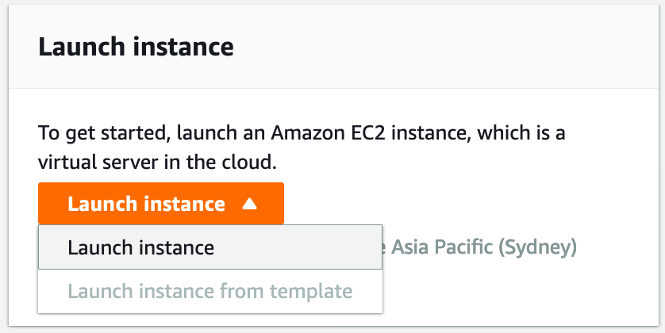
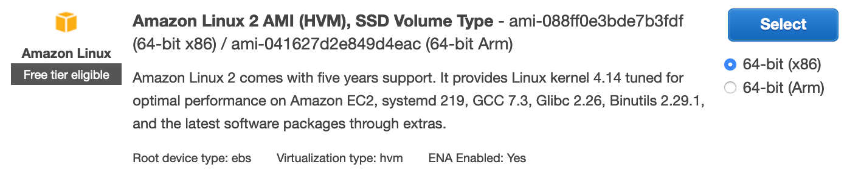
- In the Choose Instance Type tab, select the t2.micro instance size and click Next: Configure Instance Details

- On this page, you decide which network and subnet this resource will be put into. Change the Network field to the VPC that you just created and change the Subnet field to the Public subnet. Leave the other default settings as is. Click Next.
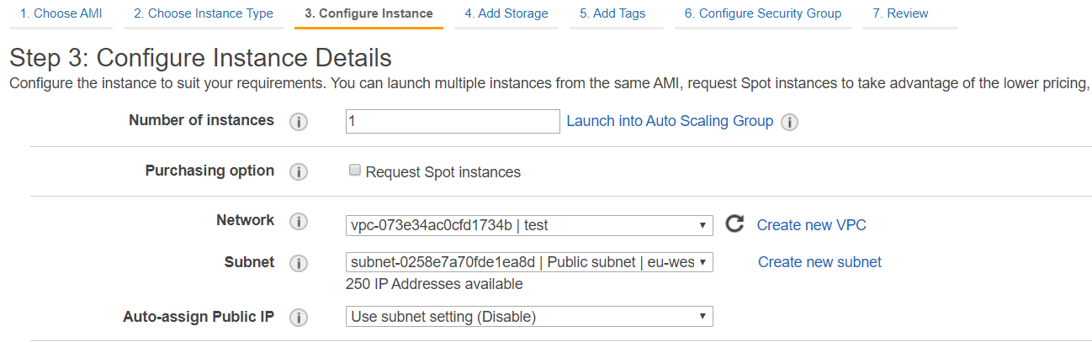

- For this lab, you can accept the default values in the remaining steps, so finish creating this instance by clicking on Review and Launch. You will see a warning that your security group is open to the world. You can ignore this warning and select Launch.
- In the pop-up window, select Proceed without a key pair from the drop-down and check the acknowledgement box. For this lab, you will not need to SSH into this instance. Click Launch Instances and then View Instances.
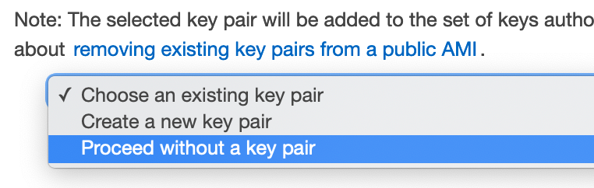

Congratulations! You have just launched a virtual server in your private network.

Test Access to Public Instance
In this section, you will ping the EC2 instance that you just created and learn more about security groups along the way.

You should be on the EC2 Instances dashboard from the last section, looking at all of the EC2 instances in this region. If you just finished the last section, your EC2 instance might still be spinning up. You can tell by looking at the Instance State and Status Checks columns. If you see pending state and/or status Initializing, the instance is not ready yet.

While you’re waiting for your instance to be ready, select the instance to look at the Description tab. At the top of the right-hand column, there is the information that we need to access the instance – the IP addresses and DNS records associated with the instance. However, you can see that this instance doesn’t have a public IP or DNS yet. We will need at least one of these to ping this instance via the Internet.

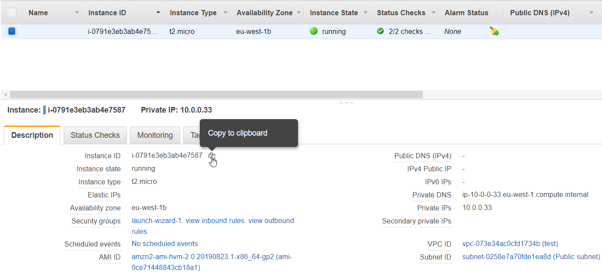
To fix this, we are going to attach an Elastic IP to the EC2 instance. First, copy the Instance ID of this EC2 instance by hovering your mouse to the right of the Instance ID line in the Description tab, and clicking on the Copy to clipboard icon that appears.

Next, click on Elastic IPs in the sidebar (under the Network & Security section). Create a new Elastic IP as before, except this time, do not click on the Close button. Instead, you will: Allocate Elastic IP address, Amazon's pool, Allocate, and then click on the Elastic IP link in the New address request succeeded box.

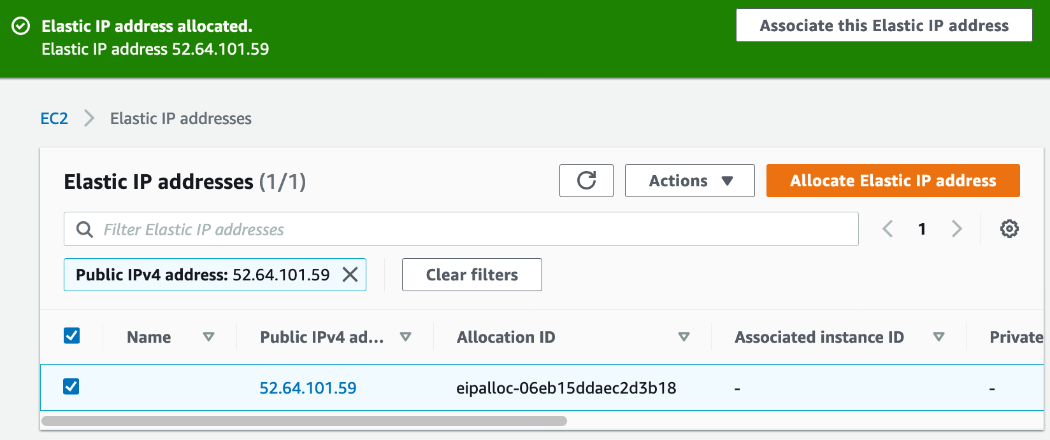

Go to the Actions dropdown and select Associate address.
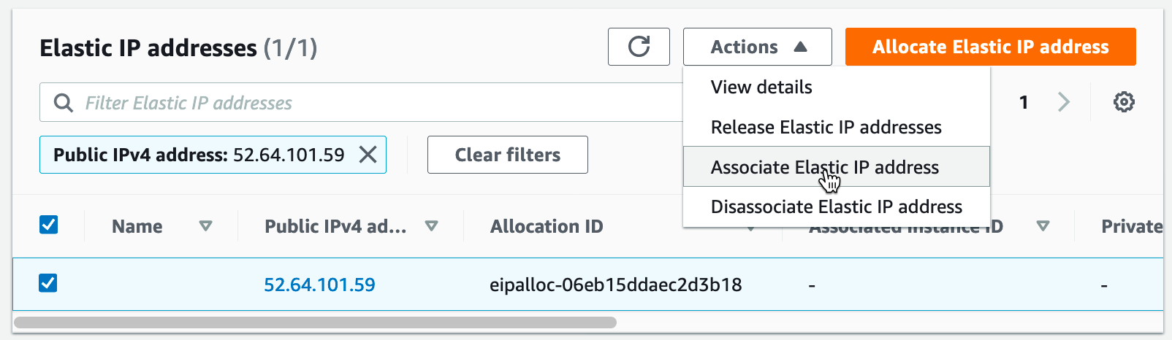

Paste the Instance ID that you copied previously into the Instance box (or select from the drop-down list) and click on Associate, then Close.

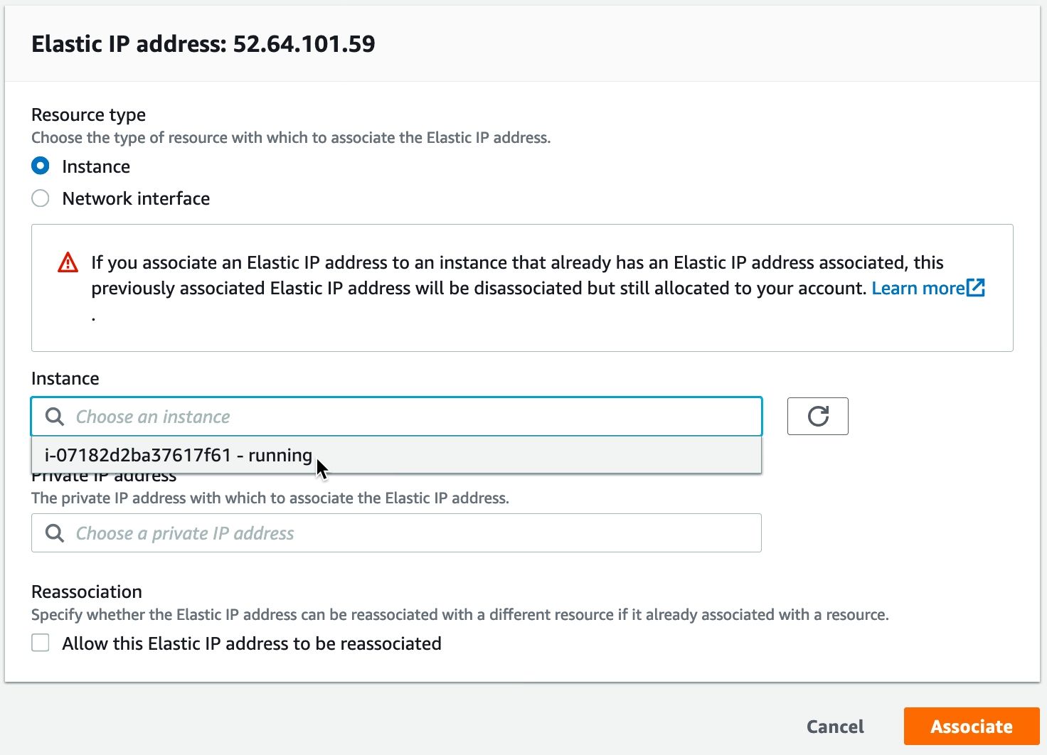

Now that an Elastic IP is attached to the EC2 instance, we should be able to ping the instance over the internet. It now has a public IP address from the Elastic IP, and it’s in the public subnet which has a route to an IGW.

In the Summary tab, copy the Elastic IP address.

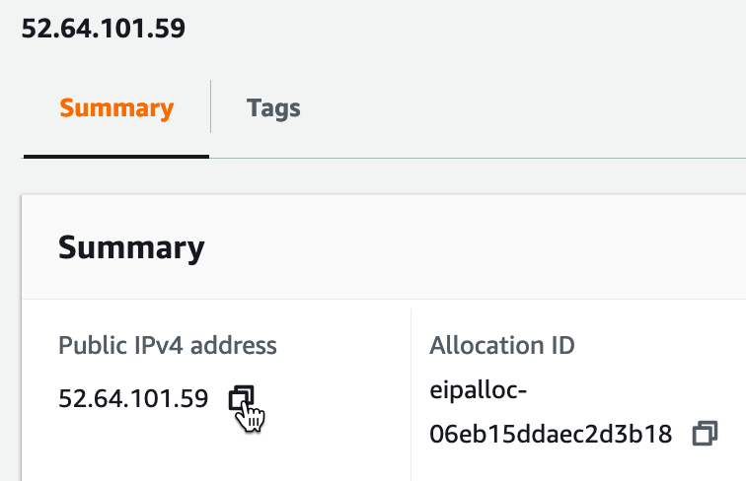
Copy to clipboard

To ping the instance, you need to open your command line interface (CLI). On Windows, open the Command Prompt. On Mac, open the Terminal. Type ping, then a space, then paste the Elastic IP from above and click enter.

If the instance is reachable, we expect to see lines appearing such as
64 bytes from 13.237.153.185: icmp_seq=0 ttl=238 time=169.294 ms

However, you will see request timeouts instead. You will see lines that say something similar to
Request timed out.

Why aren’t we able to reach this instance?

You can confirm that the instance is in the public subnet and check the route table associated with that subnet to make sure there is a route to the IGW.

Next, let’s check our networking configuration. As you remember, we left the NACL of the public subnet as is, which allows all traffic by default. So, let’s check the security group associated with this instance.

In the EC2 dashboard, go to the Instances section in the sidebar. Select the instance that you created and look at the Description tab. Click on the first Security groups link. It should be called something similar to launch-wizard-1.
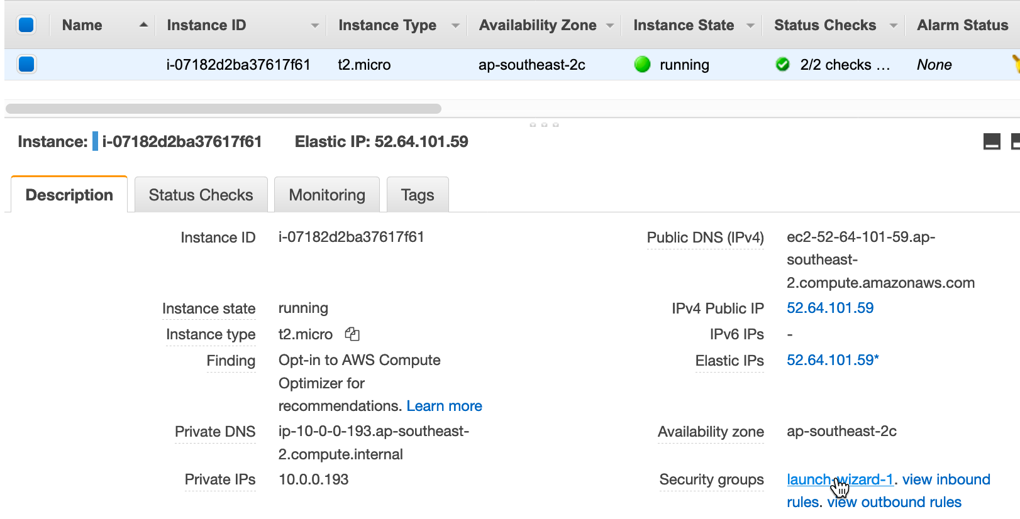

You are now in the Security Groups dashboard. Go to the Inbound rules tab.

Remember when we were creating the EC2 instance we only specified the AMI, instance type, and VPC subnet. We left all the other default settings as is. One of these default settings created this security group, which allows all inbound access on SSH port 22.

Pings use ICMP, so we will need to change the security group rule to allow ICMP traffic rather than SSH traffic. Click on the Edit Inbound Rules button.

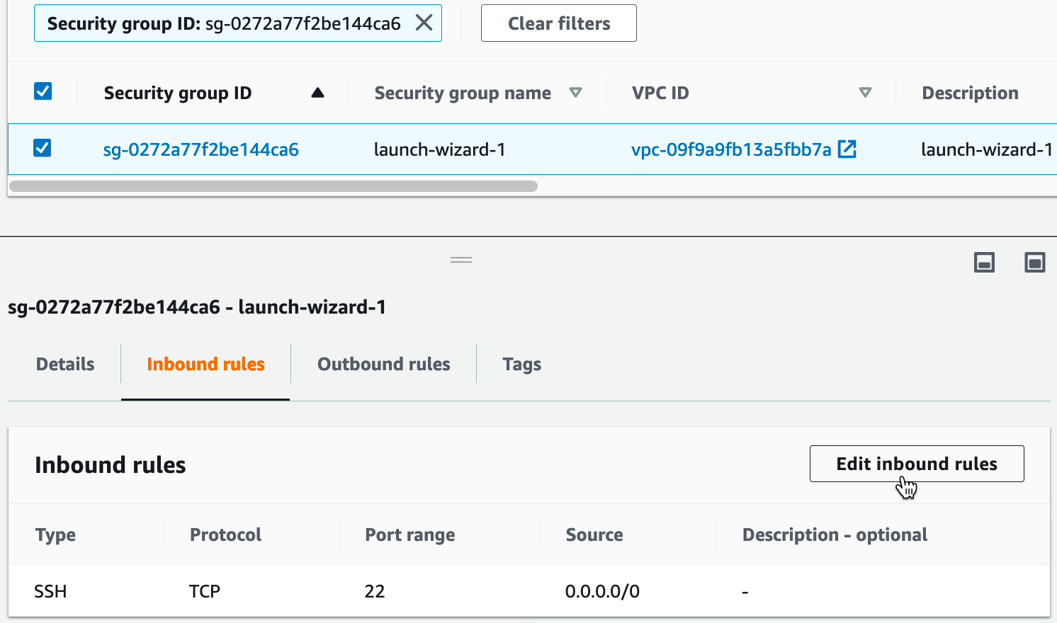
Click on SSH to open the drop-down and change it to All ICMP - IPv4. Click Save.

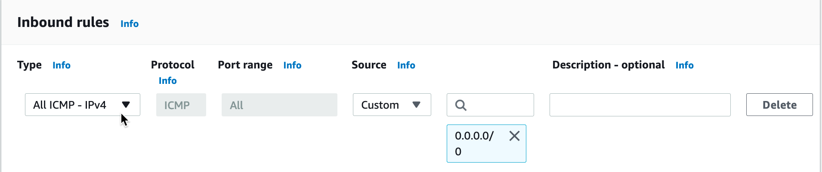
Since security groups are stateful, you don’t need to edit the outbound rules. The security group will allow the instance to respond to the ping since it saw the ping arrive at the instance. This change will also take effect immediately, so we can try to ping the instance again right away.
Go back to your CLI and hit the up arrow and then enter to try and ping the instance again.

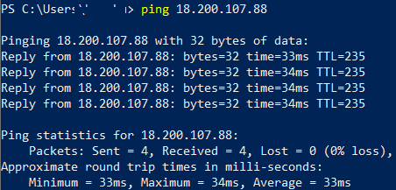
Good job! You have successfully troubleshooted why an EC2 instance was unreachable and then accessed it over the internet.

Test Access to Private Instance
Optionally, you can go through the same process in the last two sections in order to test access to a private EC2 instance. The only difference will be in the Configure Instance Details section, you will select the Private subnet. Also, if you don’t want to go through attaching an Elastic IP, in the same section, you can select Enable under Auto-assign Public IP. Remember that this is not best practice for public facing resources; however, in this case the instance will not be reachable anyway, because the private subnet does not have an IGW route. We just want a public IP to try to access, and for this, the automatically assigned public IP is sufficient. Additionally, you will want to open up your security group from the beginning. That way, this private instance will be the same in every way to the public instance you just created except that it does not have a route to an IGW and thus cannot be accessed publicly.

Clean Up Lab Resources
If you want to clean up your account to get rid of everything we created during this lab, follow the instructions in this section. You can also leave your lab environment running if you want to test other AWS networking concepts.

First, you will need to terminate the EC2 instances that are running in the VPC. In the EC2 dashboard, select Running instances, then select the public instance (as well as the private instance if you created one), go to the Actions dropdown, go to Instance State, and then Terminate. In the pop-up window, click on Yes, Terminate. You may need to wait a minute for the instances to finish shutting down. Watch the Instance State column and wait for the status to change from shutting-down to terminated.
Elastic IP addresses are completely free as long as they are attached to a resource. However, if the NAT gateway or EC2 instance they were attached to is terminated or deleted, the unattached EIP will incur a small monthly charge. To clean up, navigate to Elastic IPs on the sidebar, and Release each EIP you have allocated by selecting the checkbox to the left of the Elastic IP, then from the Actions menu drop-down, select Release Elastic IP addresses.

Now we will delete the NAT gateway that the VPC wizard created. Go to the Services dropdown in the top left corner and select the VPC option. Go to the NAT Gateways section in the sidebar. If there are multiple NAT Gateways, you can look at the VPC column to confirm which one belongs to your VPC. Select that NAT gateway and go to the Actions dropdown. Select Delete NAT Gateway. In the pop-up window, click on Delete NAT Gateway again. It may take a minute for the NAT gateway to delete. Wait for the status to change from deleting to deleted to make sure the VPC deletion will work.

Now you can finally delete your VPC. Go to the Your VPCs section in the sidebar. Select your VPC (the one with the name 'test' or similar), go the Actions dropdown, and choose Delete VPC. In the pop-up window, click Yes, Delete. This will take a minute or so to complete.

Additional Resources
- VPC Introduction: https://docs.aws.amazon.com/AmazonVPC/latest/UserGuide/VPC_Introduction.html
- VPC Subnets: https://docs.aws.amazon.com/AmazonVPC/latest/UserGuide/VPC_Subnets.html
- VPC wizard configuration: https://docs.aws.amazon.com/AmazonVPC/latest/UserGuide/VPC_Scenario2.html
- NAT Gateways: https://docs.aws.amazon.com/AmazonVPC/latest/UserGuide/vpc-nat-gateway.html
- Elastic IPs: https://docs.aws.amazon.com/AmazonVPC/latest/UserGuide/vpc-eips.html
- Security Groups and NACLs: https://docs.aws.amazon.com/AmazonVPC/latest/UserGuide/VPC_Security.html

