1. **What will happen in below commands?**

**Get-service |export-csv Services.csv |out-File**

* I got below output as powershell wasn’t able to determine the path where it needs to generate the .csv file

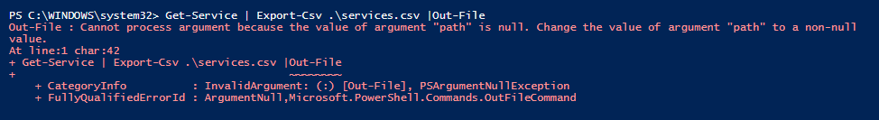

Then I tried with below command which ran successfully and generated services.csv (blank file) under the below path:-

Get-Service | Export-Csv .\services.csv |Out-File

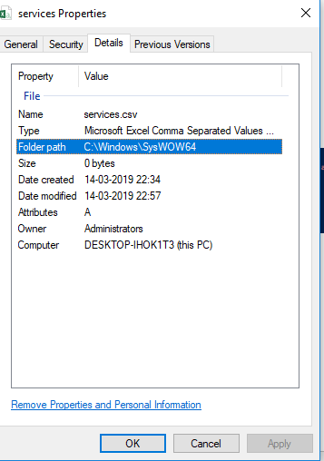

Then tried with below commands after many of variation :-

Get-Service|Format-Table|Export-Csv C:\Demo\serrn.csv

Now I got CSV file but with below output:-

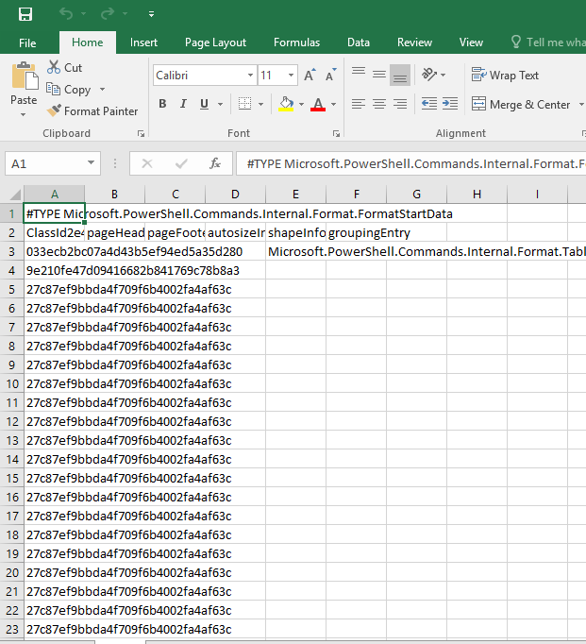

2)How can we create the pipe-delimited file instead of the comma-separated csv file? Give me output of the service in pipe-delimited file?

=>

(Get-content D:\test.csv) | % {$_ -replace ",","|"} | Out-File D:\test.csv

3)Will this provide expected output give details why or whynot?

Get-ADComputer –filter * | Get-Hotfix

* This command will give us list of Hotfix installed on Computer. It (Get-hotfix) will try to match InputObject by value first but it wont work as the data type is different. Then it will try to match it by property. there is only one common property between two commands- [-Credential <PSCredential>]

===========================================================================

4)Write a command to list the processes from the list of computer from any .txt file

Get-Process | select ProcessName |Out-File C:\Demo\test2.txt

=============================================================================