1. Input “Any string”

Output: Need output in reverse string of input

$s = Read-Host "Enter your Name here="

$t =$s.ToCharArray()

$t =($t.Count)-1

for($i=$t;$i -ge 0; $i--)

{

write-host $s[$i] -NoNewline

}

Output:-

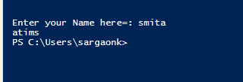

2)Calculator

firstNumber:-

SecondNumber:-

Specific Operation:1-Add, 2-Subtraction, 3-Multiplication ,4-Division

[decimal]$a= Read-host "Enter your first Number"

[decimal]$b= Read-host "Enter your second Number"

Write-host "1= Addition"

Write-host "2= Multiplication"

Write-host "3= Subtraction"

Write-host "4= Division"

$c= Read-host "Select your operation="

Switch($c)

{

1{$o =$a + $b}

2{$o =$a \*$b}

3{if ($a -gt $b)

{$o =$a -$b}

else

{$o =$b -$a}

}

4{$o =$a/$b}

}

write-host $o

output:-

