Aim of the project:
Generate fake job data (Python) (Extract) – Pandas + Faker
Load to Snowflake with Airflow (Load) – Snowflake connector
Use dbt for modeling (Transformation)
Looker/Power BI for insights/analytics
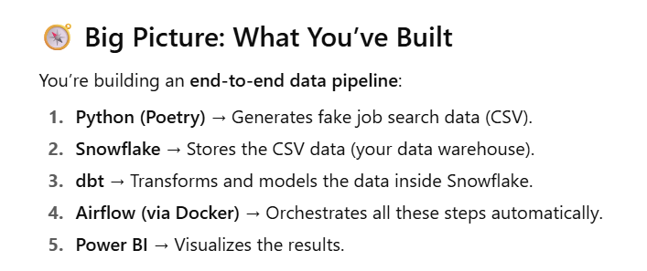

Stage | Technology | Purpose
Extract | Faker + Pandas | Generate fake job listings data
Load | Snowflake Connector | Load data into a Snowflake table
Transform | dbt | Create models and metrics from raw data
Orchestrate | Airflow | Automate and schedule the pipeline
Visualize | Power BI / Looker | Analyze job market trends
Package & Test | Poetry + Pytest | Manage dependencies and validate code
Run Locally | Docker Compose | Containerize Airflow and dependencies

Folder structure:

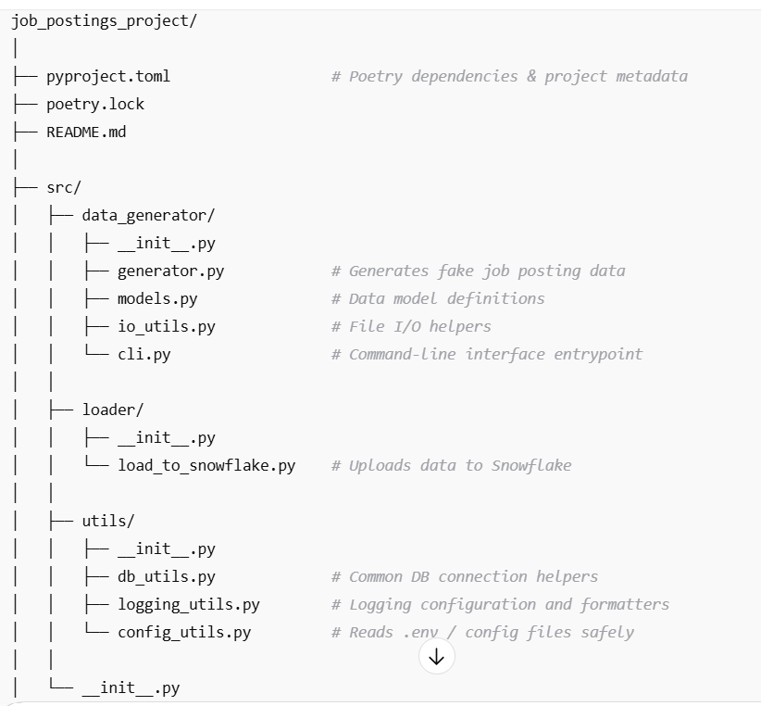
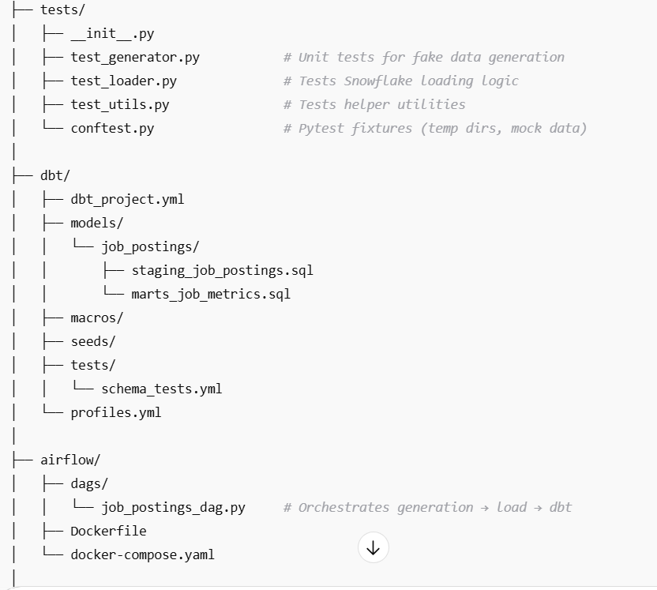

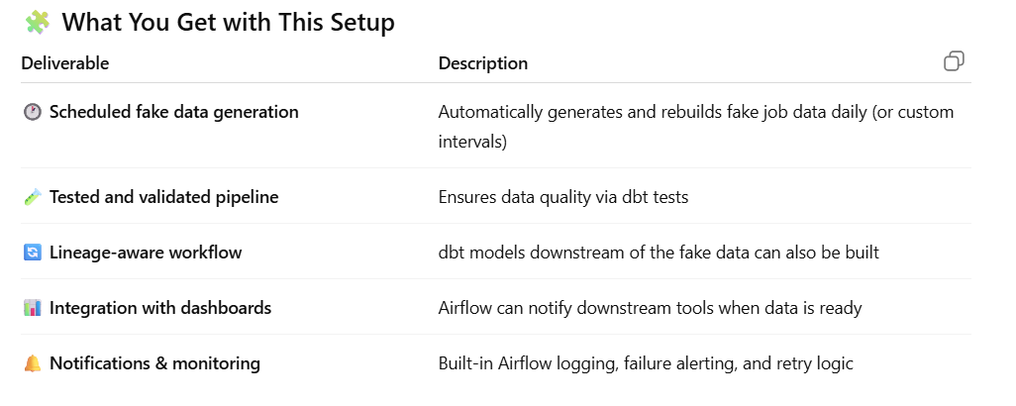

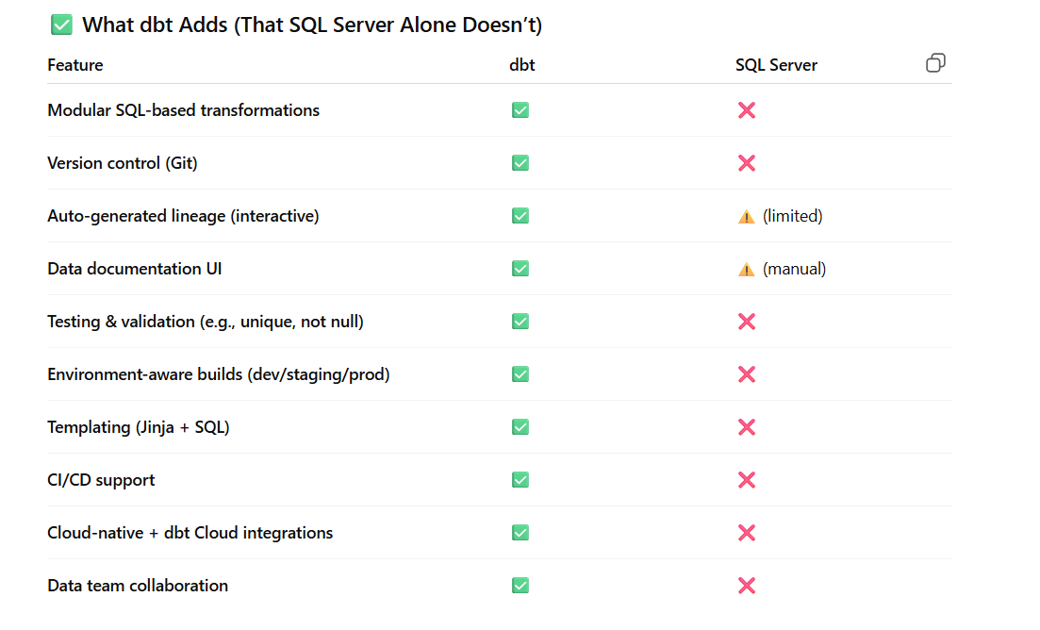

If you want to go full industry-grade, consider:
- ✅ Adding __init__.py in each subfolder under src/
- ✅ Adding pyproject.toml or setup.py if packaging
- ✅ Writing unit tests for each module in a /tests folder
- ✅ Dockerizing for deployment
- ✅ CI/CD pipeline with GitHub Actions for testing + deployment
- • A pyproject.toml-based structure
- • Unit tests for the generate_jobs.py or Snowflake loader
- • Docker + Docker Compose setup to run Airflow locally
To make the code from loader more professional, (src/loaders/load_to_snowflake.py) :
Change | Benefit
Logging | Logs each major action, useful for debugging and production monitoring
Modular functions | Easier to test, reuse, and mock
Optional connection argument | Makes it easier to reuse one connection across multiple operations
Parameterized SQL | Protects against SQL injection
Schema/table logic removed | Keep DDL (CREATE TABLE, etc.) in dbt or migration scripts — separation of concerns
Graceful error handling | Helps with reliability in production Airflow pipelines

Need to create these accounts to get going….
- Snowflake trial account
- Dbt cloud / local install
- Docker desktop (for running airflow containers)
- Looker/PowerBI
- Github/gitlab

Never commit .env or credentials to git. Use environment variables or a secrets manager for production
Also did the following:
- Created a snowflake trial account.
Open the Snowflake Web UI (Worksheets) and run these SQL statements to create a lightweight environment.
- Created a warehouse:
CREATE WAREHOUSE IF NOT EXISTS job_posting
WAREHOUSE_SIZE = 'XSMALL'
AUTO_SUSPEND = 60 -- suspend after 60 seconds idle
AUTO_RESUME = TRUE;

- Created database and schema:
CREATE DATABASE IF NOT EXISTS job_posting_data;
USE DATABASE job_posting_data;

CREATE SCHEMA IF NOT EXISTS public;
USE SCHEMA public;

- Created a user:
CREATE USER dev_user
PASSWORD = 'JobP0sting1!'
DEFAULT_WAREHOUSE = job_ posting
DEFAULT_ROLE = PUBLIC
DEFAULT_NAMESPACE = job_posting_data.public;
- CREATE ROLE dev_role;
- Grant privileges:

GRANT ROLE DEV_ROLE TO USER SATATANDALE;
GRANT USAGE ON WAREHOUSE job_posting TO ROLE dev_role;
GRANT USAGE ON DATABASE job_posting_data TO ROLE dev_role;
GRANT USAGE ON SCHEMA job_posting_data.public TO ROLE dev_role;
GRANT CREATE TABLE ON SCHEMA job_posting_data.public TO ROLE dev_role;

- Change the .env file from project:
SNOWFLAKE_USER=dev_user
SNOWFLAKE_PASSWORD=Lubidermlotion1$
SNOWFLAKE_ACCOUNT=your_accountqxa27262.east-us-2
SNOWFLAKE_WAREHOUSE=job_posting
SNOWFLAKE_DATABASE=job_posting_data
SNOWFLAKE_SCHEMA=PUBLIC

Note: to check the snowflake_account, login to snowflake and go to the session details:
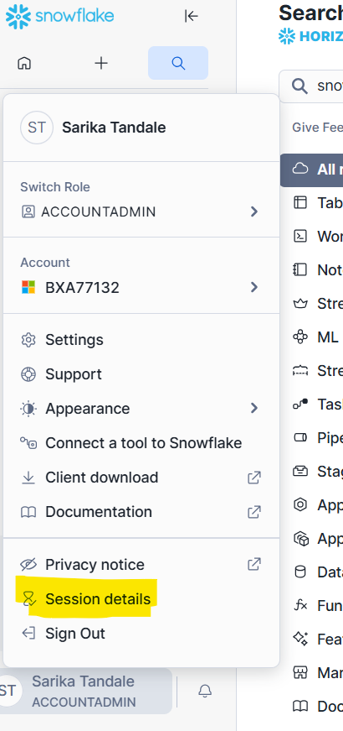

- Create a new schema in snowflake

CREATE SCHEMA IF NOT EXISTS JOB_POSTING_DATA.ANALYTICS;
GRANT USAGE ON SCHEMA JOB_POSTING_DATA.ANALYTICS TO ROLE dev_role;
GRANT CREATE TABLE, CREATE VIEW, MODIFY ON SCHEMA JOB_POSTING_DATA.ANALYTICS TO ROLE dev_role;

- Ran this on windows powershell:
Poetry install
This will:
- Read your pyproject.toml
- Install all declared dependencies (including python-dotenv)
- Set them up in Poetry’s isolated virtual environment

For dbt:
  - In powershell, cd C:\Users\15595\Desktop\learning\NewDataTools\Project_Job_Postings\dbt\Job_Postings
  - verify you can see dbt_project.yml in this directory by running: dir
  - inside same folder, run
python -m venv venv
venv\Scripts\activate
pip install dbt-snowflake
dbt –version
  - dbt looks for profile in this folder by default: C:\Users\<YourName>\.dbt\profiles.yml
if not present, create a profile here. Mine is here : C:\Users\15595\.dbt
  - Load .env variables by running these commands in powershell:
pip install python-dotenv
$env:SNOWFLAKE_USER = "SATATANDALE"
$env:SNOWFLAKE_PASSWORD = "Lubidermlotion1$"
$env:SNOWFLAKE_ACCOUNT = "qxa27262.east-us-2.azure"
$env:SNOWFLAKE_WAREHOUSE = "job_posting "
$env:SNOWFLAKE_DATABASE = "JOB_POSTING_DATA "
$env:SNOWFLAKE_SCHEMA = "PUBLIC "
$env:SNOWFLAKE_ROLE = "dev_role"
  - Then run => dbt debug followed by => dbt run
- Next time just run:
dbt clean
dbt deps
dbt debug
dbt run --select stg_job_postings

Best practices & tips for Snowflake:
- Never commit .env or credentials to git. Use environment variables or a secrets manager for production.
- For local dev, the .env file + python-dotenv is OK. For teams/production use Vault, AWS Secrets Manager, or Azure Key Vault.
- Use a small warehouse (XSMALL) for dev to keep credits low. Auto-suspend should be set short (e.g., 60s).
- Use separate roles/users: admin for management, service account for apps/pipelines. Assign only necessary privileges.
- For large loads, prefer Snowflake bulk ingestion (PUT + COPY INTO) or write_pandas() from the Snowflake connector — row-by-row inserts are fine for small test loads but are slow for big datasets.
- If you plan to connect Power BI: choose a region/cloud compatible with your Power BI deployment (Azure can be more straightforward for some Microsoft integrations).
- If you use dbt: configure your profiles.yml to point to Snowflake credentials and the database/schema you created.

Installed docker on windows.(AMD64 version)

To wire everything together( 1st run airflow i.e this following script, followed by dbt part)
  - Cd C:\Users\15595\Desktop\learning\NewDataTools\Project_Job_Postings
  - docker build -t airflow-job-postings:latest -f airflow/Dockerfile .
  - cd airflow
  - docker-compose up -d
  - Then open Airflow at 👉 http://localhost:8080
Login:
  - username: admin
  - password: admin

Rule of thumb: Snowflake is not optimized for row-by-row inserts. Always try bulk operations for better performance. Hence I am using write_pandas utility provided by snowflake.connector.pandas_tools.
Steps in installing that on windows powershell:
- pip install "snowflake-connector-python[pandas]"
- pip install pandas

Then re-wrote the loader.

