Use dbt when you want to:
- Make transformations version-controlled
- Treat your data pipeline like code
- Make lineage and documentation automatic
- Enforce data quality rules
- Enable multiple developers to collaborate cleanly
- Build repeatable, auditable, and testable workflows

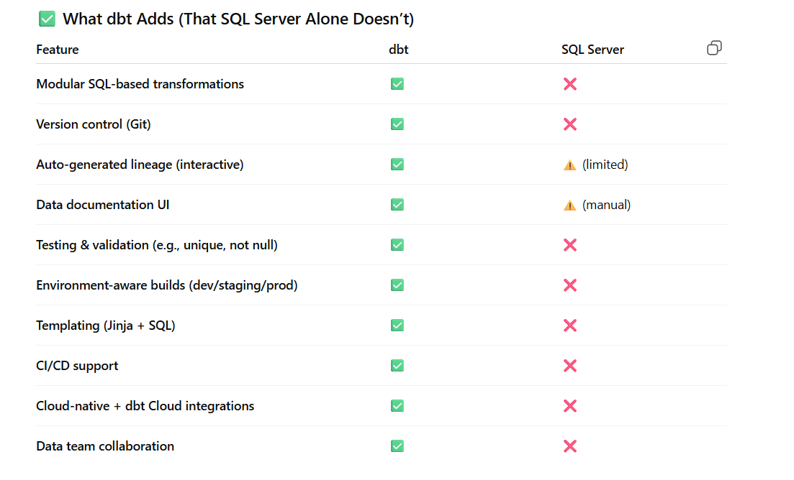

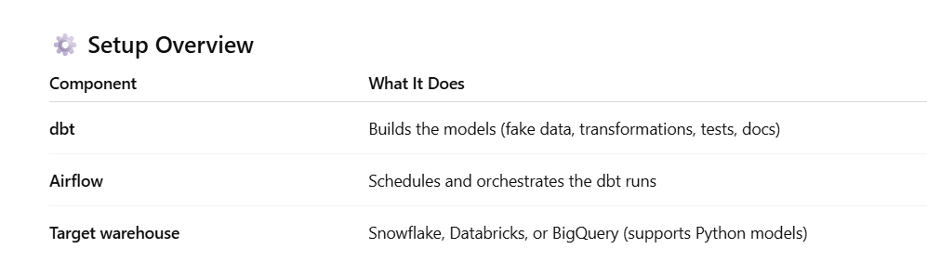

Steps:
- Cd C:\Users\15595\Desktop\learning\NewDataTools\Project_Job_Postings\dbt
- python -m venv venv (do this only 1st time)
- venv\Scripts\activate (second time just run this: cd C:\Users\15595\Desktop\learning\NewDataTools\Project_Job_Postings\dbt and then venv\Scripts\activate and then directly run dbt debug)
- pip install dbt-snowflake
- verify by running: dbt –version
- dbt init Job_Postings
- create profile.yaml file under this folder: C:\Users\15595\Desktop\learning\NewDataTools\Project_Job_Postings\dbt\.dbt
- GRANT ROLE DEV_ROLE TO USER SATATANDALE;
This is how profiles.yml should look:
Job_Postings:
target: dev
outputs:
dev:
type: snowflake
account: QXA27262.east-us-2.azure (go to session details in snowflake account to find it)
user: SATATANDALE (execute select current_user in sql)
password: Lubidermlotion1$
role: DEV_ROLE
database: JOB_POSTING_DATA
warehouse: job_posting
schema: PUBLIC
threads: 4

This will be the output on powershell when you run dbt debug:
