- Complete Git first…..
- Leave logger portion…only 1 or 2 que will ask on logger.
- How to resolve the production env. Issue. (this is the only ques which ask on logger)
Check the servers log file, in log file exception or steps to reproduce are mention.

Prepare the following topics
- GIThub
- Pythoncore
- Flask or Django (prepare anyone for interview)
- Databases
- ORM Queries
- Processes….
- Pull request
- SDLC
- Agile
- Methodologies

- No need to prepare Selenium but at least you should know some concept of Selenium.
- Prepare anyone framework either Django or flask
- you should know MVC applications
- crud operations
- REST/ web Services
- Postman
- how to generate the API
- how to consume the API
- Also ask the types of method
- Difference between pull and push
- difference between get and post
- For GIRA watch one video. Its is just project management tool.
Questions
- How many API you have prepared?
Ans: Don’t know the exact number but many APIs I have prepared.

- What are the different types of methods?
Ans:
Methods: function inside the class (function: it is a set of instruction which we can repeatedly call for reuse)

Types of methods
- Instance Method: When first parameter define as a self which is ref. of object. And there is no decorator.
- In instance method ,By coding convention the first parameter is always “self”
- When we have to write the code for object specific then use instance method….(for individual object…example: id, name,), it means it is a object specific method.

- Class methods: when the first parameter reserved as (cls) then that method is called as class method, and there is a decorator called as @classmethod (@=Decorator symbol)
- In class method ,By coding convention the first parameter is always (cls).
- It is a class specific method.

- Static method: when there is no reserved parameter called as static method and decorator is @staticmethod

- Class method and static method common for all

- Which method is used for which purpose?
Ans: Refer the question number 2

- how to secure the API
Ans:

- What are the problems occur during the pull request?
Ans: Pull conflict: when there is pull conflict by default there is push conflict(not possible to pull the code)
How to resolve pull conflicts: we have different mechanism to resolve the pull conflict
1.Code merge---but avoid (may problems occur during merge)…..in interview u have this option…but practically not feasible
2. manually.
3. by tools:

- Difference between clone and pull
Ans: Clone: copy, coping entire project code with requirement txt file(libraries)
Pull: importing modified code from repository

- What are the sql queries
Ans: You can directly say that I mostly work on ORM. I don’t have that much hands on sql where as I mostly work on ORM queries. So I’m not able to recollect the concepts now, it will be better to ask the question on ORM quires.

- How many APIs you have created in your project
Ans: I can not remember the exact number there are multiple APIs I worked on.

- What kind of libraries you used in your project?
Ans:
- Pypdf- PDF generaration
- DRF-
- Request-
- Django-restframework
- Openpyxl-
- Pymysql-
- Swagger-
- Mysqldbclient-
- Pypdf/reportlab-
- Boto3-
- Pandas-
- Smptlib----email sending
- Asgiref-----required in application for synchronization
- Sqlpars-

Project Questions:
- Tell me about yourself
Ans: I am Sarika Telang, I have completed my bachelors in Civil Engg. and masters in Environmental Engg. I worked as a developer for three years

What do you like best about being a software developer?
“I love getting to create a product that solves a problem for someone. My favorite part of the process is sitting down with the client’s list of requests and coming up with ideas to meet all of them in the most effective way possible.”

- Tell me about your project
Ans:

- How will you rate yourself out of 10 or out of 5 frontend and backend or database
- Who is your client?
Ans: it is confidential information, sorry, I can not share with you.

- Is this your permanent company.
Ans:
- Which is the payroll company.

- Types of meeting
Ans:
What are the four types of Agile meetings?
There are several types of Agile meetings (for example, the 3 amigos meeting in Agile) but here are the four most common. You’ll also hear Agile meetings referred to as “ceremonies” or “Scrum events.” As Scrum Alliance explains, there are four specific types of events in Scrum.
1. Sprint planning meeting
What it is: The sprint planning session is when the Scrum team discusses what work they want to tackle in the next sprint and then prioritizes that work accordingly.
Meeting goals:
- Decide on objectives for the next sprint (i.e. what features should be developed)
- Divide tasks and responsibilities
Who should attend:
- Development team
- Scrum master
- Product owner
How long it lasts: It’s recommended that you schedule two hours of meeting time for every week of your sprint. So, if your team works in two-week sprints, your sprint planning meeting should be four hours. Cap meetings at eight hours, though. Anything longer than that is too cumbersome.

2. Daily standup meeting
What it is: This Agile standup meeting happens every day of the sprint. It’s a quick check-in on what each team member is working on, how the process is going for them, and what stands in their way. As Scrum Alliance explains, it’s important to note that this isn’t a glorified status update — it’s a chance to improve the process (and ultimately, the end product) daily, before too much more work is invested.
Meeting goals:
- Discuss progress on work for that sprint
- Identify roadblocks and impediments to work
Who should attend:
- Development team
How long it lasts: No more than 15 minutes.

3. Sprint review meeting
What it is: Sprint reviews are easily confused with sprint retrospectives, but the two are different. During the sprint review, the development team presents the work that was done during the sprint (often with a demonstration), with the aim of collecting as much feedback as possible.
Meeting goals:
- Collect feedback
Who should attend:
- Development team
- Scrum master
- Product owner
- All relevant stakeholders
How long it lasts: It’s recommended to allocate one hour for every week of the sprint. So, if your sprint was two weeks, your sprint review should be two hours. Your sprint review should not go over four hours.

4. Sprint retrospective meeting
What it is: During a sprint retrospective, the Scrum team focuses specifically on their work together — and not necessarily the product or output. What went well? What didn’t go well? What should they do differently in the next sprint? Each sprint retrospective should conclude with action items the team will implement to improve their collaboration.
Meeting goals:
- Evaluate what worked and what didn’t in the previous sprint
- Establish action items to improve the next sprint
Who should attend:
- Development team
- Scrum master
How long it lasts: It’s recommended that you allow 45 minutes for each week of your sprint. Sticking with our two-week sprint example, your sprint retrospective would be an hour and a half. Sprint retrospectives shouldn’t go longer than three hours.

- What you discuss in sprint meeting.
Meeting goals:
- Decide on objectives for the next sprint (i.e. what features should be developed)
- Divide tasks and responsibilities

- which methodology you used in your project (agile)
Ans: Agile is an iterative approach to project management and software development that helps teams deliver value to their customers faster and with fewer headaches.

- What to do if your task is not completed within given time frame.

- Rules and responsibilities
Ans:
- Plan Ad- hoc calls with clients to understand the requirements clearly.
- Develop code as per the SRS (software requirement specification), the requirements, the Jira tickets, and as per client suggestions.
- Write the unit test cases for the module or the task which is been assigned to the developer.
- Working closely with the tester.
- Give suggestions for improvement in developing the application.
- active participation in every call.

- daily routine

- Which project management tools you used.
Ans: Jira

- How you resolve the issue on production environment .
Ans: Check the servers log file, in log file exception or steps to reproduce are mention.

- sprint duration
Ans: 2 to 3 week not more than three weeks

- Team size
Ans: 11
  - Scrum Master
  - Full stack developer
  - Front end-developer(3)
  - Back end-developer(3)
  - Tester(2)
  - Database

- Which was the last task you worked on.
Ans:

- what are the comments that you get for your pull request?
Ans:

- What are the design patterns used in your project?
Ans:

- Technical mapping of your project
Ans:

- tell me the flow of your project
Ans:

- Project business case.
Ans:

- Deployment of your project
Ans: (python anywhere), huruku

- Project architecture
Ans:

- What are components of your project
Ans:

- Challenges that you face in your project implementation.
Ans:

- Purpose of ecom application
Ans: Minimize the gap between product manufactures and customers.

- Purpose of telecom application.
Ans: Provide the list of telecom services, like data, voice call.

Question from D_python video

- String object are immutable then how you can perform replacement operation
Ans: If we performed replace operation it created the new object we never going make change in old object…. you can check by id(address)…both old and new str id will be different.

- Difference Between append and insert
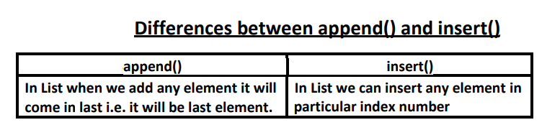

- Difference between remove and pop
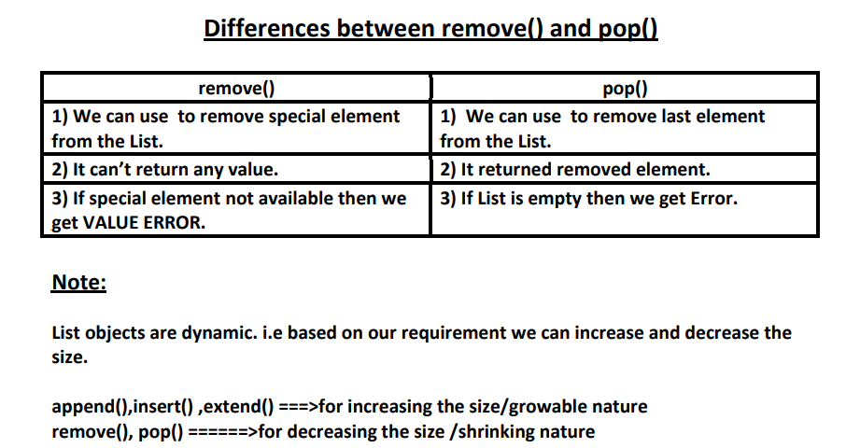

- List objects are dynamic. Explain.
Based on our requirement we can increase or decrease the size of list
append(),insert() ,extend() ===>for increasing the size/growable nature
remove(), pop() ======>for decreasing the size /shrinking nature

- Difference between = operator and copy() function
# = operator meant for aliasing
# copy() function meant for cloning

- Difference between list and tuple

List and Tuple are exactly same except small difference: List objects are mutable where as Tuple objects are immutable.
In both cases insertion order is preserved, duplicate objects are allowed, heterogenous objects are allowed, index and slicing are supported.
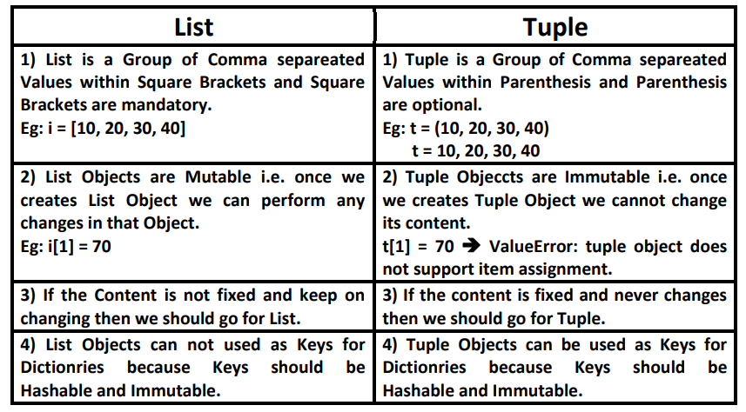

- What is the difference between add() and update() functions in set?
We can use add() to add individual item to the Set,where as we can use update() function to add multiple items to Set. add() function can take only one argument where as update() function can take any number of arguments but all arguments should be iterable objects

