**My Report Page**

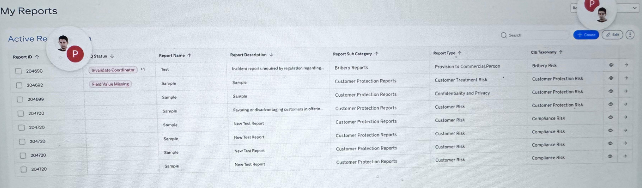

Based on the UI from the image you’ve shared (titled **“My Reports”** with an **Active Reports** table), here’s a potential **user story** for developing or enhancing this module in your application:

**🧾 User Story: View and Manage Active Reports**

**Title**: As a compliance officer or analyst, I want to view and manage all active reports, so that I can quickly review issues, track statuses, and take necessary actions.

**✅ Acceptance Criteria:**

1. **Report Listing Table**
   * The user should see a table listing all active reports.
   * Each row includes:
     + Report ID
     + DQ Status
     + Report Name
     + Report Description (truncated if long)
     + Report Sub Category
     + Report Type
     + Citi Taxonomy
     + View and Action Icons (eye and arrow icons)
2. **Sort and Filter Options**
   * The user can sort the table by columns such as Report Name, Status, or Report Type.
   * The user can search reports using a keyword search bar.
3. **View Report Details**
   * Clicking the eye icon allows the user to view the report in detail.
4. **Navigate to Full Report**
   * Clicking the arrow icon opens the full report details for further actions (edit, comment, escalate, etc.).
5. **Create and Edit Reports**
   * “Create” button allows user to open a form to submit a new report.
   * “Edit” button enables bulk or single edit mode for existing reports.
6. **Handle Duplicate Report IDs**
   * The table displays multiple entries with the same Report ID (e.g., 204720), which suggests the user might need to merge, group, or investigate duplicates.

**Report Details**

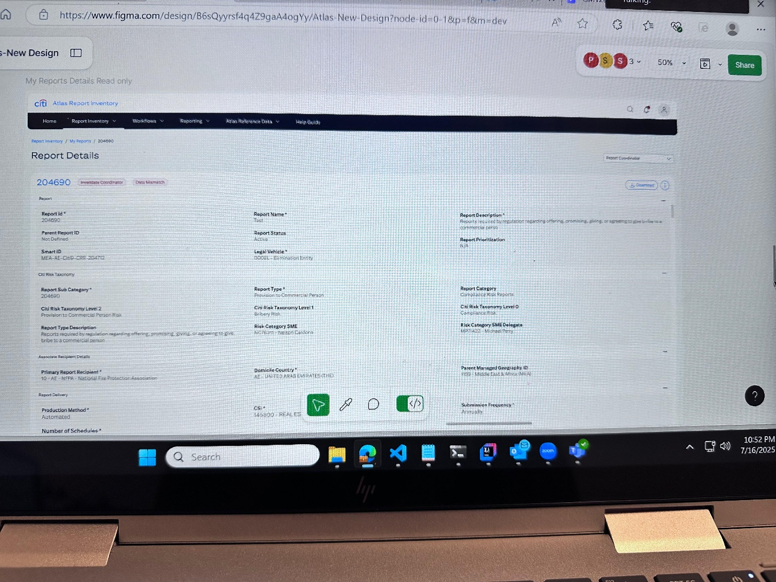

Based on the second image (which shows detailed report data for **Report ID: 204690**), here's a continued user story and a breakdown of how to organize the Angular components meaningfully.

**🧾 User Story: View Report Details**

**Title**: As a report coordinator or reviewer, I want to view the complete details of a report in a clean, organized format, so that I can understand the risk and take necessary actions.

**✅ Acceptance Criteria**

1. **Report Detail Layout**
   * Show high-level report metadata (ID, status, name, Smart ID, etc.)
   * Include **risk taxonomy** information (category, level, SME)
   * Show **recipient and delivery** information
   * Include **submission frequency** and **legal vehicle**
   * Support tags like *“Invalidate Coordinator”* and *“Data Mismatch”*
   * Provide buttons for:
     + Download
     + Initiate review
     + Mark/Edit
     + Navigate back
2. **UI Sections (Visually grouped)**
   * **Basic Info Section** (Report ID, Name, Status, Description)
   * **Risk Taxonomy Section**
   * **Recipient & Legal Info Section**
   * **Submission & Delivery Section**
   * **Actions Toolbar**

**🧱 Recommended Angular Component Structure**

| **Component Name** | **Purpose** |
| --- | --- |
| report-detail.component.ts | Root component for full report detail page |
| report-header.component.ts | Displays title, tags, and top-level metadata like Report ID, status |
| report-basic-info.component.ts | Shows name, status, legal vehicle, report description |
| report-taxonomy-info.component.ts | Displays taxonomy levels, risk types, SME and SME delegate |
| report-recipient-info.component.ts | Handles recipient details and domicile info |
| report-delivery-info.component.ts | Displays production method, schedule, submission frequency |
| report-actions-toolbar.component.ts | Provides action buttons: download, edit, validate, go back |

✅ **Modularizing** these as subcomponents makes it easy to maintain, reuse, and test individually.

Here's a structured list of **all fields** extracted from the detailed report screen you shared, grouped by **logical sections**. These sections can be used directly for form layout, display grouping, or component design.

**🧾 Section-wise Field List for Report Details**

**🔹 1. Report Header Section**

| **Field** | **Example Value** |
| --- | --- |
| Report ID | 204690 |
| Status Tags | Invalidate Coordinator, Data Mismatch |
| Report Name | Test |
| Report Status | Active |
| Report Description | Reports required by regulation regarding offering, promising, giving... |

**🔹 2. Identification & Classification**

| **Field** | **Example Value** |
| --- | --- |
| Parent Report ID | Not Defined |
| Smart ID | MEA-AE-CitB-CRR-204720 |
| Report Sub Category | 204690 |
| Report Type | Provision to Commercial Person |
| Report Category | Compliance Risk Report |
| Report Prioritization | N/A |

**🔹 3. Citi Risk Taxonomy**

| **Field** | **Example Value** |
| --- | --- |
| Citi Risk Taxonomy Level 2 | Provision to Commercial Person Risk |
| Citi Risk Taxonomy Level 1 | Bribery Risk |
| Citi Risk Taxonomy Level 0 | Compliance Risk |
| Risk Category SME | NC7831T - Nelson Cardona |
| Risk Category SME Delegate | MP7422 - Michael Perry |

**🔹 4. Legal and Geographic Information**

| **Field** | **Example Value** |
| --- | --- |
| Legal Vehicle | 00DEL - Elimination Entity |
| Domicile Country | AE - UNITED ARAB EMIRATES (THE) |
| Parent Managed Geography ID | HBO - Middle East & Africa (MEA) |

**🔹 5. Report Delivery & Execution**

| **Field** | **Example Value** |
| --- | --- |
| Primary Report Recipient | 10 - AE - NFPA - National Fire Protection Association |
| Production Method | Automated |
| Number of Schedules | (not visible, assumed to be a number field) |
| Submission Frequency | Annually |

**🔹 6. CSI & Metadata**

| **Field** | **Example Value** |
| --- | --- |
| CSI | 145800 : REAL ES |

**🔹 7. Action Bar / Controls**

| **Item** | **Function** |
| --- | --- |
| Download Button | Download report data |
| Edit/Mark Buttons | Validate, Annotate |
| View/Code Buttons | Possibly used for developer or audit views |

**Dashboard**

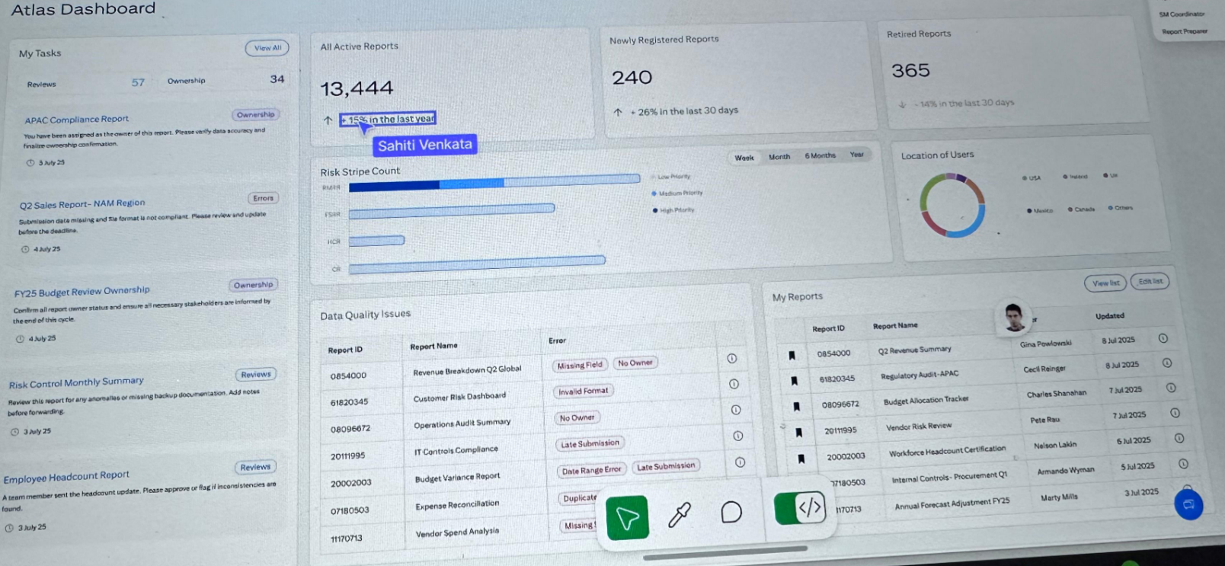

Based on the provided **Atlas Dashboard** image, we can identify multiple sections offering different types of report analytics, tasks, quality issues, and user insights. Here's how you can convert this screen into **user stories** along with **suggested Angular component names**.

**🧾 User Stories and Angular Component Mapping**

**🔹 1. My Tasks Section (Left Panel)**

**🧩 User Story**

**As a report owner or reviewer**, I want to see my assigned tasks along with due dates and ownership status, so that I can prioritize and take timely actions.

**📦 Component Name**

* my-tasks-panel.component.ts
* Sub-components:
  + task-item.component.ts (for individual task entries)

**🔹 2. Report Stats Summary (Top Center Cards)**

**🧩 User Story**

**As a dashboard user**, I want to view quick stats of report activities like active reports, new registrations, and retirements, so I get an overall view of the reporting trends.

**📦 Component Name**

* report-stats-summary.component.ts
* Sub-components (optional):
  + stat-card.component.ts (for each metric like Active, Registered, Retired)

**🔹 3. Risk Stripe Count (Center Chart)**

**🧩 User Story**

**As a risk analyst**, I want to analyze the distribution of risk types by priority (Low/Medium/High) using a visual bar chart, so I can identify critical areas quickly.

**📦 Component Name**

* risk-stripe-chart.component.ts

**🔹 4. Time Filter Toolbar (Above Chart)**

**🧩 User Story**

**As a user**, I want to filter risk trends based on timeframes (Week, Month, 6 Months), so I can perform time-based analysis.

**📦 Component Name**

* time-filter-toolbar.component.ts

**🔹 5. Location of Users (Pie Chart)**

**🧩 User Story**

**As a global administrator**, I want to see the distribution of users by country, so I can understand usage patterns across regions.

**📦 Component Name**

* user-location-chart.component.ts

**🔹 6. Data Quality Issues Table**

**🧩 User Story**

**As a data quality auditor**, I want to view a list of reports with issues like missing fields, invalid dates, or late submissions, so I can follow up and fix them.

**📦 Component Name**

* data-quality-issues-table.component.ts
* Sub-components (optional):
  + quality-tag.component.ts (to show "Missing Field", "Late Submission" etc.)

**🔹 7. My Reports Table (Bottom Right)**

**🧩 User Story**

**As a report user**, I want to view a list of reports I’ve recently accessed or created, so I can quickly revisit or update them.

**📦 Component Name**

* my-reports-table.component.ts

**🔹 8. Header and Layout**

**📦 Component Name**

* dashboard-header.component.ts (for “Atlas Dashboard” title and navigation)
* atlas-dashboard.component.ts (main layout wrapper, aggregates all sections)

**✅ Summary of Angular Component Names**

| **Section Name** | **Component Name** |
| --- | --- |
| My Tasks | my-tasks-panel.component.ts |
| Task Item | task-item.component.ts |
| Report Stats Summary | report-stats-summary.component.ts |
| Individual Stat Card | stat-card.component.ts |
| Risk Stripe Chart | risk-stripe-chart.component.ts |
| Time Filter Toolbar | time-filter-toolbar.component.ts |
| Location of Users Chart | user-location-chart.component.ts |
| Data Quality Issues Table | data-quality-issues-table.component.ts |
| Quality Tag (status label) | quality-tag.component.ts |
| My Reports Table | my-reports-table.component.ts |
| Dashboard Header | dashboard-header.component.ts |
| Dashboard Shell | atlas-dashboard.component.ts |

Absolutely! Based on the **"Atlas Dashboard"** image you provided, here's a breakdown of **each section** and the **list of field names (labels/data points)** shown in the UI.

**🧾 Section-wise Field Names from the Dashboard**

**🔹 1. My Tasks Section (Left Panel)**

| **Field / Label** | **Notes** |
| --- | --- |
| My Tasks | Section heading |
| Reviews | Count of tasks requiring review (e.g., 57) |
| Ownership | Count of owned tasks (e.g., 34) |
| View All | Button/link to navigate to full list |
| Report Title | e.g., "APAC Compliance Report", "Q2 Sales Report – NAM Region" |
| Action Required | e.g., "Ownership", "Review" |
| Due Date | e.g., "4 July 25", "3 July 25" |
| Instruction Text | e.g., "You have been assigned..." |

**🔹 2. All Active / Registered / Retired Reports (Top-Center Cards)**

| **Field / Label** | **Notes** |
| --- | --- |
| All Active Reports | Count displayed (e.g., 13,444) |
| % Change | e.g., "+15% in the last year" |
| Newly Registered Reports | e.g., 240 |
| % Change | e.g., "+26% in the last 30 days" |
| Retired Reports | e.g., 365 |
| % Change | e.g., "-14% in the last 30 days" |

**🔹 3. Risk Stripe Count Chart**

| **Field / Label** | **Notes** |
| --- | --- |
| Risk Stripe Count | Section title |
| Risk Types | Y-axis values like A, B, C |
| Priority Bands | Color coded (Low, Medium, High Priority) |
| Time Filters | Work, Month, 6 Months (radio buttons or tabs) |

**🔹 4. Location of Users (Pie Chart)**

| **Field / Label** | **Notes** |
| --- | --- |
| Location of Users | Section title |
| Country Names | e.g., USA, Mexico, Canada, Others |
| Color-coded Pie Slices | Representing user counts by region |

**🔹 5. Data Quality Issues Table**

| **Field / Label** | **Notes** |
| --- | --- |
| Report ID | e.g., 0845000, 0851405 |
| Report Name | e.g., "Revenue Breakdown Q2 Global", "Customer Risk Dashboard" |
| Issue Tags | e.g., "Missing Field", "No Owner", "Invalid Format", "Late Submission", "Date Range Error" |

**🔹 6. My Reports Table (Bottom-Right Table)**

| **Field / Label** | **Notes** |
| --- | --- |
| Report ID | e.g., 0854005, 0843056 |
| Report Name | e.g., "Q2 Income Summary", "Vendor Risk Review" |
| Owner Name | e.g., "Gina Pawlowski", "Cecil Ringer" |
| Updated Date | e.g., "3 Jul 2025", "5 Jul 2025" |
| User Profile Image | Profile pic of report owner |
| View List / Edit List | Button for toggling/editing the report list |

**🔹 7. Top Menu / Context Info (Top-Right Corner)**

| **Field / Label** | **Notes** |
| --- | --- |
| SMF Coordinator | Possibly current user role |
| Report Preparer | Alternate role info |

**Register New Report**

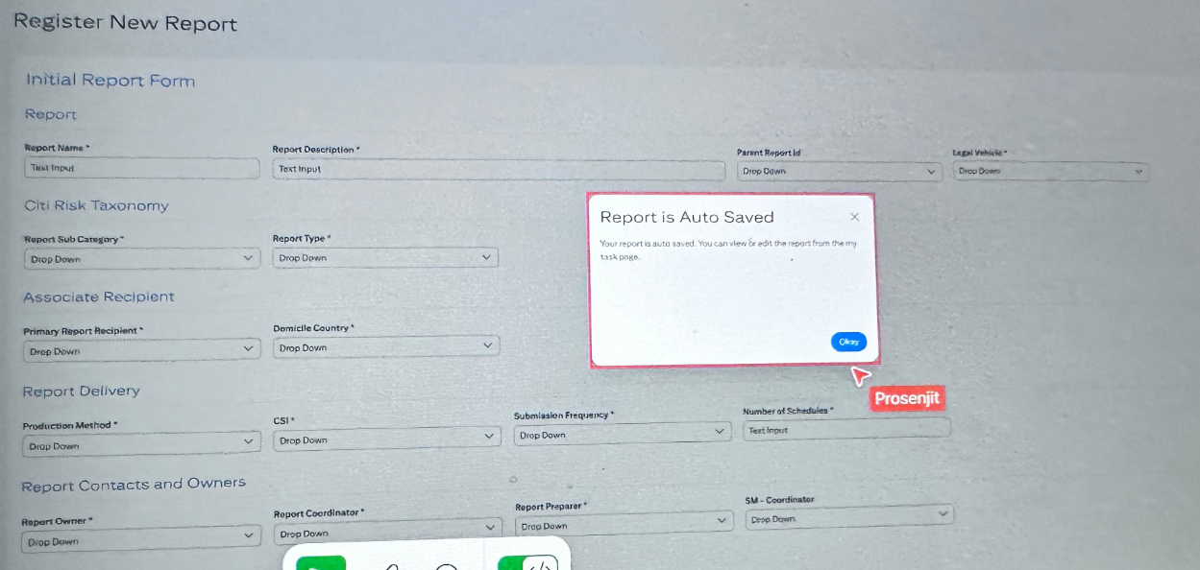

Based on the image of the **“Register New Report”** screen, here's a detailed breakdown of:

**✅ 1. User Stories (Imagined for Development)**

**🧾 User Story: Register a New Report**

**As a report preparer**, I want to fill in and save all relevant information for a new report, so that it can be tracked, categorized, and processed efficiently in the system.

**🧾 User Story: Auto-Save Functionality**

**As a user**, I want the system to auto-save the report while filling the form, so I don’t lose progress and can continue later.

**🧾 User Story: Categorize the Report by Risk and Delivery**

**As a risk analyst or preparer**, I want to assign correct taxonomy, ownership, and delivery frequency, so the report flows through the correct risk, compliance, and ownership pipeline.

**✅ 2. Do We Need Separate Angular Components per Section?**

**Yes, splitting into modular sections is beneficial** for maintainability, reusability, and validation handling. So you can have:

| **Section Name** | **Angular Component Name** |
| --- | --- |
| Initial Report Form | initial-report-form.component.ts |
| Citi Risk Taxonomy | report-taxonomy-form.component.ts |
| Associate Recipient | report-recipient-form.component.ts |
| Report Delivery | report-delivery-form.component.ts |
| Report Contacts and Owners | report-contacts-form.component.ts |
| Root Wrapper | register-report.component.ts |

Use ReactiveFormsModule with FormGroup for each sub-component and pass data via @Input()/@Output() or shared form group.

**✅ 3. Fields per Section (Grouped)**

**🔹 Initial Report Form**

| **Field Label** | **Input Type** |
| --- | --- |
| Report Name | Text Input |
| Report Description | Text Area |
| Parent Report ID | Dropdown |
| Legal Vehicle | Dropdown |

**🔹 Citi Risk Taxonomy**

| **Field Label** | **Input Type** |
| --- | --- |
| Report Sub Category | Dropdown |
| Report Type | Dropdown |

**🔹 Associate Recipient**

| **Field Label** | **Input Type** |
| --- | --- |
| Primary Report Recipient | Dropdown |
| Domicile Country | Dropdown |

**🔹 Report Delivery**

| **Field Label** | **Input Type** |
| --- | --- |
| Production Method | Dropdown |
| CSI | Dropdown |
| Submission Frequency | Dropdown |
| Number of Schedules | Text Input |

**🔹 Report Contacts and Owners**

| **Field Label** | **Input Type** |
| --- | --- |
| Report Owner | Dropdown |
| Report Coordinator | Dropdown |
| Report Preparer | Dropdown |
| SM – Coordinator | Dropdown |

**🔹 Auto-Save Message**

| **Field Label** | **Input Type** |
| --- | --- |
| Message Popup: “Report is Auto Saved” | Modal/Toast |