1. General Concept

$$dependent variable=\left(y intercept\right)+(slope times independent variable)$$



Predictor

1. Simple Equation

$y=α+βx$

1. Sample a population so we estimate

$$y=\hat{α}+\hat{β}x$$

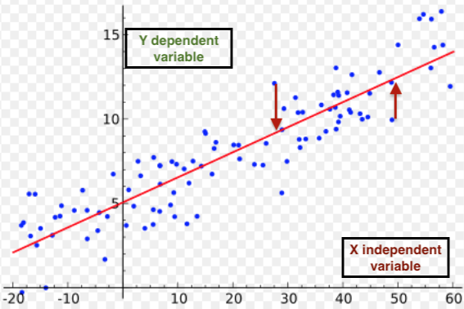

1. Expand from Simple to Multiple Regression

$$\hat{y}={\hat{α}}_{o}+{\hat{β}}_{1}x_{1}+{\hat{β}}_{2}x_{2}+ϵ$$

For example, diet $x_{1}$ and exercise $x_{2}$ predicts you will lose weight, $\hat{y}$. If ${\hat{β}}_{2}=0.5$, then single units change of $x_{2}$ will change $\hat{y}$ by 0.5 . . . or increase your exercise by half, then lose a bunch of weight.

1. Capstone Multiple Regression
$$\hat{y}=2.6478+0.0348x_{1}+0.4789x_{2}+ϵ$$

2. Normality and Goodness of Fit . . . Jacques Bera Test

$$JB=sample size∙\left(\frac{{sample skewness}^{2}}{6}+\frac{{\left(sample kurtosis-3\right)}^{2}}{24}\right)$$