Tab 4

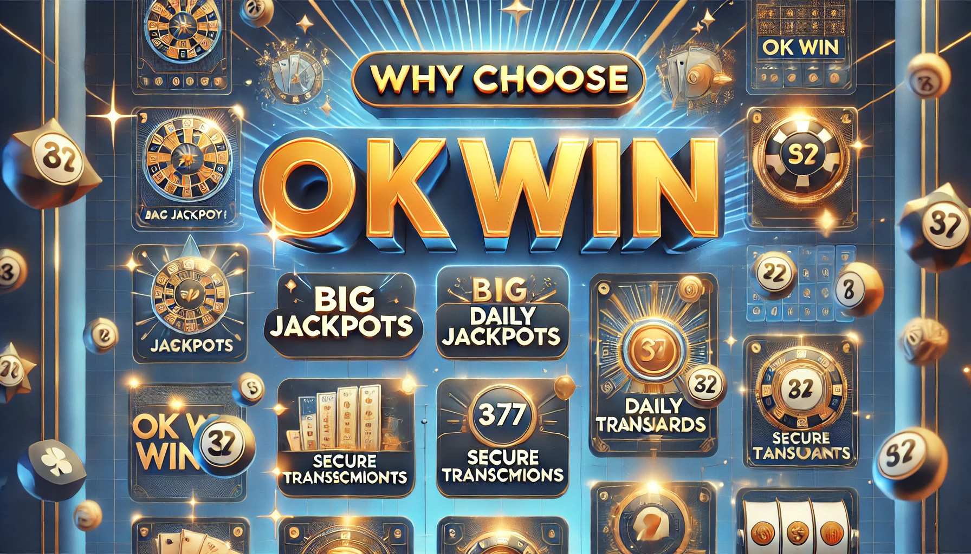The world of online gaming has evolved, and players are constantly seeking platforms that offer not only entertainment but also real cash rewards. [**Okwin**](https://ok-win.org/), India’s premier online lottery and gaming platform, delivers a thrilling experience that combines the excitement of games with the opportunity to win big. Whether you’re a beginner or an experienced player, Okwin offers everything you need to enjoy your favorite games and earn incredible rewards. In this article, we’ll explore how Okwin stands out in the competitive world of online gaming, the bonuses and rewards it offers, and why it’s becoming the go-to platform for players in India.

### **Why Okwin is the Ultimate Destination for Online Gaming in India**

Okwin isn’t just another online gaming platform. It’s designed to provide a premium gaming experience, tailored to the needs of every player. Let’s look at some of the features that make Okwin the ideal choice for online gaming enthusiasts in India.

#### **1. A Vast Selection of Games**

Okwin offers a wide array of games that appeal to all kinds of players. Whether you’re a fan of traditional lotteries, prefer the thrill of casino games, or want to try your luck with sports betting, Okwin has something for everyone. Some of the most popular games available on the platform include:

* **Lottery Games**: Play a variety of exciting lottery games with the chance to win huge prizes.
* **Casino Games**: Enjoy the best of casino gaming with options like poker, blackjack, and roulette, all available with high-quality graphics and smooth gameplay.
* **Sports Betting**: Bet on cricket, football, basketball, and more. Okwin offers competitive odds and real-time updates, ensuring that you’re always part of the action.
* **Color Prediction**: Try your luck with color prediction games, where players predict outcomes to win instant rewards.
* **Slots**: With various themes and huge jackpots, Okwin’s slot machines offer a fun and rewarding experience for all types of players.

No matter what kind of gaming experience you’re looking for, Okwin ensures that there’s always something to suit your style.

#### **2. Seamless User Experience**

Okwin prioritizes user experience, making it easy for players to navigate the platform and enjoy their favorite games. Whether you’re accessing the site via a mobile app or a browser, the interface is designed to be intuitive and user-friendly. Players can easily find the games they want to play, manage their account, and track their winnings without any hassle. Okwin’s clean and sleek design makes it easy for both beginners and experienced players to get started.

#### **3. Security You Can Trust**

When it comes to online gaming, security is paramount. Okwin understands this and employs the latest encryption technology to ensure that all your personal and financial information is kept safe. Whether you’re making deposits, withdrawals, or simply navigating the site, you can trust that your data is in good hands. Okwin also uses secure payment gateways, making transactions smooth and safe.

### **Okwin’s Attractive Bonuses: Your Ticket to Big Wins**

One of the best things about Okwin is its rewarding bonus system. From the moment you sign up, you’re greeted with exciting bonuses that enhance your gaming experience. Let’s dive into the various bonuses that Okwin offers.

#### **1. 100% First Deposit Bonus**

As a new player, you’re immediately eligible for the **100% first deposit bonus**. This means that when you make your first deposit, Okwin will double your deposit, giving you extra funds to play with. This bonus allows you to explore the platform and try different games without worrying about running out of funds too quickly.

#### **2. Wingo Win Streak Bonus**

If you’re a lucky streak player, Okwin’s **Wingo win streak bonus** is perfect for you. For every consecutive win you achieve, you’ll receive up to a 100% bonus on your winnings. This incentive encourages players to keep playing and rewards you for maintaining a winning streak.

#### **3. Lucky 10-Day Prize Rewards**

Okwin keeps players engaged with its **Lucky 10-day prize rewards**. This bonus is unlocked when you log in for 10 consecutive days, rewarding you for being an active player. The longer you stay active, the better your rewards. Daily logins ensure that you’re always earning rewards, which keeps the excitement going.

#### **4. Mystery Bonuses**

In addition to the standard bonuses, Okwin also offers **mystery bonuses**. These surprises can appear at any time, giving players the chance to earn extra rewards. Whether it’s free spins, cash prizes, or deposit bonuses, the mystery bonuses add an element of excitement to every game.

#### **5. Super Jackpot**

For players who dream of life-changing rewards, Okwin’s **Super Jackpot** is the ultimate prize. You can win up to ₹12,00,000 in the jackpot, which could completely transform your gaming experience. The Super Jackpot is the highlight of Okwin’s offerings, and it’s one of the most exciting ways to win big.

#### **6. Aviator Special Challenge**

The **Aviator Special Challenge** is an exclusive event that allows players to participate in high-stakes games and win extraordinary rewards. This challenge is perfect for those who love the thrill of big wins and high-risk, high-reward gameplay. If you’re a risk-taker, this challenge could be your chance to hit it big.

### **Become a VIP: Unlock Premium Perks**

For those who play regularly and want to enjoy the best Okwin has to offer, becoming a **VIP member** is the way to go. The VIP program provides access to exclusive rewards, bonuses, and features that regular players don’t get. Here are some of the benefits of being a VIP member:

* **Exclusive Bonuses**: VIP members receive larger deposit bonuses, free spins, and other exclusive rewards.
* **Priority Customer Support**: VIP members get priority access to Okwin’s customer support, ensuring faster response times for any issues.
* **Faster Withdrawals**: Withdrawals are processed faster for VIP members, allowing you to access your winnings more quickly.
* **Special Promotions**: VIP players enjoy access to unique promotions and events that are available only to them.
* **Personalized Rewards**: VIP members often receive personalized rewards based on their gaming preferences and behavior.

Becoming a VIP at Okwin is the best way to enjoy a premium gaming experience while reaping the rewards of loyalty.

### **How to Get Started with Okwin**

Joining Okwin is easy, and in just a few simple steps, you can start playing and winning. Here’s how to get started:

1. **Sign Up**: Download the Okwin app or visit the website to create an account. Registration is quick and requires only a mobile number.
2. **Make Your First Deposit**: After signing up, make your first deposit to claim your 100% deposit bonus. This will give you extra funds to explore the platform.
3. **Explore Games**: Browse through Okwin’s vast collection of games. Try out lottery games, slots, sports betting, and more.
4. **Start Winning**: Once you’ve explored the games, it’s time to start playing. Use your bonuses and rewards to increase your chances of winning.
5. **Refer Friends**: Share Okwin with friends and earn extra cash through the referral program. The more friends you refer, the more rewards you earn.

### **Okwin’s Referral Program: Earn Extra Cash by Sharing the Fun**

Okwin’s **referral program** is a great way to earn extra rewards. For every friend you refer to Okwin, you’ll earn cash bonuses when they sign up and start playing. This is a fantastic way to share the excitement of Okwin with others while earning extra cash on the side.

The referral program is easy to use. Simply invite your friends to join Okwin, and once they make their first deposit and start playing, you’ll receive your reward. The more friends you refer, the more money you can make.

### **Conclusion: Start Playing and Winning Today with Okwin**

Okwin offers everything a player could want in an online gaming platform. With a vast selection of games, attractive bonuses, VIP rewards, and top-notch security, Okwin is the perfect place to enjoy your favorite games and win real cash rewards. Whether you’re a beginner or a seasoned player, Okwin ensures a thrilling and rewarding gaming experience.

Don’t wait any longer—[**download the Okwin app**](https://ok-win.org/) today and start your journey toward big wins and exciting rewards.