Cover Sheet for Coursework

Surname (in CAPITALS): KHALIL
First name (in CAPITALS): SARIM ________
Email ID: shk17

I understand that this is a piece of coursework. I confirm that I handed in a signed Declaration of Academic Honesty Form (available at https://campus.cs.le.ac.uk/ForStudents/plagiarism/) and that I am fully aware of the statements contained therein.

Date: 15/01/2024 Signature:Sarim Khalil

Please give a summary of your submission in the table below:

Category: Web Application (Web Application/Mobile iOS App/Android App)

Your choice of language and framework: Python with Flask and Bootstrap & Popper.js

Section | Sub-tasks | A: achieved  P: partially implemented  N: not attempt
Task 1  Voter | register | A
Task 1  Voter | login | A
Task 1  Voter | voting page | A
Task 1  Election commission | login | A
Task 1  Election commission | start/stop election | A
Task 1  Election commission | view election result | A
Task 2  REST API | 2.1 | A
Task 2  REST API | 2.2 | A
Bonus |  | Graph for viewing election results in real time  System supports adding constituencies, if you would need that at some point in the future (they are not hard coded).

Note: You do not need to implement everything in the functional requirement. But we encourage you to accomplish as much as you can. Your coursework will be evaluated based on factors such as the complexity level, the quality of implemented functions, and the overall effort you invest in the project.

Please attach at least TWO screenshots below:

Voter dashboard
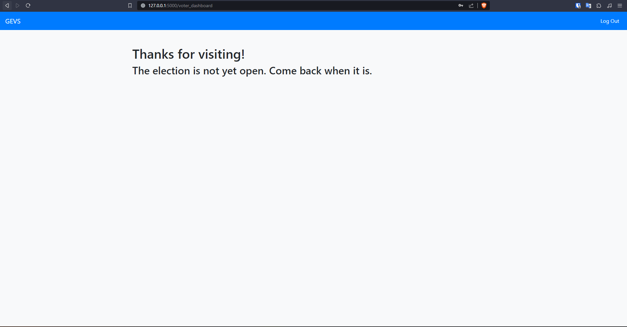

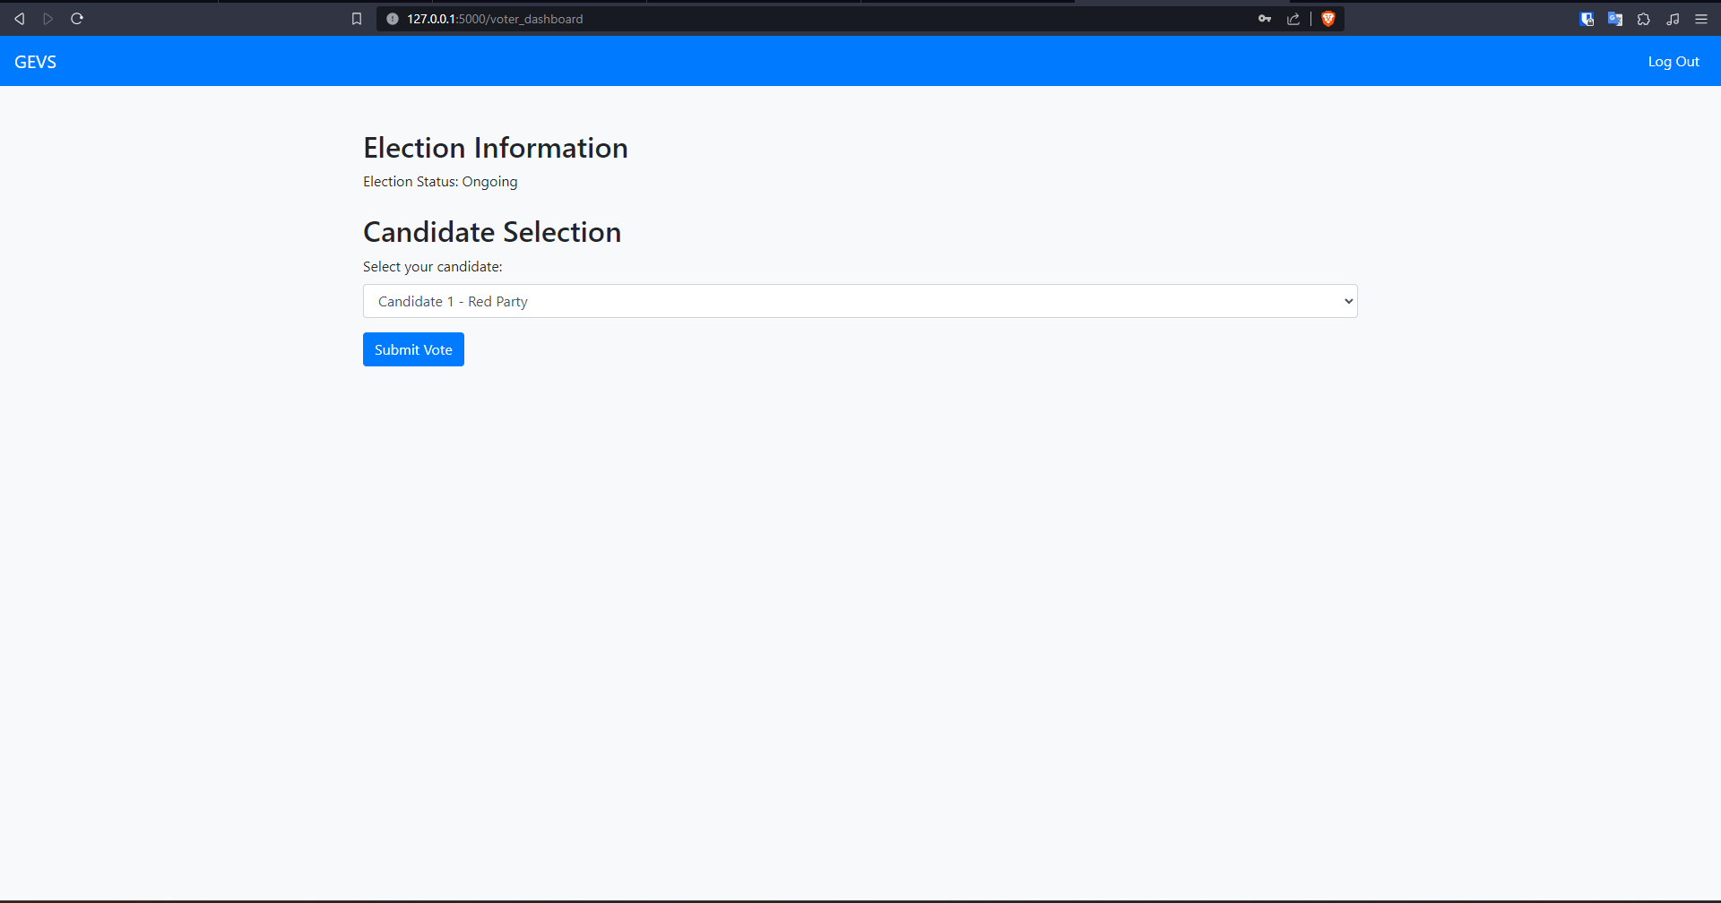

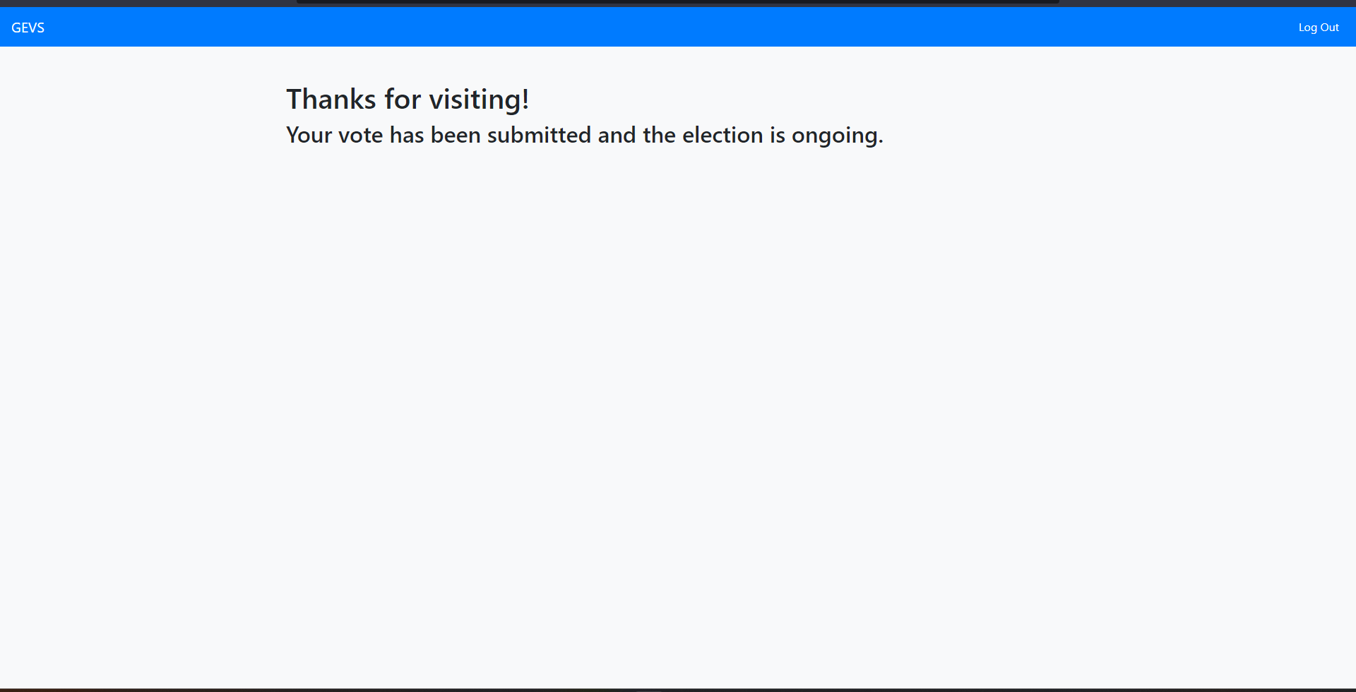

Election commission dashboard

