Game Design Document

Fill up the Following document

1. Write the title of your project.

RIO THE RUNNER

1. What is the goal of the game?

Rio needs to run from his enemy called dark man

1. Write a brief story of your game?

Rio was coming back home from a normal school day and then he meets his enemy called dark man and tries to escape from him

1. Which are the playing characters of this game?

* Playing characters are the ones which respond to the user based on the input from the user
* Cars, monkeys, dinos, wizards etc, are the playing characters in the game.

|  |  |  |
| --- | --- | --- |
| Number | Character Name | What can this character do? |
| 1 | Rio | He can jump above obstacles and run very fast |
| 2 |  |  |
| 3 |  |  |
| 4 |  |  |
| 5 |  |  |
| 6 |  |  |
| 7 |  |  |
| 8 |  |  |

1. Which are the Non Playing Characters of this game?

* Non Playing characters are the ones which don't have an action or a behaviour when the user interacts with the game.
* Hurdles, stones, bananas, coins, etc are non playing characters in the game.

|  |  |  |
| --- | --- | --- |
| Number | Character Name | What can this character do? |
| 1 | Dark man | Runs behind Rio to scare him |
| 2 |  |  |
| 3 |  |  |
| 4 |  |  |
| 5 |  |  |
| 6 |  |  |
| 7 |  |  |
| 8 |  |  |

Draw your imagination of this game. What does this game look like?

* Draw the game either on your computer or on paper,
* Add images of scenes of the game to show each of the playing and non-playing characters at least once.

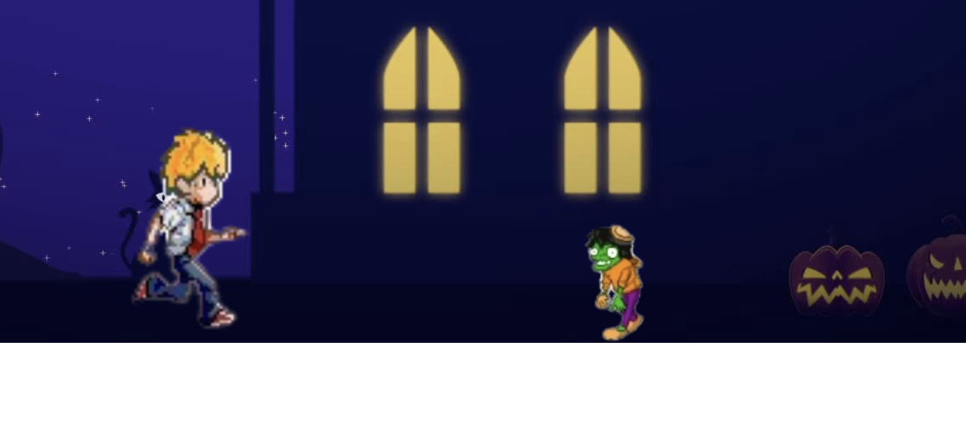

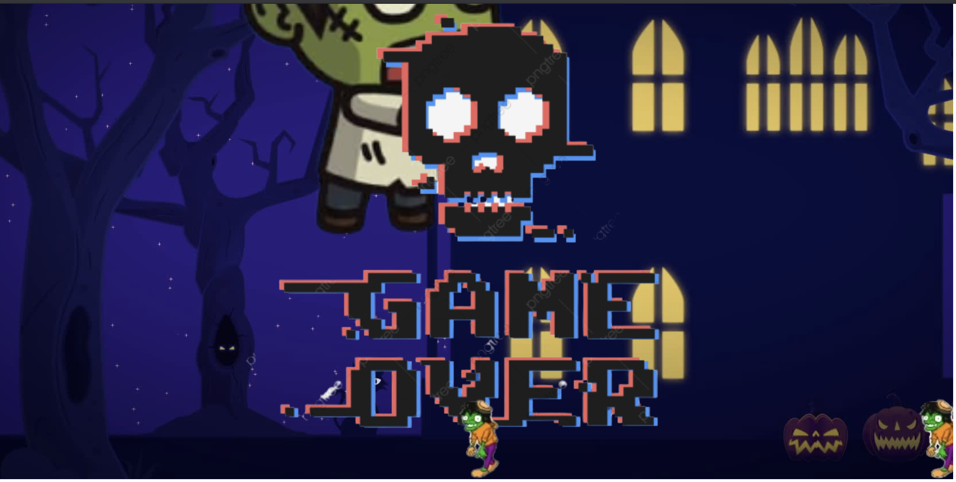

How do you plan to make your game engaging?

There will be a score board on which it will show your high score and the Dark man will be able to jump from any obstacle so it will be tough for the player to escape