MANIPAL UNIVERSITY JAIPUR
Department of Computer Science and Engineering

SOFTWARE TESTING REPORT
Library Management System
A Flask + SQLite REST API tested with pytest

Submitted by: Sarim Khan
Registration No.: 23F10CSE00486
B.Tech CSE, Semester VII, 2026-27
Course: Software Testing
Submitted to: Dr. Manmohan Sharma

Repository: github.com/sarimkhan-sketch/library-management-testing

1. Project Overview
Problem statement. Small libraries often track books and loans in registers or spreadsheets. This makes it easy to lend a copy that is not on the shelf, to forget who has a book, and to calculate late fines inconsistently.
Objectives. Build a small, well-tested back-end service that (1) lets members register and log in, (2) lets the librarian (admin) manage the catalogue, (3) enforces the lending rules automatically, and (4) is verified by an automated test suite that can be re-run after every change.
Proposed solution. A REST API written in Python with Flask, storing data in a single SQLite file. All business rules are implemented on the server, and 45 automated pytest test cases check them.

1.1 Technology stack
Layer | Technology | Use in the project
Language | Python 3.12 | All application and test code
Web framework | Flask 3 | Routing, JSON requests and responses, blueprints per module
Database | SQLite (Python sqlite3) | Tables users, tokens, books, loans; parameterised SQL
Security | Werkzeug password hashing, secrets.token_hex | Hashed passwords, random 64-character login tokens
Testing | pytest, Flask test client, pytest-cov | Unit, integration and system tests; coverage

1.2 Architecture and modules
The application follows a layered design. A request reaches a Flask blueprint, passes the access-control decorators (login_required, admin_required), is checked by the validators, and then reads or writes the SQLite database through db.py.
Module (file) | Responsibility | Endpoints
validators.py | Input rules: username, password, ISBN-13 checksum, copies, text fields | (used by all modules)
auth.py | Registration, login, logout, token check, admin check | POST /auth/register, /auth/login, /auth/logout
books.py | Catalogue: search (public); add, update, delete (admin) | GET/POST /books, GET/PUT/DELETE /books/<id>
loans.py | Borrow, return, due date (14 days), fine (Rs 5/day), limit of 3 books | POST /loans, POST /loans/<id>/return, GET /loans/me, GET /loans
db.py | SQLite connection, schema, admin account creation | -

1.3 User roles and main workflows
- Admin (librarian): adds, updates and deletes books; views all loans and the overdue list. The admin account is created at start-up; it cannot be obtained through registration.
- Member: registers, logs in, searches books, borrows up to 3 books, returns them and sees their own loan history.
- Guest (not logged in): can only search and view the catalogue.
Main workflow: member registers → logs in and receives a token → searches the catalogue → borrows a book (available copies decrease, due date = today + 14 days) → returns it (copies increase, fine = days late × Rs 5) → logs out (token is deleted).

2. Testing Strategy
All testing is automated with pytest. Each test gets a fresh temporary SQLite database, and the application's clock is replaced by a fixed date (1 September 2026) so that due dates and fines are predictable. The Flask test client sends real HTTP requests to the application without starting a server.
Technique | How it is applied in this project | Test cases
Unit testing | validators.py and calculate_fine() tested directly as functions | TC-01 to TC-09
Integration testing | Requests pass through auth, validation, business logic and database together | TC-28, TC-30, TC-32 to TC-42
System / end-to-end testing | One test walks the complete member journey across all modules | TC-43
Functional testing | Each endpoint checked against its specified behaviour | TC-10 to TC-42
Boundary value analysis | Username 2/3/20/21, password 5/6/64/65, copies 0/1/100/101, fine on due date, 3-book limit | TC-02, 04, 07, 09, 35, 37
Equivalence class partitioning | Valid and invalid classes for username, ISBN, copies, book_id | TC-01, 03, 05, 06, 08, 36
Negative testing | Missing fields, wrong passwords, unknown ids, bad JSON, wrong methods | TC-11, 17, 26, 36, 45
Security testing | Password hashing, token checks, role escalation, SQL injection | TC-14, 15, 18, 19, 44
Role-based access testing | Member blocked from admin actions; members cannot touch others' loans | TC-21, 39, 42
Regression testing | Full suite re-run after every fix (3 cycles) | All 45

3. Testing Responsibility Allocation
This is an individual project, so development and testing of every module were carried out by Sarim Khan. To keep the testing independent of the code, each test was written from the requirement first (scenario and expected result in the test docstring) and then run against the code.
Team member | Developed module | Testing responsibility
Sarim Khan | validators.py, fine calculation | Phase 1: unit tests, BVA and ECP
Sarim Khan | auth.py | Phase 2: authentication and security tests
Sarim Khan | books.py, db.py | Phase 3: catalogue, role and database tests
Sarim Khan | loans.py | Phase 4: lending rules and integration tests
Sarim Khan | Complete application | Phase 5: end-to-end, security and regression runs

4. Phase-wise Testing Plan
Phase | Module tested | Testing activity | Testing type | Tool | Expected outcome | Status (cycle 3)
1 | Validation & fine rules (validators.py, calculate_fine) | Check every input rule and the fine formula in isolation | Unit, BVA, ECP | pytest | All 9 test cases (TC-01 to TC-09) pass | PASS (9/9)
2 | Authentication (auth.py) | Register, log in, log out, token and role checks | Functional, Negative, Security | pytest + Flask test client | All 10 test cases (TC-10 to TC-19) pass | PASS (10/10)
3 | Book catalogue (books.py) | Admin add/update/delete, member access denied, search | Functional, Role-based access, Database | pytest + Flask test client + sqlite3 | All 12 test cases (TC-20 to TC-31) pass | PASS (12/12)
4 | Loans (loans.py) | Borrow and return, 3-book limit, stock, due dates, fines | Functional, BVA, Integration | pytest + Flask test client | All 11 test cases (TC-32 to TC-42) pass | PASS (11/11)
5 | Whole system | End-to-end member journey, SQL injection, error handling | System, Integration, Security | pytest + Flask test client | All 3 test cases (TC-43 to TC-45) pass | PASS (3/3)

5. Detailed Test Cases
45 test cases. Each one is an automated pytest function in the tests/ folder (for example TC-35 is test_tc35_borrow_limit in tests/test_phase4_loans.py). The scenario, steps, expected result and priority below are taken from the test's docstring; the actual result and status come from the pytest JUnit output of the three test cycles (C1, C2, C3).
Test ID | Module | Test scenario | Test steps | Expected result | Priority | Actual result | Status
TC-01 | Validation & fine rules | A username made of letters, digits and underscore is accepted (valid class) | 1. Call check_username("sarim_khan1") | No error is returned | High | Matches expected result | PASS
TC-02 | Validation & fine rules | Username length boundaries 2, 3, 20 and 21 characters (BVA) | 1. Check a 2-character name; 2. Check 3 characters; 3. Check 20; 4. Check 21 | 3 and 20 are accepted; 2 and 21 are rejected | High | Matches expected result | PASS
TC-03 | Validation & fine rules | Usernames with spaces, symbols, empty string or a non-string value (invalid classes) | 1. Check "sarim khan"; 2. Check "sarim@1"; 3. Check ""; 4. Check None | Every value is rejected with an error message | Medium | Matches expected result | PASS
TC-04 | Validation & fine rules | Password length boundaries 5, 6, 64 and 65 characters (BVA) | 1. Check 5 characters; 2. Check 6; 3. Check 64; 4. Check 65 | 6 and 64 are accepted; 5 and 65 are rejected | High | Matches expected result | PASS
TC-05 | Validation & fine rules | A correct ISBN-13 with a valid checksum is accepted | 1. Call check_isbn("9780306406157") | No error is returned | High | Matches expected result | PASS
TC-06 | Validation & fine rules | ISBNs with a wrong checksum, 12 or 14 digits, letters or a number type | 1. Check "9780306406158" (bad checksum); 2. Check 12 and 14 digits; 3. Check "97803064061X7"; 4. Check the integer 9780306406157 | Every value is rejected | High | Matches expected result | PASS
TC-07 | Validation & fine rules | Number of copies boundaries 0, 1, 100 and 101 (BVA) | 1. Check 0; 2. Check 1; 3. Check 100; 4. Check 101 | 1 and 100 are accepted; 0 and 101 are rejected | High | Matches expected result | PASS
TC-08 | Validation & fine rules | Copies given as text, decimal, boolean or negative number (invalid classes) | 1. Check "5"; 2. Check 2.5; 3. Check True; 4. Check -3 | Every value is rejected | Medium | Matches expected result | PASS
TC-09 | Validation & fine rules | Late fine of Rs 5 per day for early, on-time, 1-day-late and 10-days-late returns | 1. Due date 15-Sep-2026; 2. Return on 10-Sep, 15-Sep, 16-Sep and 25-Sep | Fines are 0, 0, 5 and 50 | High | Matches expected result | PASS
TC-10 | Authentication | New user registers with a valid username and password | 1. POST /auth/register {"username": "sarim", "password": "secret123"} | 201 Created; response role is "member" | High | Matches expected result | PASS
TC-11 | Authentication | Registration with empty body, missing password and missing username | 1. POST /auth/register {}; 2. POST with only username; 3. POST with only password | 400 Bad Request with an error message each time | High | Matches expected result | PASS
TC-12 | Authentication | Registering a username that already exists | 1. Register "sarim"; 2. Register "sarim" again | Second request returns 409 Conflict | High | Matches expected result | PASS
TC-13 | Authentication | Registering "Sarim" when "sarim" already exists | 1. Register "sarim"; 2. Register "Sarim" | 409 Conflict, usernames are unique regardless of letter case | Medium | C1 FAIL (DEF-02), C2 FAIL (DEF-02); C3 PASS after fix | PASS
TC-14 | Authentication | Password is not stored in plain text in the database | 1. Register "sarim" with "secret123"; 2. Read users table directly with sqlite3 | Stored value is a hash, not "secret123" | High | Matches expected result | PASS
TC-15 | Authentication | User tries to register as admin by sending "role": "admin" | 1. POST /auth/register with role "admin"; 2. Log in; 3. Check the role returned | Account is created as "member"; extra role field is ignored | High | Matches expected result | PASS
TC-16 | Authentication | Registered user logs in with correct credentials | 1. Register "sarim"; 2. POST /auth/login with the same credentials | 200 OK with a 64-character token and role "member" | High | Matches expected result | PASS
TC-17 | Authentication | Login with a wrong password, an unknown username and an empty body | 1. Register "sarim"; 2. Login with wrong password; 3. Login as "ghost"; 4. POST {} | 401 Unauthorized each time with the same generic message | High | Matches expected result | PASS
TC-18 | Authentication | Accessing /loans/me with no token, a malformed header and a made-up token | 1. GET /loans/me without header; 2. With "Authorization: Token abc"; 3. With "Bearer fake" | 401 Unauthorized each time | High | Matches expected result | PASS
TC-19 | Authentication | Token cannot be used after logout | 1. Log in as member; 2. POST /auth/logout; 3. GET /loans/me with the old token | Logout returns 200; later request returns 401 | High | Matches expected result | PASS
TC-20 | Book catalogue | Admin adds a new book with valid details | 1. Log in as admin; 2. POST /books with isbn, title, author, total_copies = 2 | 201 Created; available_copies equals total_copies (2) | High | C1 FAIL (DEF-01); C3 PASS after fix | PASS
TC-21 | Book catalogue | Member (non-admin) tries to add a book | 1. Log in as member; 2. POST /books | 403 Forbidden; book is not created | High | Matches expected result | PASS
TC-22 | Book catalogue | Admin adds a book with an ISBN whose checksum is wrong | 1. Log in as admin; 2. POST /books with isbn "9780306406158" | 400 Bad Request "isbn checksum is invalid" | Medium | Matches expected result | PASS
TC-23 | Book catalogue | Admin adds a book whose title is only spaces | 1. Log in as admin; 2. POST /books with title " " | 400 Bad Request | Medium | Matches expected result | PASS
TC-24 | Book catalogue | Admin adds two books with the same ISBN | 1. Add a book; 2. Add another book with the same ISBN | Second request returns 409 Conflict | Medium | C1 FAIL (blocked by DEF-01); C3 PASS after fix | PASS
TC-25 | Book catalogue | Public search matches part of the title or author, ignoring case | 1. Add "Software Testing" (Ron Patton) and "Clean Code" (Robert Martin); 2. GET /books?q=testing; 3. GET /books?q=MARTIN; 4. GET /books?q=zzz | Step 2 returns only Software Testing; step 3 only Clean Code; step 4 an empty list | High | C1 FAIL (blocked by DEF-01); C3 PASS after fix | PASS
TC-26 | Book catalogue | Requesting a book id that does not exist | 1. GET /books/999 | 404 Not Found with an error message | Low | Matches expected result | PASS
TC-27 | Book catalogue | Admin corrects the title of an existing book | 1. Add a book; 2. PUT /books/1 {"title": "Software Testing, 2nd Ed."}; 3. GET /books/1 | 200 OK; new title is saved, other fields unchanged | Medium | C1 FAIL (blocked by DEF-01); C3 PASS after fix | PASS
TC-28 | Book catalogue | Admin reduces total copies below the number currently borrowed | 1. Add a book with 2 copies; 2. Two members borrow it; 3. PUT /books/1 {"total_copies": 1} | 400 Bad Request; available_copies never becomes negative | High | C1 FAIL (blocked by DEF-01), C2 FAIL (DEF-04); C3 PASS after fix | PASS
TC-29 | Book catalogue | Admin updates total_copies with text and with 0 | 1. Add a book; 2. PUT /books/1 {"total_copies": "abc"}; 3. PUT /books/1 {"total_copies": 0} | 400 Bad Request both times (no server error) | Medium | C1 FAIL (blocked by DEF-01), C2 FAIL (DEF-05); C3 PASS after fix | PASS
TC-30 | Book catalogue | Admin tries to delete a book that a member has not returned | 1. Add a book; 2. Member borrows it; 3. DELETE /books/1; 4. Member checks /loans/me | 409 Conflict; book and the member's loan record still exist | High | C1 FAIL (blocked by DEF-01), C2 FAIL (DEF-06); C3 PASS after fix | PASS
TC-31 | Book catalogue | Admin deletes a book with no loans | 1. Add a book; 2. DELETE /books/1; 3. GET /books/1 | Delete returns 200; later GET returns 404 | Medium | C1 FAIL (blocked by DEF-01); C3 PASS after fix | PASS
TC-32 | Loans | Member borrows an available book | 1. Admin adds a book with 2 copies; 2. Member POST /loans {"book_id": 1}; 3. GET /books/1 | 201 Created; due date is 14 days after borrowing; available copies drop to 1 | High | C1 FAIL (blocked by DEF-01); C3 PASS after fix | PASS
TC-33 | Loans | Member borrows a book whose only copy is already on loan | 1. Add a book with 1 copy; 2. user1 borrows it; 3. user2 tries to borrow it | 409 Conflict "no copies available" | High | C1 FAIL (blocked by DEF-01); C3 PASS after fix | PASS
TC-34 | Loans | Member tries to borrow a second copy of a book they already hold | 1. Add a book with 2 copies; 2. Member borrows it; 3. Member borrows it again | 409 Conflict "you already have this book" | Medium | C1 FAIL (blocked by DEF-01); C3 PASS after fix | PASS
TC-35 | Loans | Borrowing limit of 3 active books (BVA on the limit) | 1. Add 4 books; 2. Member borrows books 1, 2 and 3; 3. Member borrows book 4 | First 3 succeed (201); 4th returns 409 "borrowing limit of 3 books reached" | High | C1 FAIL (blocked by DEF-01), C2 FAIL (DEF-03); C3 PASS after fix | PASS
TC-36 | Loans | Borrowing with a book id that does not exist or is not an integer | 1. POST /loans {"book_id": 999}; 2. POST /loans {"book_id": "1"}; 3. POST /loans {} | 404 Not Found for 999; 400 Bad Request for "1" and for the empty body | Medium | C1 FAIL (blocked by DEF-01); C3 PASS after fix | PASS
TC-37 | Loans | Member returns a book on the due date | 1. Borrow a book on 1-Sep-2026; 2. Move clock to 15-Sep-2026 (due date); 3. POST /loans/1/return | 200 OK; fine is 0; available copies go back to 2 | High | C1 FAIL (blocked by DEF-01); C3 PASS after fix | PASS
TC-38 | Loans | Member returns a book 3 days after the due date | 1. Borrow on 1-Sep-2026 (due 15-Sep); 2. Move clock to 18-Sep-2026; 3. POST /loans/1/return | 200 OK; fine is Rs 15 (3 days x Rs 5) | High | C1 FAIL (blocked by DEF-01); C3 PASS after fix | PASS
TC-39 | Loans | A member tries to return a loan that belongs to someone else | 1. user1 borrows a book; 2. user2 POST /loans/1/return | 403 Forbidden; loan stays open | High | C1 FAIL (blocked by DEF-01); C3 PASS after fix | PASS
TC-40 | Loans | Returning the same loan twice | 1. Borrow a book; 2. Return it; 3. Return it again | Second return gives 409 Conflict; available copies are not increased twice | Medium | C1 FAIL (blocked by DEF-01); C3 PASS after fix | PASS
TC-41 | Loans | GET /loans/me shows only the logged-in member's loans | 1. user1 borrows book 1; 2. user2 borrows book 2; 3. user1 GET /loans/me | Exactly one loan, for book 1 | Medium | C1 FAIL (blocked by DEF-01); C3 PASS after fix | PASS
TC-42 | Loans | Admin views overdue loans; member is refused | 1. Member borrows a book; 2. Move clock 20 days ahead; 3. Admin GET /loans?overdue=1; 4. Member GET /loans | Admin sees 1 overdue loan; member gets 403 Forbidden | Medium | C1 FAIL (blocked by DEF-01); C3 PASS after fix | PASS
TC-43 | Whole system | Full member journey across all modules | 1. Admin adds a book; 2. Member registers and logs in; 3. Searches "testing"; 4. Borrows the book; 5. Returns it 2 days late; 6. Checks loan history; 7. Logs out | Every step succeeds; fine is Rs 10; copies are restored; token is invalid after logout | High | C1 FAIL (blocked by DEF-01); C3 PASS after fix | PASS
TC-44 | Whole system | SQL injection text in the search box and in the login username | 1. Add a book; 2. GET /books?q=' OR '1'='1; 3. POST /auth/login with username "admin' --" | Search returns an empty list (no rows leaked, no error); login returns 401 | High | C1 FAIL (blocked by DEF-01); C3 PASS after fix | PASS
TC-45 | Whole system | Unknown URL, wrong HTTP method and a non-JSON body | 1. GET /nothing; 2. DELETE /auth/login; 3. POST /auth/register with plain text body | JSON errors with 404, 405 and 400 respectively (no HTML error page, no crash) | Low | Matches expected result | PASS

6. Testing Evidence
All evidence files are committed in the repository under reports/: junit.xml and console.txt for each cycle, and coverage.json for cycle 3. Every result in this report can be reproduced with python -m pytest.
Area | Evidence | Result
Requirements verification | Each rule (3-book limit, 14-day loan, Rs 5/day fine, unique ISBN, admin-only catalogue changes) has at least one test case | All rules covered; see Section 5
UI and navigation | Demo web page (library/static) checked in a real browser by scripts/ui_check.py (Playwright): 14/14 checks pass, see Section 6.1. API routing: unknown URL → 404 JSON, wrong method → 405 JSON (TC-45) | PASS
Authentication | TC-10 to TC-19: register, duplicate names, hashing, login, invalid tokens, logout | 10/10 PASS
Functional | TC-20 to TC-42: catalogue and loan operations | 23/23 PASS
Database | TC-14 reads the users table directly; TC-28, TC-30, TC-37, TC-40 check stored stock and loan rows | PASS
Integration | Phase 4 tests exercise auth + books + loans + database in one request chain | PASS
End-to-end | TC-43 runs the full member journey; demo.py shows the same flow for a live demonstration | PASS
Code coverage | pytest-cov, cycle 3: 270 of 274 statements executed | 98.5%

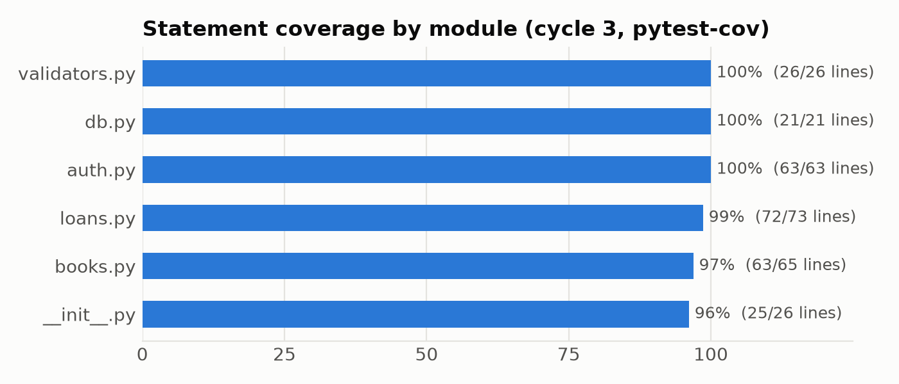
Figure 1: Statement coverage per module after cycle 3.

6.1 Web front end check
A demo web page (library/static: index.html, app.js, style.css) was added after the three test cycles. It only calls the JSON API, so every rule is still enforced and tested on the server. It is not part of the 45 test cases above; instead scripts/ui_check.py uses Playwright to drive Microsoft Edge or Chrome through the main flows on a fresh database. Its output is saved in reports/ui_check.txt.
Browser check | Result
Guest sees the 6 sample books | PASS
Guest sees no Borrow buttons | PASS
Search 'clean' shows only Clean Code | PASS
Wrong password shows 401 message | PASS
Seeded loan shows as overdue with Rs 30 fine | PASS
Borrowing reduces available copies | PASS
4th book refused: 409 borrowing limit | PASS
Late return charges Rs 30 | PASS
Logout returns to guest view | PASS
Admin panel visible to admin | PASS
Bad ISBN rejected: 400 checksum | PASS
Overdue filter: no overdue loans after return | PASS
HTML in a title is shown as text, not run (XSS) | PASS
No JavaScript errors on the page | PASS

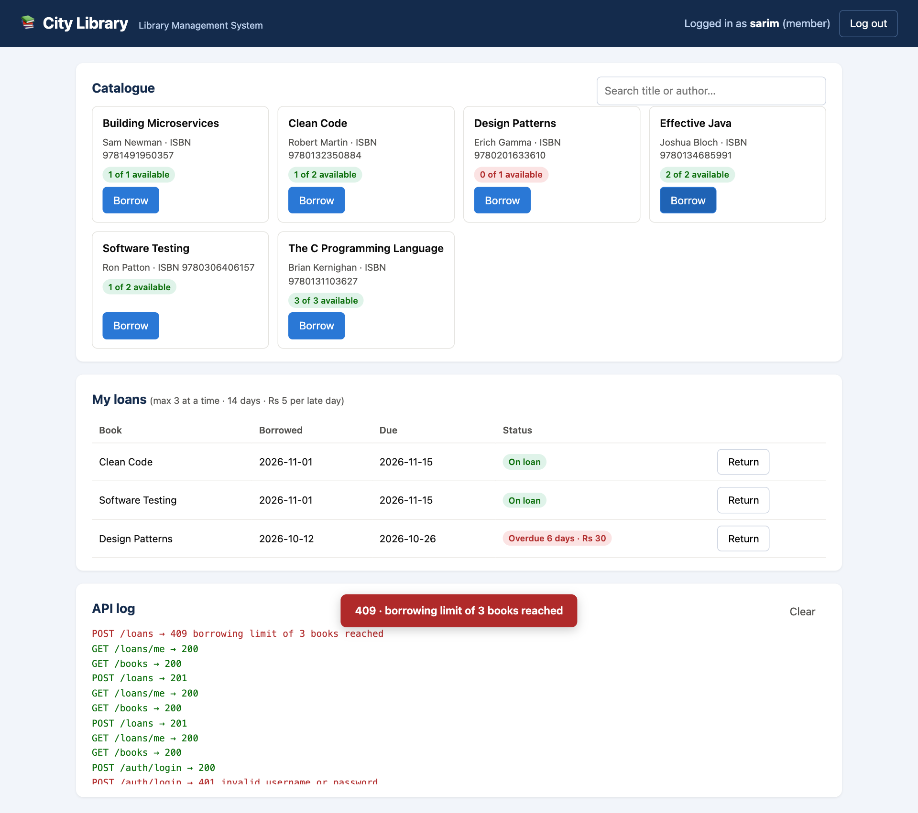
Figure 2: Member view during the browser check: the 4th borrow is refused (409) and the overdue fine is shown.
Automation. All 45 test cases are automated and run in about 7 seconds. The same suite can run on every push using GitHub Actions; a workflow file (.github/workflows/tests.yml) that runs it on Windows and Ubuntu is included in the repository. Possible additions: Postman/Newman collections for manual API checks, Locust for load testing, and Selenium only if a web front end is added later.

7. Test Execution Summary
Cycle | Code version | Purpose | Executed | Passed | Failed | Pass %
Cycle 1 | v1.0 (commit eb8772f) | First run of the suite on the initial code | 45 | 23 | 22 | 51.1%
Cycle 2 | v1.0 + DEF-01 fix (commit 2d7cd48) | Re-test after fixing the crash that blocked 21 tests | 45 | 40 | 5 | 88.9%
Cycle 3 | v1.1 (commit 72837f4) | Regression run after fixing DEF-02 to DEF-06 | 45 | 45 | 0 | 100.0%
Total |  |  | 135 | 108 | 27 | 80.0%

Measure | Value
Total test cases | 45
Total automated executions (3 cycles × 45) | 135
Passed executions | 108
Failed executions | 27
Overall pass percentage (all executions) | 80.0%
Pass percentage in final regression cycle | 100.0%

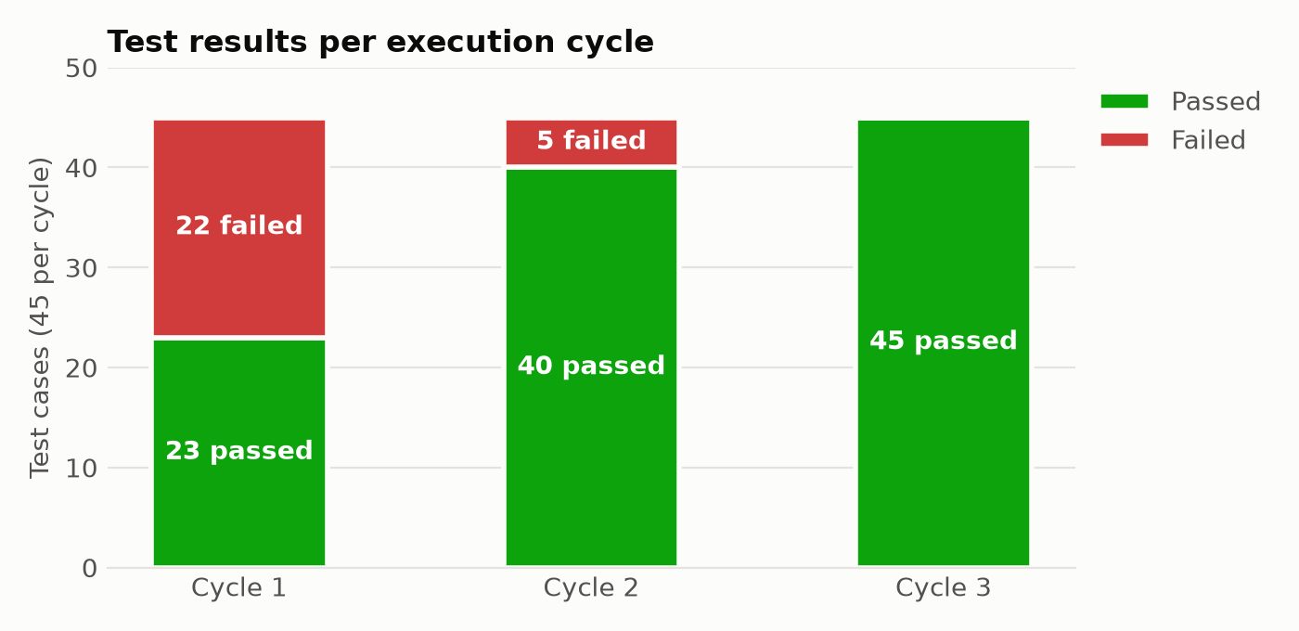
Figure 3: Passed and failed test cases in each cycle.
Cycle 1 had 22 failures, but 21 of them were caused by one crash (DEF-01): adding a book returned HTTP 500, so every test that needed a book failed at setup. Fixing that single line exposed five real logic defects in cycle 2. After fixing those, the full suite passed in cycle 3.

8. Defect Log
DEF-01 to DEF-06 were reproduced by failing automated tests (evidence in reports/cycle1 and reports/cycle2) and fixed in commits 2d7cd48 and 72837f4. DEF-07 to DEF-09 were found by reading the code; they are not caught by any failing test and remain open or deferred.
Defect ID | Severity | Description | Test case | Found in | Type | Status
DEF-01 | Critical | POST /books saved the book but returned HTTP 500 (TypeError: add_book indexed the Response object). Blocked every test that needs a book. | TC-20 | Cycle 1 | Reproduced | Fixed
DEF-02 | Medium | Usernames differing only in case ('sarim' / 'Sarim') could both be registered; UNIQUE column was case-sensitive. | TC-13 | Cycle 1 | Reproduced | Fixed
DEF-03 | High | Borrowing limit off by one: check used '> 3' so a member could hold 4 books. | TC-35 | Cycle 2 | Reproduced | Fixed
DEF-04 | High | Reducing total_copies below the number on loan was accepted and made available_copies negative. | TC-28 | Cycle 2 | Reproduced | Fixed
DEF-05 | Medium | PUT /books did not validate total_copies: text caused HTTP 500, 0 was accepted. | TC-29 | Cycle 2 | Reproduced | Fixed
DEF-06 | High | Deleting a book that was on loan was allowed and silently deleted the members' loan records. | TC-30 | Cycle 2 | Reproduced | Fixed
DEF-07 | Medium | Login tokens never expire; a token is only removed by logout (no expiry column in tokens table). | TC-19 | Code review | Static review | Deferred
DEF-08 | Medium | No limit on failed login attempts, so passwords can be guessed by brute force. | TC-17 | Code review | Static review | Open
DEF-09 | Low | Suspected race: the copies check and the decrement in borrow() are separate statements, so two simultaneous requests could both take the last copy. Not reproduced (tests run sequentially). | TC-33 | Code review | Static review | Open

9. Conclusion
The Library Management System API was tested with 45 automated test cases over five phases and three execution cycles (135 executions). Testing found six real defects, including one crash and two business-rule errors (the off-by-one borrowing limit and negative stock) that would have caused wrong behaviour for librarians and members. All six were fixed and confirmed by a full regression run in which all 45 test cases passed with 98.5% statement coverage.
The exercise showed the value of boundary value analysis (it found DEF-03 at exactly the limit of 3 books) and of re-running the whole suite after each fix: the cycle 1 crash hid five other defects that only appeared once it was fixed. Remaining work: add token expiry (DEF-07), limit repeated failed logins (DEF-08), make the borrow check and stock update a single atomic statement (DEF-09), and add a concurrency test for it.

