LAB 7 TASKS
  - Mohammad Sarim Raza | 25K-0075 | BA-2C
** ENLARGE TO VIEW CODE , wasn’t fitting so minimized it.

Q1

#include <iostream>
using namespace std;

class Account
{
public:
int accountNumber;
float balance;
string accountHolderName;
string accountType;

Account(int num, float bal, string name, string type)
{
accountNumber = num;
balance = bal;
accountHolderName = name;
accountType = type;
}

void deposit(float amount)
{
balance += amount;
cout << "Deposited: " << amount << endl;
}

void withdraw(float amount)
{
if (amount > balance)
{
cout << "Insufficient balance." << endl;
}
else
{
balance -= amount;
cout << "Withdrawn: " << amount << endl;
}
}

void calculateInterest()
{
cout << "No interest for base account." << endl;
}

void printStatement()
{
cout << "Account Number: " << accountNumber << endl;
cout << "Holder: " << accountHolderName << endl;
cout << "Type: " << accountType << endl;
cout << "Balance: " << balance << endl;
}

void getAccountInfo()
{
cout << "Account: " << accountNumber << " | Holder: " << accountHolderName << endl;
}
};

class SavingsAccount : public Account
{
public:
float interestRate;
float minimumBalance;

SavingsAccount(int num, float bal, string name, float rate, float minBal)
: Account(num, bal, name, "Savings")
{
interestRate = rate;
minimumBalance = minBal;
}

void calculateInterest()
{
float interest = balance * interestRate / 100;
cout << "Interest earned: " << interest << endl;
}

void withdraw(float amount)
{
if (balance - amount < minimumBalance)
{
cout << "Cannot withdraw. Minimum balance must be maintained." << endl;
}
else
{
balance -= amount;
cout << "Withdrawn: " << amount << endl;
}
}

void printStatement()
{
Account::printStatement();
cout << "Interest Rate: " << interestRate << "%" << endl;
cout << "Minimum Balance: " << minimumBalance << endl;
}
};

class CheckingAccount : public Account
{
public:
float overdraftLimit;

CheckingAccount(int num, float bal, string name, float limit)
: Account(num, bal, name, "Checking")
{
overdraftLimit = limit;
}

void withdraw(float amount)
{
if (amount > balance + overdraftLimit)
{
cout << "Overdraft limit exceeded." << endl;
}
else
{
balance -= amount;
cout << "Withdrawn: " << amount << endl;
}
}

void printStatement()
{
Account::printStatement();
cout << "Overdraft Limit: " << overdraftLimit << endl;
}
};

class FixedDepositAccount : public Account
{
public:
string maturityDate;
float fixedInterestRate;

FixedDepositAccount(int num, float bal, string name, string date, float rate)
: Account(num, bal, name, "Fixed Deposit")
{
maturityDate = date;
fixedInterestRate = rate;
}

void calculateInterest()
{
float interest = balance * fixedInterestRate / 100;
cout << "Fixed interest earned: " << interest << endl;
}

void withdraw(float amount)
{
cout << "Cannot withdraw from a Fixed Deposit account before maturity." << endl;
}

void printStatement()
{
Account::printStatement();
cout << "Maturity Date: " << maturityDate << endl;
cout << "Fixed Interest Rate: " << fixedInterestRate << "%" << endl;
}
};

int main()
{
SavingsAccount sa(1001, 5000, "Ali", 5.0, 1000);
sa.deposit(2000);
sa.withdraw(500);
sa.calculateInterest();
sa.printStatement();

cout << endl;

CheckingAccount ca(1002, 3000, "Sara", 500);
ca.withdraw(3400);
ca.printStatement();

cout << endl;

FixedDepositAccount fd(1003, 10000, "Ahmed", "2025-12-31", 8.5);
fd.withdraw(1000);
fd.calculateInterest();
fd.printStatement();

return 0;
}

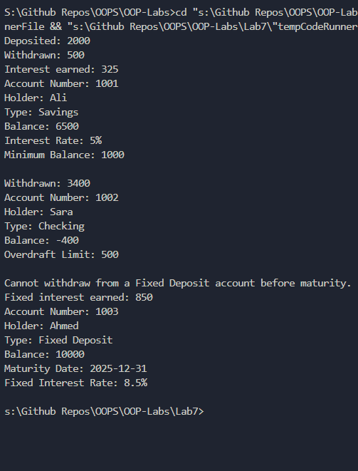

Q2

#include <iostream>
#include <cmath>
using namespace std;

class Shape
{
public:
string color;
float borderThickness;

Shape(string c, float bt)
{
color = c;
borderThickness = bt;
}

void draw()
{
cout << "Drawing a shape." << endl;
}

void calculateArea()
{
cout << "Area: N/A" << endl;
}

void calculatePerimeter()
{
cout << "Perimeter: N/A" << endl;
}
};

class Circle : public Shape
{
public:
float radius;
float centerX;
float centerY;

Circle(string c, float bt, float r, float cx, float cy) : Shape(c, bt)
{
radius = r;
centerX = cx;
centerY = cy;
}

void draw()
{
cout << "Drawing Circle at (" << centerX << ", " << centerY << ") with radius " << radius << endl;
}

void calculateArea()
{
float area = 3.14 * radius * radius;
cout << "Circle Area: " << area << endl;
}

void calculatePerimeter()
{
float perimeter = 2 * 3.14 * radius;
cout << "Circle Perimeter: " << perimeter << endl;
}
};

class Rectangle : public Shape
{
public:
float width;
float height;
float topLeftX;
float topLeftY;

Rectangle(string c, float bt, float w, float h, float x, float y) : Shape(c, bt)
{
width = w;
height = h;
topLeftX = x;
topLeftY = y;
}

void draw()
{
cout << "Drawing Rectangle at (" << topLeftX << ", " << topLeftY << ") width=" << width << " height=" << height << endl;
}

void calculateArea()
{
cout << "Rectangle Area: " << width * height << endl;
}

void calculatePerimeter()
{
cout << "Rectangle Perimeter: " << 2 * (width + height) << endl;
}
};

class Triangle : public Shape
{
public:
float side1;
float side2;
float side3;

Triangle(string c, float bt, float s1, float s2, float s3) : Shape(c, bt)
{
side1 = s1;
side2 = s2;
side3 = s3;
}

void draw()
{
cout << "Drawing Triangle with sides " << side1 << ", " << side2 << ", " << side3 << endl;
}

void calculateArea()
{
float s = (side1 + side2 + side3) / 2;
float area = sqrt(s * (s - side1) * (s - side2) * (s - side3));
cout << "Triangle Area: " << area << endl;
}

void calculatePerimeter()
{
cout << "Triangle Perimeter: " << side1 + side2 + side3 << endl;
}
};

class Polygon : public Shape
{
public:
int sides;
float sideLength;

Polygon(string c, float bt, int n, float sl) : Shape(c, bt)
{
sides = n;
sideLength = sl;
}

void draw()
{
cout << "Drawing Polygon with " << sides << " sides of length " << sideLength << endl;
}

void calculateArea()
{
float area = (sides * sideLength * sideLength) / (4 * tan(3.14159 / sides));
cout << "Polygon Area: " << area << endl;
}

void calculatePerimeter()
{
cout << "Polygon Perimeter: " << sides * sideLength << endl;
}
};

int main()
{
Circle c("Red", 1.5, 7.0, 0, 0);
c.draw();
c.calculateArea();
c.calculatePerimeter();

cout << endl;

Rectangle r("Blue", 2.0, 10, 5, 1, 1);
r.draw();
r.calculateArea();
r.calculatePerimeter();

cout << endl;

Triangle t("Green", 1.0, 3, 4, 5);
t.draw();
t.calculateArea();
t.calculatePerimeter();

cout << endl;

Polygon p("Yellow", 1.0, 6, 4);
p.draw();
p.calculateArea();
p.calculatePerimeter();

return 0;
}

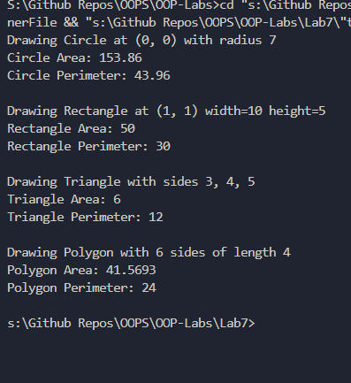

Q3

#include <iostream>
using namespace std;

class Currency
{
public:
float amount;
string currencyCode;
string currencySymbol;
float exchangeRate;

Currency(float amt, string code, string symbol, float rate)
{
amount = amt;
currencyCode = code;
currencySymbol = symbol;
exchangeRate = rate;
}

void convertToBase()
{
cout << "Base value: " << amount * exchangeRate << " USD" << endl;
}

void convertTo(Currency &target)
{
float baseValue = amount * exchangeRate;
float converted = baseValue / target.exchangeRate;
cout << amount << " " << currencyCode << " = " << converted << " " << target.currencyCode << endl;
}

void displayCurrency()
{
cout << currencySymbol << amount << " (" << currencyCode << ")" << endl;
}
};

class Dollar : public Currency
{
public:
Dollar(float amt) : Currency(amt, "USD", "$", 1.0)
{
}

void convertToBase()
{
cout << "Base value: " << amount << " USD (already base)" << endl;
}

void displayCurrency()
{
cout << "Dollar: $" << amount << endl;
}
};

class Euro : public Currency
{
public:
Euro(float amt) : Currency(amt, "EUR", "E", 1.08)
{
}

void convertToBase()
{
cout << "Base value: " << amount * exchangeRate << " USD" << endl;
}

void displayCurrency()
{
cout << "Euro: E" << amount << " (Rate: " << exchangeRate << ")" << endl;
}
};

class Rupee : public Currency
{
public:
Rupee(float amt) : Currency(amt, "PKR", "Rs", 0.0036)
{
}

void convertToBase()
{
cout << "Base value: " << amount * exchangeRate << " USD" << endl;
}

void displayCurrency()
{
cout << "Rupee: Rs" << amount << " (Rate: " << exchangeRate << ")" << endl;
}
};

int main()
{
Dollar d(100);
d.displayCurrency();
d.convertToBase();

cout << endl;

Euro e(50);
e.displayCurrency();
e.convertToBase();

cout << endl;

Rupee r(10000);
r.displayCurrency();
r.convertToBase();

cout << endl;

e.convertTo(d);

return 0;
}

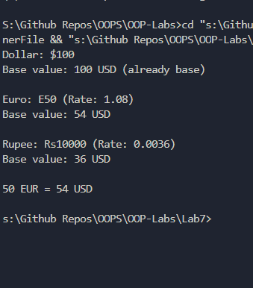

Q4

#include <iostream>
using namespace std;

class Person
{
public:
string name;
int id;
string address;
string phoneNumber;
string email;

Person(string n, int i, string addr, string phone, string mail)
{
name = n;
id = i;
address = addr;
phoneNumber = phone;
email = mail;
}

void displayInfo()
{
cout << "Name: " << name << endl;
cout << "ID: " << id << endl;
cout << "Address: " << address << endl;
cout << "Phone: " << phoneNumber << endl;
cout << "Email: " << email << endl;
}

void updateInfo(string addr, string phone)
{
address = addr;
phoneNumber = phone;
cout << "Info updated." << endl;
}
};

class Student : public Person
{
public:
string coursesEnrolled;
float GPA;
int enrollmentYear;

Student(string n, int i, string addr, string phone, string mail, string courses, float gpa, int year)
: Person(n, i, addr, phone, mail)
{
coursesEnrolled = courses;
GPA = gpa;
enrollmentYear = year;
}

void displayInfo()
{
Person::displayInfo();
cout << "Courses: " << coursesEnrolled << endl;
cout << "GPA: " << GPA << endl;
cout << "Enrollment Year: " << enrollmentYear << endl;
}
};

class Professor : public Person
{
public:
string department;
string coursesTaught;
float salary;

Professor(string n, int i, string addr, string phone, string mail, string dept, string courses, float sal)
: Person(n, i, addr, phone, mail)
{
department = dept;
coursesTaught = courses;
salary = sal;
}

void displayInfo()
{
Person::displayInfo();
cout << "Department: " << department << endl;
cout << "Courses Taught: " << coursesTaught << endl;
cout << "Salary: " << salary << endl;
}
};

class Staff : public Person
{
public:
string department;
string position;
float salary;

Staff(string n, int i, string addr, string phone, string mail, string dept, string pos, float sal)
: Person(n, i, addr, phone, mail)
{
department = dept;
position = pos;
salary = sal;
}

void displayInfo()
{
Person::displayInfo();
cout << "Department: " << department << endl;
cout << "Position: " << position << endl;
cout << "Salary: " << salary << endl;
}
};

class Course
{
public:
string courseId;
string courseName;
int credits;
string instructor;
string schedule;

Course(string id, string name, int cr, string inst, string sched)
{
courseId = id;
courseName = name;
credits = cr;
instructor = inst;
schedule = sched;
}

void registerStudent(Student &s)
{
cout << s.name << " registered in " << courseName << endl;
}

void calculateGrades()
{
cout << "Grades calculated for course: " << courseName << endl;
}

void displayInfo()
{
cout << "Course ID: " << courseId << endl;
cout << "Course Name: " << courseName << endl;
cout << "Credits: " << credits << endl;
cout << "Instructor: " << instructor << endl;
cout << "Schedule: " << schedule << endl;
}
};

int main()
{
Student s("Ali", 101, "Karachi", "03001234567", "ali@uni.edu", "OOP, DSA", 3.8, 2022);
cout << "--- Student ---" << endl;
s.displayInfo();

cout << endl;

Professor p("Dr. Khan", 201, "Islamabad", "03119876543", "khan@uni.edu", "CS", "OOP, Algorithms", 150000);
cout << "--- Professor ---" << endl;
p.displayInfo();

cout << endl;

Staff st("Bilal", 301, "Lahore", "03211112222", "bilal@uni.edu", "Admin", "Registrar", 60000);
cout << "--- Staff ---" << endl;
st.displayInfo();

cout << endl;

Course c("CS301", "Object Oriented Programming", 3, "Dr. Khan", "Mon/Wed 10am");
cout << "--- Course ---" << endl;
c.displayInfo();
c.registerStudent(s);
c.calculateGrades();

return 0;
}

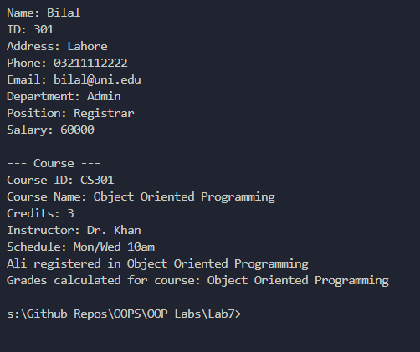

Q5
#include <iostream>
using namespace std;

class Media
{
public:
string title;
string publicationDate;
int uniqueID;
string publisher;
bool checkedOut;

Media(string t, string date, int id, string pub)
{
title = t;
publicationDate = date;
uniqueID = id;
publisher = pub;
checkedOut = false;
}

void displayInfo()
{
cout << "Title: " << title << endl;
cout << "Publication Date: " << publicationDate << endl;
cout << "ID: " << uniqueID << endl;
cout << "Publisher: " << publisher << endl;
}

void checkOut()
{
if (checkedOut)
{
cout << title << " is already checked out." << endl;
}
else
{
checkedOut = true;
cout << title << " checked out successfully." << endl;
}
}

void returnItem()
{
checkedOut = false;
cout << title << " returned." << endl;
}
};

class Book : public Media
{
public:
string author;
string ISBN;
int numberOfPages;

Book(string t, string date, int id, string pub, string auth, string isbn, int pages)
: Media(t, date, id, pub)
{
author = auth;
ISBN = isbn;
numberOfPages = pages;
}

void displayInfo()
{
Media::displayInfo();
cout << "Author: " << author << endl;
cout << "ISBN: " << ISBN << endl;
cout << "Pages: " << numberOfPages << endl;
}
};

class DVD : public Media
{
public:
string director;
int duration;
string rating;

DVD(string t, string date, int id, string pub, string dir, int dur, string rate)
: Media(t, date, id, pub)
{
director = dir;
duration = dur;
rating = rate;
}

void displayInfo()
{
Media::displayInfo();
cout << "Director: " << director << endl;
cout << "Duration: " << duration << " mins" << endl;
cout << "Rating: " << rating << endl;
}
};

class CD : public Media
{
public:
string artist;
int numberOfTracks;
string genre;

CD(string t, string date, int id, string pub, string art, int tracks, string gen)
: Media(t, date, id, pub)
{
artist = art;
numberOfTracks = tracks;
genre = gen;
}

void displayInfo()
{
Media::displayInfo();
cout << "Artist: " << artist << endl;
cout << "Tracks: " << numberOfTracks << endl;
cout << "Genre: " << genre << endl;
}
};

void search(Book arr[], int size, string title)
{
for (int i = 0; i < size; i++)
{
if (arr[i].title == title)
{
cout << "Found by title:" << endl;
arr[i].displayInfo();
return;
}
}
cout << "Not found by title." << endl;
}

void search(Book arr[], int size, string author, bool byAuthor)
{
for (int i = 0; i < size; i++)
{
if (arr[i].author == author)
{
cout << "Found by author:" << endl;
arr[i].displayInfo();
return;
}
}
cout << "Not found by author." << endl;
}

int main()
{
Book b1("The Alchemist", "1988", 1, "HarperCollins", "Paulo Coelho", "978-0062316097", 208);
Book b2("1984", "1949", 2, "Secker & Warburg", "George Orwell", "978-0451524935", 328);

cout << "--- Book 1 ---" << endl;
b1.displayInfo();
b1.checkOut();
b1.checkOut();
b1.returnItem();

cout << endl;

DVD d("Inception", "2010", 3, "Warner Bros", "Christopher Nolan", 148, "PG-13");
cout << "--- DVD ---" << endl;
d.displayInfo();

cout << endl;

CD c("Thriller", "1982", 4, "Epic Records", "Michael Jackson", 9, "Pop");
cout << "--- CD ---" << endl;
c.displayInfo();

cout << endl;

Book books[2] = {b1, b2};
cout << "--- Search by Title ---" << endl;
search(books, 2, "1984");
cout << endl;
cout << "--- Search by Author ---" << endl;
search(books, 2, "Paulo Coelho", true);

return 0;
}

