**NAME:SARINA AMJAD**

**REG NO:SP22-BSE-095**

**MODULE NAME:REVIEWS AND FEEDBACK:**

**USECASE DIAGRAM:**

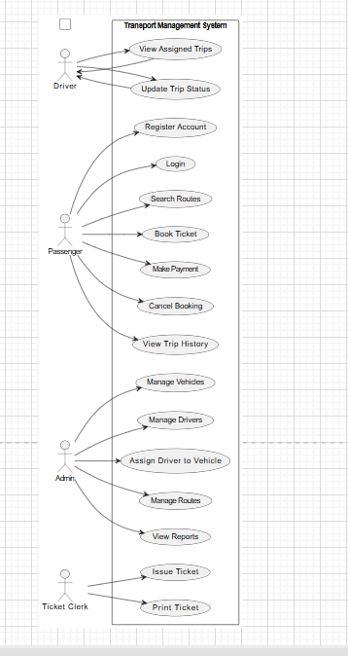

**FULLY DRESSED USECASE:**

|  |  |  |  |  |  |  |  |  |  |  |  |  |  |  |  |  |  |  |  |  |  |  |  |  |  |  |  |  |  |  |  |  |  |  |
| --- | --- | --- | --- | --- | --- | --- | --- | --- | --- | --- | --- | --- | --- | --- | --- | --- | --- | --- | --- | --- | --- | --- | --- | --- | --- | --- | --- | --- | --- | --- | --- | --- | --- | --- |
| |  |  |  |  |  |  |  |  | | --- | --- | --- | --- | --- | --- | --- | --- | | |  |  |  |  |  |  | | --- | --- | --- | --- | --- | --- | | |  |  |  |  |  | | --- | --- | --- | --- | --- | |  |  |  |  |  | |   **Use Case Element** | **Description** | | **Use Case Name** | Submit Reviews and Feedback | | **Scope** | Transport Management System | | **Level** | User Goal | | **Primary Actor** | Registered User (Passenger/Driver/Admin) | | **Stakeholders and Interests** | - User wants to share experience to help improve service. - Admin wants to monitor feedback to enhance service quality. | | **Preconditions** | - User is logged in to the system. - Feedback GUI form is accessible. | | **Postconditions** | - Feedback (Name, Gmail, Rating, Review) is stored in the database. - Confirmation is shown to user. | | **Main Success Scenario** | 1. User selects the “Feedback” option from GUI. 2. System displays feedback form. 3. User enters Name, Gmail, Review, and selects Rating (1–5). 4. User clicks “Submit”. 5. System validates fields. 6. System stores data in database. 7. System shows success message. | | **Extensions** | - If any field is empty → Error message. - If Gmail is invalid → Show error. - If DB fails → Show technical error. | | **Special Requirements** | - Rating via dropdown/stars. - Gmail must be validated. - Review max 500 characters. - Input must be sanitized. | | **Frequency of Use** | Frequently after transport service used. | | **Business Rules** | - One feedback per user per trip. - Admin can view only. - Gmail must be valid and unique. | | **Assumptions** | - User is authenticated. - Database is working. | |

**1.CLASS DIAGRAM:**

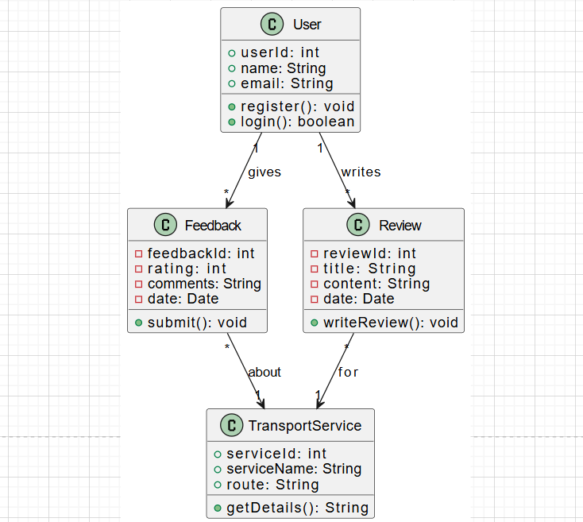

**STATE DIAGRAM:**

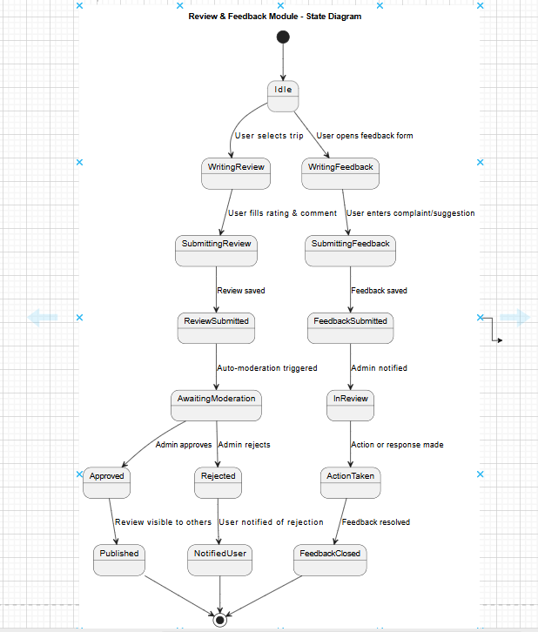

**SYSTEM SEQUENCE DIAGRAM:**

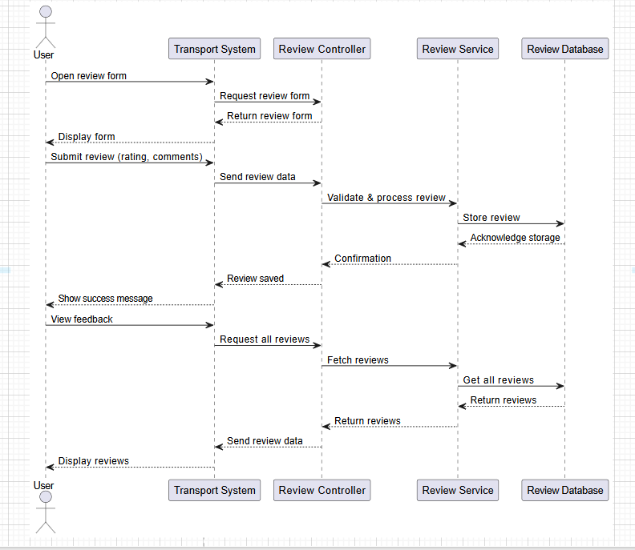

**PACKAGE DIAGRAM:**

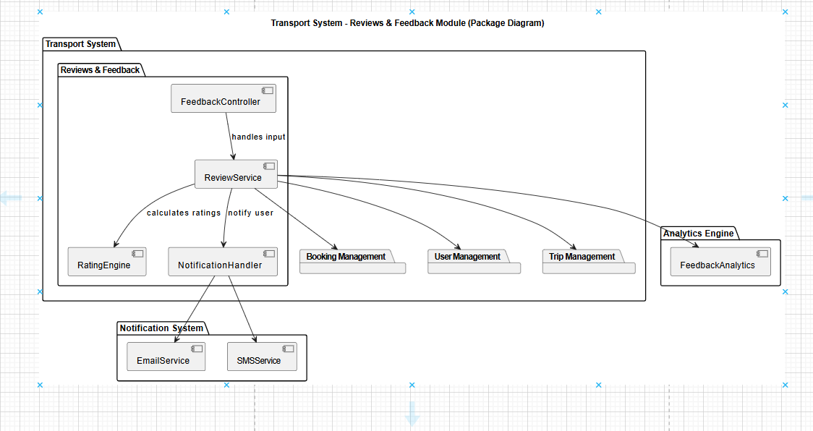

**COMMUNICATION DIAGRAM:**

