

Database II

**Group-17**

Group Members

Pemba Sherpa **18413646**

Milan Tiwari **18406514**

Ramesh Kunwar **18413696**

Damodar Bhattarai **18408446**

**1) Introduction**:

Basically, the assessment was based on group work. The group was divided into four members and the task was related to the festivals. As we were provided with the schema and by choosing the different tables from the schema we created a new schema for the assessment. The main aim was to use object types, tables, procedures, triggers, functions, cursors and packages.

Everyone in the group have contributed equally to complete the assessment in given time.

1. **Old Schema**

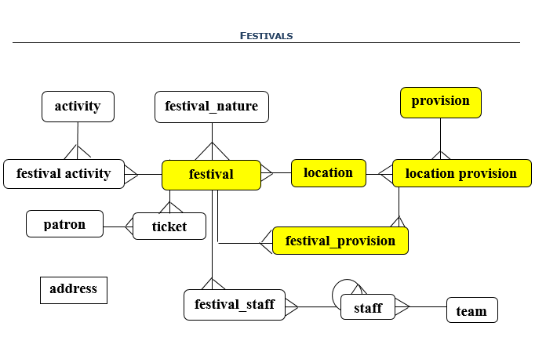

**3) Selected Tables**

festivals

locations

provisions

location_provisions

festival_provisions

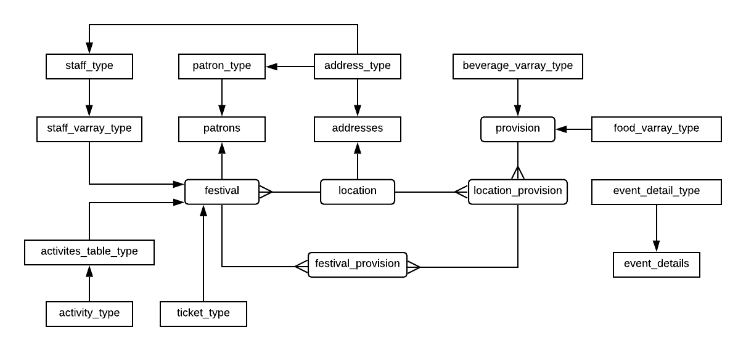

**4) New Schema**

**5) Table Specifications**

|  |  |  |  |  |  |
| --- | --- | --- | --- | --- | --- |
| Tables | attribute | Data type | | Constraints | Defaults |
| addresses | address_type: | | | | |
|  | city | VARCHAR2(30) | |  |  |
|  | street | VARCHAR2(30) | |  |  |
|  | country | VARCHAR2(30) | |  |  |
|  |  | | | | |
| PATRONS | patron_type: | | | | |
|  | patron_reg_number | NUMBER(15) | |  |  |
|  | patron_name | VARCHAR2(30) | |  |  |
|  | patron_address | ADDRESS_TYPE | |  |  |
|  | patron_contact | VARCHAR2(15) | | *UNIQUE* |  |
|  | patron_email | VARCHAR2(30) | | *UNIQUE* |  |
|  | | | | | |
|  | | | | | |
| EVENT_DETAILS | event_detail_type: | | | | |
|  | username | VARCHAR2(30) | |  |  |
|  | event_type | VARCHAR2(30) | |  |  |
|  | login_date | DATE | |  |  |
|  | login_time | VARCHAR2(20) | |  |  |
|  | logout_date | DATE | |  |  |
|  | logout_time | VARCHAR2(20) | |  |  |
|  |  |  | |  |  |
| STAFF_VARRAY_TYPE | staff_type: | | | | |
|  | firstname | VARCHAR2(30) | |  |  |
|  | surname | VARCHAR2(30) | |  |  |
|  | role | VARCHAR2(30) | |  |  |
|  | salary | NUMBER(8,2) | |  |  |
|  | email | VARCHAR2(30) | |  |  |
|  | contact | VARCHAR2(15) | |  |  |
|  | address | address_type | |  |  |
|  |  | |  |  |  |
| TICKET_VARRAY_TYPE | ticket_type: | | | | |
|  | ticket_price | | NUMBER(6,2) |  |  |
|  | ticket_class | | VARCHAR2(30) |  |  |
|  | ticket_validity | | NUMBER(6) |  |  |
|  |  | |  |  |  |
| ACTIVITIES_TABLE_TYPE | activity_type |  | |  |  |
|  | games | VARCHAR2(30) | |  |  |
|  | entertainment | VARCHAR2(30) | |  |  |

|  |  |  |  |  |  |  |
| --- | --- | --- | --- | --- | --- | --- |
| ­ | attribute | Data type | Constraints | | Default | Sequence |
| FESVITALS | festival_id | NUMBER(6) | pk_festivals | |  | seq_festivals |
|  | festival_name | VARCHAR2(30) | NOT NULL, UPPER | |  |  |
|  | festival_nature | VARCHAR2(30) | NOT NULL, UPPER | |  |  |
|  | staff | staff_varray_type |  | |  |  |
|  | activities | activity_table_type |  | |  |  |
|  | patrons | ref of patron_type |  | |  |  |
|  | ticket_details | ticket_varray_type |  | |  |  |
|  | *location_id | NUMBER(6) | *fk_f_locations NOT NULL* | |  |  |
|  |  |  |  | |  |  |
| LOCATIONS | location_id | NUMBER(6) | pk_locations | |  | seq_locations |
|  | address | address_type |  | |  |  |
|  | venue | VARCHAR2(30) | UPPER | | ‘GROUND’ |  |
|  | venue_detail | CLOB |  | |  |  |
|  | image | BLOB |  | |  |  |
|  |  |  |  | |  |  |
| PROVISIONS | provision_id | NUMBER(6) | pk_provisions | |  | seq_provision |
|  | foods | food_varray_type |  | |  |  |
|  | beverages | beverage_varray_type |  | |  |  |
|  |  |  |  | |  |  |
| LOCATION_PROVISIONS | *location_id | NUMBER(6) | *pk_location_provisions* | *fk_lp_locations NOT NULL* |  |  |
|  | *provision_id | NUMBER(6) |  | *fk_lp_provisions NOT NULL* |  |  |
|  |  |  |  |  |  |  |
| FESTIVAL_PROVISIONS | *festival_id | NUMBER(6) | *pk_festival_provisions* | *fk_fp_festivals NOT NULL* |  |  |
|  | *location_id | NUMBER(6) | *fk_fp_location_provisions NOT NULL* |  |  |
|  | *provision_id | NUMBER(6) |  |  |

**6) User Types**

address_type

ticket_type

ticket_varray_type

staff_type

staff_varray_type

patron_type

food_varray_type

event_detail_type

beverage_varray_type

activity_type

activity_table_type

**7) Object Types**

address_type

patron_type

staff_type

activity_type

ticket_type

**8) Object Tables**

addresses

patrons

event_details

**9) Varray type**

staff_varray_type

beverage_varray_type

food_varray_type

ticket_varray_type

**10) Nested Table**

activity_table_type

**11) Relational Tables**

festivals

locations

provisions

location_provisions

festival_provisions

**12) Primary keys**

pk_festivals

pk_locations

pk_provisions

pk_location_provisions

pk_festival_provisions

**13) Foreign keys**

fk_f_locations

fk_lp_locations

fk_lp_provisions

fk_fp_festivals

fk_fp_locations_provisions

**14) Sequences**

seq_festivals

seq_locations

seq_provisions

**15) Check Constraints**

ck_l_venue

ck_f_festival_nature

ck_f_festival_name

**16) Unique**

uk_p_contact

uk_p_email

**17) Procedures**

proc_imp_cursor

proc_exp_cursor

proc_staff_email_cursor

proc_ticket_discount

proc_calculate_yearly_wage

proc_insert_patrons

proc_insert_locations

proc_insert_addresses

proc_username

proc_return_id

proc_test_calculate_salary

**18) Functions**

func_username

func_return_id

func_calculate_total_salary

**19) Triggers**

trig_email_patrons

trig_patrons_reg_number

trig_db_logout

trig_db_login

trig_contact

trig_patrons

**20) Cursors and packages**

proc_staff_email_cursor

prc_exp_cursor

proc_imp_cursor

pkg_add_provisions