**Table of Contents**

1 Design 3

1.1 ERD 3

1.2 Chosen ERD 3

1.3 Schema 4

1.4 Table Specification 5

1.4.1 Address_type 5

1.4.2 Contact_type 5

1.4.3 Activity_type 5

1.4.4 Festival_nature 6

1.4.5 Location 6

1.4.6 Festival 6

1.4.7 Staff 6

1.4.8 Festival_staff 7

# Design

## ERD

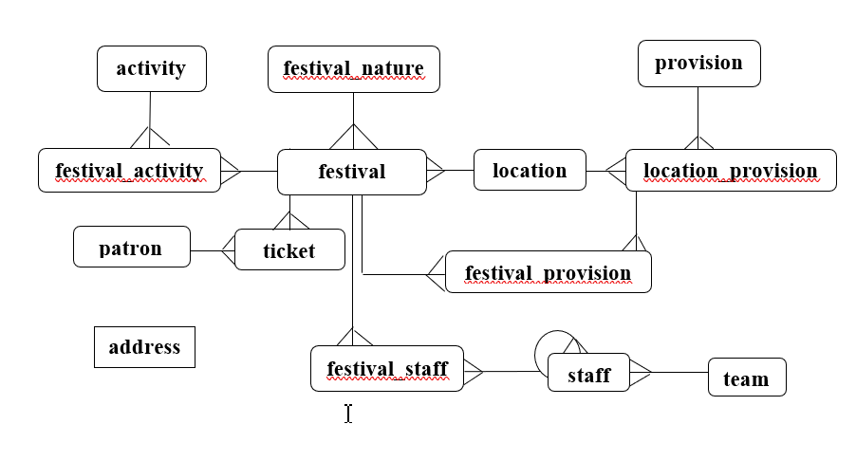

Fig 1.1: Given ERD

## Chosen ERD

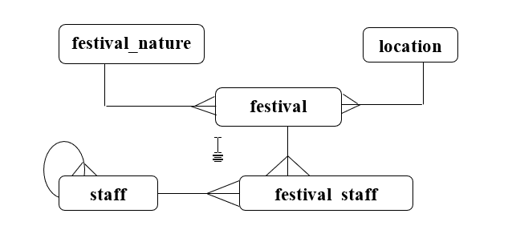

Fig 1.2: Chosen ERD

## Schema

Fig 1.3: Schema

## Table Specification

### Address_type

Table 1.1:Address_type

|  |  |  |  |  |
| --- | --- | --- | --- | --- |
| **ATTRIBUTES** | **DATATYPE** | **CONSTRAINT** | **DEFAULT** | **SEQUENCE** |
| street | VARCHAR2(25) |  |  |  |
| city | VARCHAR2(25) |  |  |  |
| country | VARCHAR2(25) |  |  |  |

### Contact_type

Table 1.2: Contact_type

|  |  |  |  |  |
| --- | --- | --- | --- | --- |
| **ATTRIBUTES** | **DATATYPE** | **CONSTRAINT** | **DEFAULT** | **SEQUENCE** |
| medium | VARCHAR2(25) |  |  |  |
| contact_number | VARCHAR2(25) | UNIQUE |  |  |

### Activity_type

Table 1.3: Activity_type

|  |  |  |  |  |
| --- | --- | --- | --- | --- |
| **ATTRIBUTES** | **DATATYPE** | **CONSTRAINT** | **DEFAULT** | **SEQUENCE** |
| activity_name | VARCHAR2(25) |  |  |  |
| type | VARCHAR2(25) |  |  |  |

### Festival_nature

Table 1.4: Festival_natures table

|  |  |  |  |  |
| --- | --- | --- | --- | --- |
| **ATTRIBUTES** | **DATATYPE** | **CONSTRAINT** | **DEFAULT** | **SEQUENCE** |
| festival_id | NUMBER (7) | pk_festival_natures |  | seq_festival_natures |
| nature_name | VARCHAR2(25) | NOT NULL |  |  |

### Location

Table 1.5: Locations table

|  |  |  |  |  |
| --- | --- | --- | --- | --- |
| **ATTRIBUTES** | **DATATYPE** | **CONSTRAINT** | **DEFAULT** | **SEQUENCE** |
| location _no | NUMBER (7) | pk_locations |  | seq_locations |
| address | REF address_type |  |  |  |

### 

### Festival

Table 1.6: Festivals table

|  |  |  |  |  |
| --- | --- | --- | --- | --- |
| **ATTRIBUTES** | **DATATYPE** | **CONSTRAINT** | **DEFAULT** | **SEQUENCE** |
| location _no | NUMBER (7) | fk_f_locations, pk_festivals,  NOT NULL |  |  |
| festival_id | VARCHAR2(50) | fk_f_festival_natures  pk_festivals,  NOT NULL |  |  |
| festival_name | VARCHAR2(50) | UPPER, NOT NULL |  |  |
| acivities | activity_varray_type |  |  |  |
| venue | VARCHAR2(50) |  |  |  |
| festival_start_date | DATE |  |  |  |
| festival_end_date | DATE |  |  |  |

### Staff

Table 1.7: Staff table

|  |  |  |  |  |
| --- | --- | --- | --- | --- |
| **ATTRIBUTES** | **DATATYPE** | **CONSTRAINT** | **DEFAULT** | **SEQUENCE** |
| staff_id | NUMBER (7) | pk_staff |  | seq_staff |
| reports_to | NUMBER (7) | fk_s_staff |  |  |
| firstname | VARCHAR2(20) | UPPER |  |  |
| lastname | VARCHAR2(20) | UPPER |  |  |
| address | address_type |  |  |  |
| contact | contact_table_type | NOT NULL |  |  |
| staff_gender | CHAR (1) | CHECK IN(‘M’,’F’,’O’) | M |  |
| email | VARCHAR2(35) | UNIQUE |  |  |
| staff_employed_date | DATE |  | SYSDATE |  |
| username | VARCHAR2 |  |  |  |
| password | VARCHAR2 |  |  |  |
| salary | NUMBER (10,2) |  |  |  |
| dob | DATE |  |  |  |

### Festival_staff

Table 1.8: Festival_staff table

|  |  |  |  |  |
| --- | --- | --- | --- | --- |
| **ATTRIBUTES** | **DATATYPE** | **CONSTRAINT** | **DEFAULT** | **SEQUENCE** |
| staff_id | NUMBER (7) | fk_fs_staff,  pk_festival_staff |  |  |
| location _no, | NUMBER (7) | fk_fs_festivals,  pk_festival_staff |  |  |
| festival_id | NUMBER (7) | fk_fs_festivals,  pk_festival_staff |  |  |