MusicMind
AI Music Discovery & Playlist Management Agent
EECS3311 Software Design (Fall 2026)
Stage 1 — Project Design Report
Author: Sarina [full name] Student ID: [ ]
GitHub repository: [public repo URL]

Contents

Task 1 — Define Your Agent Project

1.1 Project Description

Problem
Music listeners accumulate large libraries and long listening histories, yet turning a high-level intent — "a 90-minute study playlist, no explicit songs, mostly familiar but with some new artists" — into a concrete, well-ordered playlist is still slow and manual. Spotify's built-in suggestions are opaque, are not constraint-aware (they do not enforce a target duration, an explicit-content rule, or a personal blocklist), and do not remember a listener's standing preferences or the recommendations they have already rejected. MusicMind closes that gap: it interprets the goal, reasons over constraints, builds the playlist on the user's behalf, and explains its choices.

Target Users
Individual Spotify listeners — in particular students and knowledge workers who want goal-driven playlists (study, focus, workout, wind-down) and controlled music discovery, and who value transparency into why each track was chosen.

What the Agent Can Do
- Interpret a natural-language music goal and its constraints.
- Build a higher-level profile of the user's taste from their listening data, and describe how it is changing.
- Plan and execute a multi-step sequence of retrievals and actions.
- Run its own deterministic recommender to balance familiar and novel tracks.
- Validate a playlist against machine-checkable constraints and create or edit a real Spotify playlist.
- Remember preferences and feedback, explain its selections, and negotiate infeasible constraints instead of silently violating them.

Why an AI Agent Is Appropriate
The task requires understanding under-specified natural language, decomposing a goal into steps, selecting and invoking external tools, reasoning over returned data, and recovering from ambiguity or failure — and then taking a real action on an external system. It cannot be answered by a single LLM call. Track selection, constraint checking and persistence are deterministic; only intent interpretation and explanation need the LLM. The agent therefore uses the LLM to plan and narrate, while deterministic components decide and act — exactly the separation the course asks for.

User Interfaces — GUI and CLI
MusicMind exposes all of its major functionality through two interfaces, satisfying both interface requirements of the assignment:
Graphical User Interface (GUI): The system provides a graphical user interface through which users can interact with the major functionality of the application — authenticating with Spotify, viewing their taste profile and trends, searching and discovering music, creating and modifying playlists, reviewing recommendations and explanations, managing preferences, and browsing history. The GUI is built as a set of views over a shared application core (see the MVC pattern in Section 2.1).
Command-Line Interface (CLI): The system also provides a command-line interface through which users can access the major functionality of the agent. Every major feature is reachable as a command (e.g. musicmind create, musicmind discover, musicmind modify), and the CLI invokes the same AppController and MusicAgentFacade as the GUI, so no business logic is duplicated. The full command-to-feature mapping is given at the end of Section 1.2.

AI / LLM Model
The system integrates one hosted chat LLM, reached only through an LLMProvider interface so the concrete model is configurable and replaceable. The reference implementation targets an OpenAI GPT-4-class or Anthropic Claude model; the design does not depend on any single vendor, and the exact model will be confirmed before implementation.

How the AI Model Interacts with the System
The LLM is invoked through LLMProvider by two components only: the Planner, which parses a request into a validated PlaylistSpec / AgentPlan, and the ExplanationService, which renders a grounded rationale from a recorded decision trace. The LLM never selects tracks directly and never receives bulk catalogue data — RecommendationEngine performs selection deterministically. Every LLM response passes through ResponseParser, which rejects any track that is not confirmed by a real Spotify result, guarding against hallucinated content.

Platform Constraints & Compliance (shaping the design)
Spotify's current Web API no longer exposes recommendations, audio features, related-artists or popularity to new developer-mode applications, so MusicMind builds discovery from the user's own listening data together with search and genre metadata rather than Spotify's algorithms. In line with Spotify's developer terms, the system does not train any model on Spotify data, does not durably cache Spotify content (it keeps only stored identifiers and its own derived data), attributes content to Spotify, authenticates user data with the Authorization Code with PKCE flow, and keeps the client secret and access tokens out of the public repository.

1.2 Feature Specification
MusicMind provides twelve meaningful, non-trivial features (F1–F12), described below against the required fields. All major functionality is reachable through both the GUI and the CLI, which share a single application core (see the CLI summary at the end of this section). Low-level Spotify data access is treated as infrastructure and is not counted among the twelve features.

F1 — Music Taste Profile
Description: Aggregates the user's top artists, top tracks and saved library into a higher-level representation of taste — a genre distribution, a ranked list of core artists, and a familiarity baseline used by discovery and planning.
GUI Interaction: A "Profile" tab shows the genre breakdown and top artists/tracks, with a "Refresh profile" button.
CLI Access: musicmind profile [--refresh]
Input: Authenticated Spotify user; optional listening time range.
Output: A ListeningProfile object (genre histogram, ranked artists/tracks) plus a short natural-language summary.
AI Involvement: Hybrid — deterministic aggregation of listening data; the LLM only writes the summary sentence.
Expected Workflow: AppController calls MusicAgentFacade.analyzeTaste(); ToolManager runs GetTopItems / GetSavedTracks through SpotifyTool → MusicService → SpotifyAdapter (GET /me/top, GET /me/tracks); a ProfileBuilder aggregates genres from artist metadata; LLMProvider summarizes; the ListeningProfile is persisted and displayed.
Error / Alternative Cases: New account with little history → show a partial profile with a notice; expired Spotify token → prompt re-authentication; HTTP 429 → retry with exponential backoff (RetryingMusicService).

F2 — Taste-Change Analysis
Description: Compares the user's short-, medium- and long-term top items to describe how their taste has shifted over time (newly prominent genres/artists, ones that have faded).
GUI Interaction: A "Trends" view shows genres and artists side-by-side across the three time ranges, with a short narrative.
CLI Access: musicmind trends
Input: Authenticated user; the three Spotify time ranges (short / medium / long term).
Output: A diff report (added / dropped artists and genres per range) plus a narrative summary.
AI Involvement: Hybrid — deterministic set differences over the three ranges; the LLM narrates the change.
Expected Workflow: ToolManager fetches GET /me/top/{type} for short_term, medium_term and long_term; a deterministic comparator computes set differences; LLMProvider renders the narrative; the result is displayed.
Error / Alternative Cases: Insufficient history in a range → mark the gap and compare only populated ranges; partial Spotify data → note incompleteness.

F3 — Natural-Language Music Search
Description: Translates a free-text request (e.g. "mellow alternative for studying") into a structured Spotify search and returns ranked results the user can add to a candidate set.
GUI Interaction: A search bar with a results list; each result has an "add to candidates" action.
CLI Access: musicmind search "<query>"
Input: A free-text query string.
Output: A ranked list of track / artist results.
AI Involvement: Hybrid — the LLM parses the query into a structured SearchQuery; search and ranking are deterministic.
Expected Workflow: LLMProvider.parse() produces a SearchQuery (genre / keyword / filters); ToolManager → SpotifyTool issues GET /search (limit ≤ 10, paginated via offset); ResponseParser validates results; a deterministic ranker orders them; results are shown.
Error / Alternative Cases: No results → suggest a relaxed query; malformed or low-confidence parse → fall back to a raw keyword search on the original text.

F4 — Personalized Discovery
Description: Produces novel recommendations that balance familiarity and novelty, exclude tracks the user already knows, and respect stored preferences and past feedback. This is the project's own recommender — it does not depend on Spotify's deprecated recommendation endpoint.
GUI Interaction: A "Discover" panel lists recommendations with per-item accept / reject controls.
CLI Access: musicmind discover [--novelty 0.3]
Input: The user's ListeningProfile, stored preferences and feedback; an optional novelty ratio.
Output: A scored list of Recommendation objects, each with a recorded reason.
AI Involvement: AI / Hybrid — deterministic candidate generation and scoring selected via a RecommendationStrategy; the LLM is optional, used only to phrase reasons.
Expected Workflow: MemoryManager loads preferences and feedback; RecommendationEngine, using the chosen RecommendationStrategy, builds candidates from top / saved / recently-played items, genre-adjacent searches, and artist albums → album tracks; it excludes the user's existing library, filters blocked artists, then scores familiarity vs. novelty and records reasons.
Error / Alternative Cases: Too few candidates for a niche taste → widen the genre set and/or lower the novelty target and inform the user; all candidates filtered by blocklist → report and ask to adjust.

F5 — AI Playlist Planning & Generation
Description: The flagship agent feature. Accepts a high-level goal with constraints and executes a multi-step plan — interpret, retrieve, select, validate, act — that creates a real Spotify playlist rather than returning text.
GUI Interaction: A "Create Playlist" dialog collects the goal text and constraint fields (target duration, explicit toggle, familiar-vs-new ratio, name); a progress indicator shows the current step; the finished playlist is displayed.
CLI Access: musicmind create "<goal>" [--minutes 90] [--no-explicit] [--familiar 0.7] [--name "..."]
Input: A natural-language goal plus structured constraints.
Output: A created Playlist (Spotify playlist ID and ordered track list) with an explanation.
AI Involvement: AI / Hybrid.
Expected Workflow: Planner.plan() uses LLMProvider to parse the goal into a validated PlaylistSpec / AgentPlan; MemoryManager loads preferences; ToolManager retrieves candidate pools; RecommendationEngine selects via the BalancedStrategy, applying a curated mood→genre mapping in place of audio features; PlaylistValidator checks duration, explicit content, duplicates and blocked artists, looping back to adjust within a bounded retry count; PlaylistManager runs a CreatePlaylistCommand and AddItemsCommand through MusicService (POST /me/playlists, POST /playlists/{id}/items); MemoryManager saves the session and history; ExplanationService produces the rationale.
Error / Alternative Cases: API outage or 429 → bounded retry with backoff, then inform; not enough eligible tracks to reach the target duration → shortfall notice and offer to relax; token expiry mid-run → re-authenticate and resume; contradictory constraints → delegate to F11 (negotiation).

F6 — Natural-Language Playlist Modification
Description: Interprets an edit request against an existing playlist and applies reversible, structural changes (remove explicit, shorten by N minutes, replace some tracks with new artists, reorder).
GUI Interaction: Opening a playlist exposes a "Modify" box for the instruction and an "Undo" button.
CLI Access: musicmind modify <playlistId> "<instruction>" / musicmind undo <playlistId>
Input: A target playlist and a natural-language instruction.
Output: The updated playlist and a summary of what changed; the last change is undo-able.
AI Involvement: AI / Hybrid.
Expected Workflow: LLMProvider parses the instruction into a sequence of PlaylistCommands (Add / Remove / Replace / Reorder); ResponseParser validates them; PlaylistManager.execute() applies them through MusicService (PUT/POST/DELETE /playlists/{id}/items); each command is pushed to a history stack to support undo(); the playlist is re-validated.
Error / Alternative Cases: A mood-style edit with no reliable signal (e.g. "calmer") → apply the genre heuristic and flag the result as approximate; invalid playlist or missing permission → error; ambiguous instruction → apply a conservative interpretation or ask.

F7 — Playlist Constraint Validation
Description: The deterministic safety core: checks a candidate or final playlist against machine-checkable constraints and reports every violation. Used internally by F5 and F6 and exposed directly to the user.
GUI Interaction: Validation badges and warnings appear in the result view (e.g. "2 explicit tracks", "over target by 6 min").
CLI Access: musicmind validate <playlistId>
Input: A track list plus the PlaylistSpec (constraints).
Output: A ValidationResult: pass/fail per rule with the offending items listed.
AI Involvement: Deterministic.
Expected Workflow: PlaylistValidator runs an ordered rule set — explicit content (track.explicit), duplicates (by track ID), target duration (sum of duration_ms within tolerance), blocked artists/tracks, and minimum/maximum length.
Error / Alternative Cases: No LLM involvement; violations are returned to the caller, which drives the F5/F6 adjustment loop.

F8 — Preference Memory
Description: Stores standing, application-specific preferences that the Spotify account itself does not represent: disliked artists, preferred styles, explicit-content policy, and a default familiar-vs-exploratory leaning.
GUI Interaction: A "Preferences" settings screen to edit each preference.
CLI Access: musicmind prefs get | set | list
Input: Preference edits from the user.
Output: Persisted UserPreference records.
AI Involvement: Deterministic.
Expected Workflow: AppController → MemoryManager → PreferenceRepository performs CRUD against PostgreSQL; preferences are read by F4, F5 and F6.
Error / Alternative Cases: Database unavailable → operate with safe defaults and warn; input validation on preference values.

F9 — Recommendation Feedback
Description: Captures accept / reject signals on recommendations and tracks, and feeds them into future scoring so the recommender adapts to the user over time.
GUI Interaction: Thumbs-up / thumbs-down controls on recommendations and on playlist tracks.
CLI Access: musicmind feedback <trackId> accept | reject
Input: An item identifier and a verdict.
Output: A stored Feedback record and adjusted future scores.
AI Involvement: Deterministic.
Expected Workflow: MemoryManager → FeedbackRepository persists the verdict; RecommendationEngine reads feedback to penalize previously rejected items and boost accepted ones during scoring.
Error / Alternative Cases: Repeated feedback on the same item → upsert rather than duplicate; database error handling.

F10 — Grounded Recommendation Explanation
Description: Explains why particular tracks and artists were chosen, strictly from the decision trace recorded during selection — never from invented facts.
GUI Interaction: A "Why these?" expander on each playlist and recommendation.
CLI Access: musicmind explain <playlistId>
Input: The recorded decision trace / selection reasons for a session.
Output: A natural-language explanation citing actual reasons (strategy used, matched genre, familiarity bucket, constraint satisfied).
AI Involvement: AI.
Expected Workflow: ExplanationService gathers the recorded reasons; PromptBuilder constructs a constrained prompt containing only those facts; LLMProvider renders the text; ResponseParser checks that the output references only real, recorded facts.
Error / Alternative Cases: Missing trace → produce a generic explanation and note the limitation; the component never fabricates specific track-level claims.

F11 — Infeasible-Constraint Negotiation
Description: Detects conflicting or unsatisfiable constraints and proposes concrete relaxations instead of silently violating them — e.g. "100% familiar" combined with "30% new", or a 90-minute target when only 40 minutes of eligible tracks exist.
GUI Interaction: When a conflict is detected, a dialog states the conflict and offers options (lower the familiar ratio, allow explicit tracks, shorten the duration).
CLI Access: An interactive prompt presented during create / modify.
Input: A PlaylistSpec plus the availability of eligible candidates.
Output: A conflict report with proposed relaxations; the agent proceeds according to the user's choice.
AI Involvement: AI / Hybrid — deterministic feasibility check; the LLM phrases the options.
Expected Workflow: During planning, a ConstraintChecker evaluates feasibility against the candidate pool; on conflict, Planner surfaces options; once the user chooses, the plan is regenerated with the adjusted spec.
Error / Alternative Cases: User cancels → abort cleanly without partial changes; no viable relaxation exists → explain and stop.

F12 — Agent History & Snapshot/Restore
Description: Records past requests, plans, generated playlists and important interactions, and supports restoring a previous playlist state — effectively undo across sessions.
GUI Interaction: A "History" list; opening a past session shows its plan and result; a "Restore" action reverts a playlist to a saved snapshot.
CLI Access: musicmind history / musicmind restore <snapshotId>
Input: The authenticated user; an optional session or snapshot identifier.
Output: History records, and on restore, the reverted playlist state.
AI Involvement: Deterministic / Hybrid.
Expected Workflow: MemoryManager persists AgentSession, AgentRequest, AgentPlan and playlist snapshots through SessionRepository and PlaylistHistoryRepository; restore replays the stored snapshot via PlaylistManager commands.
Error / Alternative Cases: A snapshot that references a deleted Spotify playlist → offer to recreate it or warn; database error handling.

Command-Line Interface — Access to Major Functionality
The CLI exposes every major feature through the same AppController and MusicAgentFacade used by the GUI, so no business logic is duplicated between the two interfaces. The commands below map directly to the features above.
Command | Feature(s) reached
musicmind profile | F1 Music Taste Profile
musicmind trends | F2 Taste-Change Analysis
musicmind search | F3 Natural-Language Music Search
musicmind discover | F4 Personalized Discovery
musicmind create | F5 Playlist Planning & Generation (+ F11 negotiation)
musicmind modify / undo | F6 Playlist Modification
musicmind validate | F7 Constraint Validation
musicmind prefs | F8 Preference Memory
musicmind feedback | F9 Recommendation Feedback
musicmind explain | F10 Recommendation Explanation
musicmind history / restore | F12 Agent History & Snapshot/Restore
Authentication, help and exit (musicmind login, musicmind help, musicmind exit) are supporting commands and are not counted toward the feature requirement.

Task 2 — Design the System Using UML
This section presents the UML models of MusicMind. The class diagram defines the structure and the names used everywhere else; the use-case diagram shows how external actors interact with the system; and the sequence diagrams show how objects collaborate at runtime. All diagrams use the same class and method names and are consistent with the twelve features of Task 1.

2.1 Class Diagram
Because the system has both a traditional software layer and an AI/agent layer, the class diagram is presented in two consistent views. Figure 2.1a (Application & Agent Architecture) shows the interfaces, inheritance, design patterns and dependencies; Figure 2.1b (Domain Model) shows the entity classes with their associations, composition/aggregation and multiplicities. Together they form one coherent class model. Both diagrams appear on the following landscape pages, and full-resolution copies are kept in the project repository under /docs/diagrams.

UML Notation Key
The class diagrams use standard UML notation, summarised below; «interface» and «abstract» stereotypes mark interfaces and abstract classes, and member visibility is shown as + public, − private and # protected.
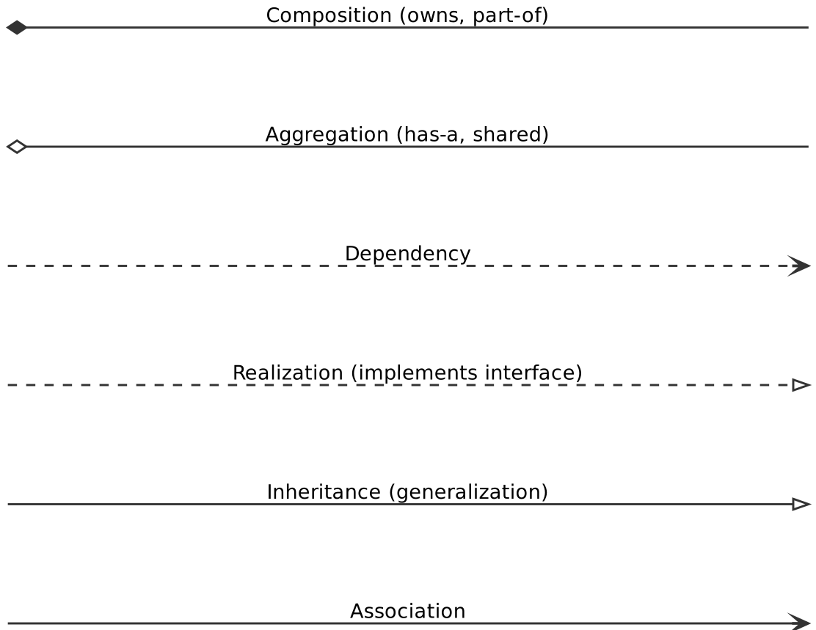
UML relationship notation used in Figures 2.1a and 2.1b.

Figure 2.1a — Application & Agent Architecture
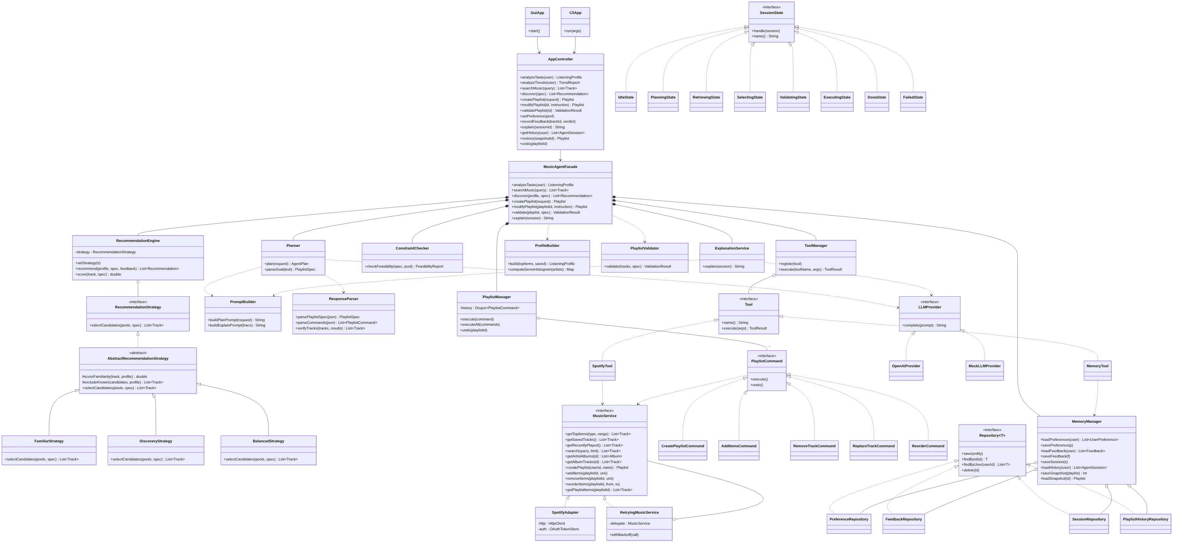
Boundary (GUI/CLI), controller, the MusicAgentFacade subsystem, and the Adapter, Strategy, Command, State and repository structures. «interface» stereotypes, inheritance (hollow triangle), composition (filled diamond), aggregation (hollow diamond) and dependency (dashed) are shown. A full-resolution copy is in the repository under /docs/diagrams.

Figure 2.1b — Domain Model
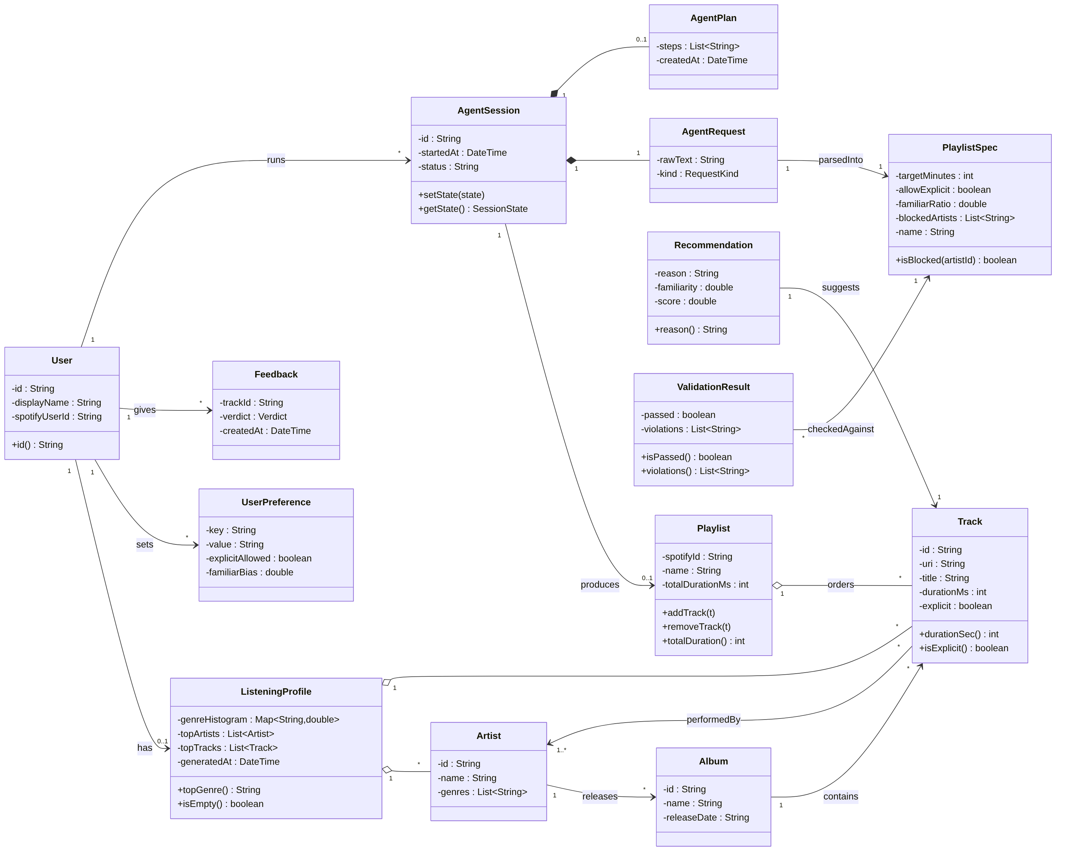
Entity classes with associations, composition/aggregation and meaningful multiplicities (e.g. User 1–0..1 ListeningProfile; Playlist 1–* Track; AgentSession 1–1 AgentRequest, 1–0..1 AgentPlan).

Design Patterns
MusicMind applies five design patterns covered in the course, each solving a concrete design problem rather than added to reach a count. For each pattern the design problem, participating classes and their roles, the rationale, and the consequence of omitting it are given. Two further patterns that the design also applies (MVC and Decorator) are noted at the end.

Pattern 1 — Adapter
Design problem: The agent needs music data and playlist actions, but Spotify's Web API speaks HTTP/JSON, requires OAuth, and changes often (endpoints were removed in Nov 2024 and Feb 2026). Coupling the application directly to those calls would scatter Spotify-specific details across the codebase and break widely on every API change.
Participating classes: MusicService (Target interface); SpotifyAdapter (Adapter); the Spotify Web API (Adaptee); all agent components (Clients).
Roles: MusicService declares stable internal operations (getTopItems, search, createPlaylist, addItems, …). SpotifyAdapter implements them by translating to HTTP calls and mapping JSON into domain objects (Track, Artist, Playlist). Every client depends only on MusicService.
Why appropriate: All Spotify-specific knowledge is confined to one class; the Feb-2026 rename (/playlists/{id}/tracks → /playlists/{id}/items) is absorbed in SpotifyAdapter alone, and the music source becomes mockable for testing.
Without it: Every component would contain HTTP/JSON code; a single API change would ripple across the system; swapping or mocking the music source would be impossible.

Pattern 2 — Strategy
Design problem: Discovery must select candidate tracks by different policies — stay close to familiar taste, maximise novelty, or balance the two — chosen at runtime from the user's request. Hard-coding this branching inside the recommender makes it rigid and hard to test.
Participating classes: RecommendationStrategy (Strategy interface); AbstractRecommendationStrategy (abstract base providing shared, protected helpers such as #scoreFamiliarity() and #excludeKnown()); FamiliarStrategy, DiscoveryStrategy, BalancedStrategy (Concrete Strategies); RecommendationEngine (Context).
Roles: RecommendationEngine holds a RecommendationStrategy and delegates selectCandidates() to it. AbstractRecommendationStrategy implements the interface and factors out the scoring/exclusion logic common to all policies; each concrete strategy extends it and overrides only its own selection policy.
Why appropriate: A new policy is a new class, not a new branch; each policy is unit-testable in isolation; the user's request selects the policy at runtime.
Without it: RecommendationEngine would grow into a large conditional, and adding a policy would mean editing and risking existing selection logic.

Pattern 3 — Command
Design problem: Playlist edits must be discrete, reversible operations that can be recorded for history and undone — both within a session and across sessions via snapshots. Calling MusicService mutators directly gives no uniform way to queue, log, or reverse them.
Participating classes: PlaylistCommand (Command interface, execute()/undo()); CreatePlaylistCommand, AddItemsCommand, RemoveTrackCommand, ReplaceTrackCommand, ReorderCommand (Concrete Commands); PlaylistManager (Invoker, holds the undo stack); MusicService (Receiver).
Roles: Each command encapsulates one operation together with how to reverse it; PlaylistManager executes commands and pushes them onto a history stack; the receiver performs the actual change on Spotify.
Why appropriate: A uniform execute/undo contract is exactly what F6 (undo) and F12 (snapshot/restore) need; commands can also be composed into a plan and logged for the agent history.
Without it: Undo and history would be ad-hoc; every edit path would re-implement its own reversal logic; snapshot/restore would be far harder to build.

Pattern 4 — State
Design problem: An agent session moves through a lifecycle — idle → planning → retrieving → selecting → validating → executing → done/failed — with different behaviour in each phase and well-defined transitions. Representing this with status flags and scattered conditionals is error-prone and hard to extend.
Participating classes: SessionState (State interface); IdleState, PlanningState, RetrievingState, SelectingState, ValidatingState, ExecutingState, DoneState, FailedState (Concrete States); AgentSession (Context).
Roles: AgentSession delegates handle() to its current SessionState; each state performs its phase and sets the next state; FailedState centralises error handling. The GUI reflects progress by reading the current state's name().
Why appropriate: It makes the agent's control flow explicit, diagrammable and testable; transitions live in one place per state; a new phase is a new class.
Without it: The agent loop would become a large switch on a status field, inviting invalid transitions and tangled error handling.

Pattern 5 — Facade
Design problem: The GUI and CLI must trigger complex, multi-component workflows (planning, tools, recommendation, validation, memory, explanation) without being coupled to all of those subsystems, and without each interface duplicating the orchestration.
Participating classes: MusicAgentFacade (Facade); Planner, ToolManager, RecommendationEngine, PlaylistManager, PlaylistValidator, ConstraintChecker, MemoryManager, ExplanationService (Subsystem); AppController (Client).
Roles: MusicAgentFacade exposes coarse operations (createPlaylist, modifyPlaylist, analyzeTaste, discover, explain) and internally coordinates the subsystem; AppController — shared by both the GUI and the CLI — calls only the facade.
Why appropriate: One orchestration point is reused by both interfaces, directly supporting the GUI+CLI requirement with no duplicated business logic; subsystem internals can change without affecting the boundary.
Without it: The GUI and CLI would each wire up the whole subsystem, duplicating and risking divergence in the core logic.

Additional patterns applied
MVC (structural): The GUI views (e.g. PlaylistView, ProfileView, DiscoveryView) are the View, AppController is the Controller, and the domain/entity classes are the Model. The GUI and CLI reuse the same controller and model and differ only in their boundary, which is what lets both interfaces expose the same functionality without duplicated logic.
Decorator: RetryingMusicService implements MusicService and wraps another MusicService to add exponential-backoff retry on HTTP 429/5xx responses, without modifying SpotifyAdapter — a genuine need given Spotify's tightened rate limits. A CachingMusicService decorator is a possible extension, bounded by Spotify's no-durable-cache terms.

2.2 Use-Case Diagram and Use-Case Descriptions
The use-case diagram (Figure 2.2, following page) shows the Listener (primary actor) together with two external actors — the Spotify Web API and the LLM Provider — and the thirteen use cases that collectively cover all twelve features. «include» relationships show that Create Playlist and Modify Playlist always validate the result, that Create Playlist may negotiate infeasible constraints, and that it draws on Discover Music.

Figure 2.2 — Use-Case Diagram
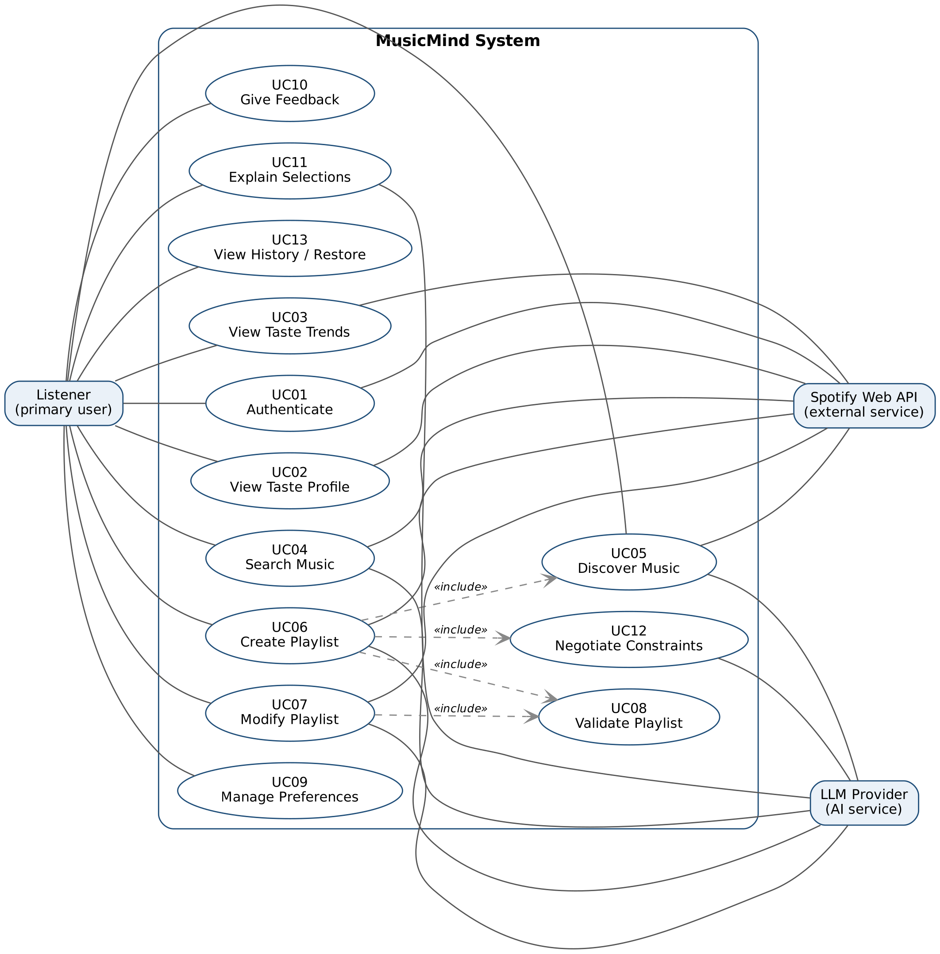
MusicMind use-case diagram. Actors: Listener (primary), Spotify Web API and LLM Provider (external/AI services). Associations connect actors to use cases; dashed «include» arrows show mandatory sub-use-cases.

Detailed Use-Case Descriptions
Detailed descriptions for the major use cases follow; the remaining use cases are summarised in the table after them.

UC06 — Create Playlist
Actors: Listener (primary); Spotify Web API and LLM Provider (supporting).
Goal: Produce a Spotify playlist that satisfies a natural-language goal and its constraints.
Preconditions: The Listener is authenticated with Spotify; the LLM Provider is reachable.
Trigger: The Listener submits a goal and constraints via the GUI "Create Playlist" dialog or the musicmind create command.
Main Success Scenario:
1. AppController calls MusicAgentFacade.createPlaylist(request).
2. Planner.plan() uses LLMProvider to parse the goal, and ResponseParser validates it into a PlaylistSpec / AgentPlan.
3. MemoryManager loads the Listener's preferences and feedback.
4. ToolManager retrieves candidate pools through SpotifyTool → MusicService.
5. ConstraintChecker confirms the request is feasible against the candidate pool.
6. RecommendationEngine selects tracks using the BalancedStrategy.
7. PlaylistValidator validates the selection against the PlaylistSpec.
8. PlaylistManager executes a CreatePlaylistCommand and AddItemsCommand through MusicService.
9. MemoryManager saves the session; the playlist and an explanation are returned and displayed.
Alternative / Exception Flows:
- 4a. Spotify returns HTTP 429 → RetryingMusicService backs off per Retry-After; persistent failure is reported to the Listener.
- 5a. Constraints are infeasible → the flow continues as UC12 Negotiate Constraints.
- 7a. Validation fails → bounded re-selection loop to fix duration / explicit / duplicate issues.
- 2a. Low-confidence parse → the system asks the Listener to clarify the goal.
- *a. Access token expired → re-authenticate (UC01) and resume.
Postconditions: A new playlist exists in the Listener's Spotify account; the session and history are stored.
Related Features: F5 (primary), F4, F7, F8, F10, F11.

UC07 — Modify Playlist
Actors: Listener (primary); Spotify Web API, LLM Provider (supporting).
Goal: Apply a natural-language edit to an existing playlist, reversibly.
Preconditions: The Listener is authenticated; the target playlist exists and is editable by the Listener.
Trigger: The Listener enters an instruction in the GUI or runs musicmind modify.
Main Success Scenario:
1. AppController calls MusicAgentFacade.modifyPlaylist(playlistId, instruction).
2. LLMProvider parses the instruction; ResponseParser produces a list of PlaylistCommands.
3. PlaylistManager.executeAll() applies the commands through MusicService, pushing each onto the undo stack.
4. PlaylistValidator re-validates the playlist; a change summary is returned and displayed.
Alternative / Exception Flows:
- 2a. Ambiguous instruction → a conservative interpretation is applied, or the Listener is asked.
- 2b. Mood-style edit with no reliable signal (e.g. "calmer") → the genre heuristic is applied and the result flagged as approximate.
- 3a. Invalid playlist or missing permission → error returned.
- *a. Undo requested → PlaylistManager.undo() reverses the last change.
Postconditions: The playlist is updated; the last change is undo-able.
Related Features: F6 (primary), F7, F12.

UC05 — Discover Music
Actors: Listener (primary); Spotify Web API (supporting); LLM Provider (optional, for phrasing reasons).
Goal: Obtain personalized recommendations that balance familiar and novel tracks and exclude tracks the Listener already knows.
Preconditions: The Listener is authenticated; a ListeningProfile is available or is built on demand.
Trigger: The Listener opens the Discover panel or runs musicmind discover.
Main Success Scenario:
1. AppController calls MusicAgentFacade.discover(profile, spec).
2. MemoryManager loads preferences and feedback.
3. RecommendationEngine sets the strategy and retrieves candidate pools via ToolManager → MusicService.
4. The strategy selects candidates; the engine excludes the existing library, filters blocked artists, and scores the results.
5. Recommendations with recorded reasons are returned and shown with accept/reject controls.
Alternative / Exception Flows:
- 3a. Too few candidates for a niche taste → widen the genre set and/or lower the novelty target, and inform the Listener.
- 4a. All candidates filtered by the blocklist → report and ask the Listener to adjust.
Postconditions: Recommendations are displayed; none are persisted unless the Listener acts on them (UC10).
Related Features: F4 (primary), F8, F9, F10.

UC02 — View Taste Profile
Actors: Listener (primary); Spotify Web API (supporting); LLM Provider (for the summary).
Goal: Present a higher-level view of the Listener's music taste.
Preconditions: The Listener is authenticated.
Trigger: The Listener opens the Profile tab or runs musicmind profile.
Main Success Scenario:
1. AppController calls MusicAgentFacade.analyzeTaste(user).
2. ToolManager retrieves top items and saved tracks via MusicService.
3. ProfileBuilder aggregates genres and ranks artists/tracks into a ListeningProfile.
4. LLMProvider produces a short summary; the profile is persisted and displayed.
Alternative / Exception Flows:
- 2a. Little listening history → a partial profile is built and the gap is flagged.
- 2b. HTTP 429 → RetryingMusicService backs off and retries.
Postconditions: A ListeningProfile is displayed and stored.
Related Features: F1 (primary), F2.

UC10 — Give Feedback
Actors: Listener (primary).
Goal: Record an accept/reject verdict so future recommendations adapt.
Preconditions: The Listener is authenticated; a recommendation or track is in view.
Trigger: The Listener clicks the thumbs-up/down control or runs musicmind feedback.
Main Success Scenario:
1. AppController calls recordFeedback(trackId, verdict).
2. MemoryManager persists the verdict through FeedbackRepository.
3. RecommendationEngine reads stored feedback during later scoring.
Alternative / Exception Flows:
- 2a. Repeated feedback on the same item → the record is upserted rather than duplicated.
- 2b. Database error → the Listener is warned; the operation is retried or deferred.
Postconditions: A Feedback record is stored and influences future scoring.
Related Features: F9 (primary), F4, F8.

UC12 — Negotiate Constraints
Actors: Listener (primary); LLM Provider (for phrasing the options).
Goal: Resolve conflicting or unsatisfiable constraints by proposing concrete relaxations instead of silently violating them.
Preconditions: A create or modify request is in progress and a constraint conflict has been detected.
Trigger: ConstraintChecker reports infeasibility during planning.
Main Success Scenario:
1. The system states the conflict and offers relaxation options (e.g. lower the familiar ratio, allow explicit tracks, shorten the duration).
2. The Listener chooses an option.
3. The plan is regenerated with the adjusted PlaylistSpec and the originating use case resumes.
Alternative / Exception Flows:
- 2a. The Listener cancels → the operation aborts cleanly with no changes.
- 1a. No viable relaxation exists → the system explains and stops.
Postconditions: Either an adjusted, feasible specification proceeds, or the operation is cancelled with no changes made.
Related Features: F11 (primary), F5.
Remaining use cases (summary)
ID | Name | Goal / Actors | Related
UC01 | Authenticate | Obtain OAuth access to Spotify (Listener, Spotify). Supporting use case. | All features
UC03 | View Taste Trends | Describe how taste changed across time ranges (Listener, Spotify, LLM). | F2
UC04 | Search Music | Turn a free-text query into a Spotify search and ranked results (Listener, Spotify, LLM). | F3
UC08 | Validate Playlist | Check a playlist against machine-checkable constraints (Listener). Included by UC06/UC07. | F7
UC09 | Manage Preferences | Create/update standing preferences and blocklists (Listener). | F8
UC11 | Explain Selections | Explain why tracks were chosen, from the recorded trace (Listener, LLM). | F10
UC13 | View History / Restore | Browse past sessions and restore a playlist snapshot (Listener). | F12

2.3 Sequence Diagrams
Four sequence diagrams cover the system's major behaviours. Per the assignment, closely related features that share an interaction structure are represented together: taste-trends (F2) mirrors the profile interaction (SD03); natural-language search (F3) is the retrieval step shown in SD01 and SD03; preference management (F8) and explanation (F10) are simple interactions visible at the edges of these diagrams; and restore (F12) reuses the Command mechanism of SD02. Each diagram uses the exact class and method names from the class diagram and shows the initiating actor, boundary, controller, agent components, external services, returned results, and important error/alternative flows.

SD01 — Create Playlist (UC06 / F5)
The flagship agent workflow: goal parsing via the LLM, preference loading, tool-based retrieval, feasibility checking, strategy-based selection, validation, and the state-changing playlist creation — including the 429-backoff, infeasible-constraint (UC12) and validation-retry alternative flows.
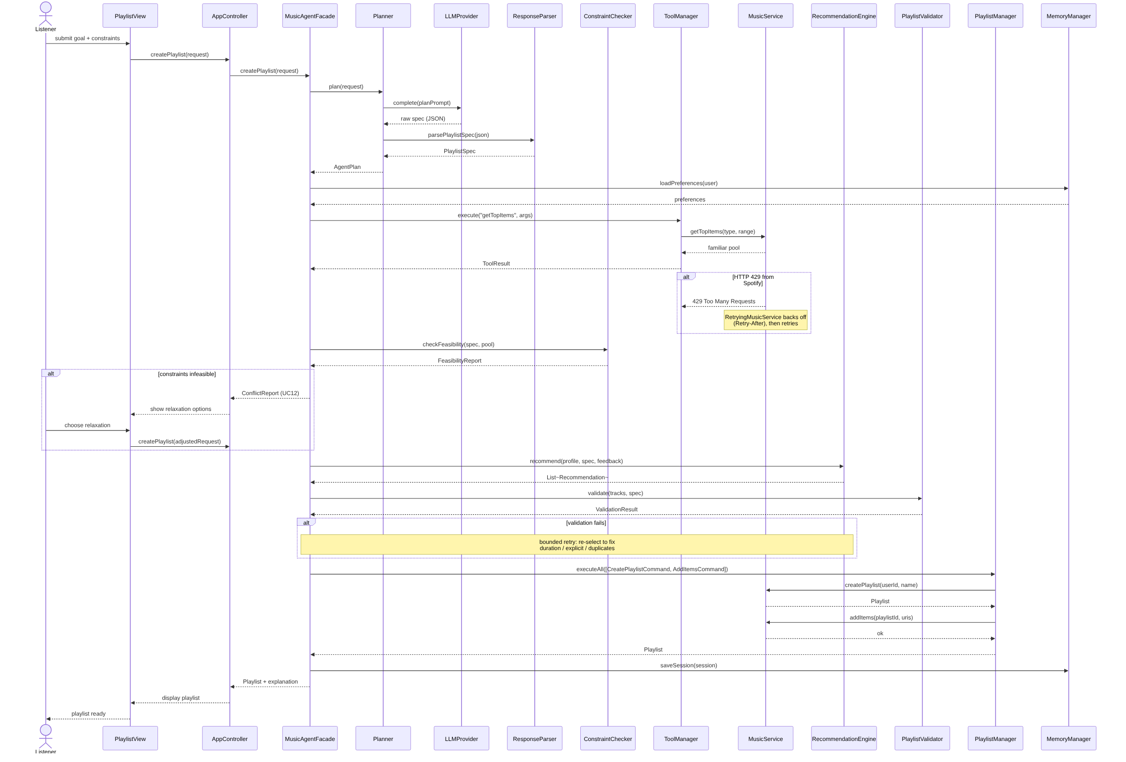
Figure 2.3-SD01 — Create Playlist.

SD02 — Modify Playlist with Undo (UC07 / F6)
Natural-language edits are parsed into PlaylistCommands and applied by the Invoker (PlaylistManager), which records each on the undo stack; the optional Undo fragment reverses the last change via the same Command mechanism that F12 restore reuses.
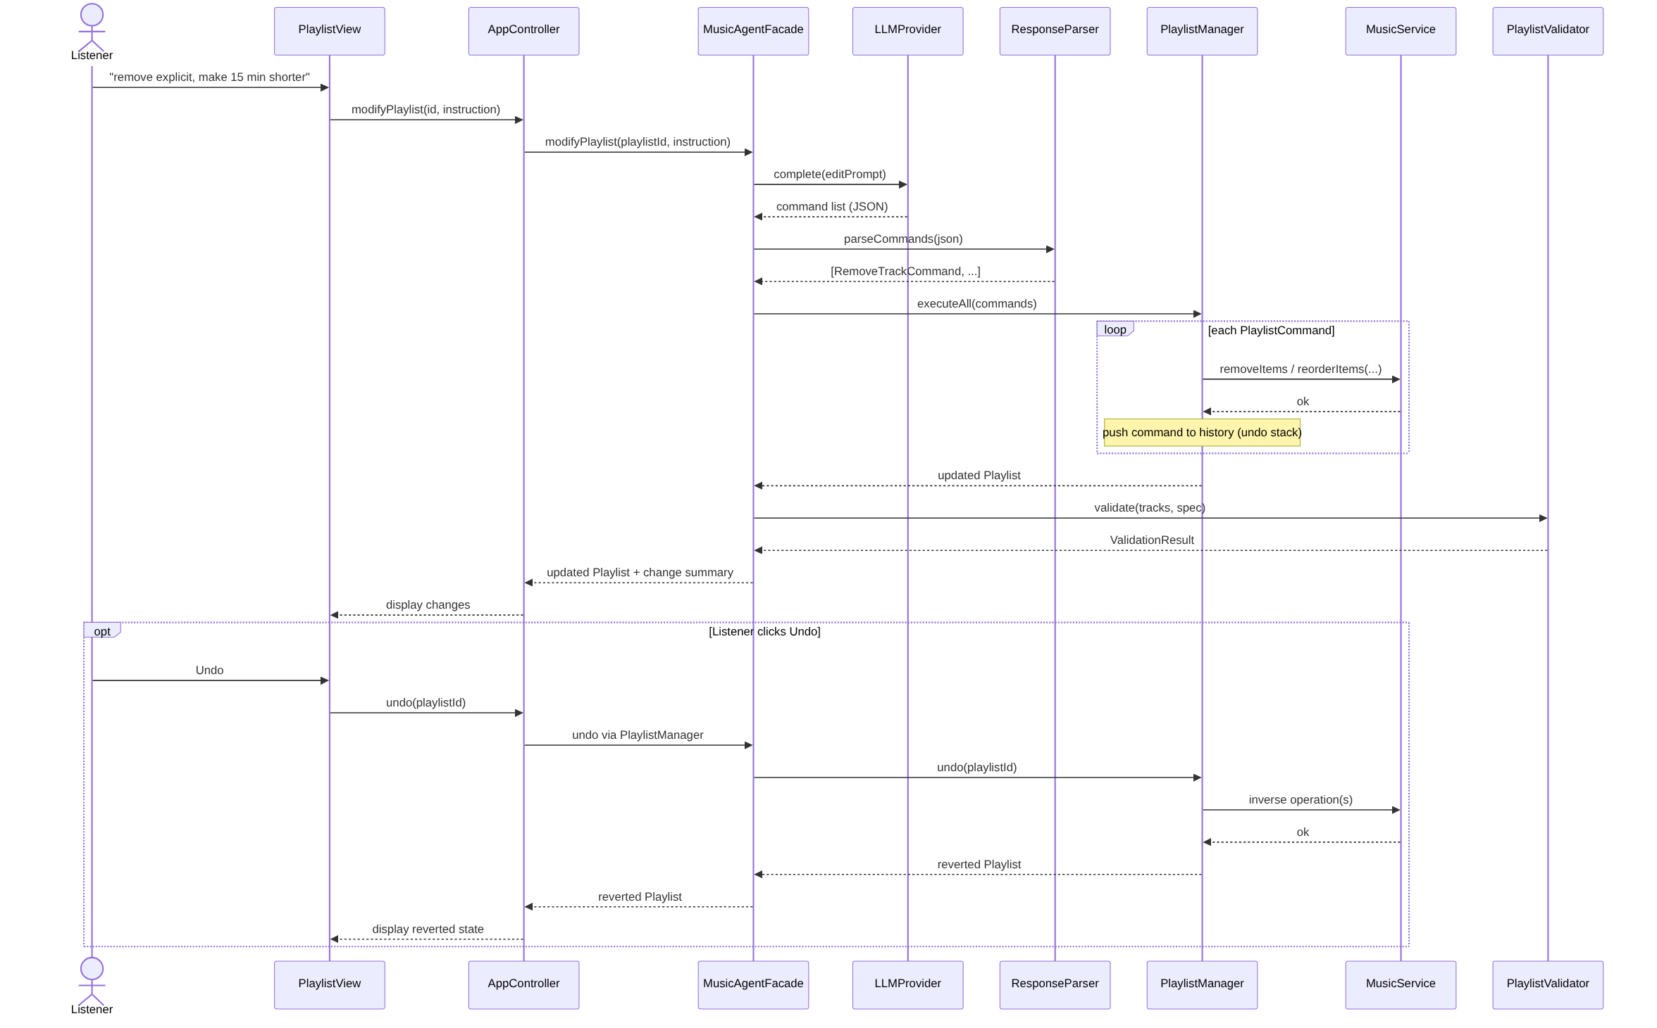
Figure 2.3-SD02 — Modify Playlist with Undo.

SD03 — View Taste Profile (UC02 / F1)
Deterministic aggregation of listening data by ProfileBuilder, with the LLM used only for the summary, plus the partial-history alternative flow.
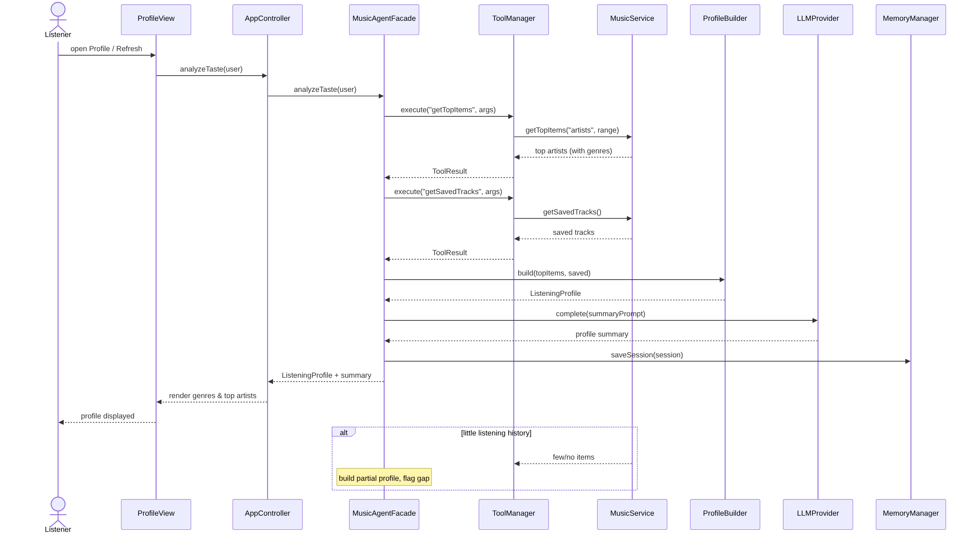
Figure 2.3-SD03 — View Taste Profile.

SD04 — Discover Music & Give Feedback (UC05, UC10 / F4, F9)
Strategy-based candidate selection with library exclusion and scoring, followed by the feedback loop that persists an accept/reject verdict for future scoring.
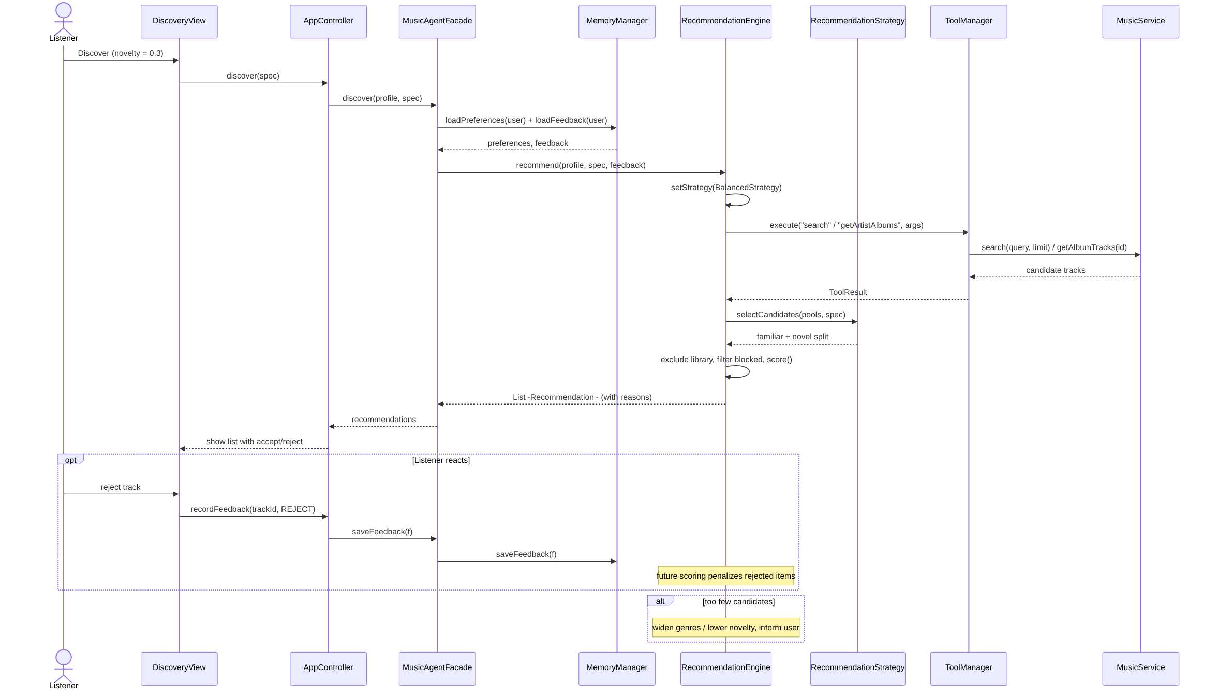
Figure 2.3-SD04 — Discover Music & Give Feedback.

Task 3 — Feature-to-Design Traceability
The traceability table maps every feature to the design that implements it: its type, the use case that exercises it, the classes and key methods that realise it, the sequence diagram that shows it at runtime, and the design pattern(s) involved. The class and method names match the class diagram (Figures 2.1a/2.1b) and the sequence diagrams of Section 2.3 exactly.
ID | Description | Type | Use Case | Classes | Key Methods | Seq. | Design Pattern(s)
F1 | Music taste profile | Hybrid | UC02 | AppController, MusicAgentFacade, ToolManager, SpotifyTool, MusicService / SpotifyAdapter, ProfileBuilder, LLMProvider, MemoryManager | analyzeTaste(), execute(), getTopItems(), getSavedTracks(), build(), complete(), saveSession() | SD03 | Facade, Adapter, MVC
F2 | Taste-change analysis | Hybrid | UC03 | AppController, MusicAgentFacade, ToolManager, MusicService, LLMProvider | analyzeTrends(), execute(), getTopItems(), complete() | SD03 | Facade, Adapter
F3 | Natural-language music search | Hybrid | UC04 | AppController, MusicAgentFacade, Planner, LLMProvider, ResponseParser, ToolManager, SpotifyTool, MusicService | searchMusic(), parseGoal(), complete(), search(), verifyTracks() | SD01 | Adapter, Facade
F4 | Personalized discovery | AI / Hybrid | UC05 | MusicAgentFacade, MemoryManager, RecommendationEngine, RecommendationStrategy, AbstractRecommendationStrategy, Balanced/Familiar/DiscoveryStrategy, ToolManager, MusicService | discover(), loadPreferences(), loadFeedback(), recommend(), setStrategy(), selectCandidates(), scoreFamiliarity(), score() | SD04 | Strategy, Facade, Adapter
F5 | AI playlist planning & generation | AI / Hybrid | UC06 | AppController, MusicAgentFacade, Planner, LLMProvider, ResponseParser, ConstraintChecker, ToolManager, RecommendationEngine, PlaylistValidator, PlaylistManager, CreatePlaylistCommand, AddItemsCommand, MusicService, MemoryManager, AgentSession, SessionState | createPlaylist(), plan(), complete(), parsePlaylistSpec(), checkFeasibility(), recommend(), validate(), executeAll(), createPlaylist(), addItems(), saveSession() | SD01 | Facade, Strategy, Command, State, Adapter
F6 | Natural-language playlist modification | AI / Hybrid | UC07 | MusicAgentFacade, LLMProvider, ResponseParser, PlaylistManager, RemoveTrackCommand, ReplaceTrackCommand, ReorderCommand, AddItemsCommand, MusicService, PlaylistValidator | modifyPlaylist(), complete(), parseCommands(), executeAll(), execute(), undo(), removeItems(), reorderItems(), validate() | SD02 | Command, Facade, Adapter
F7 | Playlist constraint validation | Deterministic | UC08 | MusicAgentFacade, PlaylistValidator, PlaylistSpec, ValidationResult, Track | validate(), isPassed(), violations(), isExplicit(), durationSec() | SD01, SD02 | — (deterministic core invoked via Facade by F5 / F6)
F8 | Preference memory | Deterministic | UC09 | AppController, MusicAgentFacade, MemoryManager, PreferenceRepository, Repository<T>, UserPreference | setPreference(), savePreference(), loadPreferences(), save(), findByUser() | SD01, SD04 | Repository (DAO)
F9 | Recommendation feedback | Deterministic | UC10 | AppController, MemoryManager, FeedbackRepository, Repository<T>, Feedback, RecommendationEngine | recordFeedback(), saveFeedback(), loadFeedback(), save(), score() | SD04 | Repository (DAO)
F10 | Grounded recommendation explanation | AI | UC11 | MusicAgentFacade, ExplanationService, PromptBuilder, LLMProvider, ResponseParser, AgentSession | explain(), buildExplainPrompt(), complete(), verifyTracks() | SD01 | Facade
F11 | Infeasible-constraint negotiation | AI / Hybrid | UC12 | MusicAgentFacade, Planner, ConstraintChecker, PlaylistSpec, LLMProvider | createPlaylist(), checkFeasibility(), plan(), complete() | SD01 | Facade, State
F12 | Agent history & snapshot / restore | Deterministic / Hybrid | UC13 | AppController, MemoryManager, SessionRepository, PlaylistHistoryRepository, AgentSession, AgentRequest, AgentPlan, PlaylistManager, PlaylistCommand | getHistory(), loadHistory(), saveSnapshot(), loadSnapshot(), restore(), undo() | SD02 | Command, Repository, State
Every feature is therefore realised by named classes and methods, exercised by a use case, and demonstrated by at least one sequence diagram — no feature exists only in the project description. (The Repository pattern supports persistence features F8/F9/F12; the five patterns counted toward the course requirement remain Adapter, Strategy, Command, State and Facade, as explained in Section 2.1.)

Task 4 — How Each Feature Is Realized
For each feature, the related use case and sequence diagram, the classes and their roles, the important methods, and a short execution narrative are given — showing exactly how the proposed design implements the feature. All names are consistent with the class diagram, the sequence diagrams and the traceability table.

F1 — Music Taste Profile
Related Use Case: UC02 — View Taste Profile
Related Sequence Diagram: SD03 — View Taste Profile
Classes involved:
- AppController — receives the request from the GUI/CLI and forwards it to the facade.
- MusicAgentFacade — orchestrates the profiling workflow.
- ToolManager / SpotifyTool — run the retrieval tools on behalf of the agent.
- MusicService / SpotifyAdapter — fetch top items and saved tracks from Spotify.
- ProfileBuilder — aggregates genres and ranks artists/tracks into a ListeningProfile.
- LLMProvider — writes the natural-language summary.
- MemoryManager — persists the session and profile.
Important methods:
analyzeTaste(), execute(), getTopItems(), getSavedTracks(), build(), computeGenreHistogram(), complete()
Execution: When the user opens the Profile tab, AppController.analyzeTaste() calls MusicAgentFacade.analyzeTaste(), which uses ToolManager to fetch top items and saved tracks through MusicService (SpotifyAdapter). ProfileBuilder.build() aggregates them into a ListeningProfile — a genre histogram and ranked artists/tracks — and LLMProvider.complete() adds a short summary. MemoryManager persists the result, which is returned to the view. The aggregation is deterministic; the LLM only phrases the summary.

F2 — Taste-Change Analysis
Related Use Case: UC03 — View Taste Trends
Related Sequence Diagram: SD03 — View Taste Profile (time-range variant)
Classes involved:
- AppController — forwards the trends request to the facade.
- MusicAgentFacade — coordinates retrieval across the three time ranges and the narration.
- ToolManager / MusicService — fetch top items for short-, medium- and long-term ranges.
- LLMProvider — narrates the computed changes.
Important methods:
analyzeTrends(), execute(), getTopItems(type, range), complete()
Execution: AppController.analyzeTrends() calls the facade, which retrieves the user's top items for the short-, medium- and long-term ranges via MusicService.getTopItems(). A deterministic comparator computes the artists and genres that were added or dropped between ranges, and LLMProvider.complete() turns that diff into a readable narrative. The comparison is deterministic and reproducible; only the wording is generated.

F3 — Natural-Language Music Search
Related Use Case: UC04 — Search Music
Related Sequence Diagram: SD01 — Create Playlist (retrieval portion)
Classes involved:
- AppController — forwards the query.
- MusicAgentFacade — coordinates parsing, search and ranking.
- Planner / LLMProvider — parse the free-text query into a structured SearchQuery.
- ResponseParser — validates the parsed query and the returned results.
- ToolManager / SpotifyTool / MusicService — execute the Spotify search.
Important methods:
searchMusic(), parseGoal(), complete(), search(query, limit), verifyTracks()
Execution: AppController.searchMusic() calls the facade. The LLM (through Planner) parses the request into a structured query; ToolManager runs MusicService.search() (limit ≤ 10, paginated by offset). ResponseParser validates the results, a deterministic ranker orders them, and the list is returned. If the parse is low-confidence, the system falls back to a raw keyword search on the original text.

F4 — Personalized Discovery
Related Use Case: UC05 — Discover Music
Related Sequence Diagram: SD04 — Discover Music & Give Feedback
Classes involved:
- MusicAgentFacade — entry point for discovery.
- MemoryManager — loads stored preferences and feedback.
- RecommendationEngine — the Context that drives candidate generation and scoring.
- RecommendationStrategy / AbstractRecommendationStrategy / Familiar·Discovery·BalancedStrategy — encapsulate the selection policy; the abstract base provides shared scoring/exclusion helpers.
- ToolManager / MusicService — retrieve candidate pools (search, artist albums, album tracks).
Important methods:
discover(), loadPreferences(), loadFeedback(), recommend(), setStrategy(), selectCandidates(), scoreFamiliarity(), score()
Execution: MusicAgentFacade.discover() loads preferences and feedback via MemoryManager, then calls RecommendationEngine.recommend(). The engine selects a RecommendationStrategy, retrieves candidate pools through MusicService, and the strategy's selectCandidates() produces a familiar/novel split. The engine excludes the user's existing library, filters blocked artists, and scores each candidate (scoreFamiliarity(), score()), returning Recommendation objects that each record a reason. Selection is deterministic, which keeps results explainable and testable.

F5 — AI Playlist Planning & Generation
Related Use Case: UC06 — Create Playlist
Related Sequence Diagram: SD01 — Create Playlist
Classes involved:
- AppController — receives the goal and constraints.
- MusicAgentFacade — orchestrates the full planning workflow.
- Planner / LLMProvider / ResponseParser — parse the goal into a validated PlaylistSpec / AgentPlan.
- ConstraintChecker — confirms feasibility before work proceeds.
- RecommendationEngine (+ Strategy) — selects tracks under the spec.
- PlaylistValidator — validates the selection.
- PlaylistManager + CreatePlaylistCommand / AddItemsCommand — perform the playlist creation.
- MusicService / MemoryManager — create the playlist on Spotify and persist the session.
- AgentSession / SessionState — track the lifecycle of the run.
Important methods:
createPlaylist(), plan(), complete(), parsePlaylistSpec(), checkFeasibility(), recommend(), validate(), executeAll(), createPlaylist(userId, name), addItems(), saveSession()
Execution: AppController.createPlaylist() calls MusicAgentFacade.createPlaylist(). Planner.plan() uses the LLM to parse the goal into a PlaylistSpec, which ResponseParser validates. MemoryManager loads preferences; ToolManager retrieves candidate pools; ConstraintChecker.checkFeasibility() verifies the request (delegating to F11 if infeasible). RecommendationEngine selects tracks via the BalancedStrategy, PlaylistValidator.validate() checks the result (looping back on failure within a bounded retry), and PlaylistManager.executeAll() runs a CreatePlaylistCommand and AddItemsCommand through MusicService to create the real playlist. MemoryManager saves the session; an explanation is produced and the playlist returned. The AgentSession moves through its SessionState lifecycle throughout.

F6 — Natural-Language Playlist Modification
Related Use Case: UC07 — Modify Playlist
Related Sequence Diagram: SD02 — Modify Playlist with Undo
Classes involved:
- MusicAgentFacade — coordinates parsing and application of the edit.
- LLMProvider / ResponseParser — parse the instruction into a list of PlaylistCommands.
- PlaylistManager — the Invoker; applies commands and maintains the undo stack.
- RemoveTrackCommand / ReplaceTrackCommand / ReorderCommand / AddItemsCommand — concrete reversible operations.
- MusicService — the Receiver that performs each change on Spotify.
- PlaylistValidator — re-validates the modified playlist.
Important methods:
modifyPlaylist(), complete(), parseCommands(), executeAll(), execute(), undo(), removeItems(), reorderItems(), validate()
Execution: MusicAgentFacade.modifyPlaylist() sends the instruction to the LLM; ResponseParser.parseCommands() turns the response into PlaylistCommands. PlaylistManager.executeAll() applies each command through MusicService and pushes it onto the undo stack, then PlaylistValidator re-validates. If the user requests Undo, PlaylistManager.undo() reverses the last change via the same Command mechanism. Mood-style edits with no reliable signal are handled by the genre heuristic and flagged as approximate.

F7 — Playlist Constraint Validation
Related Use Case: UC08 — Validate Playlist
Related Sequence Diagram: SD01 / SD02 (validation step)
Classes involved:
- MusicAgentFacade — invokes validation within the create/modify flows and on demand.
- PlaylistValidator — runs the ordered rule set.
- PlaylistSpec — supplies the constraints.
- ValidationResult — reports pass/fail and the offending items.
- Track — provides the machine-checkable fields (explicit, durationMs).
Important methods:
validate(tracks, spec), isPassed(), violations(), isExplicit(), durationSec()
Execution: PlaylistValidator.validate() checks a track list against the PlaylistSpec using an ordered rule set — explicit content (Track.isExplicit()), duplicates (by track id), target duration (sum of durationSec() within tolerance), blocked artists, and min/max length — and returns a ValidationResult. This is a purely deterministic component with no LLM involvement; its result drives the adjustment loops in F5 and F6.

F8 — Preference Memory
Related Use Case: UC09 — Manage Preferences
Related Sequence Diagram: within SD01 / SD04
Classes involved:
- AppController — handles preference edits from the GUI/CLI.
- MemoryManager — the service over the repositories.
- PreferenceRepository / Repository<T> — persist preferences to PostgreSQL.
- UserPreference — the stored entity.
Important methods:
setPreference(), savePreference(), loadPreferences(), save(), findByUser()
Execution: AppController.setPreference() calls MemoryManager.savePreference(), which persists a UserPreference through PreferenceRepository (a Repository/DAO over PostgreSQL). Stored preferences — disliked artists, preferred styles, explicit-content policy and familiar-vs-exploratory bias — are read back by F4, F5 and F6 via MemoryManager.loadPreferences(). This is a deterministic CRUD feature with no AI involvement.

F9 — Recommendation Feedback
Related Use Case: UC10 — Give Feedback
Related Sequence Diagram: SD04 — Discover Music & Give Feedback
Classes involved:
- AppController — receives the accept/reject action.
- MemoryManager — persists the verdict.
- FeedbackRepository / Repository<T> — store Feedback records.
- Feedback — the stored entity.
- RecommendationEngine — reads feedback during later scoring.
Important methods:
recordFeedback(), saveFeedback(), loadFeedback(), save(), score()
Execution: AppController.recordFeedback() calls MemoryManager.saveFeedback(), persisting a Feedback record through FeedbackRepository. On subsequent discovery, RecommendationEngine reads stored feedback and adjusts scoring — penalising previously rejected items and favouring accepted ones. Repeated feedback on the same item is upserted rather than duplicated.

F10 — Grounded Recommendation Explanation
Related Use Case: UC11 — Explain Selections
Related Sequence Diagram: SD01 — Create Playlist (explanation step)
Classes involved:
- MusicAgentFacade — requests the explanation.
- ExplanationService — gathers the recorded selection reasons.
- PromptBuilder — builds a constrained prompt from only those facts.
- LLMProvider — renders the explanation text.
- ResponseParser — checks the output references only real, recorded facts.
- AgentSession — holds the decision trace.
Important methods:
explain(), buildExplainPrompt(), complete(), verifyTracks()
Execution: MusicAgentFacade.explain() asks ExplanationService to collect the reasons recorded during selection (strategy used, matched genre, familiarity bucket, constraints satisfied). PromptBuilder.buildExplainPrompt() constructs a prompt containing only those facts; LLMProvider.complete() renders the text; ResponseParser verifies it references only real recorded facts, so the explanation cannot fabricate track-level claims. If the trace is missing, a generic explanation is produced and the limitation noted.

F11 — Infeasible-Constraint Negotiation
Related Use Case: UC12 — Negotiate Constraints
Related Sequence Diagram: SD01 — Create Playlist (alternative flow)
Classes involved:
- MusicAgentFacade — surfaces the conflict and resumes the originating flow.
- Planner — regenerates the plan with the adjusted spec.
- ConstraintChecker — detects infeasibility against the candidate pool.
- PlaylistSpec — the constraints being evaluated and relaxed.
- LLMProvider — phrases the relaxation options.
Important methods:
createPlaylist(), checkFeasibility(), plan(), complete()
Execution: During planning, ConstraintChecker.checkFeasibility() evaluates the PlaylistSpec against the available candidates. On a conflict (e.g. 100% familiar combined with 30% new, or a 90-minute target with only 40 minutes of eligible tracks), the facade surfaces concrete relaxation options (phrased by the LLM). Once the user chooses, Planner regenerates the plan with the adjusted PlaylistSpec and the create/modify flow resumes. If the user cancels, the operation aborts cleanly with no changes.

F12 — Agent History & Snapshot / Restore
Related Use Case: UC13 — View History / Restore
Related Sequence Diagram: SD02 — Modify Playlist with Undo (Command reuse)
Classes involved:
- AppController — handles history browsing and restore requests.
- MemoryManager — reads and writes history and snapshots.
- SessionRepository / PlaylistHistoryRepository — persist sessions and playlist snapshots.
- AgentSession / AgentRequest / AgentPlan — the recorded run.
- PlaylistManager / PlaylistCommand — replay a snapshot via the Command mechanism.
Important methods:
getHistory(), loadHistory(), saveSnapshot(), loadSnapshot(), restore(), undo()
Execution: MemoryManager persists each AgentSession (with its AgentRequest and AgentPlan) and playlist snapshots through SessionRepository and PlaylistHistoryRepository. AppController.getHistory() lists past sessions; restore() loads a snapshot via MemoryManager.loadSnapshot() and PlaylistManager replays it as a sequence of PlaylistCommands — the same Command mechanism used for F6 undo — reverting the playlist to the saved state. A snapshot referencing a deleted Spotify playlist is handled by offering to recreate it.

