Individual Homework 4: Dialogue Agent

**RAZERBOT**

RAZER เป็นผู้ให้บริการการผลิตและจัดจำหน่ายอุปกรณ์คอมพิวเตอร์ รวมถึงดูแลลูกค้า มีบริการหลังการขาย โดดเด่นในการพัฒนาอุปกรณ์คอมพิวเตอร์สำหรับเล่นเกม ส่วน RAZERBOT จะทำการแนะนำสินค้าประเภทเมาส์ คีย์บอร์ด หูฟัง และโปรแกรม Synapse ที่ใช้เป็นโปรแกรมสำหรับตั้งค่าผลิตภัณฑ์ของ RAZER ทั้งหมด ผู้ใช้ที่ไม่เคยใช้งานอุปกรณ์คอมพิวเตอร์แบบมีโปรแกรมปรับแต่งอาจเกิดข้อสงสัยเกี่ยวกับ Synapse โดยขอบเขตการทำงานของ RAZERBOT มีดังนี้

1. แนะนำสินค้าประเภท เมาส์ คีย์บอร์ด หูฟัง
2. แนะนำโปรแกรม Synapse
3. แนะนำวิธีการตั้งค่าบางอย่าง
4. นำเสนอวิธีแก้ปัญหาเบื้องต้นเกี่ยวกับการใช้งาน
5. นำเสนอช่องทางการติดต่อกับผู้ผลิต

RAZERBOT ได้นำตัวอย่างบอทจาก eliza.py มาปรับปรุงเพิ่มเติม โดยใช้ Regular Expression ช่วยตัด Article และใช้ไลบราลี่ NLTK ทำ Stemming และ Lemmatization

**Shopping test conversation**

การทดสอบประโยคสนทนาทั่วไป ถามข้อมูลการติดต่อกับบริษัท และถามข้อมูลเกี่ยวกับสินค้า

Hello

Please help me.

Hello RAZERBOT.

What is RAZER?

What is your product?

What is the esports?

Which the new product?

How do I contact you?

website

address

Where is RAZER location?

What should I buy?

mouse

wired mouse

How to buy now?

Can I tell operator?

Can I order now?

What is your email address?

How to order the product?

Do you have an online shopping?

Do you have a facebook page?

What products do you have?

Can you recommend a mouse for me?

Can you recommend a keyboard for me?

Can you recommend a headset for me?

I interest a wired mouse.

I interest a wireless mouse.

**Problem test conversation**

การทดสอบการสนทนาเกี่ยวกับปัญหาการใช้งานเบื้องต้น ปัญหาบางชนิดนำมาจากเว็บ reddit

I have a problem with my mouse.

Why is my mouse auto double clicking?

How to change my RGB of my device?

How to config any device?

How to disable the light of my mouse?

How to custom DPI of my mouse?

I want to claim my device.

I want to check warranty of my device.

Why my device doesn’t work?

How to factory reset of my device?

How to reset my setting?

I have a problem with my keyboard.

Why synapse doesn’t detect my device?

My keyboard has a problem.

How do I fix my double typing keyboard?

How to replace a switch?

Why is my headphone has only one side work?

How to limit a scrolling of my mouse?

How to install a device driver?

**Synapse test conversation**

What is the Synapse software?

How to download Synapse?

Can I use device without Synapse software?

Can I control the lighting without Synapse?

How to close a Synapse?

How to disable a Synapse?

**ตัวอย่างการทดสอบการใช้งานด้วย LINE Chatbot API**

**Shopping test conversation**

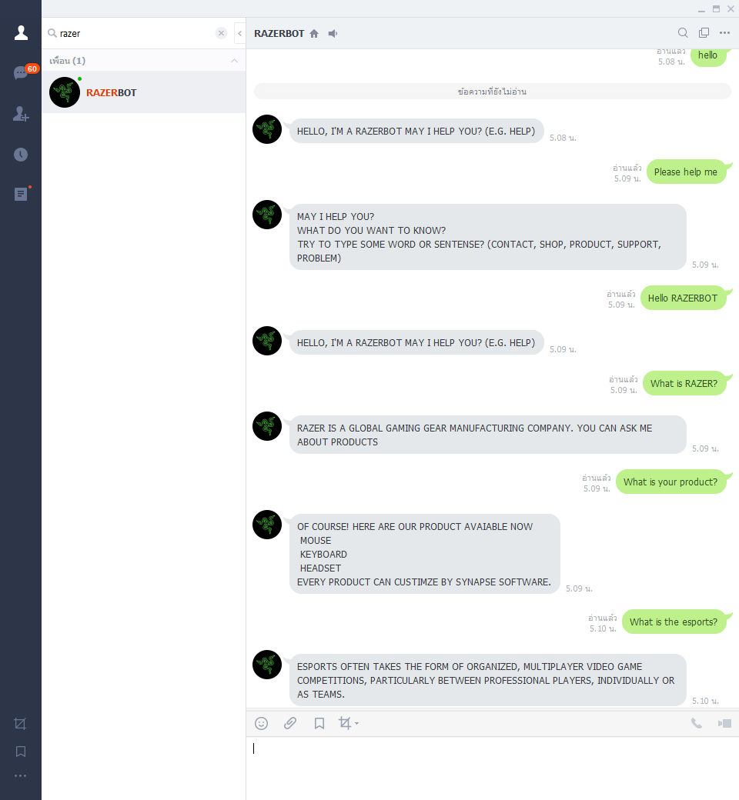

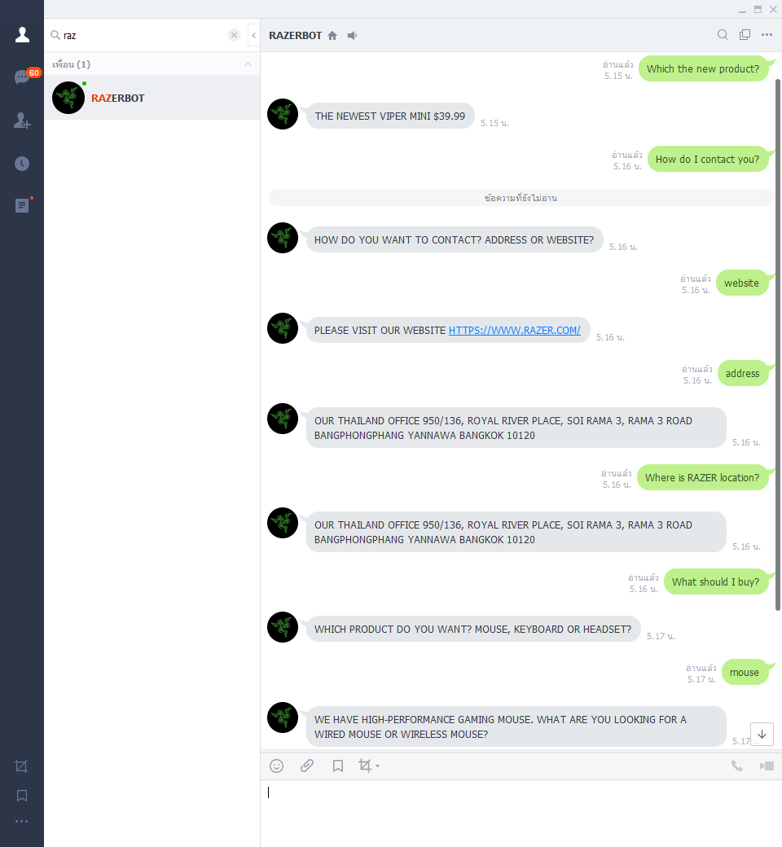

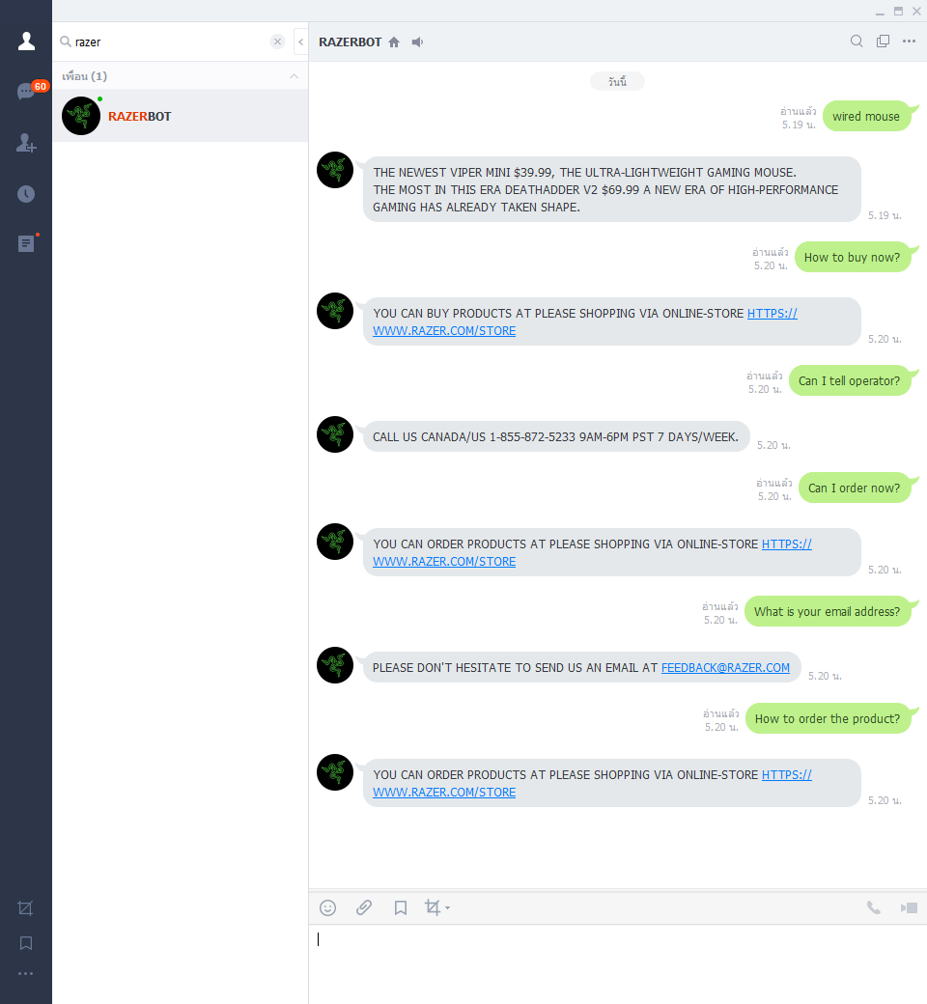

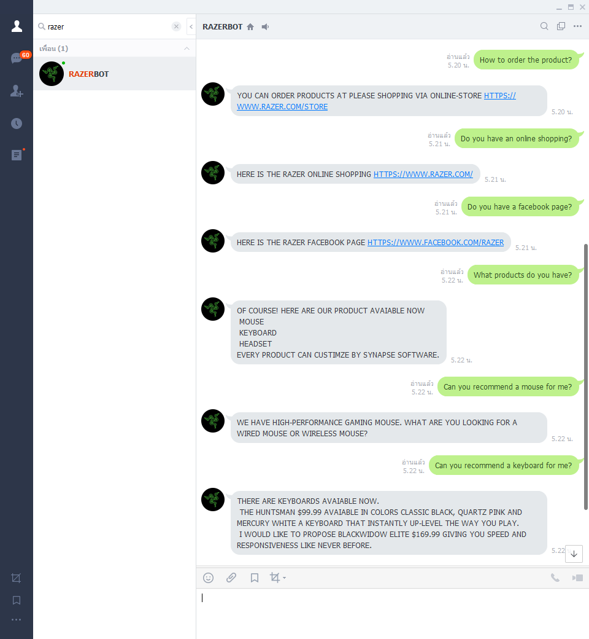

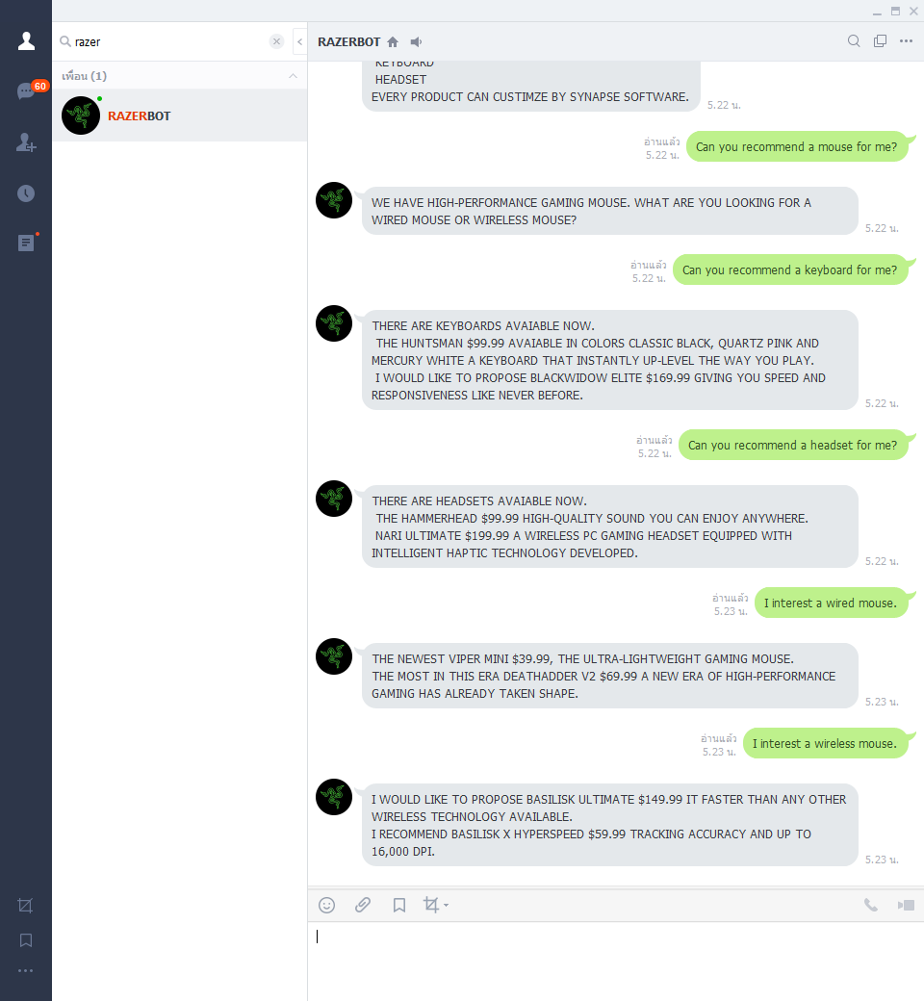

**Problem test conversation**

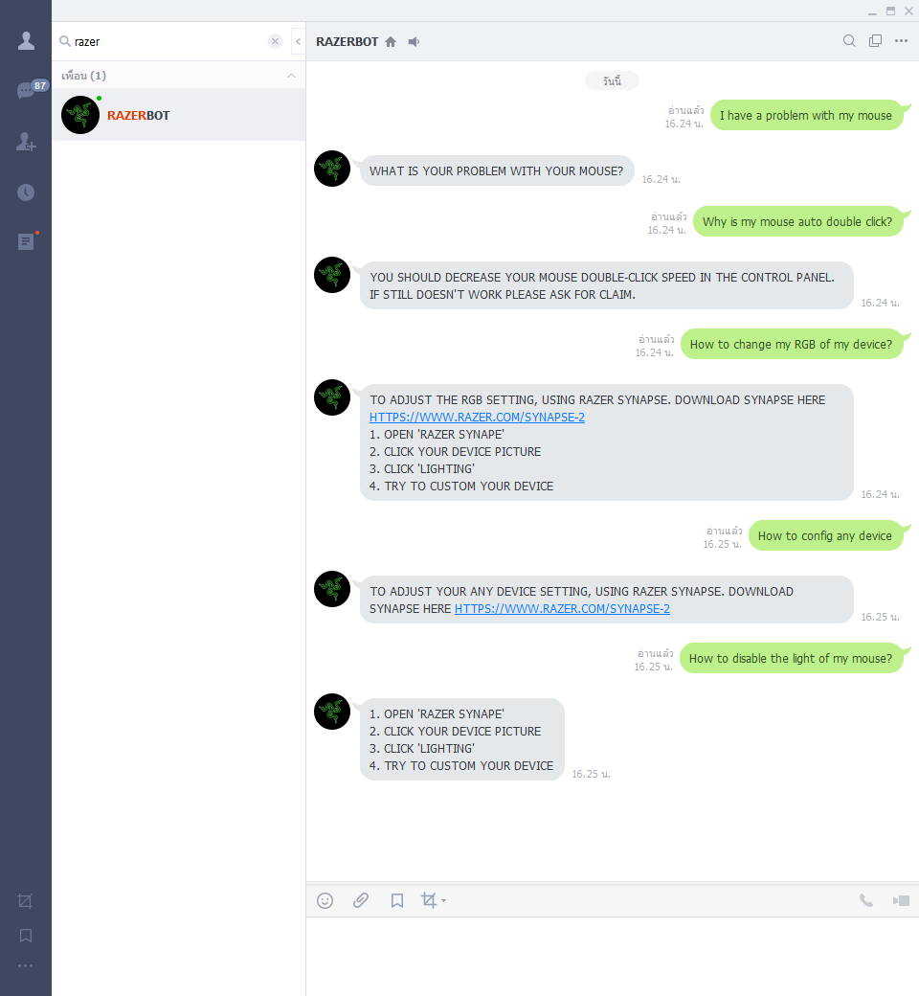

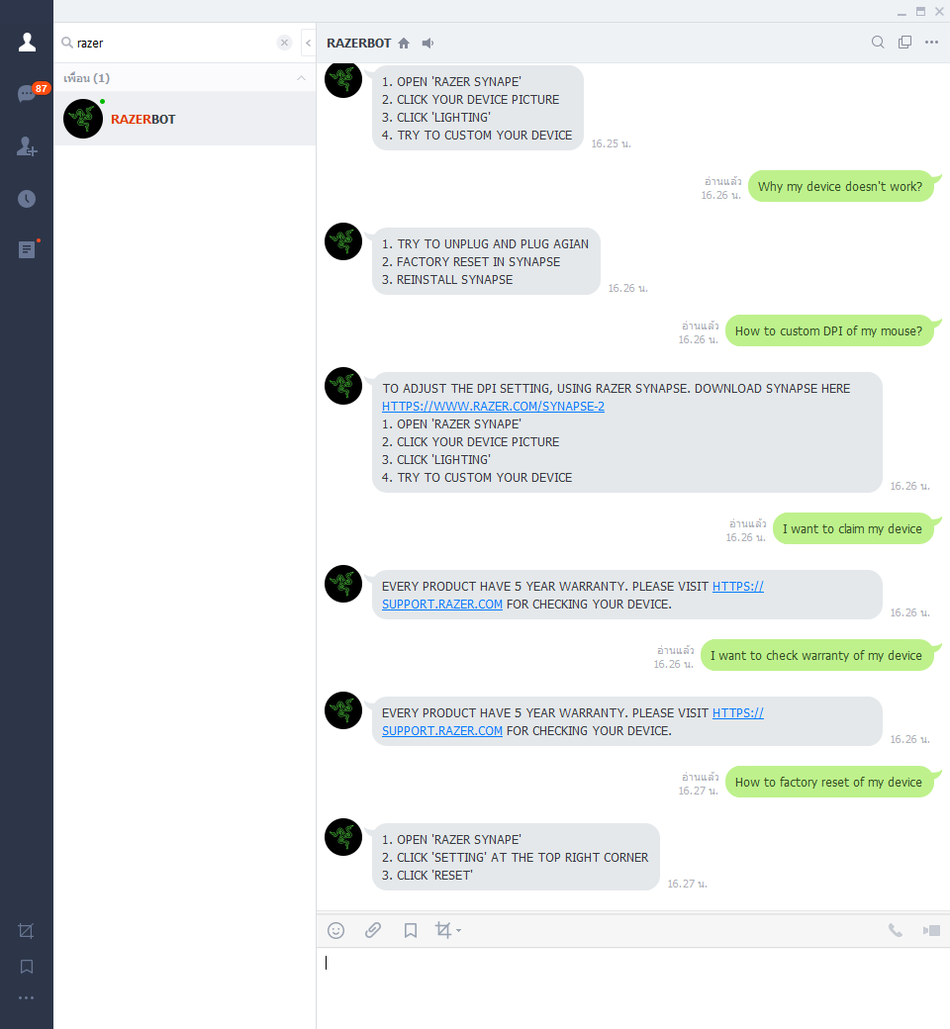

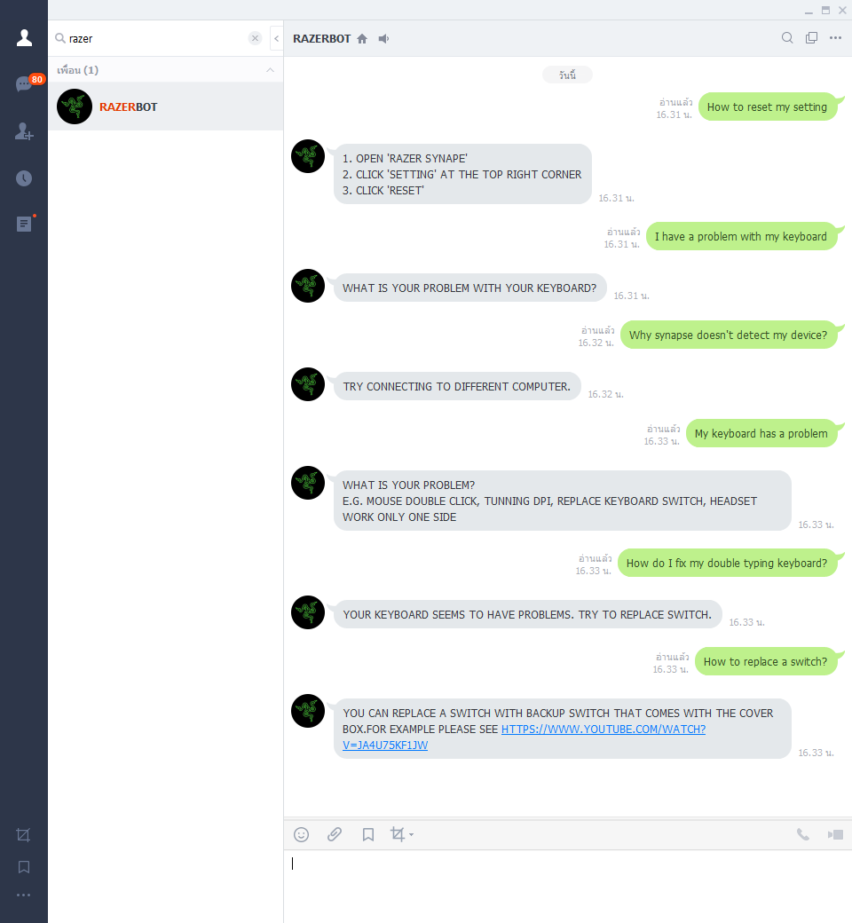

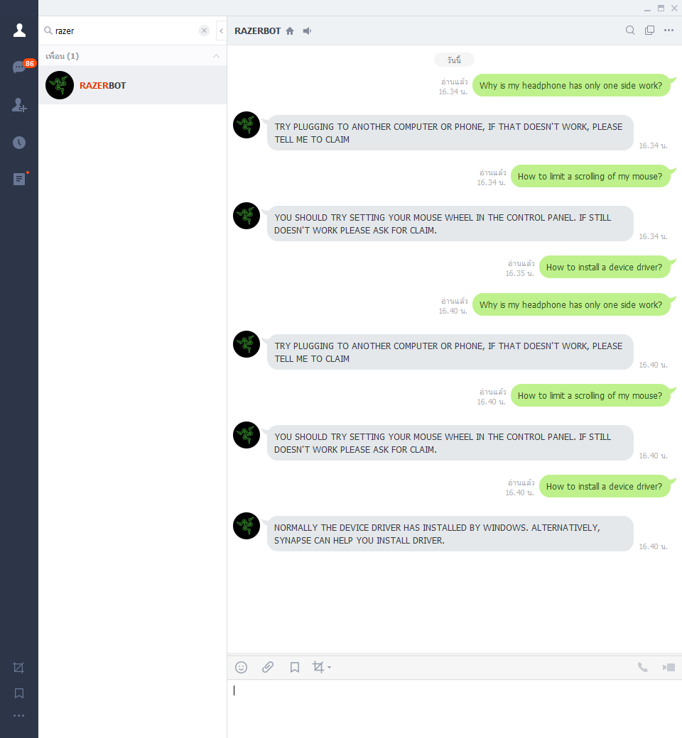

**Synapse test conversation**

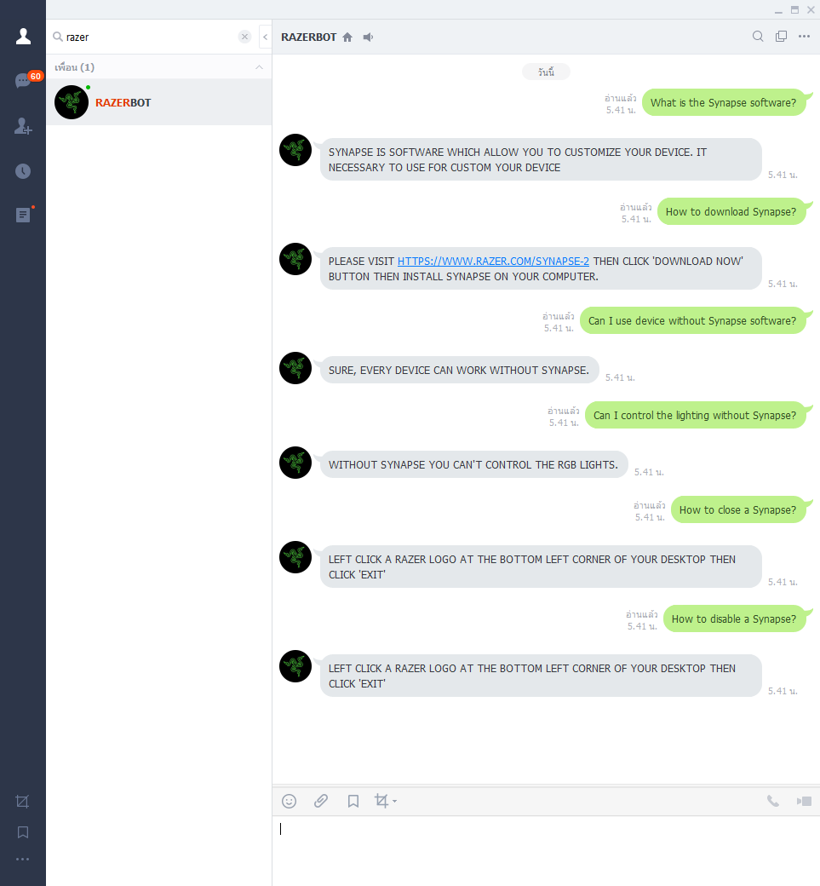

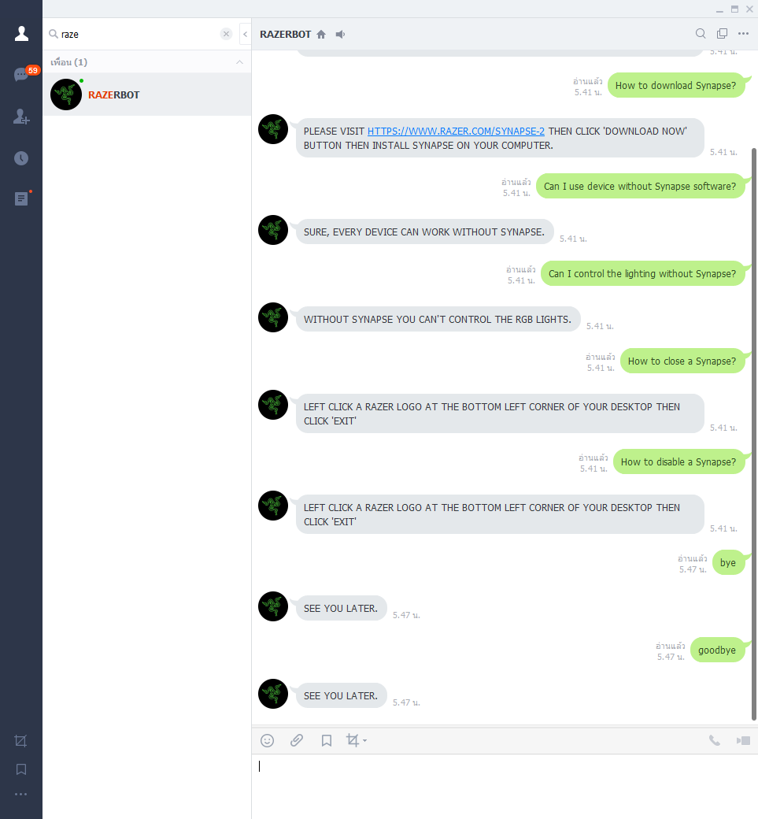

**ทดสอบเมื่อส่งข้อความที่ RAZERBOT ไม่รู้จัก**

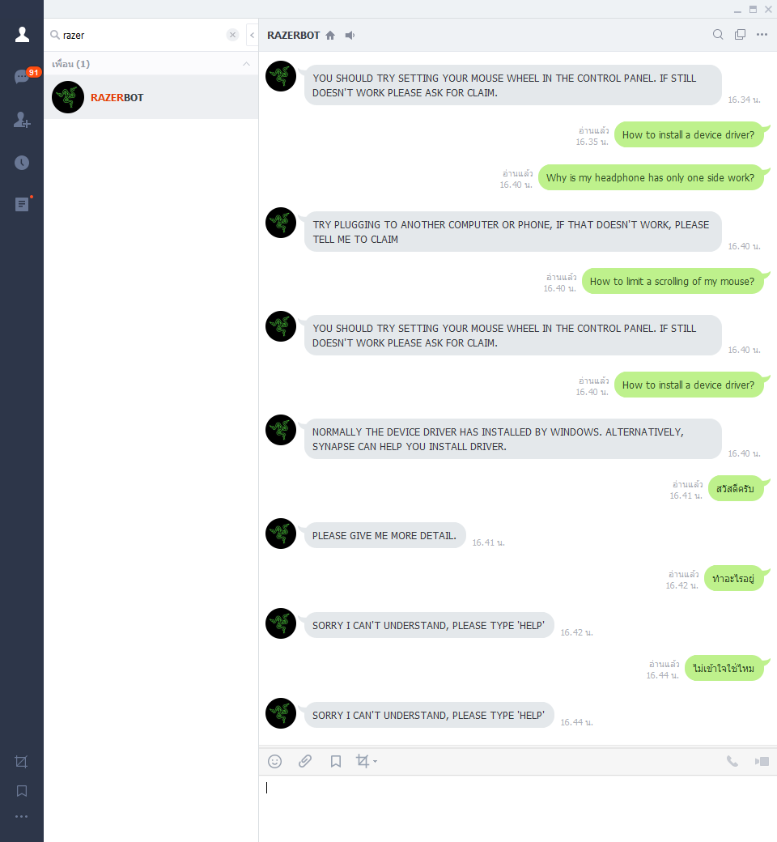

**ตัวอย่างการทดสอบการใช้งานผ่าน Command line**

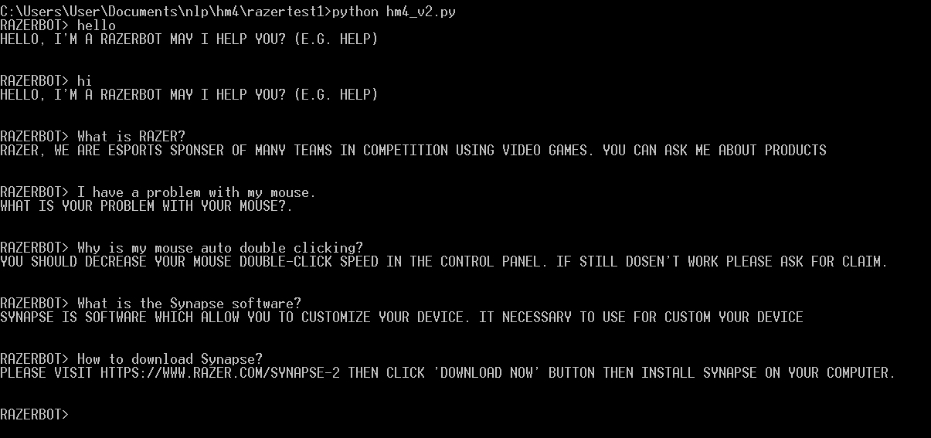

**Code**

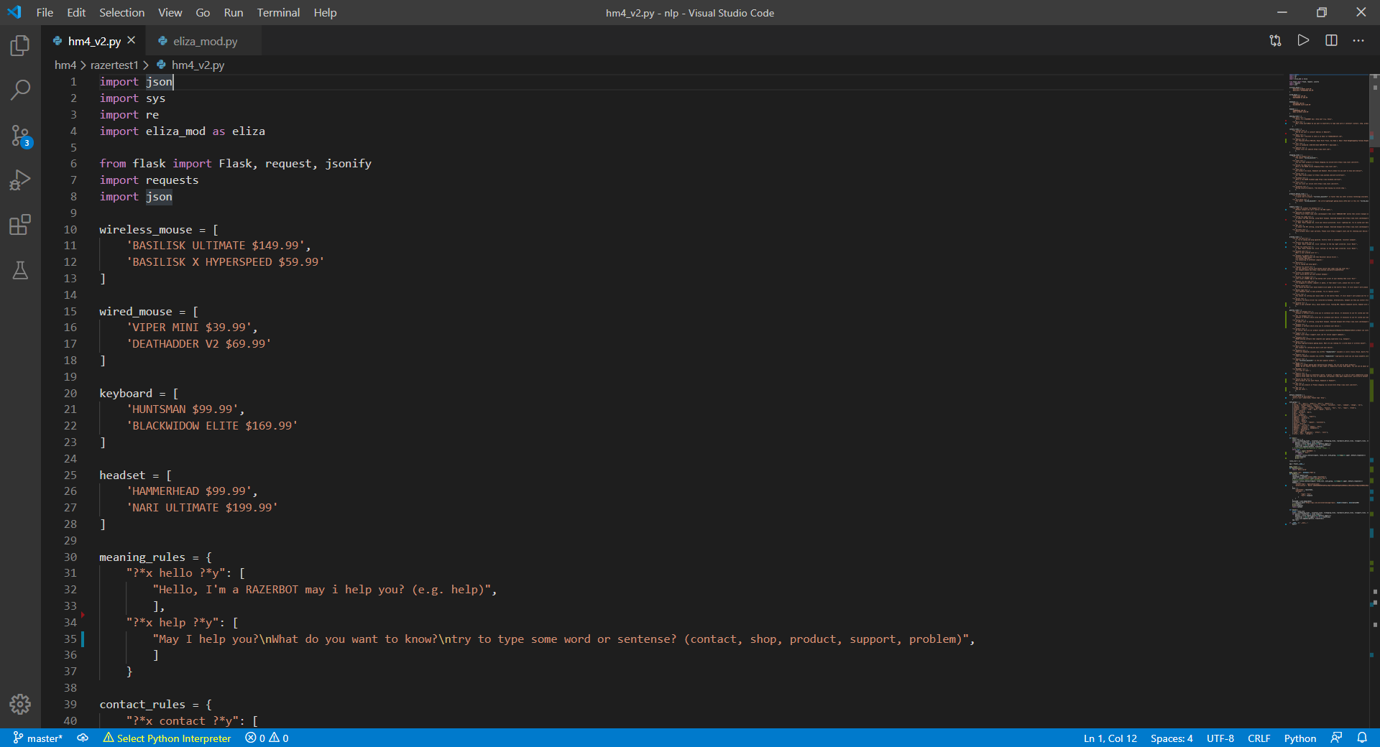

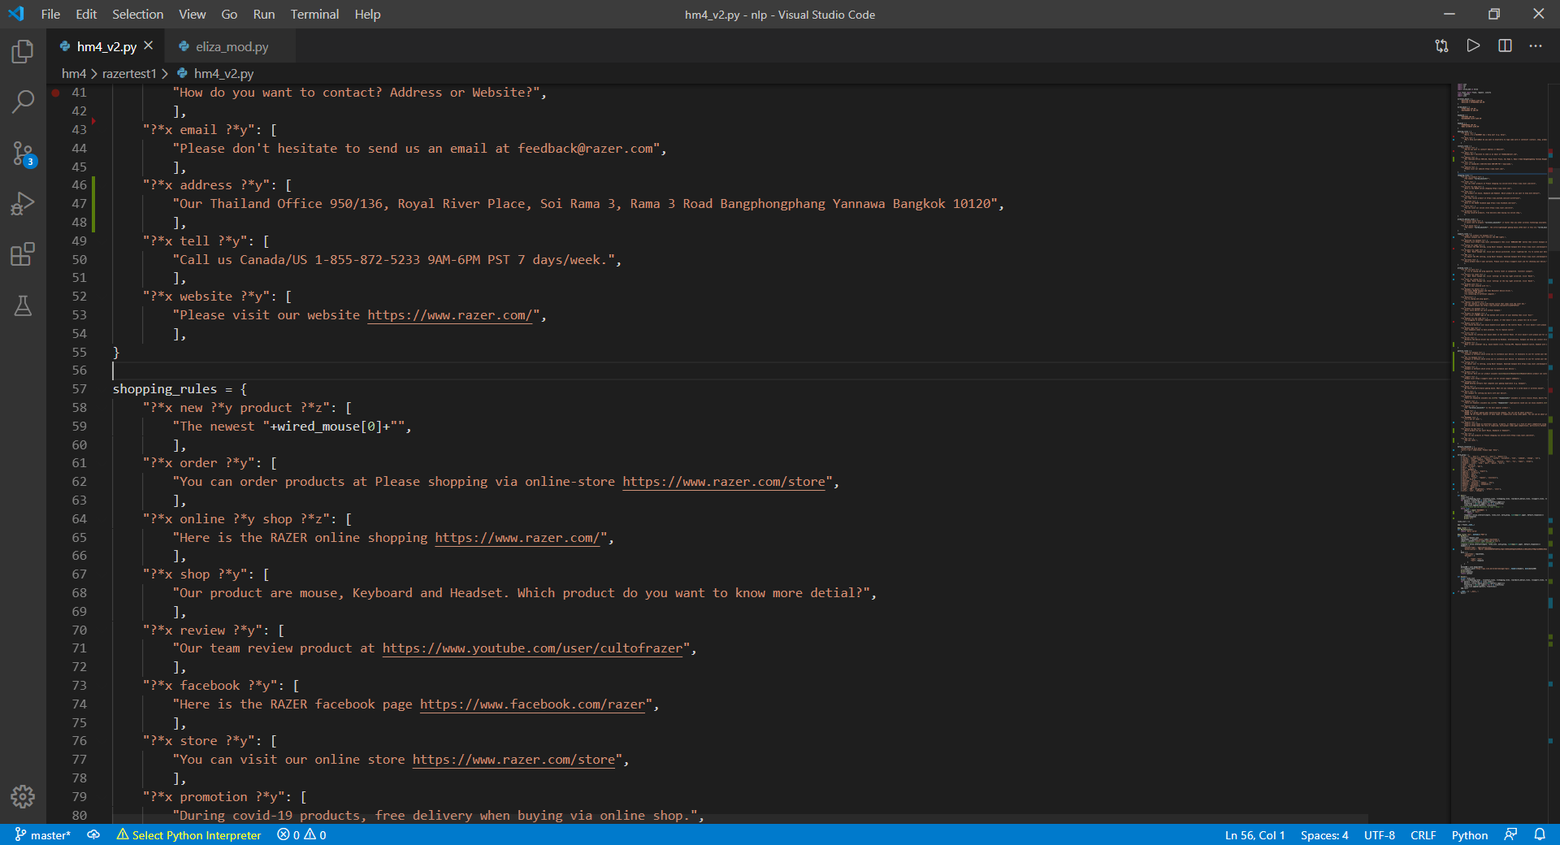

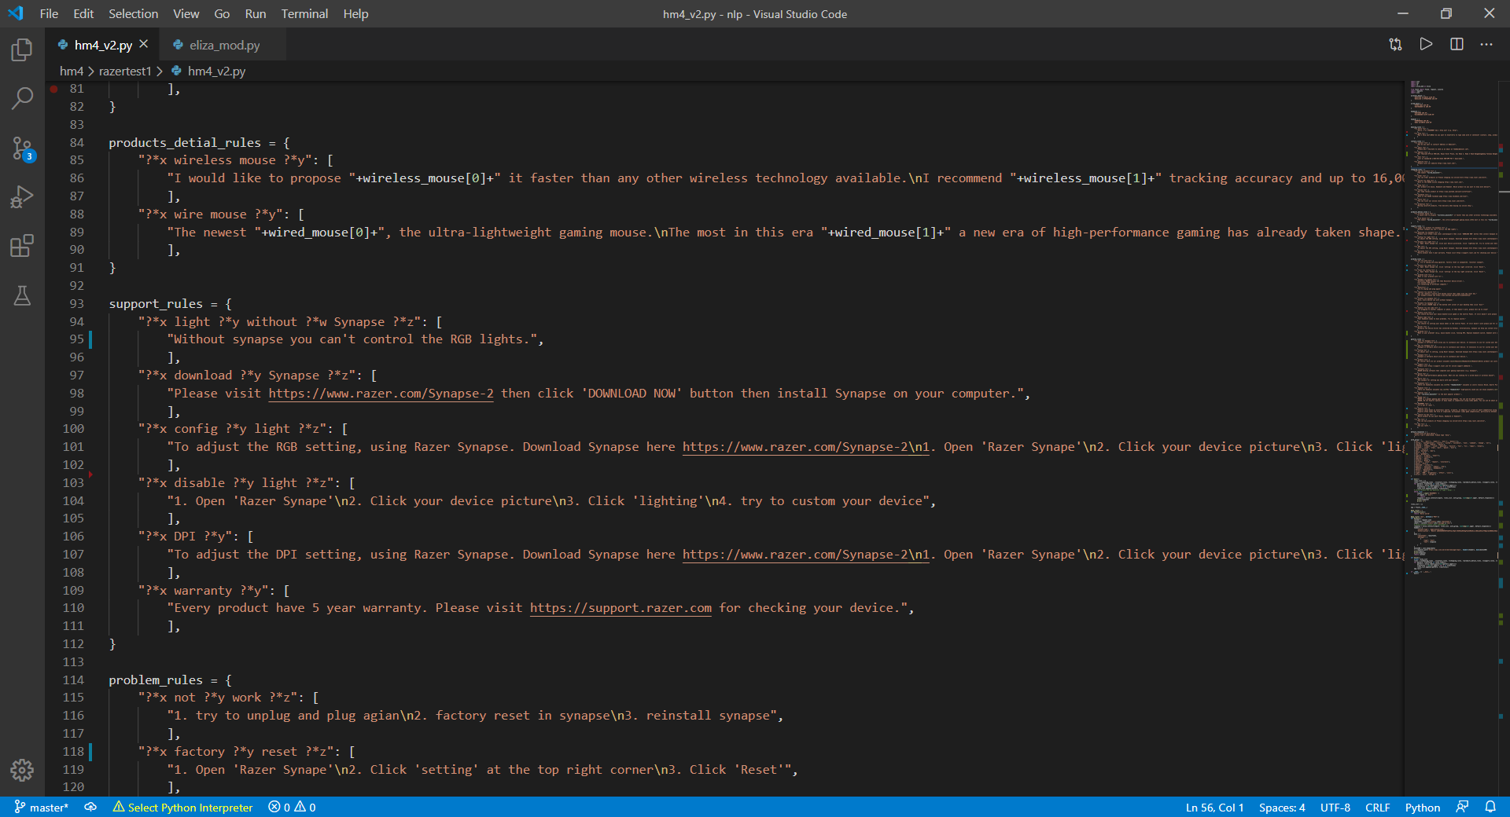

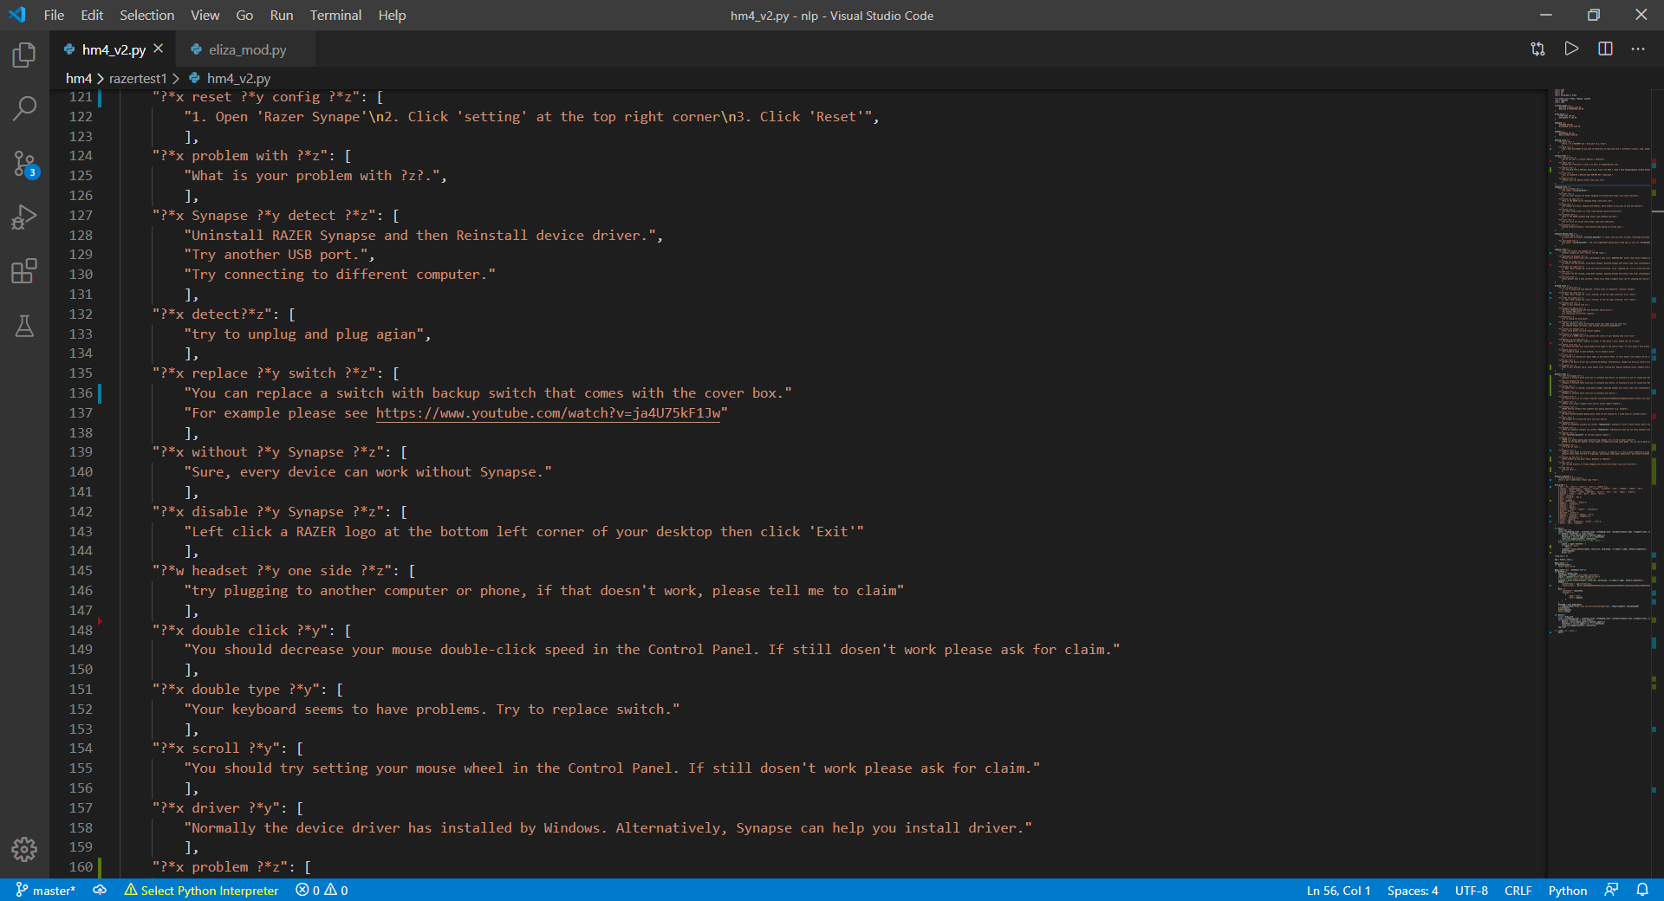

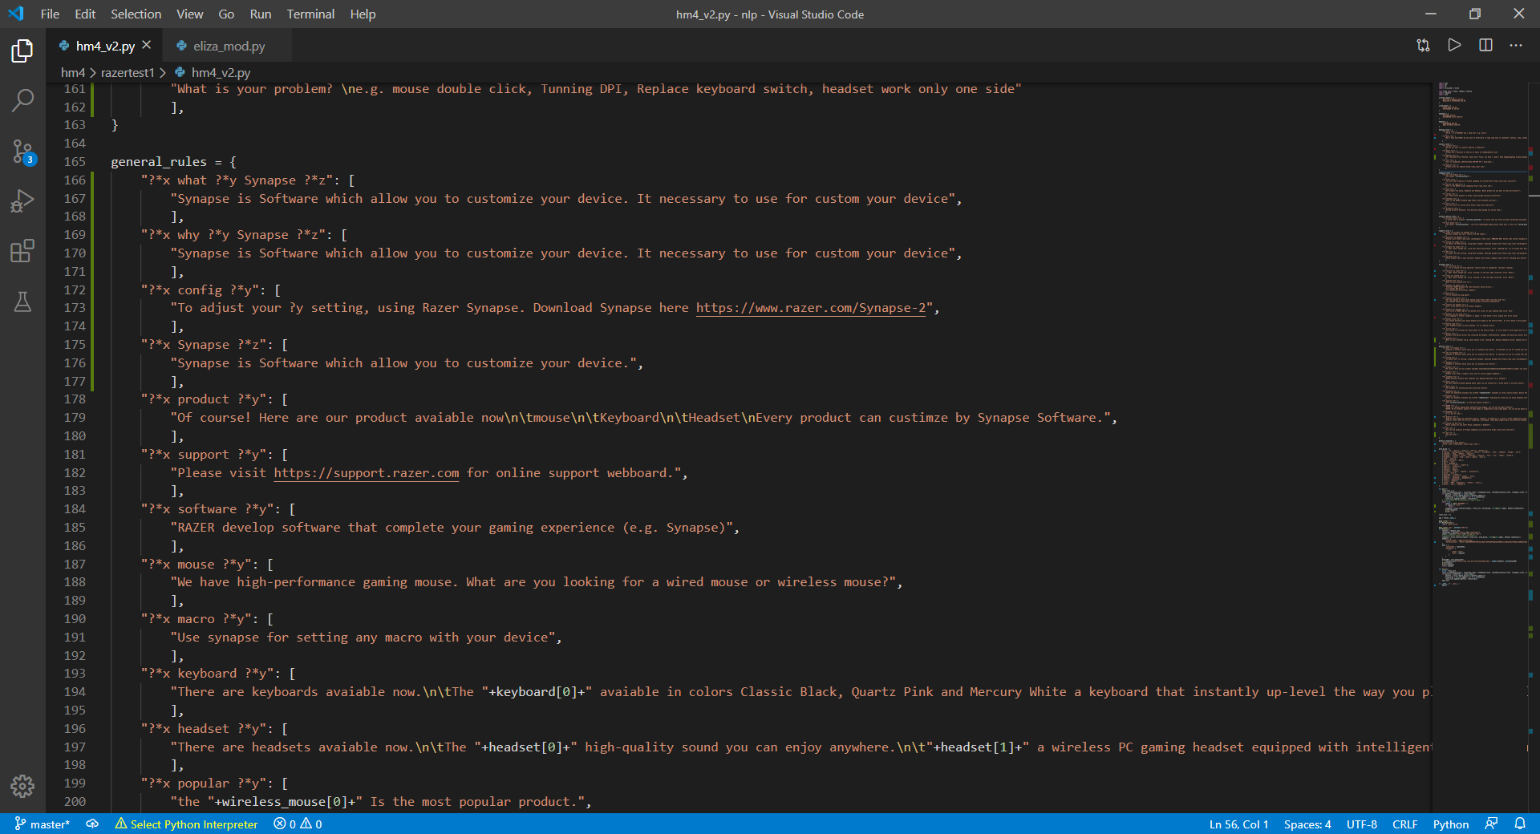

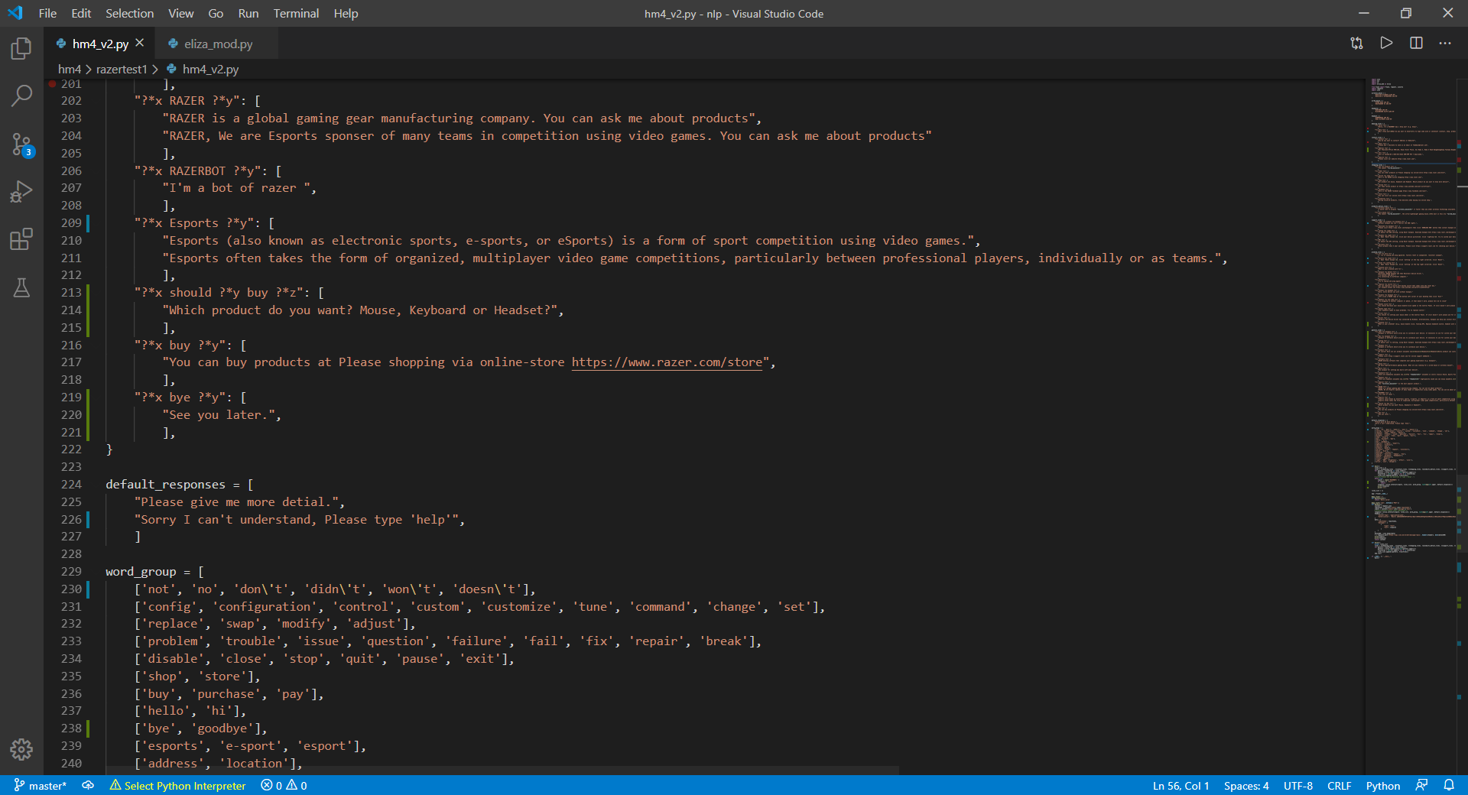

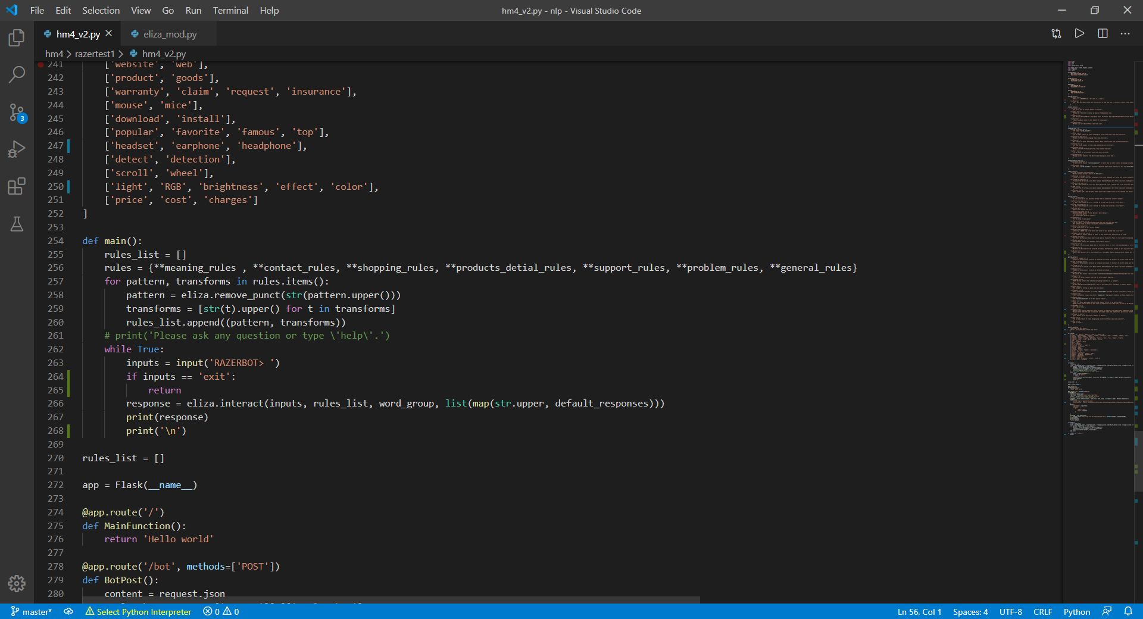

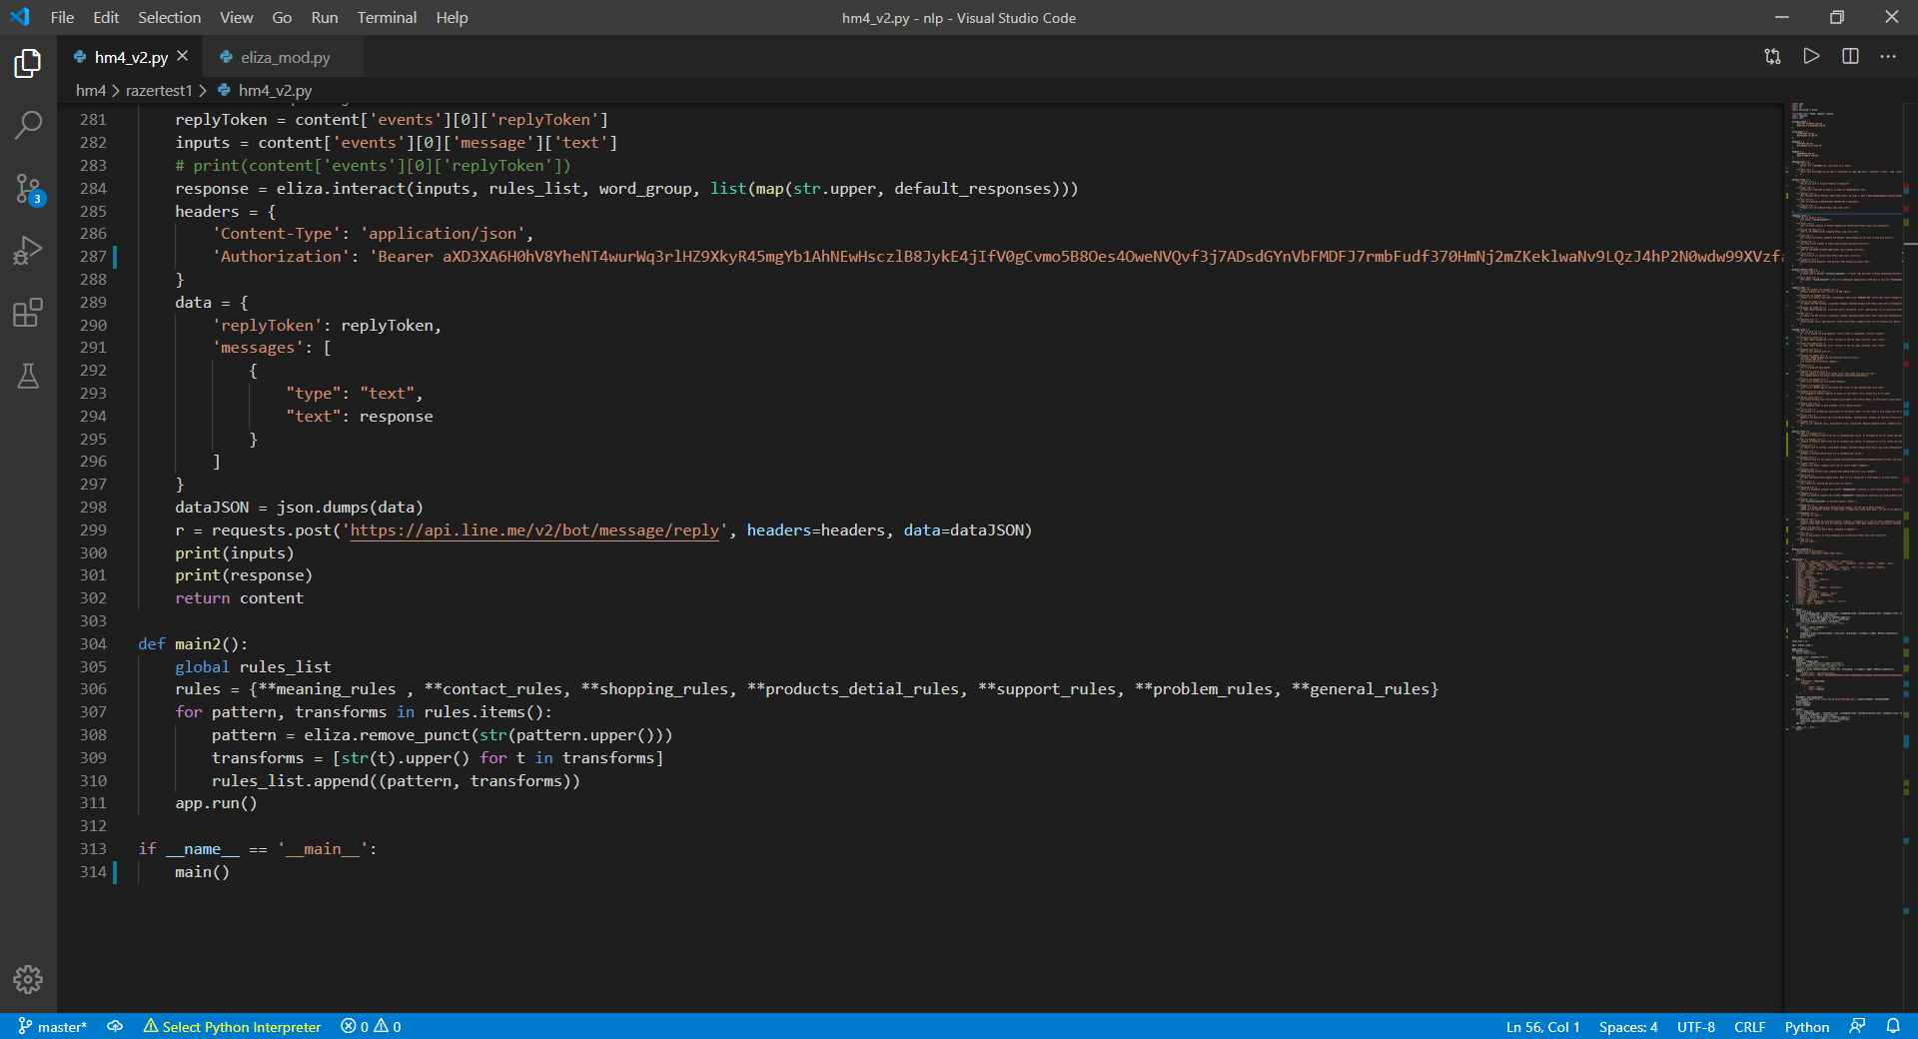

**Rule/Pattern (จากใน Code)**

?*x hello ?*y

Hello, I'm a RAZERBOT may i help you? (e.g. help)

?*x help ?*y

May I help you?

What do you want to know?

try to type some word or sentence? (contact, shop, product, support, problem)

?*x contact ?*y

How do you want to contact? Address or Website?

?*x email ?*y

Please don't hesitate to send us an email at feedback@razer.com

?*x address ?*y

Our Thailand Office 950/136, Royal River Place, Soi Rama 3, Rama 3 Road Bangphongphang Yannawa Bangkok 10120

?*x tell ?*y

Call us Canada/US 1-855-872-5233 9AM-6PM PST 7 days/week.

?*x website ?*y

Please visit our website https://www.razer.com

?*x new ?*y product ?*z

The newest "+wired_mouse[0]+"

?*x order ?*y

You can order products at Please shopping via online-store https://www.razer.com/store

?*x online ?*y shop ?*z

Here is the RAZER online shopping https://www.razer.com

?*x shop ?*y

Our product are mouse, Keyboard and Headset. Which product do you want to know more detail?

?*x review ?*y

Our team review product at https://www.youtube.com/user/cultofrazer

?*x facebook ?*y

Here is the RAZER facebook page https://www.facebook.com/razer

?*x store ?*y

You can visit our online store https://www.razer.com/store

?*x promotion ?*y

During covid-19 products, free delivery when buying via online shop.

?*x wireless mouse ?*y

I would like to propose "+wireless_mouse[0]+" it faster than any other wireless technology available.

I recommend "+wireless_mouse[1]+" tracking accuracy and up to 16,000 DPI.

?*x wire mouse ?*y

The newest "+wired_mouse[0]+", the ultra-lightweight gaming mouse.

The most in this era "+wired_mouse[1]+" a new era of high-performance gaming has already taken shape.

?*x light ?*y without ?*w Synapse ?*z

Without synapse you can't control the RGB lights.

?*x download ?*y Synapse ?*z

Please visit https://www.razer.com/Synapse-2 then click 'DOWNLOAD NOW' button then install Synapse on your computer.

?*x config ?*y light ?*z

To adjust the RGB setting, using Razer Synapse. Download Synapse here <https://www.razer.com/Synapse-2>

1. Open 'Razer Synape'

2. Click your device picture

3. Click 'lighting'

4. try to custom your device

?*x disable ?*y light ?*z

1. Open 'Razer Synape'

2. Click your device picture

3. Click 'lighting'

4. try to custom your device

?*x DPI ?*y

To adjust the DPI setting, using Razer Synapse. Download Synapse here <https://www.razer.com/Synapse-2>

1. Open 'Razer Synape'

2. Click your device picture

3. Click 'lighting'

4. try to custom your device

?*x warranty ?*y

Every product have 5 year warranty. Please visit https://support.razer.com for checking your device.

?*x not ?*y work ?*z

1. try to unplug and plug again

2. factory reset in synapse

3. reinstall synapse

?*x factory ?*y reset ?*z

1. Open 'Razer Synape'

2. Click 'setting' at the top right corner

3. Click 'Reset'

?*x reset ?*y config ?*z

1. Open 'Razer Synape'

2. Click 'setting' at the top right corner

3. Click 'Reset'

?*x problem with ?*z

What is your problem with ?z?.

?*x Synapse ?*y detect ?*

Uninstall RAZER Synapse and then Reinstall device driver.

Try another USB port.

Try connecting to different computer.

?*x detect?*z

try to unplug and plug again

?*x replace ?*y switch ?*z

You can replace a switch with backup switch that comes with the cover box.

For example please see https://www.youtube.com/watch?v=ja4U75kF1Jw

?*x without ?*y Synapse ?*z

Sure, every device can work without Synapse.

?*x disable ?*y Synapse ?*z

Left click a RAZER logo at the bottom left corner of your desktop then click 'Exit'

?*w headset ?*y one side ?*z

try plugging to another computer or phone, if that doesn't work, please tell me to claim.

?*x double click ?*y

You should decrease your mouse double-click speed in the Control Panel. If still doesn't work please ask for claim.

?*x double type ?*y

Your keyboard seems to have problems. Try to replace switch.

?*x scroll ?*y

You should try setting your mouse wheel in the Control Panel. If still doesn't work please ask for claim.

?*x driver ?*y

Normally the device driver has installed by Windows. Alternatively, Synapse can help you install driver.

?*x problem ?*z

What is your problem?

e.g. mouse double click, Tunning DPI, Replace keyboard switch, headset work only one side

?*x what ?*y Synapse ?*z

Synapse is Software which allow you to customize your device. It necessary to use for custom your device

?*x why ?*y Synapse ?*z

Synapse is Software which allow you to customize your device. It necessary to use for custom your device

?*x config ?*y

To adjust your ?y setting, using Razer Synapse. Download Synapse here https://www.razer.com/Synapse-2

?*x Synapse ?*z

Synapse is Software which allow you to customize your device.

?*x product ?*y

Of course! Here are our product available

Mouse

Keyboard

Headset

Every product can customize by Synapse Software.

?*x support ?*y

Please visit https://support.razer.com for online support webboard.

?*x software ?*y

RAZER develop software that complete your gaming experience (e.g. Synapse)

?*x mouse ?*y

We have high-performance gaming mouse. What are you looking for a wired mouse or wireless mouse?

?*x macro ?*y

Use synapse for setting any macro with your device

?*x keyboard ?*y

There are keyboards avaiable now.

The "+keyboard[0]+" avaiable in colors Classic Black, Quartz Pink and Mercury White a keyboard that instantly up-level the way you play.

I would like to propose "+keyboard[1]+" giving you speed and responsiveness like never before.

?*x headset ?*y

There are headsets avaiable now.

The "+headset[0]+" high-quality sound you can enjoy anywhere.

"+headset[1]+" a wireless PC gaming headset equipped with intelligent haptic technology developed.

?*x popular ?*y

The "+wireless_mouse[0]+" Is the most popular product.

?*x RAZER ?*y

RAZER is a global gaming gear manufacturing company. You can ask me about products

RAZER, We are Esports sponsor of many teams in competition using video games. You can ask me about products

?*x RAZERBOT ?*y

I'm a bot of RAZER

?*x Esports ?*y

Esports (also known as electronic sports, e-sports, or eSports) is a form of sport competition using video games.

Esports often takes the form of organized, multiplayer video game competitions, particularly between professional players, individually or as teams.

?*x should ?*y buy ?*z

Which product do you want? Mouse, Keyboard or Headset?

?*x buy ?*y

You can buy products at Please shopping via online-store https://www.razer.com/store

?*x bye ?*y

See you later.