RELEASE OF SEMESTER I EXAMINATIONS RESULTS

Examination results for semester I have been released on SARIS system. To access your results you need to do the following:

- Log on www.ifm.ac.tz
- Click on SARIS Login link
- Click on Create Account link
- Fill in the Registration Form
  - Make sure you type in your Full Registration Number (as shown in an example table)
  - Use firstname.surname as your username (eg. Kibakuli.kikombe) use small letters only.
  - Password should have at least five characters
  - Click submit button
- When SARIS Login form appears, enter your username and password and press login button
- Click on academic records link
- Click on exam results link to see your results

In case of any problem, click on Get Help for assistance from contact details given

PROGRAM | REGISTRATION NUMBER
1. ODSP1 | ODS/09/XXXX
2. ODSP2 | DSP/09/XXXX
3. ODBF1 | ODB/09/XXXX
4. ODBF2 | DBF/09/XXXX
5. ODIRM1 | ODI/09/XXXX
6. ODRM2 | BSP/09/XXXX
7. ODIT1 | ODT/09/XXXX
8. ODIT2 | DIT/09/XXXX
9. ODCS1 | ODC/09/XXXX
10. ODCS2 | DCS/09/XXXX
11. BACC1 | BAC/09/XXXX
12. BACC2 | BAC/08/XXXX
13. BSCIT1 | BIT/09/XXXX
14. BSCIT2 | BIT/08/XXXX
15. BCS1 | BCS/09/XXXX
16. BCS2 | BCS/08/XXXX
17. BBF1 | BBF/09/XXXX
18. BBF2 | BBF/08/XXXX
19. BSCSP1 | BSP/09/XXXX
20. BSCSP2 | BSP/08/XXXX
21. BSCIRM1 | BIR/09/XXXX
22. BSCIRM2 | BIR/08/XXXX
23. BSCTAX1 | BTX/09/XXXX
24. BSCTAX2 | BTX/08/XXXX
25. ADA3 | ADA/07/XXXX
26. ADB3 | ADB/07/XXXX
27. ADIT3 | ADIT/07/XXXX
28. ADCS3 | ADCS/07/XXXX
PROGRAM | REGISTRATION NUMBER
30. ADSP3 | ADSP/07/XXXX
31. ADTM3 | ADTM/07/XXXX
32. PGDA | PA-FT/09/XXXX
 | PA-PT/09/XXXX
33. PGDTM | PT-PT/09/XXXX
 | PT-FT/09/XXXX
34. PGDBA | BA-FT/09/XXXX
 | BA-PT/09/XXXX
35. PGDHRM | HRM-FT/09/XXXX
 | HRM-PT/09/XXXX
36. PGDIRM | IRM-FT/09/XXXX
 | IRM-PT/09/XXXX
37. PGDFM | FM-PT/09/XXXX
 | FM-FT/09/XXXX

Note:
- Repeaters will have to use a respective year of admission instead of the year given on the table. (e.g ADTM3 repeater could be ADTM/06/XXXX if he/she was admitted in 2006 etc)

- There is no space between characters and numbers

INSTITUTE OF FINANCE MANAGEMNET WEBPAGE
STEP 1: LOG ON IFM WEBSITE: www.ifm.ac.tz

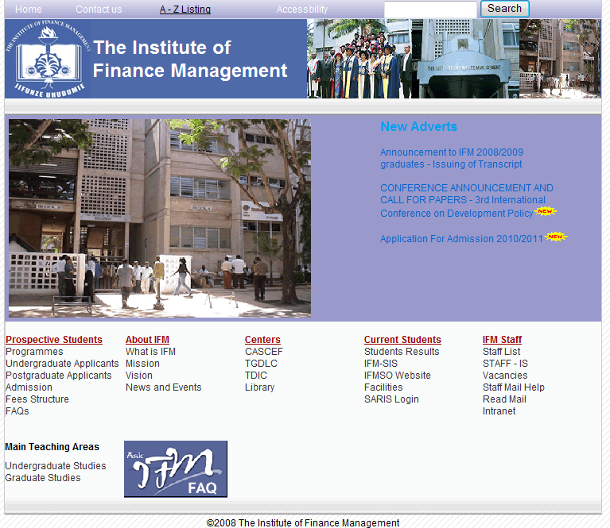
CLICK HERE TO LOGIN

STEP 2

SARIS LOGIN FORM
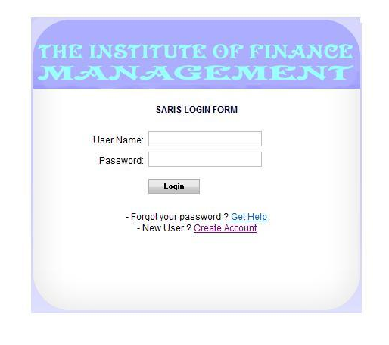
CLICK HERE TO CREATE YOUR ACCOUNT
STEP 3
STEP 5
STEP 6

REGISTRATION FORM
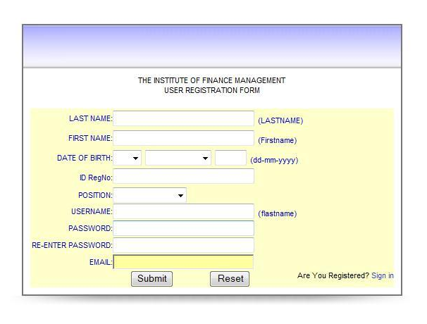
AFTER FILLING THE FORM CLICK HERE TO SUBMIT
STEP 4

