Design document

Automated greenhouse

# Components

### Frame

* Lego set
  + Cost: $0 (Already owned)
  + Main advantages:
    - Recyclable
    - Lighting control easier
  + Main disadvantage:
    - Opaque – System won’t be seen from the outside so easily
  + Difficulty: Easy
* Acrylic
  + Cost: $87
  + Main advantages:
    - Transparent – The system could be seen from the outside
  + Main disadvantages:
    - Lighting control would be harder, since LEDs wouldn’t be enough
  + Difficulty: Hard

**Conclusion: I’m using the LEGO set because the lighting control requirement will be easier to fulfill and the cost is minimum**

### Processor

* Arduino
  + Cost: $0 (Already owned)
  + Operating voltage: 5V
  + PWM pins:6
  + Network Connectivity: None
  + OS: None
  + Difficulty: Medium
* Raspberry Pi
  + Cost: $0 (Already owned)
  + Operating voltage: 3.3V
  + PWM pins: 4
  + Network connectivity: WiFi and Ethernet
  + OS: Raspbian
  + Difficulty: Medium

**Conclusion: I’m using both Raspberry Pi and Arduino, since I need the connectivity and the processing power from Raspberry Pi, but I’m using a Servomotor, which would benefit from the 5V output from the Arduino. The Arduino will also be needed to read both temperature and lighting sensors, since they both have Analog outputs which need to be turned to digital outputs**

### Servomotor

* Microservo TS90A
  + Cost: $0 (Already owned)
  + Operation voltage: 4.8V – 6V
  + Torque 4.8V: 1.8kg/cm
  + Speed 4.8V: 0.12s/60°
* Microservo MG90S
  + Cost: $76
  + Operation voltage: 4-0 – 7.2 V
  + Torque 4.8V: 10kg/cm
  + Speed 4.8V: 0.2s/60°

**Conclusion: I’m using the TS90A since I already own it and that would decrease the cost. Both operation voltages are similar and the Torque of the TS90A should be enough to lift the greenhouse door**

### Lighting system

* LEDs
  + Cost: $15
  + Operation voltage: 3.2-3.4V
  + Operation current: 20mA
  + Milicandels: 13000 – 15000
  + Difficulty:Easy
* LED Matrix
  + Cost: $50
  + Operation Voltage: 2.1-2.5V
  + Operation Current: 20mA
  + Difficulty: Medium

**Conclusion: I’ll use LED’s since they are cheaper, they fit better inthe constraints and the implementation is easier**

### Lighting sensor

* LDR Photorresistor GL5516
  + Cost: $0 (Already owned)
  + Response time: 20ms rise – 30ms decay
* LDR Photorresistor PGM5
  + Cost: $35
  + Response time: 30ms rise – 40ms decay

**Conclusion: Most photorresistors are similar, I’mgoingwith the one that I already own, since it represents less cost**

### **Cooler kit**

* Peltier cell TEC1-12706 DIY kit
  + Cost: $350
  + Operation voltage: 12-15V
  + Operation current: 4-4.6A
  + Difficulty: Easy
* Home-made Peltier cell
  + Cost: ~$400
  + Diffuculty: Hard

**Conclusion: I’m using the DIY kit, since it is cheaper at the end of the day and easier to use**

### Temperature sensor

* LM35
  + Cost: $0 (Already owned)
  + Operating voltage: 4V – 30V
  + Temperature range: -55°C – 150°C
  + Difficulty: Easy
  + Size: Small
* PT100
  + Cost: $45
  + Operating voltage: 5V
  + Difficulty: Easy
  + Size: Medium

**Conclusion: Both sensors meet the requirements for the project. The LM35 is the best option since I already own it and that would decrease the cost, and it is also smaller than the PT100.**

### Power source

* Commuted source A-150FAO-12
  + Cost: $430
  + Output voltage: 12V
  + Output current: 12.5A
  + Size: Small
  + Difficulty: Easy
* DIY Variable Source
  + Cost: $443
  + Output voltage: 1.25-15V
  + Difficulty: Medium

**Conclusion: I’ll use a commuted source since it is cheaper and easier. That way, I won’t take time building the power source**

# Diagram

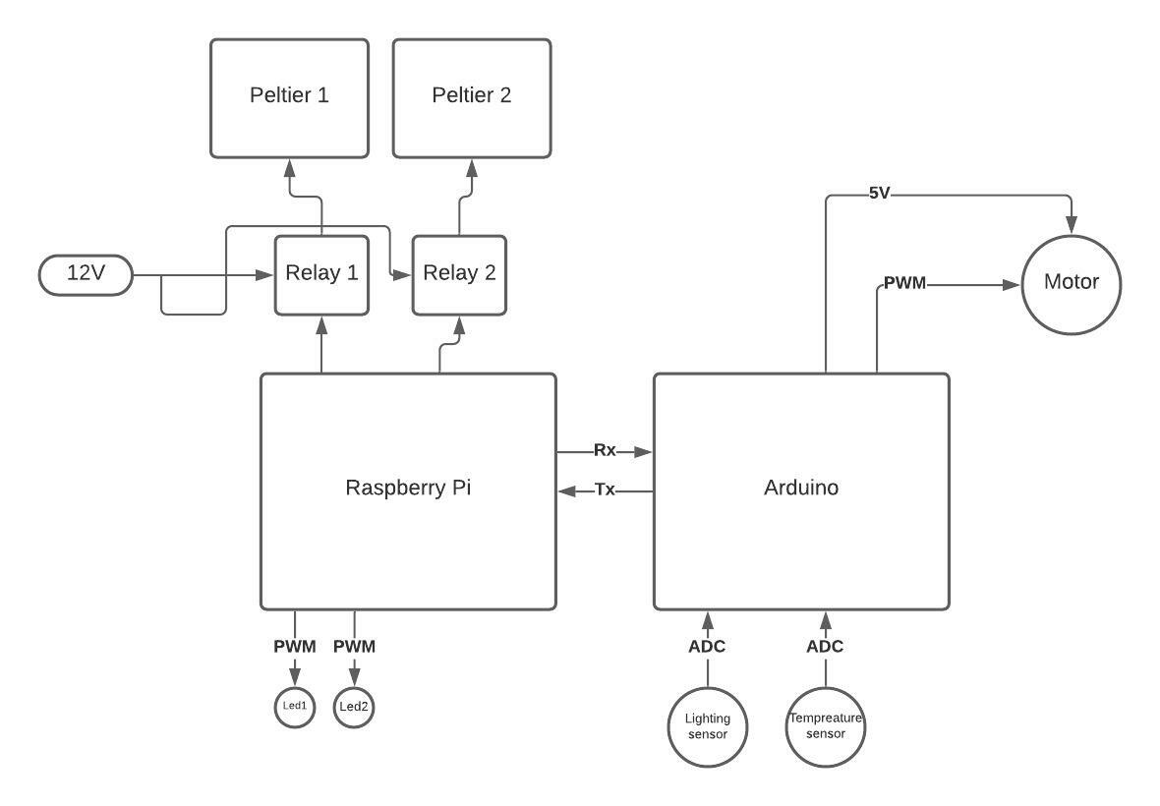

# References

* https://articulo.mercadolibre.com.mx/MLM-905777979-lamina-de-acrilico-transparente-medida-20-x-30-cm-en-3-mm-\_JM?matt\_tool=21623879&matt\_word=&matt\_source=google&matt\_campaign\_id=11764776668&matt\_ad\_group\_id=115046177955&matt\_match\_type=&matt\_network=g&matt\_device=c&matt\_creative=483756047184&matt\_keyword=&matt\_ad\_position=&matt\_ad\_type=pla&matt\_merchant\_id=217571609&matt\_product\_id=MLM905777979&matt\_product\_partition\_id=945076166368&matt\_target\_id=aud-382927026873:pla-945076166368&gclid=CjwKCAjw95yJBhAgEiwAmRrutDJdGEXKMroTeL9PKDBg7zduvwZQZFO8\_DytjwZQ0N8S-qYVtD5W8hoC82kQAvD\_BwE
* https://store-usa.arduino.cc/products/arduino-uno-rev3/
* https://www.hwlibre.com/gpio-raspberry-pi/
* https://articulo.mercadolibre.com.mx/MLM-632053960-micro-servomotor-mg90s-tower-pro-engranes-metalicos-arduino-\_JM?matt\_tool=48904454&matt\_word=&matt\_source=google&matt\_campaign\_id=11714912137&matt\_ad\_group\_id=113017550359&matt\_match\_type=&matt\_network=g&matt\_device=c&matt\_creative=482511924687&matt\_keyword=&matt\_ad\_position=&matt\_ad\_type=pla&matt\_merchant\_id=164788322&matt\_product\_id=MLM632053960&matt\_product\_partition\_id=353037831509&matt\_target\_id=aud-382927026873:pla-353037831509&gclid=CjwKCAjw95yJBhAgEiwAmRrutBO60sUnCWl1vHpblGJEzXOTpFJY9R045XNNEsKIuGW8Oo7C1WBidhoC6rQQAvD\_BwE
* https://www.geekfactory.mx/tienda/motores-actuadores-servos-y-accesorios/mg90s-tower-pro-micro-servo-motor-metalico/
* http://www.servotronik.com.co/index.php/producto/micro-servo-motor-ts90a-360-grados-sg90/
* <https://www.agelectronica.com/detalle.php?p=OKY3522>
* <https://www.agelectronica.com/detalle.php?p=LED-W5D-UB-R30>
* <https://www.datasheetarchive.com/pdf/download.php?id=c1373b92ce994c174e63f1252538617ae85e5c&type=P&term=photoresistor%2520LDR%25205mm>
* <https://artofcircuits.com/product/5mm-photoresistor-gl5516>
* https://www.amazon.com.mx/tresd-print-tech-Enfriamiento-Peltier/dp/B08KSHTVK3/ref=asc\_df\_B08KSHTVK3/?tag=gledskshopmx-20&linkCode=df0&hvadid=476119879348&hvpos=&hvnetw=g&hvrand=9567429198984193045&hvpone=&hvptwo=&hvqmt=&hvdev=c&hvdvcmdl=&hvlocint=&hvlocphy=20709&hvtargid=pla-1076144106401&psc=1
* https://www.geekfactory.mx/tienda/componentes-electronicos/celda-peltier-tec1-12706/#:~:text=Caracter%C3%ADsticas%20de%20la%20Celda%20Peltier%20Tec1%2D12706%3A&text=Temperatura%20lado%20caliente%3A%2050%2D57%C2%BAC,Voltaje%20nominal%3A%2012V
* https://www.youtube.com/watch?v=7ByNDIF3860
* <https://www.hwlibre.com/lm35/>
* <https://articulo.mercadolibre.com.mx/MLM-620605748-pt100-sensor-de-temperatura-2-hilos-_JM?matt_tool=48904454&matt_word=&matt_source=google&matt_campaign_id=11714912137&matt_ad_group_id=113017550359&matt_match_type=&matt_network=g&matt_device=c&matt_creative=482511924687&matt_keyword=&matt_ad_position=&matt_ad_type=pla&matt_merchant_id=278747651&matt_product_id=MLM620605748&matt_product_partition_id=353037831509&matt_target_id=pla-353037831509&gclid=Cj0KCQjwvaeJBhCvARIsABgTDM5L-5HOhh2eCAOC3_NFp1C6Ftk8iHLs6eFuo54qF_lwAYIYmqkmcncaAtZ3EALw_wcB>
* [https://articulo.mercadolibre.com.mx/MLM-639904568-fuente-de-alimentacin-lm317-125v-12v-voltaje-regulado-\_JM#reco\_item\_pos=1&reco\_backend=machinalis-seller-items-pdp&reco\_backend\_type=low\_level&reco\_client=vip-seller\_items-above&reco\_id=60d8fb36-ce6e-4ccb-991a-7c1826d5b5bc](https://articulo.mercadolibre.com.mx/MLM-639904568-fuente-de-alimentacin-lm317-125v-12v-voltaje-regulado-_JM" \l "reco_item_pos=1&reco_backend=machinalis-seller-items-pdp&reco_backend_type=low_level&reco_client=vip-seller_items-above&reco_id=60d8fb36-ce6e-4ccb-991a-7c1826d5b5bc)
* <https://www.agelectronica.com/detalle.php?p=A-150FAO-12>