Requirement specification document

Automated greenhouse

# User Perspective

The automated greenhouse is a place where the user wil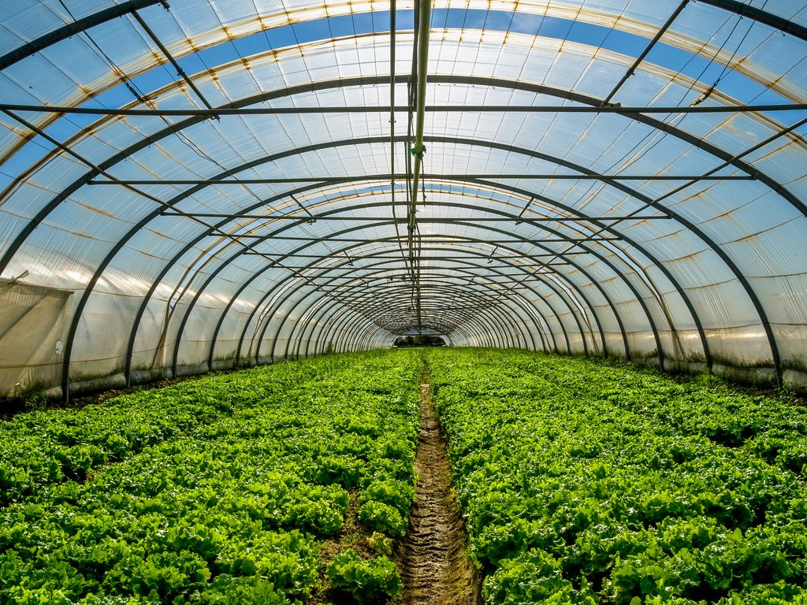l be able to grow any kind of plants. The user will be able to control some climatic conditions from a Graphic Interface:

* Lighting
* Temperature

The user should also be able to control the door.

To change any of the climatic conditions of the greenhouse or control the door, these are the steps that the user should follow:

1. Install the Greenhouse program into a computer
2. Open the Greenhouse program
3. Click on the Connect/Disconnect button
4. Wait for the “Connection successful!” message
5. Now the user is ready to use the system
6. Control the temperature, sliding a bar up and down
7. Control the lighting using a knob
8. Switch opening and closing the door with a button
9. When the user is done using the program, he should make sure to click on the Connect/Disconnect button to end the connection

# Designer Perspective

The system will be composed by two parts:

* Automated Greenhouse model
* Graphic User Interface

The Greenhouse model will be built out of LEGO. It will have a Raspberry Pi to control all the physical systems, as well as for getting information about the current condition of the greenhouse:

* A temperature sensor to know the current temperature inside the model
* A Peltier cell to heat and cool the mo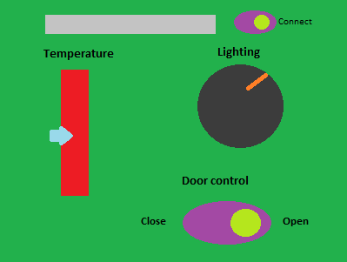del
* A lighting sensor to know the current lighting of the model
* LEDs to control lighting
* A servomotor to open and close the door

The Graphic User Interface will be programmed in LabView.

There must be a networked connection through a socket between the Graphic User Interface and the Raspberry Pi.

# Constraints

These are the constraints for the design (The cost is calculated in MXN, since the system will be built in Mexico):

* Total cost: $3,892
  + LEGO set: $389 (Already owned)
  + Raspberry Pi: $2,420 (Already owned)
  + LEGO base: $99 (Already owned)
  + Servomotor: $160 (Already owned)
  + LEDs: $20 (Already owned)
  + Lighting sensor: $25 (Already owned)
  + Peltier cell: $89
  + Kit cooler-disipator: $365
  + Temperature sensor: $75 (Already owned)
  + Power source: $250
* Design time: 2 weeks
* Implementation time: 2 weeks
* Expected results: A fully functional system that controls lighting, temperature and a door through a Graphic Interface.