The co-evolution arms race in predator-prey dynamics
Sarit Moses (211772900), Itamar Nini (207047150)

Abstract
Lsjfkljs

Introduction
The relationship between a predator and its prey is a main driver of evolution for both populations. The prey must develop new strategies to avoid the predator (increased speed, camouflage, venomous skin to prevent predation etc.) and the predator must develop new strategies to hunt the prey (increased speed, venom resistance, physical strength that will help it kill the prey etc.). This drives a co-evolutionary arms race between a predator and its prey, which leads to rapid evolution and constant improvement of their fitness values.
In this work, we aim to simulate predator-prey dynamics. We aim to repeat known works modelling this interaction (lotka-volterra), and to provide insights into the influence of this relationship on the fitness of each of the species.

Results
Lotka Volterra dynamics
Add here explanation
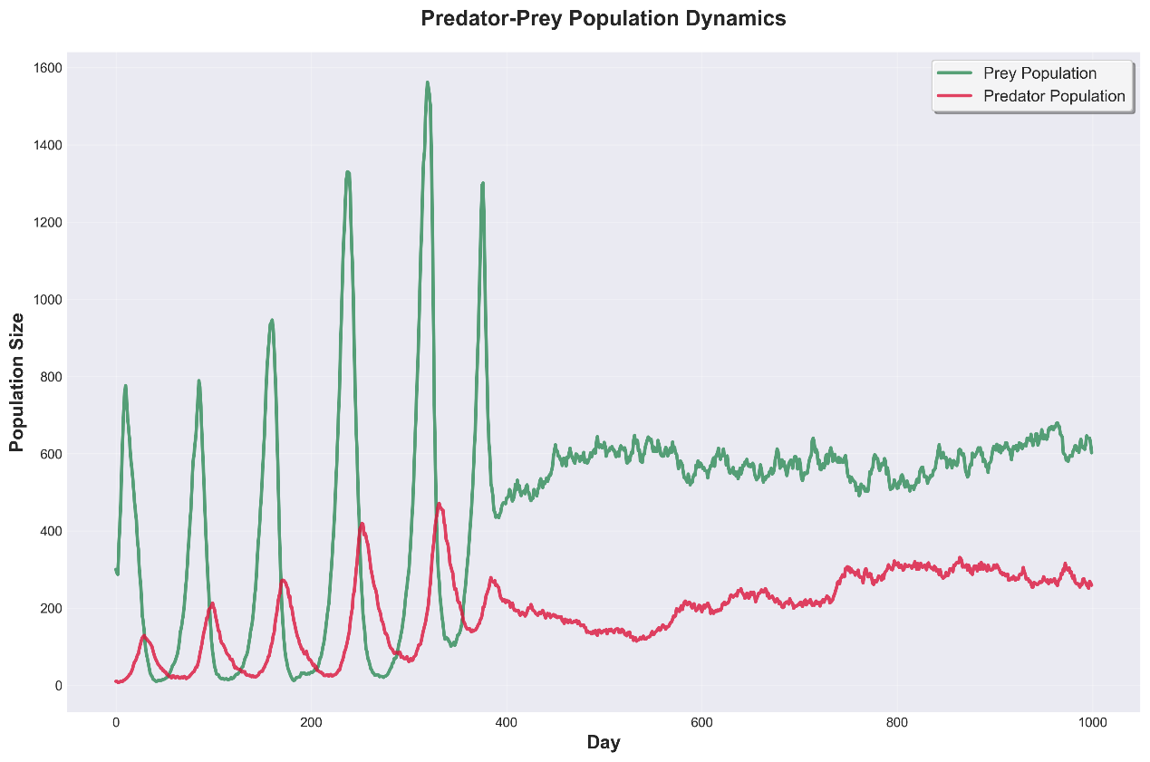
Fig 1. Population sizes of the predator and prey populations over time in the simulation.
Lsj
The presence of a predator drives improvement in prey fitness
Slkfjls
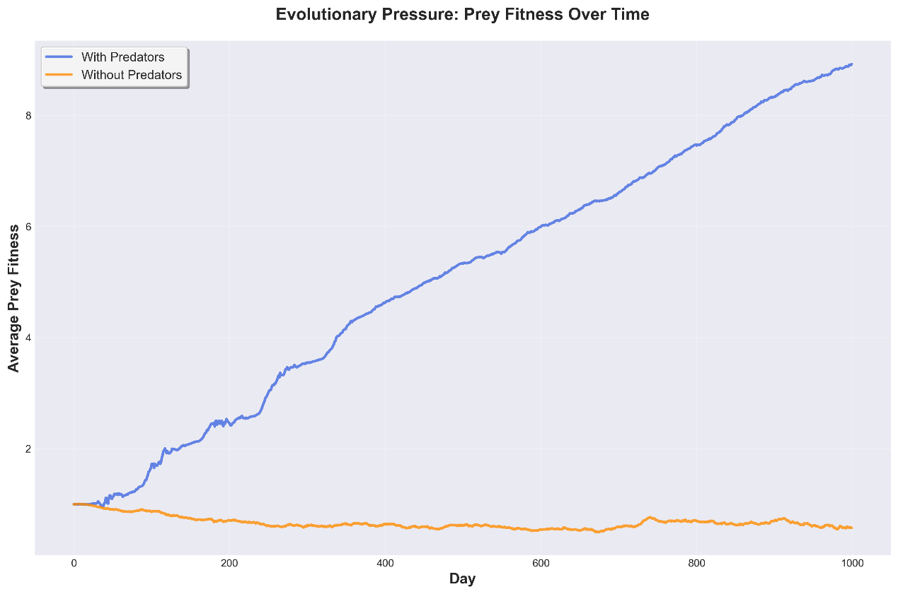
Fig 2. Prey fitness only improves with the presence of a predator (evolutionary constraint)
Lkj
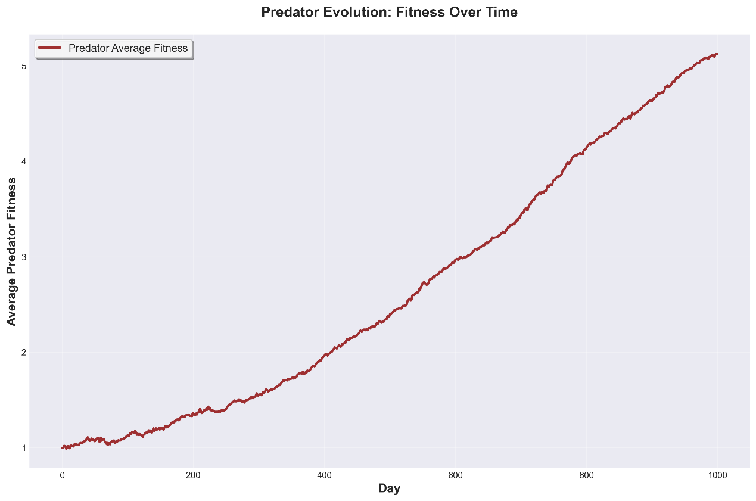
Fig 3. Predator fitness is improved as well because of the arms race
Lsjl
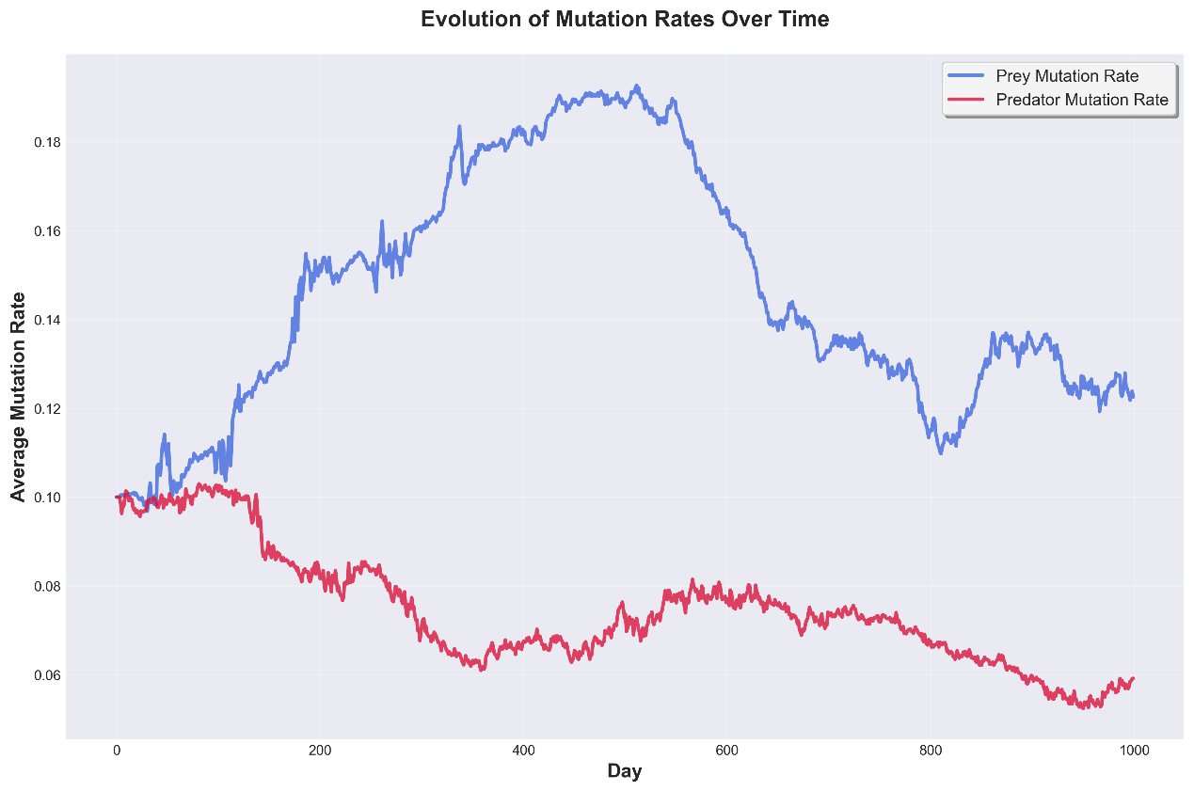
Fig 4. Mutation rate of predator and prey over time (what is this graph telling us? No particular relationship between predator and prey. Should we plot here mutation rate and population size on same plot? Maybe this will tell us something)
Llks
Seasonal impact of grass abundance (abiotic pressure)
Slkj s
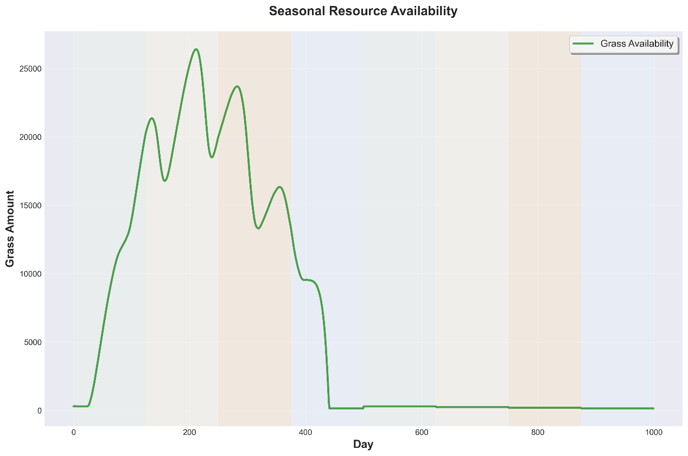
Fig 5. The impact on seasons on grass abundance
Lksjl
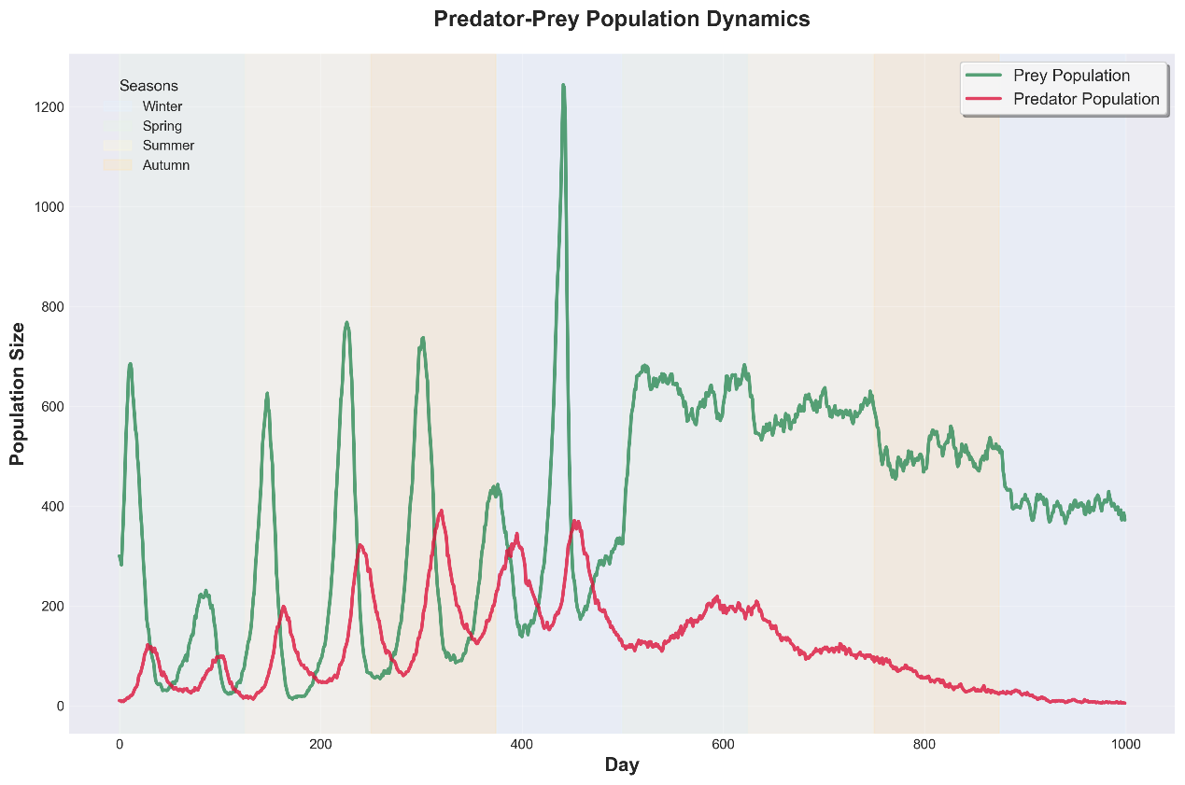
Fig 6. Impact of seasons on lotka-volterra ossilations
Lj

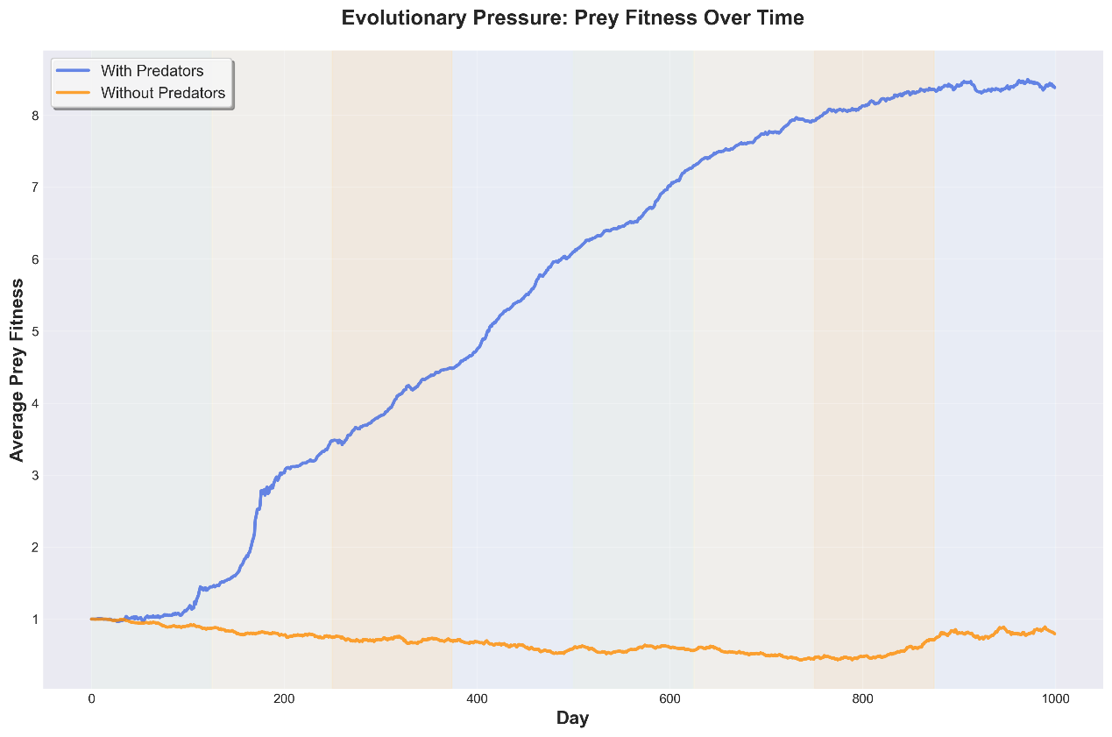
Fig 7. Seasons do not impact fitness of the prey?
Kjk
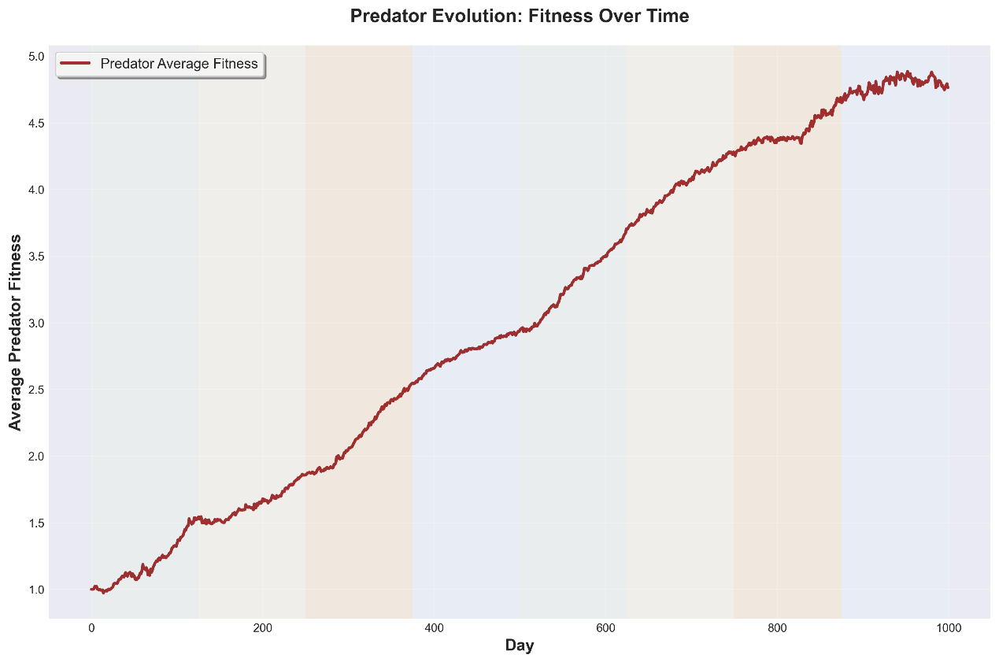
Fig 8. Impact of seasons on predator fitness
klk
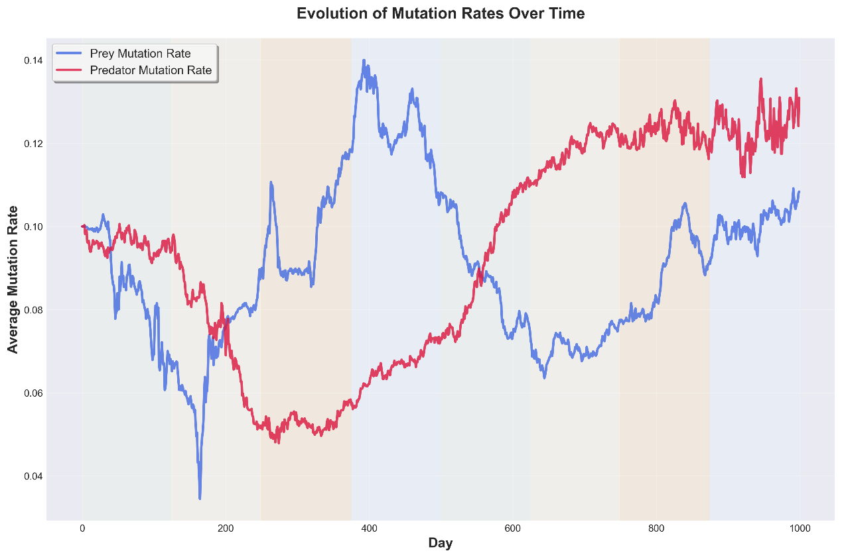
Fig 9. Seasons do not impact mutation rate?
lsjfkl

Discussion
Lkksjlk

Bibliography
Add references here

