**EventBridge Rule Creation Steps**

# **In AWS Console navigate below path:**

Amazon EventBridge ->Buses->Rules->Create  
  
**Add below details in specified steps:**STEP 1: Define rule detail

* Name: NGE-Box-Master-SF-Trigger
* Description – *optional:* Not Required
* Event bus: default
* Rule type: Schedule

## STEP2: Define schedule

* Schedule pattern: Select “A fine-grained schedule that runs at a specific time, such as 8:00 a.m. PST on the first Monday of every month.”
* Cron expression: Trigger need to be scheduled at 8 AM (EST)/12 PM (UTC) every Wednesday & Saturday.

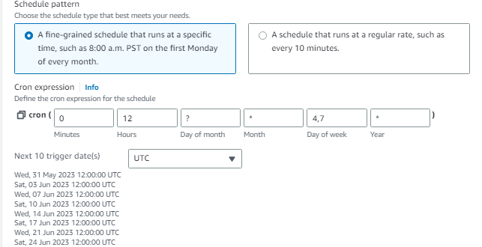

## STEP3: Select target(s)

* Target types: AWS service
* Select a target: Step Functions state machine
* State machine: NGE-Box-Master-Step-Function
* Execution role: Use existing role:

PRD-NGE-BOX-Stepfunction-Execution-role

STEP4: Configure tags

* Not Required

## STEP5: Review and create

* Need to review and create