SPRING 2025
COMP 302
KU Tower Defense
R1M1

TeamD
Ahmet Taha Ekim - 79234
Muhammed Talha Sarıtepe - 79264
Mert Tuna – 80363
Doğu Arslan – 76649
Emir Göcen – 79634

Table of Contents
Use Case Diagram 4
Use Case Narratives 5
Use Case 1: Start New Game 5
Use Case 2: Select Map 6
Use Case 3: Place Tower 7
Use Case 4: Sell Tower 8
Use Case 5: View Tower Range 9
Use Case 6: Set Game Parameters 10
Use Case 7: Save Game Options 11
Use Case 8: Save Map File 12
Use Case 9: Validate Map 13
Use Case 10: Start Enemy Wave 14
Use Case 11: Enemy Reaches Exit 15
Use Case 12: Enemy Defeated 16
Use Case 13: Pause / Resume Game 17
Use Case 14: Toggle Game Speed 18
Use Case 15: Display Game Over 19
Domain Model 20
System Sequence Diagrams 21
SSD1: Start New Game 21
SSD2: Select Map 22
SSD3: Place Tower 23
SSD4: Sell Tower 24
SSD5: View Tower Range 25
SSD6: Set Game Parameters 26
SSD8: Save Map File 27
SSD7: Save Game Options 28
SSD9: Validate Map 29
SSD10: Start Enemy Wave 30
SSD11: Enemy Reaches Exit 31
SSD12: Enemy Defeated 32
SSD13: Pause / Resume Game 33
SSD14: Toggle Game Speed 34
SSD15: Display Game Over 35
Operation Contracts 36
Vision 45
Supplementary Specifications 46
Glossary 47

Use Case Diagram
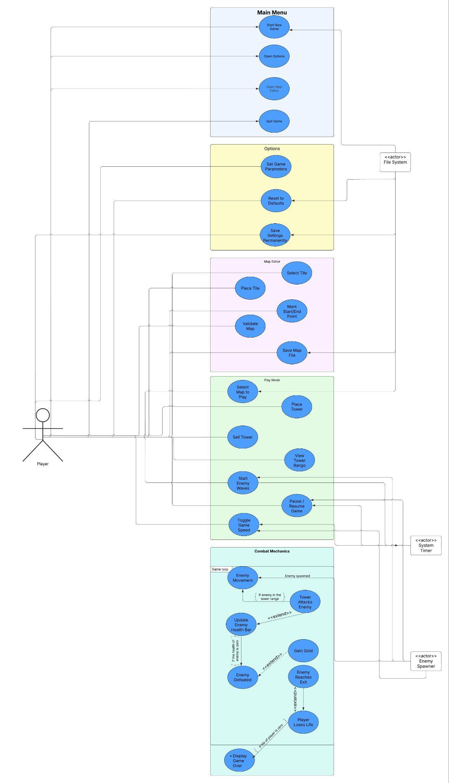
Figure 1: Use Case Diagram

Use Case Narratives

Use Case 1: Start New Game
Use Case Name | Start New Game
Scope | Main Menu
Level | User goal
Primary Actor | Player
Stakeholders and Interests | - Player: Wants to quickly begin the game.  - Game System: Must load resources and prepare the game without failure.
Preconditions | - The game is on the main menu.  - At least one saved map exists.
Postconditions | - Player is redirected to map selection.  - Game is ready to start with the selected map.
Main Success Scenario | - Player clicks "New Game" on the main menu.  - System displays a list of saved maps.  - Player selects a map.  - System loads the map data.  - Game screen and UI elements are initialized.
Extensions | - 3a. Player closes map selection screen: System returns to main menu.  - 4a. Map file is corrupted or missing: System shows error and returns to main menu.
Special Requirements | - No lag or freezing during map loading.  - Map selection UI should be responsive.

Use Case 2: Select Map
Use Case Name | Select Map
Scope | Play Mode
Level | Subfunction
Primary Actor | Player
Stakeholders and Interests | - Player: Wants to choose a desired map to play.  - Game System: Should load valid map files.
Preconditions | - Player clicked "New Game."  - At least one valid map is available.
Postconditions | - A valid map is selected and ready to load.
Main Success Scenario | - System lists available map files.  - Player clicks a map.  - System verifies the file.  - If valid, the map is queued for gameplay.
Extensions | - 3a. Map file is invalid or unreadable: System shows error and suggests alternatives.  - 2a. Player closes the screen: Return to the main menu.
Special Requirements | - Map file list should update with current directory content.

Use Case 3: Place Tower
Use Case Name | Place Tower
Scope | Play Mode
Level | User goal
Primary Actor | Player
Stakeholders and Interests | - Player: Wants to place a tower in a strategic location.  - Game System: Should ensure gold availability and build correctly.
Preconditions | - Gameplay screen is active.  - Player has enough gold.  - Selected location is empty.
Postconditions | - Selected tower is built.  - Gold is deducted.
Main Success Scenario | - Player clicks on an empty lot.  - Tower selection menu is displayed.  - Player selects the tower type.  - System checks for gold.  - Tower is built if funds are sufficient.  - Gold balance is updated.  - Tower becomes active.
Extensions | - 3a. Player cancels selection: Menu closes.  - 4a. Not enough gold: Show warning, cancel action.
Special Requirements | - Only one tower per lot.  - Responsive UI and animations.

Use Case 4: Sell Tower
Use Case Name | Sell Tower
Scope | Play Mode
Level | User goal
Primary Actor | Player
Stakeholders and Interests | - Player: Wants to reclaim some gold by selling unneeded towers.  - Game System: Must remove the tower and return the appropriate gold amount.
Preconditions | - A tower is already built on the selected lot.
Postconditions | - Tower is removed.  - Player receives a partial refund.  - The lot becomes empty again.
Main Success Scenario | - Player clicks on an existing tower.  - System shows a popup menu with the "Sell Tower" option.  - Player selects "Sell Tower."  - System removes the tower.  - Refund is added to player's gold.  - The lot is now available for new construction.
Extensions | - 2a. Player clicks elsewhere: Menu is dismissed without selling.  - 3a. Tower data is corrupted: Show error and cancel sale.
Special Requirements | - Refund calculation must be based on tower type and upgrade level.

Use Case 5: View Tower Range
Use Case Name | View Tower Range
Scope | Play Mode
Level | Subfunction
Primary Actor | Player
Stakeholders and Interests | - Player: Needs to see the effective range of a tower for strategic decisions.  - Game System: Must visually represent range accurately.
Preconditions | - At least one tower is on the map.
Postconditions | - Tower range is shown when the tower is clicked.
Main Success Scenario | - Player click on tower.  - System displays a circular overlay showing the tower's range.  - When the cursor leaves the tower, the overlay disappears.
Extensions | - 1a. Range data missing: System shows error or disables overlay.  - 2a. Overlay animation fails: Use fallback visual.
Special Requirements | - Circle should scale with the exact radius defined by tower stats.  - Must be updated in real time without lag.

Use Case 6: Set Game Parameters
Use Case Name | Set Game Parameters
Scope | Options
Level | User goal
Primary Actor | Player
Stakeholders and Interests | - Player: Wants to customize the gameplay according to preferences.  - Game System: Must apply and save parameters accurately.
Preconditions | - Options screen is open.
Postconditions | - New game parameters are applied and saved.
Main Success Scenario | - Player enters the options screen from the main menu.  - Current settings are displayed.  - Player modifies parameters (e.g., enemy count, wave delays, tower stats).  - Player clicks "Save."  - System validates input values.  - Parameters are saved.  - Player returns to the main menu or continues playing.
Extensions | - 5a. Invalid values entered: System displays error and blocks saving.  - 6a. File write fails: System notifies player and reverts to last saved config.
Special Requirements | - Inputs should be validated client-side.  - Parameters persist across sessions.

Use Case 7: Save Game Options
Use Case Name | Save Game Options
Scope | Options
Level | Subfunction
Primary Actor | Player
Stakeholders and Interests | - Player: Expects saved settings to load in future sessions.  - Game System: Must persist configuration safely.
Preconditions | - Player has modified or confirmed game settings.
Postconditions | - Settings are written to disk and loaded in next sessions.
Main Success Scenario | - Player clicks "Save" in the options menu.  - System performs input validation.  - Valid settings are written to disk.  - Confirmation message is shown.  - Settings are retained between sessions.
Extensions | - 2a. Validation fails: Show error, prevent save.  - 3a. Write operation fails: System notifies player, keeps old settings.
Special Requirements | - File format should be human-readable and editable (e.g., JSON).

Use Case 8: Save Map File
Use Case Name | Save Map File
Scope | Map Editor
Level | User goal
Primary Actor | Player
Supporting Actor | File System
Stakeholders and Interests | - Player: Wants to reuse custom maps.  - Game System: Must write structured map data correctly.
Preconditions | - Map editor is open.  - Start and end points are set.
Postconditions | - Map is saved to the file system and available for gameplay.
Main Success Scenario | - Player clicks "Save" in the map editor.  - System validates the map structure.  - System prompts for filename or uses default.  - Map is saved to disk.  - Success message is shown.
Extensions | - 2a. Validation fails: System shows errors, prevents saving.  - 4a. File system error: Notify player, allow retry.
Special Requirements | - Filename sanitization is required.  - Saved files should appear in the map selection screen.

Use Case 9: Validate Map
Use Case Name | Validate Map
Scope | Map Editor
Level | Subfunction
Primary Actor | Player
Stakeholders and Interests | - Player: Wants to ensure the map meets game rules.  - Game System: Must check for structure, connectivity, and gameplay constraints.
Preconditions | - Player has created a custom map in the editor.
Postconditions | - Validation result is displayed.  - Save is permitted only if the map is valid.
Main Success Scenario | - Player clicks "Validate" (or triggers it on save).  - System checks for validity.  - If valid, allow save.  - Otherwise, list errors.
Extensions | - 2a. Multiple issues found: All errors are shown together.  - 2b. Critical errors block saving even if minor ones are ignored.
Special Requirements | - Live validation is encouraged.

Use Case 10: Start Enemy Wave
Use Case Name | Start Enemy Wave
Scope | Combat Mechanics
Level | System-level user goal
Primary Actor | System Timer
Stakeholders and Interests | - Player: Wants waves to begin smoothly.  - Game System: Must schedule waves and spawn enemies reliably.
Preconditions | - Game is active.  - Grace period has passed.
Postconditions | - First group of enemies is spawned.  - Groups and waves continue on schedule.
Main Success Scenario | - Grace period ends.  - System spawns the first group of the wave.  - Enemies appear at correct intervals.  - After a delay, the next group is spawned.  - Wave ends, long pause before next wave.
Extensions | - 1a. Game is paused: Delay enemy spawning.
Special Requirements | - All timing should be adjustable from options.  - Wave logic must support retries and failover.

Use Case 11: Enemy Reaches Exit
Use Case Name | Enemy Reaches Exit
Scope | Combat Mechanics
Level | System-level
Primary Actor | Enemy
Stakeholders and Interests | - Player: Wants to be fairly penalized for letting enemies through.  - Game System: Must reduce life count correctly and handle end-of-game state.
Preconditions | - At least one enemy is moving toward the exit.
Postconditions | - Enemy is removed from the game.  - Player loses 1 life.  - Game ends if life reaches 0.
Main Success Scenario | - Enemy reaches the end tile.  - System detects enemy position at exit.  - Enemy is removed from the game.  - Player life count is decreased by 1.  - Life count UI is updated.  - If life is 0, show Game Over.
Extensions | - 3a. Enemy stuck at exit: Force remove and apply penalty.  - 6a. If life > 0: Game continues normally.
Special Requirements | - Visual and sound effects should indicate health loss.

Use Case 12: Enemy Defeated
Use Case Name | Enemy Defeated
Scope | Combat Mechanics
Level | System-level
Primary Actor | Tower
Supporting Actor | Game System
Stakeholders and Interests | - Player: Expects gold reward for defeating enemies.  - Game System: Must track health, kill, and reward logic.
Preconditions | - An enemy has been hit by a tower.  - Enemy health less than equals to 0 after hit.
Postconditions | - Enemy is removed from the game.  - Gold is awarded to the player.
Main Success Scenario | - A tower fires at an enemy.  - System calculates and updates health.  - Health <= 0: enemy is marked defeated.  - Enemy disappears.  - Gold amount is added to the player.  - Gold UI is updated.
Extensions | - 4a. Health > 0: Enemy continues moving.
Special Requirements | - Reward amount depends on enemy type.  - Visual effect is shown.

Use Case 13: Pause / Resume Game
Use Case Name | Pause / Resume Game
Scope | Play Mode
Level | User goal
Primary Actor | Player
Stakeholders and Interests | - Player: Needs to temporarily stop the game.  - Game System: Must pause all timers and animations.
Preconditions | - The game is active and running.
Postconditions | - The game is either paused or resumed from the previous state.
Main Success Scenario | - Player clicks "Pause."  - System freezes timers and animations.  - UI updates to show "Resume" button.  - Player clicks "Resume."  - The game continues from the previous state.
Extensions | - 1a. Pause fails: Show warning, keep running.  - 4a. Player exits instead of resuming: Return to main menu.
Special Requirements | - Pause should not affect UI responsiveness.  - State must be preserved exactly.

Use Case 14: Toggle Game Speed
Use Case Name | Toggle Game Speed
Scope | Play Mode
Level | User goal
Primary Actor | Player
Stakeholders and Interests | - Player: May want faster pace during slow segments.  - Game System: Must scale movement and timing accurately.
Preconditions | - The game is running with at least one active enemy.
Postconditions | - Game switches between normal and fast mode.
Main Success Scenario | - Player clicks the "Speed" button.  - System doubles internal timers and movement rates.  - UI displays new speed mode.  - Player clicks again to return to normal speed.  - System reverts all rates to default.
Extensions | - 1a. Game is paused: Prevent speed toggle.  - 2a. Speed change lags: Notify and disable until performance restores.
Special Requirements | - Changes must apply consistently across all components.

Use Case 15: Display Game Over
Use Case Name | Display Game Over
Scope | Combat Mechanics
Level | System-level
Primary Actor | Game System
Stakeholders and Interests | - Player: Must be clearly notified when the game ends.  - Game System: Must terminate gameplay cleanly.
Preconditions | - Player life count reaches 0.
Postconditions | - Game ends.  - Game Over screen is displayed.
Main Success Scenario | - Last enemy reaches the exit, reducing life to 0.  - System pauses the game.  - "Game Over" is shown.  - Background music stops or changes.  - Player clicks anywhere.  - Game returns to the main menu and resets the state.
Extensions | - 5a. Player closes the game directly: Exit safely.
Special Requirements | - Game Over screen should include animation and sound.  - No inputs should affect the game after Game Over appears.

Domain Model
- Following is the UML class diagram of the domain model including more than 10 domain classes.
- There is no software component in the following diagram such as database, UI, etc.
Initial Domain Model:
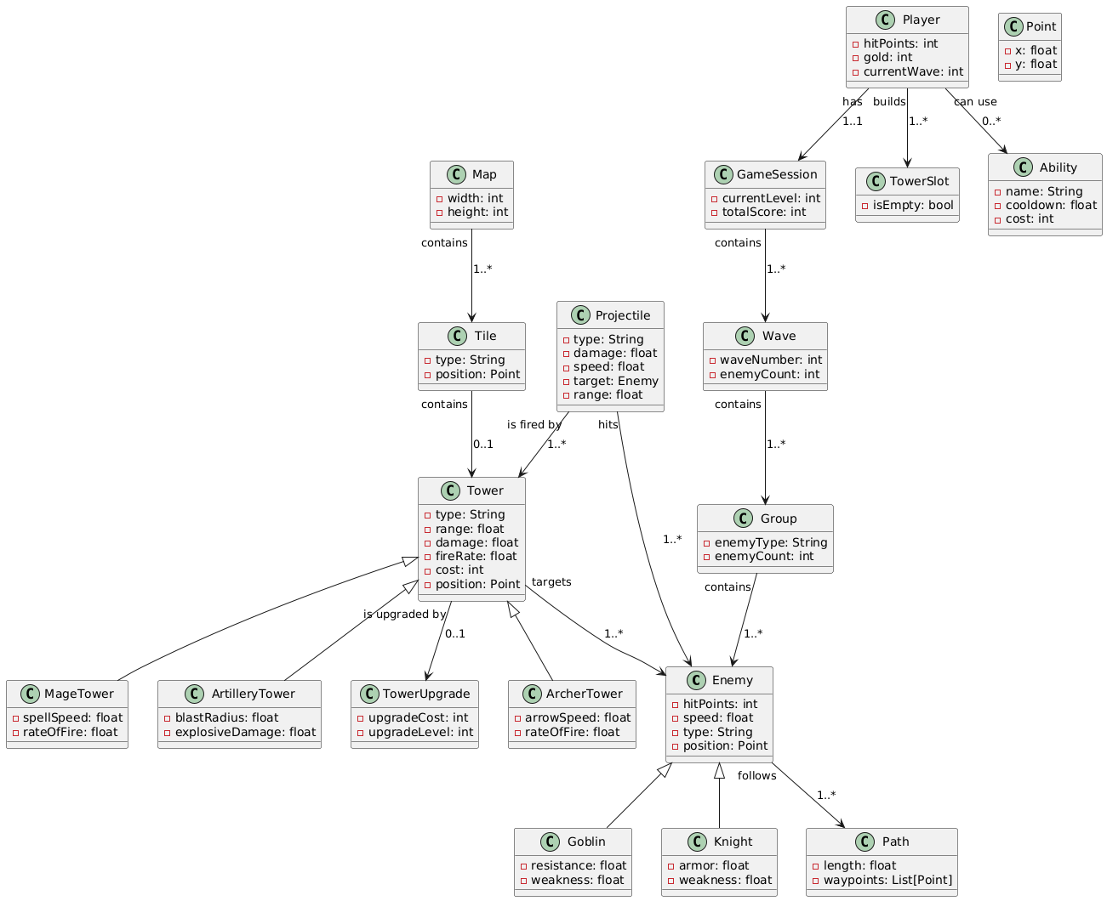
Figure 2.1: Initial Domain Model Diagram

Updated Domain Model:
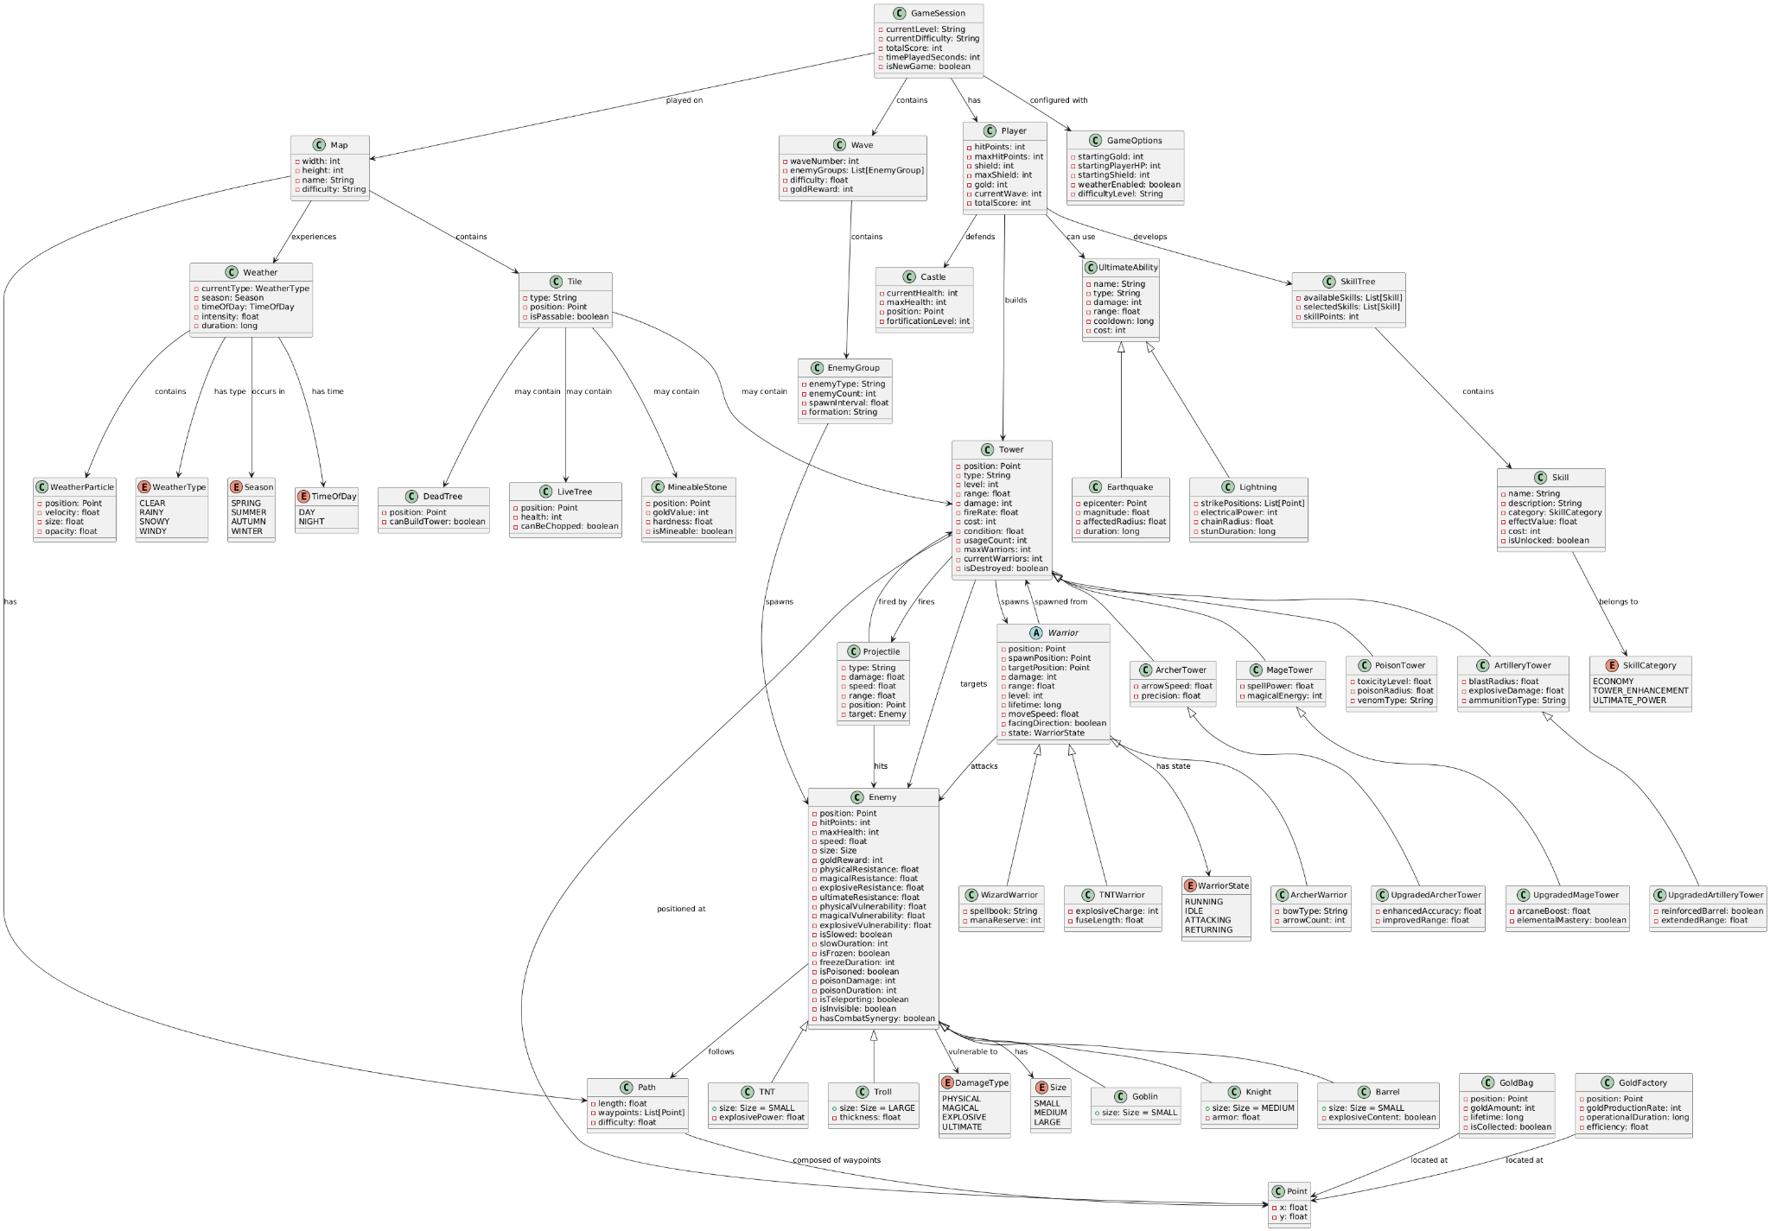
Figure 2.2: Updated Domain Model Diagram

System Sequence Diagrams
All of the UML System Sequence Diagrams below are built with PlantUML; all the UML syntax corresponding to each diagram can be found in the COMP302/SSD/ folder.

SSD1: Start New Game
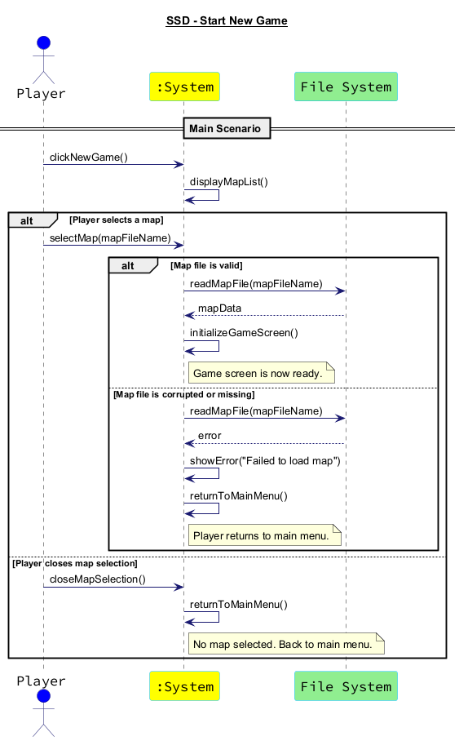
Figure 3: SSD Start New Game

SSD2: Select Map
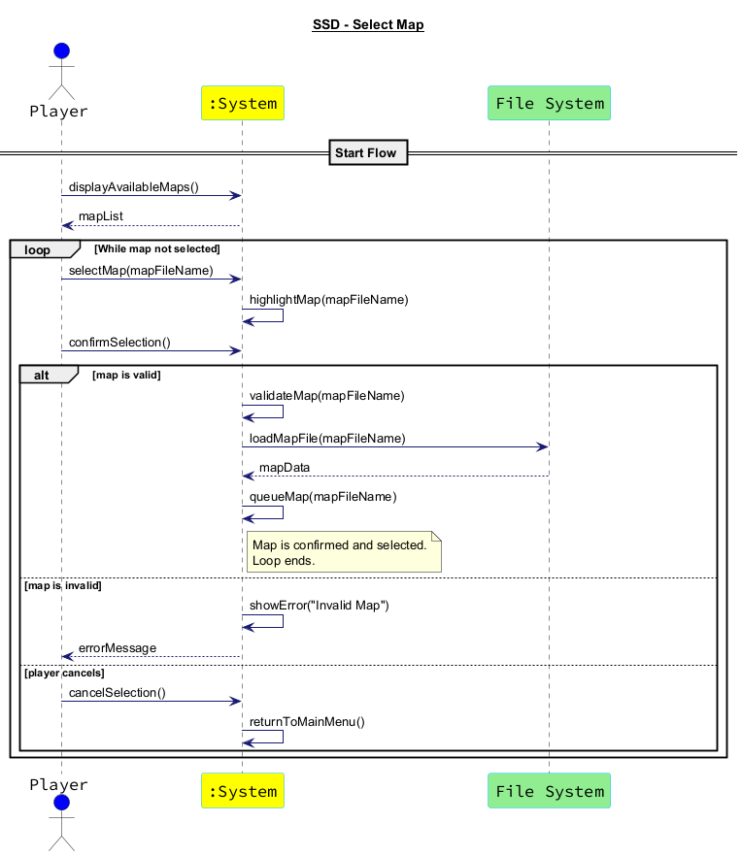
Figure 4: SSD Select Map

SSD3: Place Tower
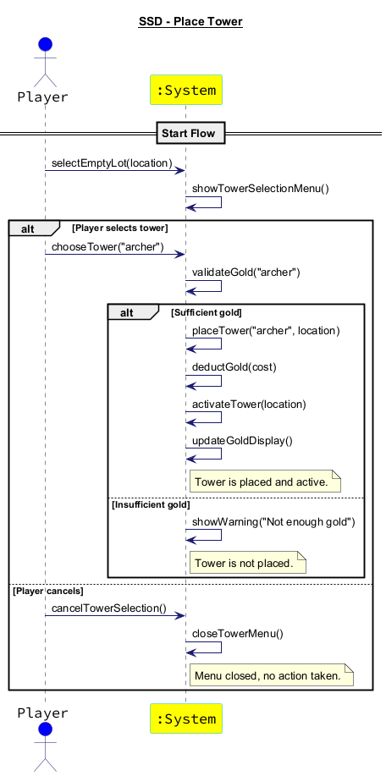
Figure 5: SSD Place Tower

SSD4: Sell Tower
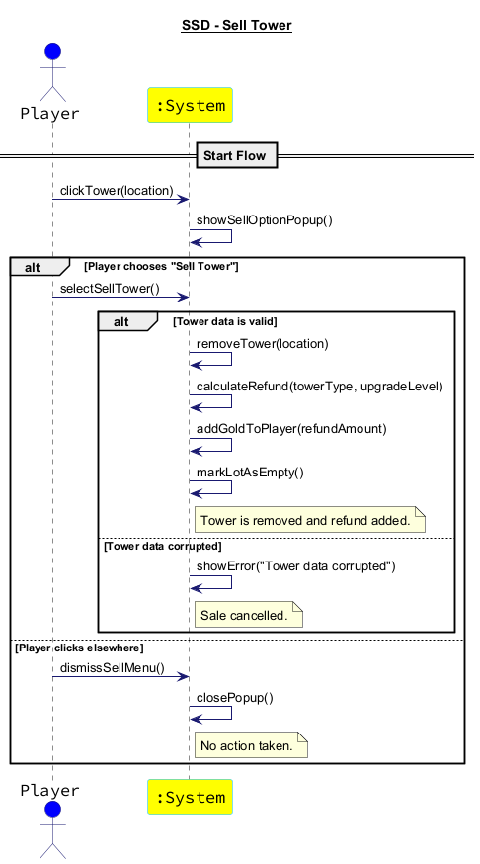
Figure 6: SSD Sell Tower

SSD5: View Tower Range
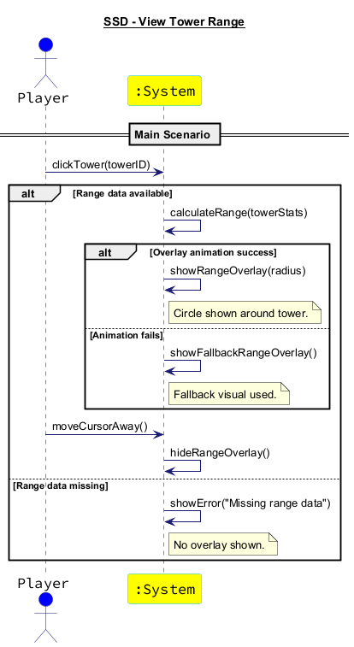
Figure 7: SSD View Tower Range

SSD6: Set Game Parameters
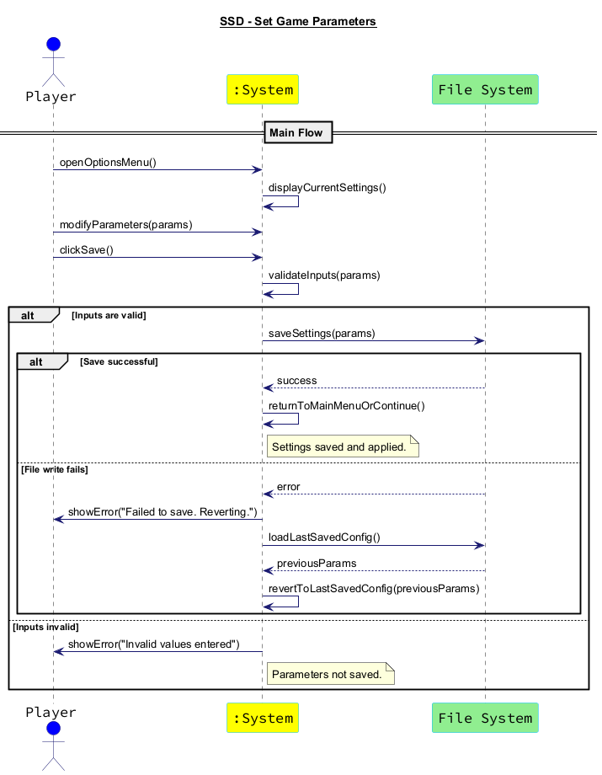
Figure 8: SSD Get Parameters

SSD8: Save Map File
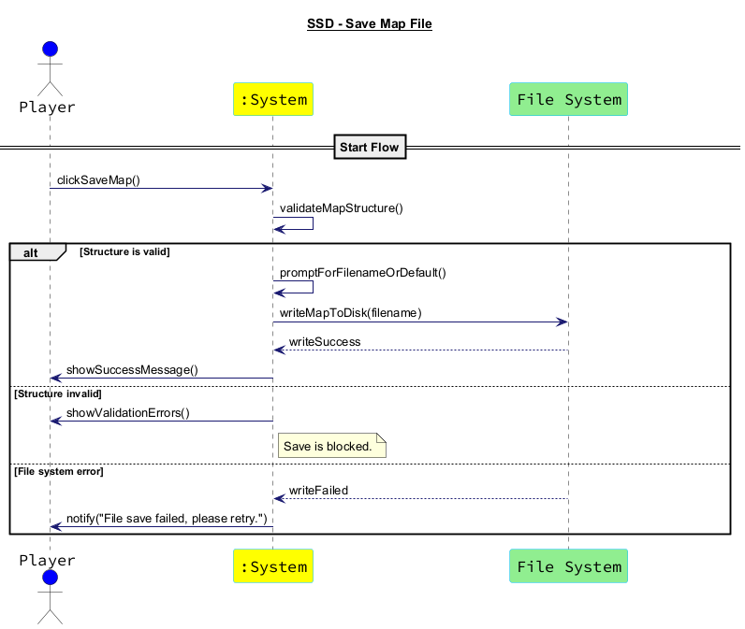
Figure :9 SSD Save Map File

SSD7: Save Game Options
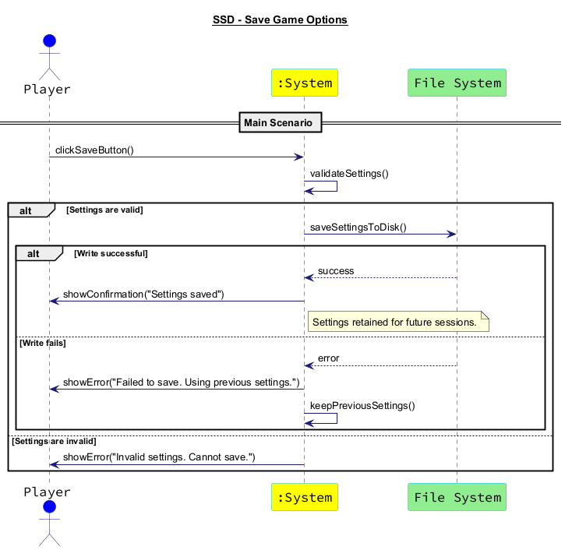
Figure 10: SSD Save Game Options

SSD9: Validate Map
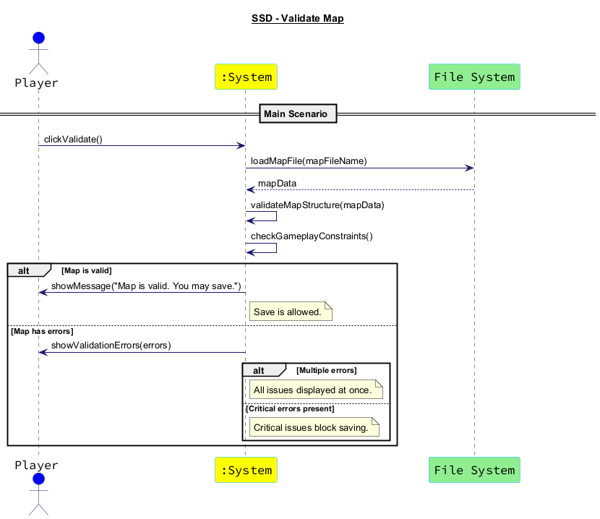
Figure 11: SSD Validate Map

SSD10: Start Enemy Wave
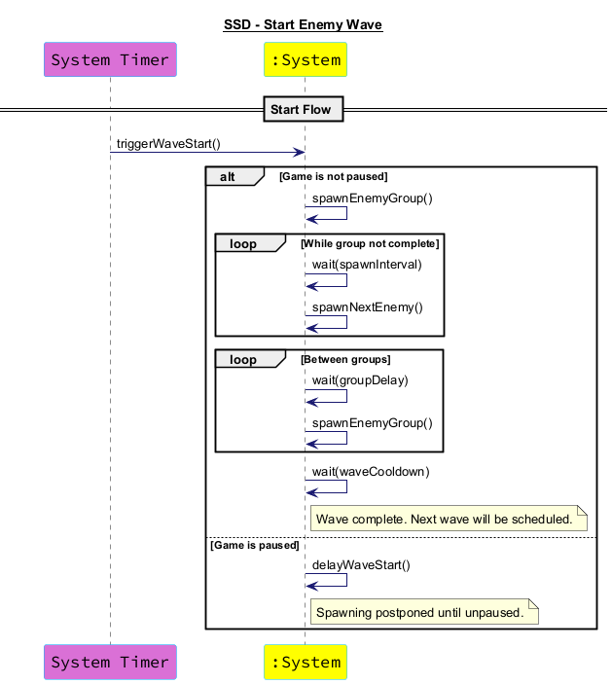
Figure 12: SSD Start Enemy Wave

SSD11: Enemy Reaches Exit
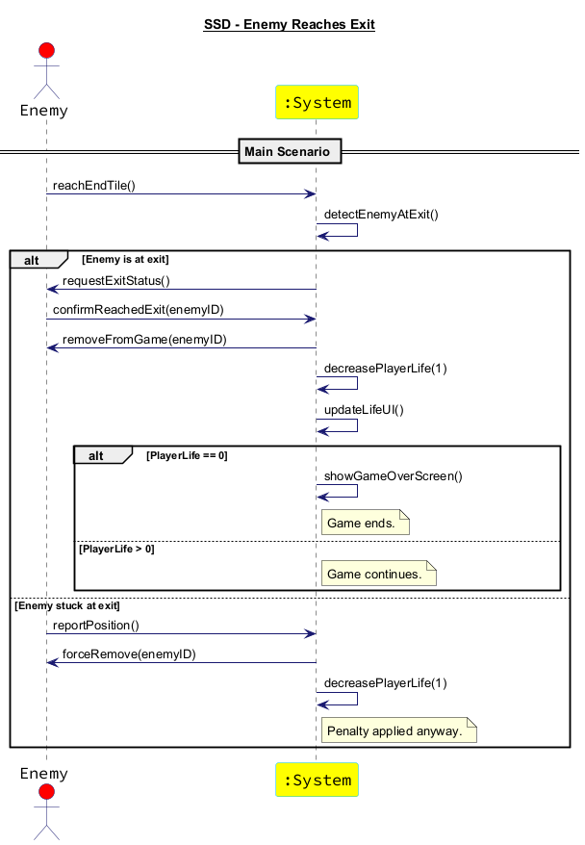
Figure 13: SSD Enemy Reaches Exit

SSD12: Enemy Defeated
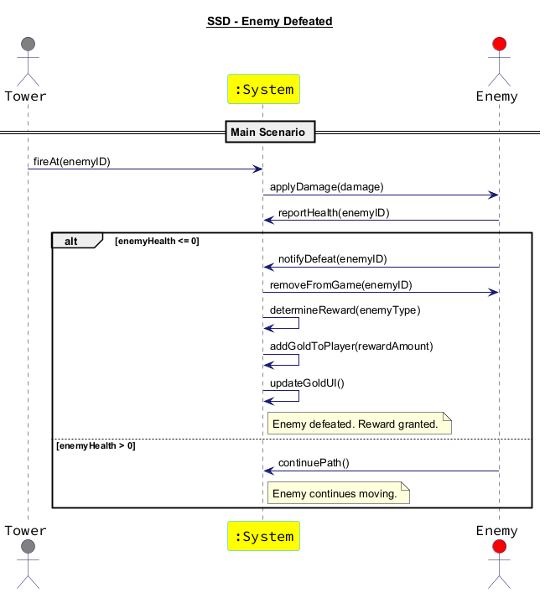
Figure 14: SSD Enemy Defeated

SSD13: Pause / Resume Game
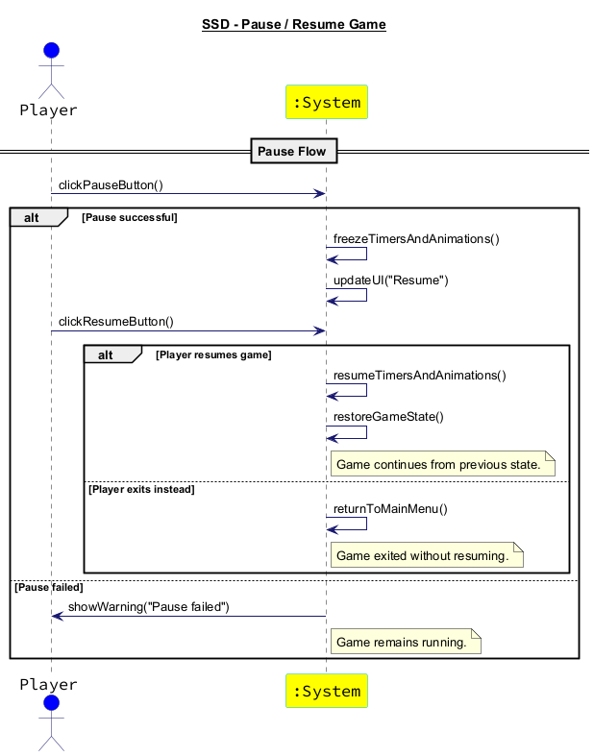
Figure 15: SSD Pause / Resume Game

SSD14: Toggle Game Speed
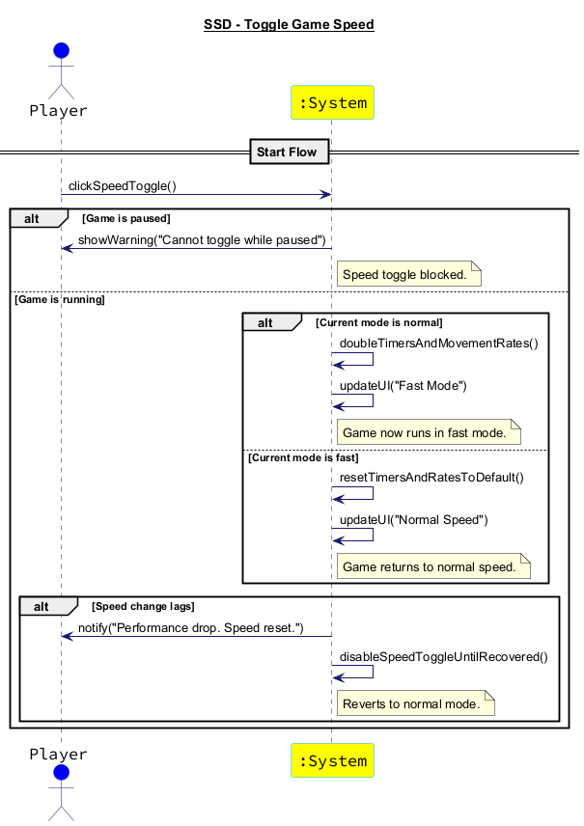
Figure 16: SSD Toggle Game Speed

SSD15: Display Game Over
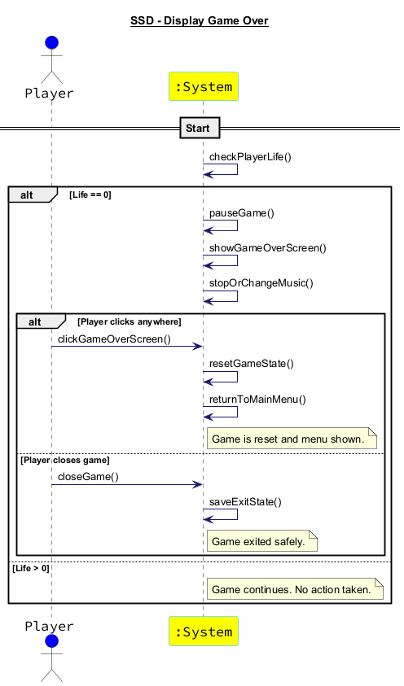
Figure 17: SSD Display Game Over

Operation Contracts
Initial Operation Contracts:
Contract CO1: clickSaveMap

Operation: clickSaveMap()
Cross References: Use Cases: Save Map File
Preconditions:
- The player has initiated the save map operation by clicking the "Save" button.
- The map structure is valid and ready for saving.
Postconditions:
- The system initiated the process to validate the map structure.
- If the map was valid, the system proceeded to prompt for a filename.
- If the structure was invalid, the system showed validation errors.
- If the file system encountered an error, the system notified the player to retry.
Constraints:
- The map structure must meet the game’s requirements for paths and available tower slots.
Contract CO2: clickNewGame

Operation: clickNewGame()
Cross References: Use Cases: Start New Game
Preconditions:
- The player is in the main menu and wants to start a new game.
Postconditions:
- The system displayed the list of available maps for the player to select.
Constraints:
- The system must have a list of available maps stored and accessible for display.

Contract CO3: selectMap

Operation: selectMap(mapFileName: String)
Cross References: Use Cases: Start New Game
Preconditions:
- The player has selected a map from the list.
- The system has received the map file for validation.
Postconditions:
- The system checked if the selected map file is valid and readable.
- If the map was valid, the system proceeded to load the map data and initialize the game screen.
- If the map was invalid, an error was shown, and the system prompted the player to select another map or return to the main menu.
Constraints:
- The system must ensure that the map file is valid and not corrupted.

Contract CO4: loadMapData

Operation: loadMapData(mapFileName: String)
Cross References: Use Cases: Start New Game
Preconditions:
- A valid map file has been selected by the player.
Postconditions:
- The map data (e.g., layout, tiles, paths) was loaded successfully from the file.
- The system prepared the map data for gameplay.
Constraints:
- The map file must be correctly formatted and contain all necessary map data.

Contract CO5: chooseTower

Operation: chooseTower(towerType)
Cross References: Use Cases: Place Tower
Preconditions:
- The player has selected a tower type (e.g., Archer).
Postconditions:
- The selected tower type was passed for validation to ensure the player has sufficient gold to place the tower.
Constraints:
- The system must ensure that the chosen tower is available for selection, based on the player's current state and resources.

Contract CO6: modifyParameters

Operation: modifyParameters(params)
Cross References: Use Cases: Set Game Parameters
Preconditions:
- The player has selected the parameters to modify (e.g., sound volume, difficulty).
Postconditions:
- The system applied the changes to the parameters temporarily, updating the display to reflect the new values.
Constraints:
- The system must ensure that only valid inputs are accepted (e.g., volume level must be within a specific range).

Contract CO7: clickNewGame

Operation: clickNewGame()
Cross References: Use Cases: Start New Game
Preconditions:
- The player is in the main menu and has chosen to start a new game.
Postconditions:
- The system displayed a list of available maps for the player to choose from.
Constraints:
- The system must retrieve and display all available maps that are valid and accessible for the player.
Contract CO8: triggerWaveStart

Operation: triggerWaveStart()
Cross References: Use Cases: Start Enemy Wave
Preconditions:
- The game has reached the point where a new enemy wave needs to start.
Postconditions:
- The system began the process of spawning enemies for the wave.
- The wave start was triggered, and the spawning process initiated.
Constraints:
- The game must not be paused when this function is called, unless explicitly managed.

Contract CO9: wait

Operation: wait(spawnInterval)
Cross References: Use Cases: Start Enemy Wave
Preconditions:
- A group of enemies is in the process of being spawned.
Postconditions:
- The system waited for the defined interval (spawnInterval) before spawning the next enemy within the group.
Constraints:
- The spawn interval must be correctly implemented to prevent too many enemies from spawning too quickly.

Contract CO10: spawnEnemyGroup()

Operation: spawnEnemyGroup
Cross References: Use Cases: Start Enemy Wave
Preconditions:
- The wave has started, and the system is ready to spawn a group of enemies.
Postconditions:
- The system spawned a new group of enemies into the game world.
Constraints:
- The group of enemies must be spawned at the correct location and in a valid game state.

Contract CO11: closeMapSelection

Operation: closeMapSelection
Cross References: Use Cases: Start New Game
Preconditions:
- The player has decided to close the map selection menu without choosing a map.
Postconditions:
- The map selection menu was closed, and the player was returned to the main menu.
- If no map was selected, the system informed the player.
Constraints:
- The system must ensure that closing the menu doesn't lead to any unwanted actions.

Contract CO12: checkPlayerLife

Operation: checkPlayerLife()
Cross References: Use Cases: Display Game Over
Preconditions:
- The player’s current game state is being checked to determine if they have any lives left.
Postconditions:
- If the player’s life is 0, the game ended and the "Game Over" screen is displayed.
- If the player still has lives left, the game continued.
Constraints:
- The system must correctly track and evaluate the player’s life count.

Contract CO13: clickGameOverScreen

Operation: clickGameOverScreen()
Cross References: Use Cases: Display Game Over
Preconditions:
- The player clicked anywhere on the "Game Over" screen.
Postconditions:
- The system processed the player’s click and took appropriate action (e.g., reset game or return to main menu).
Constraints:
- The system must wait for a valid click interaction before taking any action.

Contract CO14: resetGameState

Operation: resetGameState()
Cross References: Use Cases: Display Game Over
Preconditions:
- The player clicks anywhere on the "Game Over" screen, indicating they want to restart the game.
Postconditions:
- The game state was reset, and all variables (e.g., score, lives) were restored to their starting values.
- The main menu was displayed to the player.
Constraints:
- The system must ensure that the game state is fully reset before starting the new game.

Contract CO15: closeGame

Operation: closeGame()
Cross References: Use Cases: Display Game Over
Preconditions:
- The player decides to close the game entirely after the game is over.
Postconditions:
- The game was closed, and any remaining resources were cleaned up.
- The player exited the game safely.
Constraints:
- The system must ensure that the game exits without causing any data corruption or unsaved progress loss.

Contract CO16: clickPauseButton

Operation: clickPauseButton()
Cross References: Use Cases: Pause / Resume Game
Preconditions:
- The player is in the game and wants to pause it.
Postconditions:
- The system paused the game and prepared to display the pause menu.
Constraints:
- The system must ensure that the pause button is functional and correctly pauses the game.

Contract CO17: returnToMainMenu

Operation: returnToMainMenu()
Cross References: Use Cases: Pause / Resume Game
Preconditions:
- The player has chosen to exit the game instead of resuming after pausing.
Postconditions:
- The system returned to the main menu, exiting the current game session.
Constraints:
- The system must properly save or discard any unsaved progress before returning to the main menu.

Contract CO18: gameContinues

Operation: gameContinues()
Cross References: Use Cases: Pause / Resume Game
Preconditions:
- The player has resumed the game successfully, and the game continues from the previous state.
Postconditions:
- The game continued as it was before the pause, with all elements functioning as expected.
Constraints:
- The system must ensure no gameplay elements are left paused or frozen after resuming.

# Updated Operation Contracts

### Contract CO1-Updated: saveGameState
**Operation:** `saveGameState(filename: String)`
**Cross References:** Use Cases: Save Game State
**Preconditions:**
- Game is in a valid state for saving
- Player has initiated save operation
- Game is not in transition state (between waves, during animations)

**Postconditions:**
- Complete game state saved including: player stats (health, shield, gold), wave progress, tower states with conditions and targeting strategies
- Weather conditions and seasonal progression preserved
- Skill tree progress and selected skills saved
- Environmental objects state (DeadTrees, LiveTrees, MineableStones) preserved
- Wave start states preserved for restart capability
- Save file created with timestamp and metadata

**Constraints:**
- Save file must be valid and not corrupted
- All manager states must be serializable
- File system must be accessible for writing

---

### Contract CO2: clickNewGame
**Operation:** `clickNewGame()`
**Cross References:** Use Cases: Start New Game
**Preconditions:**
- Player is in the main menu and wants to start a new game
- Game system is initialized

**Postconditions:**
- System displayed the list of available maps for the player to select
- Game marked as new game (not loaded from save)
- Default game options loaded

**Constraints:**
- System must have valid map files stored and accessible
- Default game configuration must be available

---

### Contract CO3: selectMap
**Operation:** `selectMap(mapFileName: String, difficulty: String)`
**Cross References:** Use Cases: Start New Game
**Preconditions:**
- Player has selected a map from the list
- Difficulty level has been chosen
- System has received the map file for validation

**Postconditions:**
- System validated the selected map file structure
- If valid: map data loaded, game options applied based on difficulty, game screen initialized with weather system
- If invalid: error shown, player prompted to select another map
- Game statistics initialized (enemies spawned, defeated, etc.)

**Constraints:**
- Map file must contain valid path data and tile information
- Difficulty settings must exist in game options
- Map must be compatible with current game version

---

### Contract CO4: loadMapData
**Operation:** `loadMapData(mapFileName: String, gameOptions: GameOptions)`
**Cross References:** Use Cases: Start New Game, Load Game
**Preconditions:**
- Valid map file has been selected
- Game options are available for the selected difficulty

**Postconditions:**
- Map data (layout, tiles, paths, environmental objects) loaded successfully
- Environmental objects (DeadTrees, LiveTrees, MineableStones) positioned
- Weather system initialized with seasonal progression
- Enemy and tower stats configured based on difficulty

**Constraints:**
- Map file must be correctly formatted with all necessary data
- Environmental objects must have valid positions
- Path waypoints must form valid enemy routes

---

### Contract CO5-Updated: placeTower
**Operation:** `placeTower(towerType: TowerType, position: Point, targetingStrategy: TargetingStrategy)`
**Cross References:** Use Cases: Place Tower
**Preconditions:**
- Player has selected a tower type
- Valid placement location (DeadTree or valid tile)
- Sufficient gold for tower cost (based on game options)
- Position is not occupied by existing tower

**Postconditions:**
- Tower created with initial condition (100%), usage count (0)
- Targeting strategy assigned to tower
- Environmental object (DeadTree) removed if applicable
- Tile data updated to reflect tower placement
- Player gold reduced by tower cost
- Tower added to warrior spawning capability if applicable

**Constraints:**
- Tower must be placeable at the specified location
- Tower cost must be correctly calculated from game options
- Placement must not block enemy paths

---

### Contract CO6-Updated: updateGameOptions
**Operation:** `updateGameOptions(gameOptions: GameOptions)`
**Cross References:** Use Cases: Set Game Parameters
**Preconditions:**
- Player has modified game parameters
- New options are valid and within acceptable ranges

**Postconditions:**
- Enemy stats updated for all existing and future enemies
- Tower stats and costs refreshed
- Weather system enabled/disabled based on settings
- Starting resources (gold, health, shield) modified
- Difficulty level effects applied

**Constraints:**
- All parameter values must be within valid ranges
- Changes must not break existing game state
- Options must be persistable to file system

---

### Contract CO7: clickNewGame
*(Same as CO2 - appears to be duplicate)*

---

### Contract CO8: triggerWaveStart
**Operation:** `triggerWaveStart(waveNumber: int)`
**Cross References:** Use Cases: Start Enemy Wave
**Preconditions:**
- Game has reached the point where a new wave should start
- Previous wave is completed or this is the first wave
- Game is not paused

**Postconditions:**
- Wave start states captured for potential restart
- Enemy groups prepared for spawning
- Wave timer and counters initialized
- Player notified of wave start

**Constraints:**
- Wave data must be available and valid
- Game must not be in paused state
- All previous wave enemies must be cleared

---

### Contract CO9: wait
**Operation:** `wait(spawnInterval: float, gameSpeedMultiplier: float)`
**Cross References:** Use Cases: Start Enemy Wave
**Preconditions:**
- Enemy group is in process of spawning
- Spawn interval is defined for the enemy group

**Postconditions:**
- System waited for the defined interval adjusted by game speed
- Next enemy in group ready for spawning

**Constraints:**
- Spawn interval must account for game speed multiplier
- Wait must be interruptible if game is paused

---

### Contract CO10-Updated: spawnEnemyGroup
**Operation:** `spawnEnemyGroup(enemyGroup: EnemyGroup, gameOptions: GameOptions)`
**Cross References:** Use Cases: Start Enemy Wave
**Preconditions:**
- Wave is active and group spawn time reached
- Enemy group data is valid
- Spawn location is clear

**Postconditions:**
- Enemies spawned with stats from game options
- Resistances and vulnerabilities applied based on enemy type
- Combat synergy effects initialized for grouped enemies
- Enemy size and movement characteristics set
- Enemies added to path following system

**Constraints:**
- Enemy spawn location must be valid
- Enemy stats must be loaded from current game options
- Path must be available for enemy movement

---

### Contract CO11: closeMapSelection
**Operation:** `closeMapSelection()`
**Cross References:** Use Cases: Start New Game
**Preconditions:**
- Map selection menu is open
- Player wants to close without selecting

**Postconditions:**
- Map selection menu closed
- Player returned to main menu
- No game initialization performed

**Constraints:**
- System must cleanly close menu without side effects
- Return to main menu must be successful

---

### Contract CO12-Updated: checkPlayerStatus
**Operation:** `checkPlayerStatus()`
**Cross References:** Use Cases: Display Game Over, Check Victory
**Preconditions:**
- Game state needs evaluation
- Player status requires checking

**Postconditions:**
- Player health and shield status evaluated
- Castle health checked against maximum
- Game over triggered if health ≤ 0 and shield ≤ 0
- Victory triggered if all waves completed and no enemies remaining
- Game statistics updated

**Constraints:**
- Health and shield values must be accurately tracked
- Victory conditions must be properly evaluated
- Game over/victory states must be mutually exclusive

---

### Contract CO13: clickGameOverScreen
**Operation:** `clickGameOverScreen()`
**Cross References:** Use Cases: Display Game Over
**Preconditions:**
- Game over screen is displayed
- Player has clicked on the screen

**Postconditions:**
- Game statistics recorded
- Player choice processed (restart, main menu, or exit)

**Constraints:**
- Game over screen must be active
- Click must be valid user interaction

---

### Contract CO14: resetGameState
**Operation:** `resetGameState()`
**Cross References:** Use Cases: Display Game Over, Restart Game
**Preconditions:**
- Player wants to restart after game over
- Current game session exists

**Postconditions:**
- All game variables reset to starting values
- Managers reinitialized
- Map data reloaded
- Environmental objects restored to initial state
- Weather system reset
- Main menu displayed

**Constraints:**
- Complete state reset must be performed
- No previous game data should persist
- Reset must not cause memory leaks

---

### Contract CO15: closeGame
**Operation:** `closeGame()`
**Cross References:** Use Cases: Display Game Over, Exit Game
**Preconditions:**
- Player decides to exit the game
- Game can be safely closed

**Postconditions:**
- All resources cleaned up properly
- Any unsaved progress handled appropriately
- Game closed without data corruption
- Audio/visual resources released

**Constraints:**
- All threads and timers must be properly terminated
- File handles must be closed
- Memory must be properly released

---

### Contract CO16: clickPauseButton
**Operation:** `clickPauseButton()`
**Cross References:** Use Cases: Pause / Resume Game
**Preconditions:**
- Game is running and pauseable
- Player wants to pause

**Postconditions:**
- Game paused (all updates stopped)
- Pause menu prepared for display
- Game speed multiplier set to 0

**Constraints:**
- Game must be in playable state
- Pause functionality must be available

---

### Contract CO17: returnToMainMenu
**Operation:** `returnToMainMenu()`
**Cross References:** Use Cases: Pause / Resume Game
**Preconditions:**
- Player chooses to exit current game
- Game is paused or can be interrupted

**Postconditions:**
- Current game session ended
- Unsaved progress discarded or saved based on player choice
- Main menu displayed
- Resources cleaned up

**Constraints:**
- Player must confirm action if progress will be lost
- Clean transition to main menu required

---

### Contract CO18: gameContinues
**Operation:** `gameContinues()`
**Cross References:** Use Cases: Pause / Resume Game
**Preconditions:**
- Game is paused
- Player chooses to resume

**Postconditions:**
- Game resumed from exact previous state
- All timers and animations continue
- Game speed multiplier restored
- Pause menu closed

**Constraints:**
- All game elements must resume correctly
- No state should be lost during pause/resume cycle

---

## New Operation Contracts for Missing Systems

### Contract CO_Weather1: updateWeatherState
**Operation:** `updateWeatherState(gameTime: long, speedMultiplier: float)`
**Cross References:** Use Cases: Weather System Management
**Preconditions:**
- Weather system is enabled
- Game is running

**Postconditions:**
- Weather type updated based on season and time progression
- Seasonal transitions handled (Spring → Summer → Autumn → Winter)
- Day/night cycle progressed
- Weather effects applied (enemy speed, tower range modifications)
- Weather particles updated for visual effects

**Constraints:**
- Weather changes must follow seasonal rules
- Weather effects must be consistently applied
- Particle system must not impact performance significantly

---

### Contract CO_Weather2: applyWeatherEffects
**Operation:** `applyWeatherEffects(weatherType: WeatherType)`
**Cross References:** Use Cases: Weather Effects on Gameplay
**Preconditions:**
- Weather type is active
- Game entities exist to be affected

**Postconditions:**
- Enemy speed modified (Snow: -25%)
- Tower range modified (Rain: -20%)
- Archer accuracy affected (Wind: +30% miss chance)
- Visual effects applied to match weather

**Constraints:**
- Effects must be reversible when weather changes
- Multiple weather effects must not stack incorrectly

---

### Contract CO_Warrior1: spawnWarrior
**Operation:** `spawnWarrior(tower: Tower, targetX: int, targetY: int, warriorType: WarriorType)`
**Cross References:** Use Cases: Warrior Spawning System
**Preconditions:**
- Tower can spawn warriors (currentWarriors < maxWarriors)
- Valid spawn position (tower location)
- Valid target position within spawn distance
- Tower is not destroyed

**Postconditions:**
- Warrior created with lifetime tracking (30 seconds)
- Warrior begins movement from tower to target position
- Tower's current warrior count incremented
- Warrior state set to RUNNING

**Constraints:**
- Maximum warriors per tower must be enforced
- Spawn distance limitations must be respected
- Warrior lifetime must be properly tracked

---

### Contract CO_Warrior2: updateWarriorState
**Operation:** `updateWarriorState(warrior: Warrior, speedMultiplier: float)`
**Cross References:** Use Cases: Warrior Lifecycle Management
**Preconditions:**
- Warrior exists and is active
- Game is not paused

**Postconditions:**
- Warrior position updated based on current state
- State transitions handled (RUNNING → IDLE → ATTACKING → RETURNING)
- Lifetime countdown progressed
- Warrior removed if lifetime expired or returned to tower
- Tower warrior count decremented if warrior removed

**Constraints:**
- State transitions must be logical and consistent
- Lifetime tracking must account for game speed
- Warrior removal must properly clean up resources

---

### Contract CO_Skill1: selectSkill
**Operation:** `selectSkill(skillType: SkillType, player: Player)`
**Cross References:** Use Cases: Skill Tree Development
**Preconditions:**
- Skill is available for selection
- Player has sufficient skill points
- Skill prerequisites met

**Postconditions:**
- Skill marked as selected in skill tree
- Skill effects immediately applied to relevant systems
- Skill points deducted from player
- Dependent skills unlocked if applicable

**Constraints:**
- Skill selection must be permanent
- Effects must be applied consistently across game systems
- Skill point economy must be maintained

---

### Contract CO_Skill2: applySkillEffects
**Operation:** `applySkillEffects(selectedSkills: List[SkillType])`
**Cross References:** Use Cases: Skill System Integration
**Preconditions:**
- Skills are selected in skill tree
- Game systems exist to receive effects

**Postconditions:**
- Economy skills applied (bonus gold, interest, starting resources)
- Tower enhancement skills applied (damage, range, special abilities)
- Ultimate skill bonuses applied (cooldown reduction, effect enhancement)

**Constraints:**
- Skill effects must stack appropriately
- Performance impact must be minimized
- Effects must be recalculated when relevant

---

### Contract CO_Ultimate1: useUltimateAbility
**Operation:** `useUltimateAbility(abilityType: UltimateType, targetArea: Area, player: Player)`
**Cross References:** Use Cases: Ultimate Abilities
**Preconditions:**
- Ability cooldown has expired
- Valid target area selected
- Player has initiated ability use
- Player has sufficient resources

**Postconditions:**
- Ability effect applied to target area
- Cooldown timer reset with skill bonuses applied
- Visual and audio effects triggered
- Game statistics updated (damage dealt, enemies affected)

**Constraints:**
- Cooldown must be properly enforced
- Area effects must be calculated accurately
- Skill tree bonuses must be applied to calculations

---

### Contract CO_Ultimate2: processEarthquake
**Operation:** `processEarthquake(epicenter: Point, magnitude: float, duration: long)`
**Cross References:** Use Cases: Earthquake Ultimate Ability
**Preconditions:**
- Earthquake ability has been activated
- Valid epicenter location provided

**Postconditions:**
- Damage applied to all enemies in affected radius
- Towers in radius may be destroyed based on condition
- Debris effects created for destroyed towers
- Ground shaking visual effects applied

**Constraints:**
- Damage calculation must account for distance from epicenter
- Tower destruction must follow condition-based rules
- Visual effects must not impact performance

---

### Contract CO_Ultimate3: processLightning
**Operation:** `processLightning(strikePositions: List[Point], chainRadius: float)`
**Cross References:** Use Cases: Lightning Ultimate Ability
**Preconditions:**
- Lightning ability has been activated
- Valid strike positions calculated

**Postconditions:**
- Lightning strikes created at specified positions
- Chain lightning effects applied to nearby enemies
- Stun effects applied to struck enemies
- Visual lightning effects displayed

**Constraints:**
- Chain lightning must respect maximum chain distance
- Stun duration must be properly tracked
- Multiple strikes must be coordinated properly

---

### Contract CO_Environment1: interactWithEnvironmentalObject
**Operation:** `interactWithEnvironmentalObject(objectType: EnvironmentalObjectType, position: Point, player: Player)`
**Cross References:** Use Cases: Environmental Interaction
**Preconditions:**
- Valid environmental object exists at position
- Player has initiated interaction
- Object is in interactable state

**Postconditions:**
- Object interaction processed based on type:
- MineableStone: Gold awarded, stone removed
- LiveTree: Resources gained, tree becomes DeadTree
- DeadTree: Tower placement options shown
- Tile data updated to reflect changes
- Player resources updated

**Constraints:**
- Object state changes must be permanent
- Resource rewards must be balanced
- Tile updates must maintain map integrity

---

### Contract CO_Environment2: updateEnvironmentalObjects
**Operation:** `updateEnvironmentalObjects(speedMultiplier: float)`
**Cross References:** Use Cases: Environmental Object Management
**Preconditions:**
- Environmental objects exist on the map
- Game is running

**Postconditions:**
- Object states updated (growth, decay, availability)
- Temporary objects (GoldBags) checked for expiration
- Collection effects processed
- Object interactions validated

**Constraints:**
- Object lifecycle must be properly managed
- Expired objects must be cleaned up
- State changes must be visually represented

---

### Contract CO_Resistance1: calculateDamage
**Operation:** `calculateDamage(rawDamage: int, damageType: DamageType, enemy: Enemy)`
**Cross References:** Use Cases: Combat System
**Preconditions:**
- Damage is being applied to enemy
- Enemy has resistance/vulnerability values
- Damage type is specified

**Postconditions:**
- Actual damage calculated using resistance/vulnerability formulas
- Damage applied to enemy health
- Combat effects triggered if applicable

**Constraints:**
- Damage calculation must be consistent and balanced
- Resistances and vulnerabilities must be properly applied
- Minimum damage thresholds must be respected

---

### Contract CO_Status1: applyStatusEffect
**Operation:** `applyStatusEffect(enemy: Enemy, effectType: StatusEffectType, duration: int, intensity: float)`
**Cross References:** Use Cases: Status Effect System
**Preconditions:**
- Enemy is alive and active
- Status effect parameters are valid
- Effect is applicable to enemy type

**Postconditions:**
- Status effect applied to enemy
- Effect duration and intensity set
- Visual indicators activated
- Enemy behavior modified based on effect

**Constraints:**
- Multiple status effects must stack or override appropriately
- Effect duration must account for game speed
- Visual feedback must be clear and consistent

---

### Contract CO_Status2: updateStatusEffects
**Operation:** `updateStatusEffects(enemy: Enemy, speedMultiplier: float)`
**Cross References:** Use Cases: Status Effect Processing
**Preconditions:**
- Enemy has active status effects
- Game is not paused

**Postconditions:**
- Effect durations decremented
- Periodic effects processed (poison damage)
- Expired effects removed
- Enemy stats updated based on active effects

**Constraints:**
- Effect timers must be accurate
- Stat modifications must be reversible
- Performance must remain acceptable with many effects

---

### Contract CO_Save1: createGameStateMemento
**Operation:** `createGameStateMemento()`
**Cross References:** Use Cases: Advanced Save System
**Preconditions:**
- Game is in stable state
- All managers are initialized

**Postconditions:**
- Complete game state captured including:
- Player stats and progress
- All tower states with conditions and targeting
- Enemy positions and status effects
- Weather and environmental state
- Skill tree progress
- Wave and timing information

**Constraints:**
- Memento must be complete and consistent
- State capture must not affect game performance
- All manager states must be serializable

---

### Contract CO_Load1: restoreGameStateMemento
**Operation:** `restoreGameStateMemento(memento: GameStateMemento)`
**Cross References:** Use Cases: Advanced Load System
**Preconditions:**
- Valid game state memento provided
- Game systems are ready to receive state

**Postconditions:**
- Complete game state restored exactly as saved
- All managers properly initialized
- Game ready to continue from saved point
- Visual state matches saved state

**Constraints:**
- State restoration must be atomic (all or nothing)
- Compatibility with save format must be maintained
- No data corruption during restoration process

Vision

Introduction:

We envision a modern retro Flash tower defense game that is a hardware-wise light game and has potentially infinite replayability which will bring back old memories.

Opportunity:

Due to the dollar exchange rate, the Steam purchases in Türkiye took a dive, our purpose is to create a small retro (free) alternative to the Bloons Tower Defense game series. Thus, we are aiming to maintain the public’s accessibility to the Tower Defense game genre and to monetize the game we can add cosmetic dlc’s that change the cosmetics of the enemies, towers and map.

Problem:

Many tower defense games lack the flexibility of having a map editor mode which results in (although fun) limited play time. Although this strategy is appealing, it lacks in the creativity department which usually results in the player base abandoning the game after they finish the maps designed by the developer.

Solution:

Our game provides a map editor that allows the player to create their own map and play as they like. Our main appeal (the map editor and options screen) enables player to:

- Create their own custom maps.
- Number of enemy waves and how many groups and enemies the aforementioned waves will contain.
- The hitpoint of the player themselves.
- Speed, health of enemy units.
- Decide the delay between incoming waves of enemies (to prevent time loss or create time for developing a strategy)
- The damage, range, rate of fire and cost of the defending tower units.

These elements combined will create a staggeringly unique experience for each player, the ones who are looking for a challenge will be able to test the limits of their abilities and casual players will be able to have their fun.

Competition:

Although the main advantage of the competition will be pre-designed maps in their games, our game will have infinite replayability over them.

Stakeholders:

Players: Sharpen their creative and strategic thinking skills.
Developers: Gain team work experience and a unique project that could be added to their resumes.

Supplementary Specifications

Version | Date | Description | Author
First Draft | 27.03.25 | The first draft of the project specifications | The Project Team

Introduction:

This part provides non-functional requirements that are needed and were not mentioned in the use case diagrams this part of the document focuses on non-functional details.

Performance:

The game should hold onto its minimalistic requirements and deliver a smooth player experience while having a quick response time if the player wishes to place a tower in the middle of the wave.

Reliability:

The game must handle errors without crashing and log them appropriately if they occur such as if a player tries to place a tower on the path tile etc.

Security:

It must be ensured that any other third party cannot access the source code.

Usability:
- The game must have an intuitive interface which any new player can understand how to navigate in an instant
- The game should have a detailed options screen that enables the user to modify the game difficulty according to their wishes.

Glossary

Player: The player is the “commander in chief” who should ensure the hitpoints will not go down to zero, the player should develop a solid strategy to overcome the difficulty that the current and next waves will pose.

Empty Lots: Every map has a limited amount of available empty land that is used to place and construct towers on.

Towers: Defensive structure that can be built on empty land.
- Archer Tower: Has the widest range and fastest fire rate of all towers in exchange has low and single target damage.
- Mage Tower: Has the second widest range and has single target damage but hits harder than the archer tower.
- Artillery Tower: Has custom targeting (adjusted by the player) although it has the lowest range of all the towers it packs a punch and deals area of effect damage.

Enemy Troops: A unit that tries to traverse the road and reach the end point from start point
- Goblin: Faster and weaker (less hit points and armor) enemy type who is resistant to spell attacks.
- Knight: Slower but stronger enemy type who is resistant to arrow attacks.

Wave: A stream of enemy groups that has a longer delay between, by defeating a wave the player will progress the game level.

Group: Groups come after one another in short delays during a wave, the group consists of several enemy troops and the number of troops may vary as the game progresses.

Hit Points (HP): The representation of the player’s and enemy troops’ health, if an enemy troop crosses the end point HP goes down by one and if HP goes down to zero the player loses the game, if an enemy troop’s health reaches zero it gets eliminated.

Gold: The currency of the in-game purchases, the player gains gold as he defeats enemy troops and the player can spend gold to buy defensive towers.

Path (Road): The path is the direction enemy troops take when they spawn at the start point, they follow the path until they are eliminated or reached the end point.

Map Editor: The map editor is the crux of the game, it allows players/ users to create their own custom maps.

Options Screen: The option screen allows players to adjust the difficulty of the game as they fit, through options screen the player could adjust number of waves, number of groups per wave etc.

Play Mode: In this mode the player plays the selected map with the options they have chosen in the options menu.

Area of Effect (AOE): AOE refers to the artillery tower's ability to damage more than one enemy at once.

Projectile: Projectile is the object that is launched by the tower towards the enemy troops to deal damage to them.

Grace Period: The time period in which no enemies spawn to allow the player to prepare their defenses.

Rate of Fire: How many projectiles a defense tower can shoot per second (it could be 0.5 which would mean the tower attacks once per two seconds.)

Range/ Radius: Range/ radius is the area that towers could damage the enemy troops by shooting their projectiles at them.

Start/ End Point: Start point is the place that the enemy troops spawn, end point is the point where if the enemy troops pass the player loses hit points.

