**Connector Too****l**

Table of Contents

1. Overview……………………………………………………………………………………………………………………………………………………1

2. Sequence Diagrams …………………………………………………………………………………………………………………………………………3

3. Json Structures and field Validations…………………………………………………………………………………………………………………6

# **Overview**

A Connector Tool, which will help us to import the files from WMS (any specific location) and push to Cloud.

This is a standalone Spring boot java application which takes the input param as the path of the import folder and scans the different folders inside that and processes the files in specific order

1. List of items files will be processed.

In each item file, we will process 1000 lines at a time until EOF and push to cloud.

2. List of location files will be processed.

3. List of Selection files will be processed.

The processing will be the same as item file.

Service Endpoints for import services

Item Service

<http://voicelink.southeastasia.cloudapp.azure.com/VoiceLink/services/itemService/import>

Location Service

<http://voicelink.southeastasia.cloudapp.azure.com/VoiceLink/services/locationService/import>

Selection Service

<http://voicelink.southeastasia.cloudapp.azure.com/VoiceLink/services/selectionService/import>

# **Sequence Diagrams**

**ItemFilesImport** Sequence Diagram

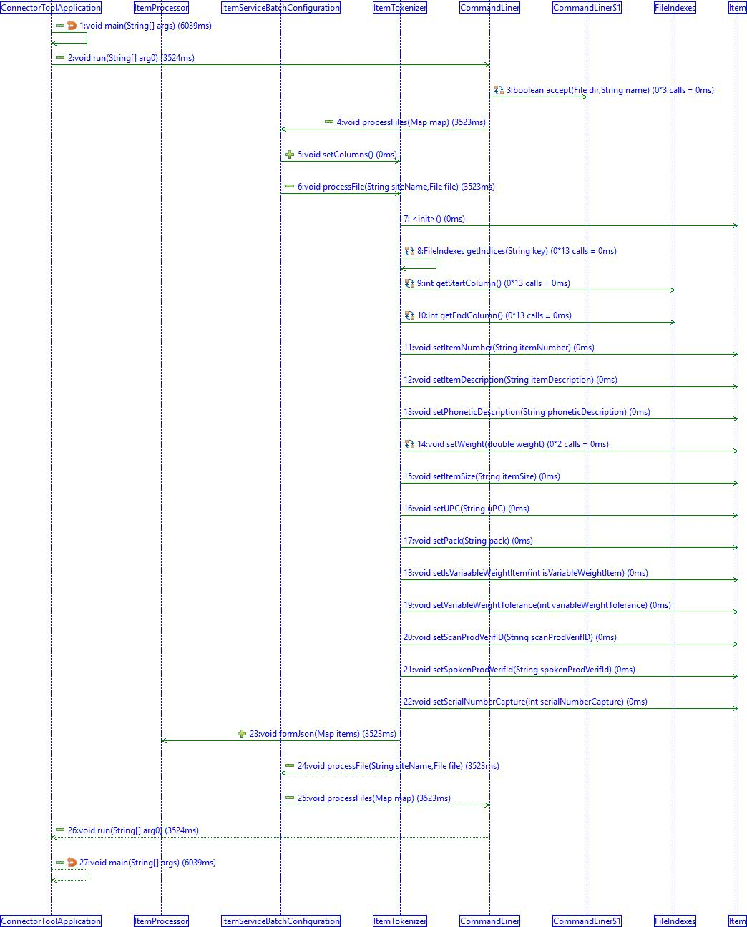

**LocationFilesImport** Sequence Diagram

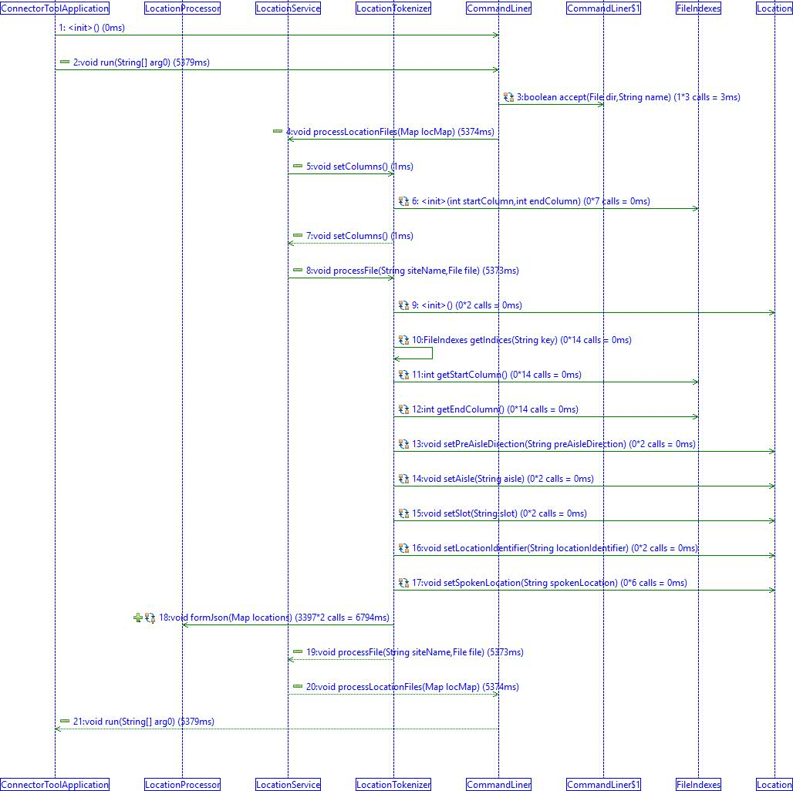

**SelectionFilesImport** Diagram

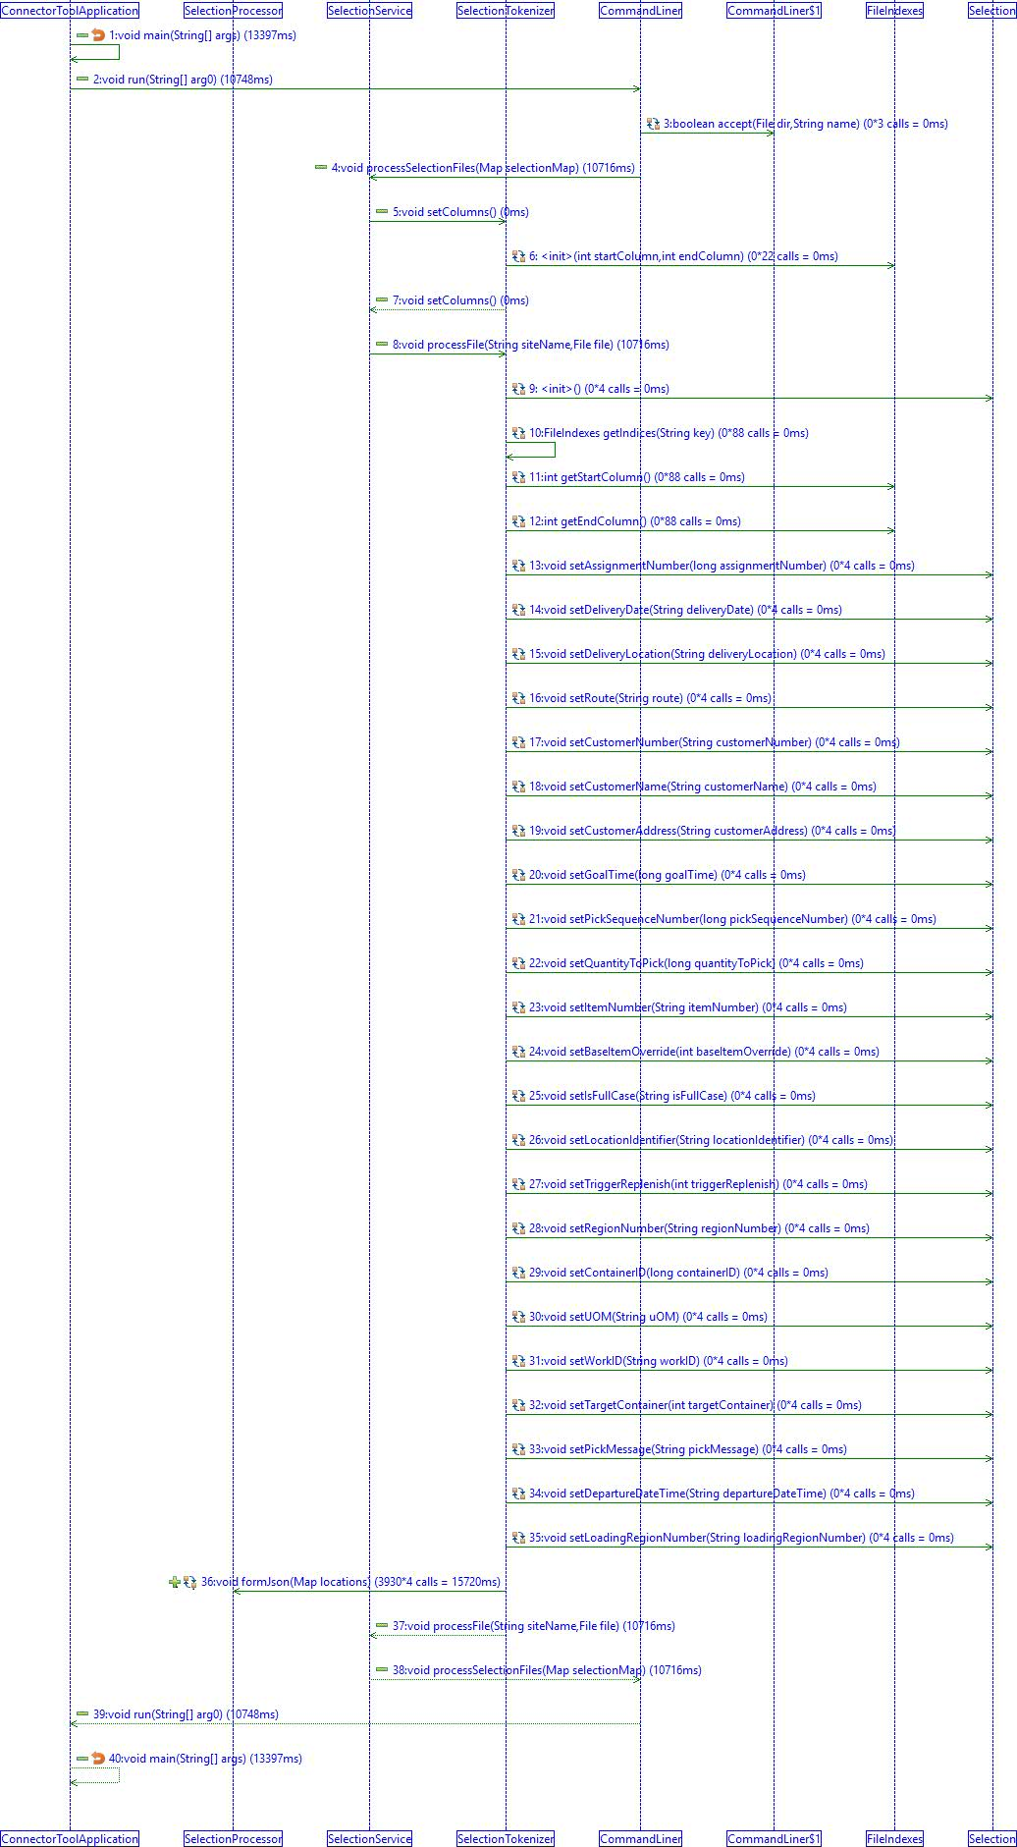

# **Json Structures and field validations**

**Item Json**

{

  "importData": [

    {

      "siteName": "Default",

      "data": [

        {

          "ItemNumber": "1234",

          "ItemDescription": "icecream",

          "PhoneticDescription": "eyescreem",

          "weight": 20.2,

          "ItemCube": 1200,

          "ItemSize": 230,

          "UPC": 2,

          "Pack": 1,

          "isVariableWeightItem": 1,

          "variableWeightTolerance": 5,

          "ScanProdVerifID": "12",

          "SpokenProdVerifID": 3230,

          "serialNumberCapture": 0

        }

      ]

    }

  ]

}

### Fields Definition and Validation

|  |
| --- |
|  |
| **Field** | **Required** | **Description** | **Validation** |
| Variable Weight Tolerance | Yes | This is a percentage. When the operator reports a variable weight, the system checks that the reported weight is within x percent of the item’s weight (provided in a field above). | Must be populated with a number >= 0 and <= 100. |
| Variable Weight Item | Yes | Flag that identifies item as a variable weight item. If this field = 1, the system prompts the operator to speak a weight for each quantity of the item picked. Else, the operator is not prompted to report a variable weight |  |
| UPC | No | UPC of the item. |  |
| Spoken Product Verification ID | No | The value that must be spoken to confirm the operator is picking the appropriate item at the appropriate slot. This is only populated for warehouses that want pick confirmation via a spoken product verification ID. |  |
| Scanned Product Verification ID | No | The value that must be scanned to confirm the operator is picking the appropriate item at the appropriate slot. This is only populated for warehouses that want pick confirmation via a scanned product verification ID. |  |
| Phonetic Description | No | Description of the item spelled phonetically so that it is spoken correctly by the device |  |
| Pack | No | How the item is packed. |  |
| Item Weight | Yes | Weight of the item | Must be a number >= 0. |
| Item Size | No | Size of the item. |  |
| Item Number | Yes | Item number (alpha-numeric) of an item. Item numbers are also imported in the Selection picks and lots files. To map items in assignments to item records, make sure the item number in the picks file matches to an imported item. |  |
| Item Description | Yes | Description of the item. |  |
| Item Cube | No | Cube space that is taken up by one quantity of the item. | Default to 0. If supplied, must be a number >= 0. |
| Capture Serial Number | No | Flag that indicates that the serial number should be captured for each quantity of 1 for this item. If this field = 1, the system prompts the operator to speak or scan the serial number for each quantity of the item picked. Else, the operator is not prompted to specify the serial number for this item. |  |

**Location Json**

{

"importData": [{

"siteName": "Default",

"data": [{

"LocationIdentifier": "0",

"SpokenLocation": "0",

"CheckDigits": "0",

"PreAisleDirection": "Building 10 Site 1",

"Aisle": "0",

"PostAisleDirection": "Bay 0",

"Slot": "0"

},

{

"LocationIdentifier": "1",

"SpokenLocation": "1",

"CheckDigits": "1",

"PreAisleDirection": "Building 0 Site 11",

"Aisle": "0",

"PostAisleDirection": "Bay 0",

"Slot": "0"

}

]

},

{

"siteName": "Hyderabad DC",

"data": [{

"LocationIdentifier": "0",

"SpokenLocation": "0",

"CheckDigits": "0",

"PreAisleDirection": "Building 10 Site 1",

"Aisle": "0",

"PostAisleDirection": "Bay 0",

"Slot": "0"

}]

}

]

}

### Fields Definition and Validation

|  |
| --- |
|  |
| **Field** | **JSON Key** | **Database column**  **name** | **width** | **Required** | **Description** | **Validation** |
| Customer Number | customerNumber | CUSTOMERNUMBER | 50 | Yes | Customer number associated with the put to store location, defined by the location identifier of this import. |  |
| Location Identifier | LocationIdentifier | LOCATIONID | 50 | Yes | This is the Location Identifier used to verify locations that are scanned by device operators (scanned verification), and is a unique identifier for every location that is shared across all VoiceLink applications. This is shown onscreen as "LocationID." | Field maps to a location defined within the VoiceLink system for the site of the import. |
| Route | route | ROUTE | 50 | No | Route number associated with the customer. Used only for display in the user interface. |  |
| Delivery Location | deliveryLocation | DELIVERYLOCATION | 9 | No | Location (within warehouse) where closed container should be delivered. Used only for display in the user interface. Pad numeric fields with spaces to the right. | Must be alphanumeric or null. |
| Customer Name | customerName | CUSTOMERNAME | 50 | No | Customer's name. Used only for display in the user interface. |  |
| Customer Address | customerAddress | CUSTOMERADDRESS | 50 | No | Customer's address. Used only for display in the user interface. |  |

**Selection Json**

{

  "importData": [

    {

      "siteName": "Default",

      "data": [

        {

          "assignmentNumber": "2011",

          "deliveryDate": "20171219",

          "deliveryLocation": "table 2 box 1",

          "route": "D001",

          "customerNumber": "4",

          "customerName":"",

          "customerAddress":"",

          "goalTime": "100",

          "pickSequenceNumber": "1",

          "quantityToPick": "1",

          "ItemNumber": "orange ball",

          "baseItemOverride": "0",

          "isFullCase":"",

          "LocationIdentifier": "box2",

          "triggerReplenish": "0",

          "regionNumber": "500",

          "containerID": "04325855",

          "UOM":"",

          "workID": "1010001",

          "targetContainer":"",

          "pickMessage": "pick orange color ball",

          "departureDateTime":"",

          "loadingRegionNumber":""

        },

        {

          "assignmentNumber": "2012",

          "deliveryDate": "20171219",

          "deliveryLocation": "table 2 box 1",

          "route": "D001",

          "customerNumber": "4",

          "customerName":"",

          "customerAddress":"",

          "goalTime": "100",

          "pickSequenceNumber": "4",

          "quantityToPick": "1",

          "ItemNumber": "green ball",

          "baseItemOverride": "0",

          "isFullCase":"",

          "LocationIdentifier": "box3",

          "triggerReplenish": "0",

          "regionNumber": "500",

          "containerID": "04325855",

          "UOM":"",

          "workID": "1010001",

          "targetContainer":"",

          "pickMessage": "pick green color ball",

          "departureDateTime":"",

          "loadingRegionNumber":""

        }

      ]

    }

  ]

}

## **Fields Definition and Validation**

|  |  |  |  |  |  |  |
| --- | --- | --- | --- | --- | --- | --- |
| Field | Width | Start Col | Data Type | Req’d | Description | Validation |
| Work ID | 18 | 482 | String | Yes | Work identifier for this assignment. In regions configured for manual assignment issuance, the value specified by the operator to request work is compared to this field. Can be any value (Work IDs that will be scanned by operators might have parenthesis, brackets, and other non alpha-numeric characters). Does not have to be a unique value (can match existing Work ID values). Note that if operators are speaking the Work ID to get work, the value must be numeric because the VoiceApplication does not recognize spoken alpha characters at the Work ID prompt. | All picks in an assignment must have the same work ID. If imported into a region based on a profile that supports manual assignment issuance, the length of this value must be greater than or equal to the value specified for Number of Digits to Speak for Manual Issuance. |
| UOM | 50 | 432 | String | No | Unit of measure for this pick. |  |
| Assignment Number | 18 | 1 | Numeric | Yes | Unique identifier for an assignment. This number appears in the user interface. Pad numeric fields with spaces to the right. |  |
| Carton ID | 50 | 382 | Numeric | No | This field links this pick item to a carton that will be sent to Line Loading. |  |
| Not Used | 1 | 315 | Numeric | No | This field is no longer used. Set to 0. |  |
| Region | 9 | 367 | Digit String | Yes | The region where this assignment should be picked. String field, but application expects an integer value. | Must be the same for all picks with the same Assignment ID. |
| Departure Date Time | 14 | 752 | Date | No | The date that the truck will leave the warehouse. This field is also used to calculate route statistics in delivery management dashboards. | Entry is in date time format (YYYYMMDDhhmmss). If departure date is unknown at the time of import, Vocollect recommends populating this field with the delivery date and a placeholder time so that route statistics shown in VoiceLink dashboards can be as accurate as possible. Note: The route departure date can be updated in the VoiceLink user interface with an action link on the Selection > Assignments page. If a user manually updates the departure date of a route in an implementation with Selection-Loading integration, subsequent imports of Selection assignment data for that route will also require the new departure date. |
| Pick Sequence Number | 9 | 246 | Numeric | Yes | Specifies the order in which the Selection VoiceApplication presents picks to an operator. When sending one assignment to the device, VoiceLink issues picks with lower sequence numbers before those with higher sequence numbers.  When sending multiple assignments to the device, VoiceLink issues picks by the following factors: ascending sequence number, ascending location (pre-aisle, aisle, post-aisle, and slot), and ascending group position of the pick assignment. Pad numeric fields with spaces to the right. Picks for co-mingled locations, where there are multiple items or UOMs, should have unique sequence numbers. VoiceLink will issue picks for co-mingled locations using the factors described above for multiple assignments. Additionally, if two picks have the same sequence number, the picks will be sequenced in the order in which they were created in the database. Generally, this is the order of the lines in the import file, but the order can differ as a result of batch imports. Using unique sequence numbers will prevent operators from being told to pick in the incorrect order. Picks that have case label check digits must have sequence numbers that are ascending for each pick, so that the case label check digit expected to be spoken by the operator matches the printed case label check digit that device operators reference. Note: Although they have similar field names, the "Sequence Number" field used in many VoiceDirect task messages is not related to this field. | Must be numeric. |
| Filler | 1 | 376 | N/A | No | Set to blank. |  |
| Route | 50 | 36 | String | Yes | Route associated to the assignment. Route is always spoken as part of the assignment summary, even if this field is not populated or if it contains all blanks. This field is also used to integrate Selection assignments with the Loading VoiceApplication. | Can be different for picks in an assignment. In this scenario, route is stored and displayed as "Multiple." An assignment with multiple route values cannot contain Loading information; the Loading Region must be null or empty for all picks in that assignment. |
| Quantity to Pick | 9 | 255 | Numeric | Yes | Pick quantity for this item. Pad numeric fields with spaces to the right. | Must be numeric and > 0. Must = 1 if case label check digit field is populated. (If the ordered quantity of an item = 5, then 5 pick lines must be imported if the system is using case label check digits). |
| Pick Message | 250 | 502 | String | No | Message for this pick. This is spoken at the pick prompt, if provided. |  |
| Location Identifier | 50 | 316 | String | Yes | Location ID (scanned verification) where this pick should be picked. The Location ID is used to retrieve the location information for this location (preaisle direction, aisle, postaisle direction and slot). | Must match to an existing location ID in the database. |
| Delivery Location | 9 | 27 | Numeric | No | Location (within warehouse) where assignment should be delivered. Pad numeric fields with spaces to the right. | Must be numeric. All picks within an assignment must have the same delivery location. |
| Item Number | 50 | 264 | String | Yes | Item Number of this pick. This is used to map the pick to an item in the database. Pad numeric fields with spaces to the right. | Should match to an item number in the database. If item does not exist in the database, a new item is created with this item number. See "Import-Generated Items in Various Imports" on page 131 for more information. |
| Case Label Check Digits | 5 | 377 | Numeric | No | If using case label check digits, this value that must be specified by the operator to ensure that the appropriate label will be put on a case. Pad numeric fields with spaces to the right. | If populated, quantity to pick for each pick in this assignment must =1. All picks in assignment must either have case label check digits populated, or have a blank case label check digit value. If populated, region must be based on a profile that supports case label check digits. |
| Loading Region | 9 | 766 | Digit String | No | Identifier of the region for the loading route associated with this pick. Optional field saved to the Selection assignment record for Loading interoperability. | If this loading field has a value, a corresponding, unique Loading Route must exist in the system. The value of this loading field must be the same for all picks in an assignment. An assignment with multiple route values cannot contain Loading information; the Loading Region must be null or empty for all picks in that assignment. Loading region must already exist in the system. |
| Goal Time | 10 | 236 | Numeric | Yes (but can specify 0) | Goal time to complete this assignment. Goal time is spoken in the assignment summary if it <> 0. It is currently not used for any other purposes. Pad numeric fields with spaces to the right. | Must be the same for all pick records in the same assignment. |
| Trigger a Replenishment | 1 | 366 | Numeric | No | Flag to indicate whether VoiceLink should trigger a replenishment for this pick when it is sent to the device. This should be set to 1 by a WMS if the WMS has determined that this pick location will probably be empty (or close to empty) when the assignment is issued to an operator. This helps to reduce the amount of shorted items. When this flag is set, VoiceLink attempts to trigger a replenishment for this location, if a replenishment assignment exists for this location. This, in turn, will raise the priority for a replenishment to be done at this pick location. Other than 1 = no effect 1 = A replenishment is triggered. If a replenishment assignment exists for this location, the replenishment indicator for the pick’s location ID is set to pending (which raises the priority for a replenishment at this location). Note that if a replenishment does not exist for this location ID, no action is taken. |  |
| Base Item Override | 1 | 314 | Numeric | No | Flag indicating whether an item is a base item (regardless of its weight and quantity). If this field = 1, this item is considered to be a base item, regardless of the item’s weight or quantity. If this field = 0, this item will only be a base item if its weight and quantity exceed the thresholds specified for the region. | If picks for a given assignment have a target container value specified, the base item override field must not indicate the pick is a base item. |
| Delivery Date | 8 | 19 | Date | Yes | Date the assignment must be delivered in the appropriate database date format. | Must be a valid date in the form YYYYMMDD. Must be the same for all pick records belonging to the same assignment. |
| Customer Address | 50 | 186 | String | No | Customer's address. Used only for display in the user interface. | Can be different for picks in an assignment. In this scenario, customer address is stored and displayed as "Multiple." |
| Customer Number | 50 | 86 | String | Yes | Customer number associated to the assignment. Pad numeric fields with spaces to the right. This field is also used to integrate Selection assignments with the Loading VoiceApplication. | All picks in an assignment must have the same customer number. If the assignment is integrated with a Loading Route, the customer number must match a customer number of one of the Stops in that Loading Route. |
| Customer Name | 50 | 136 | String | No | Customer name associated to the assignment. | Can be different for picks in an assignment. In this scenario, customer name is stored and displayed as "Multiple." |
| Target Container | 2 | 500 | Numeric | No | (Can be an empty string if not used) This field should be populated if the VoiceApplication is supposed to control which container each item should be put into. This acts as an internal tracking number for a pick’s target container. So all picks destined for the same container should have the same target container value. The VoiceApplication prompts the operator to close/open containers when the target container value changes from one pick to the next. Note: The system treats target containers of 00 and 0 as the same container. | All picks for a given assignment must either have target container values or must all have a blank target container value. Must be a number from 0-99 (i.e., no strings or decimals are allowed). If picks for a given assignment have a target container value specified, the base item override field must not indicate the pick is a base item. If picks for a given assignment have a target container value specified, the assignment cannot be imported for a region based on a profile that does not support picking to target containers. |