Activities Description

|  |  |
| --- | --- |
| Activity | Description |
| Activity1 | Button sensor will check the passenger is  Seated or not. Heater will check the heater button is ON |
| Activity2 | Temperature sensor works as a table No. 1 |
| Activity3 | Display CDD-CRO will givr the temperature value by showing Pwm |

**Assumptions**

* Switches are used to the realize the passenger in the seat and the press of the heater
* The temperature sensor is realized using the potentiometer

**Activity1**

In action

Case1: when both switches are off case2: switch1 Off switch2 ON

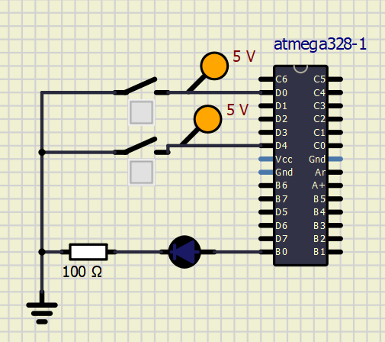 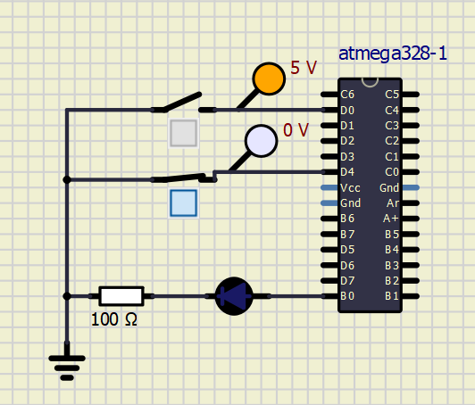

Case3: switch1 ON switch2 OFF case4: switch1 ON switch2 ON

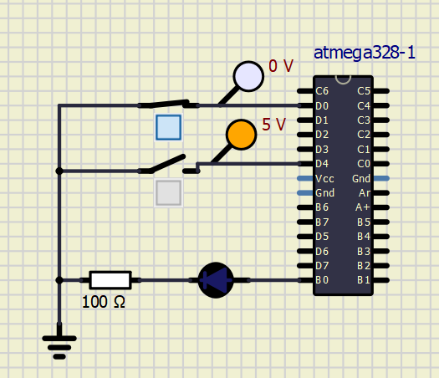 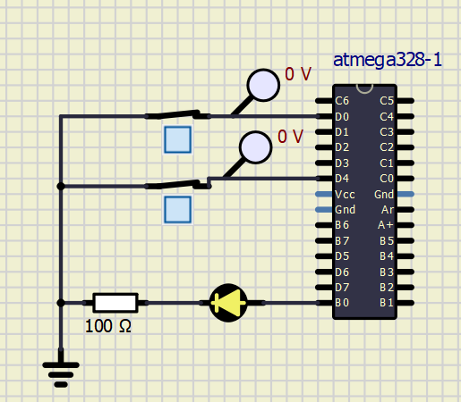

**Activity2**

