Grid World Goal Searching using Dynamic Programming and Monte Carlo Control

Student: Saritha Nandikanti
Course: CAP 6629 – Reinforcement Learning

1. Introduction and Background
Reinforcement Learning (RL) studies how an agent can learn to act in an environment by trial and error, receiving feedback in the form of rewards. Grid world environments provide a simple yet expressive way to analyze RL algorithms because states, actions, and rewards are clearly defined. In this project, I investigate how two RL approaches—Dynamic Programming (Value Iteration) and Monte Carlo Control—learn to solve a grid world goal‑search problem.
Dynamic Programming (DP) assumes knowledge of the transition dynamics and uses iterative Bellman updates to compute an optimal state‑value function V*. Monte Carlo (MC) methods, on the other hand, learn value functions from sampled episodes without requiring a full model of the environment. Comparing these two approaches on the same grid world highlights the trade‑offs between model‑based and sample‑based learning.

2. Project Specification

2.1 Problem Statement
The agent operates in a 9×10 grid world. The start state is at the bottom‑left corner, and the goal state is at the top‑right corner. Some cells are obstacles (walls) that cannot be entered, and some cells are lava states that terminate the episode with a large negative reward. At each time step, the agent chooses one of four actions: Up, Down, Left, or Right. The objective is to learn a policy that reaches the goal while minimizing the total negative reward.

2.2 Environment Design (Input Sequence)
Environment and reward design:
• Grid size: 9 rows × 10 columns (bigger than 7×9 as required).
• Start state: (8, 0).
• Goal state: (0, 9).
• Obstacles: fixed cells that act as walls and cannot be entered.
• Lava states: terminal cells with −10 reward.
• Step reward: −1 for each move.
• Goal reward: +20 when the agent reaches the goal.
• Actions: Up, Down, Left, Right (deterministic transitions).
• Discount factor γ: 0.9.
Input sequence for both algorithms consists of repeated episodes in this environment. For each episode, the agent starts from the initial state and interacts with the grid world until it reaches the goal, a lava cell, or a maximum step limit.

2.3 Expected Output
The project is expected to produce:
• Theoretical state‑value table V* from Dynamic Programming (Value Iteration).
• Estimated value function V_MC and policy from Monte Carlo Control.
• Step‑to‑goal curve showing learning progress.
• Sum of Squared Error (SSE) between V_MC and V_DP across episodes.
• Learned greedy policy grids (arrows) for both algorithms.
• A public Google Colab link to the full source code:
https://colab.research.google.com/drive/11JsTdw74ZQNlHaqBgW5t5UE4VOBpQCCb?usp=sharing

3. Implementation and Evaluation

3.1 Pseudocode for Algorithms
Two algorithms were implemented: Dynamic Programming (Value Iteration) and Monte Carlo Control.
3.1.1 Dynamic Programming (Value Iteration) Pseudocode
Initialize V(s) = 0 for all non-terminal states s
Repeat until convergence:
Δ = 0
For each non-terminal state s:
For each action a in {Up, Down, Left, Right}:
s' = next_state(s, a)
q(a) = R(s, a, s') + γ * V(s')
V_new = max_a q(a)
Δ = max(Δ, |V_new - V(s)|)
V(s) = V_new
If Δ < θ (small threshold): stop
Derive greedy policy π(s) = argmax_a [ R(s,a,s') + γ V(s') ]
3.1.2 Monte Carlo Control Pseudocode (Exploring Starts)
Initialize Q(s, a) arbitrarily, Returns(s, a) = empty list
Loop over episodes:
Generate one episode starting from random non-terminal state and random action
Episode: (s0, a0, r1, s1, a1, r2, ..., s_T)
G = 0
For t from T-1 down to 0:
G = γ * G + r_{t+1}
If (s_t, a_t) is first occurrence of this pair in the episode:
Append G to Returns(s_t, a_t)
Q(s_t, a_t) = average(Returns(s_t, a_t))
For each state s visited in the episode:
π(s) = ε-greedy(Q(s, ·)) # update policy

3.2 Dynamic Programming Implementation and Results
Value Iteration was implemented in Google Colab using Python. The algorithm iteratively updated V(s) until the maximum change across states fell below a small threshold. The final converged table below represents the theoretical optimal state‑value function V* for this grid world.
State‑Value Grid V* (Dynamic Programming):
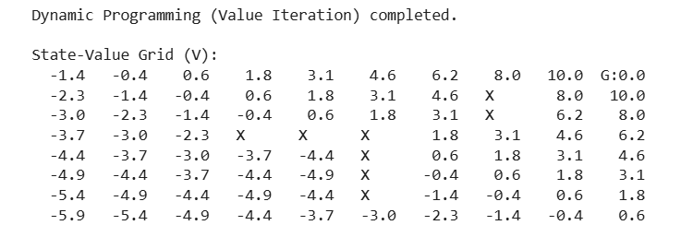
Explanation: Values increase as the agent gets closer to the goal in the top‑right corner. More negative values appear in states further from the goal or near dead‑ends, reflecting higher expected cost to reach the goal from those states. This table serves as the theoretical V table required by the instructions.
Greedy Policy derived from V* (DP Policy Grid):
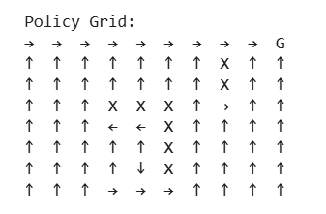
Explanation: Arrows show the optimal action from each state. The DP policy forms a smooth path that moves right and up toward the goal while avoiding obstacle cells. This is the theoretical optimal policy for the environment.

3.3 Monte Carlo Implementation and Results
Monte Carlo Control was implemented with ε‑greedy exploration. In each episode, the agent followed the current policy to generate a trajectory and then updated Q(s,a) using the average of returns for each first‑visit state–action pair. The state‑value function V_MC(s) was computed from Q by taking the maximum over actions.
Final Monte Carlo Value Function V_MC:
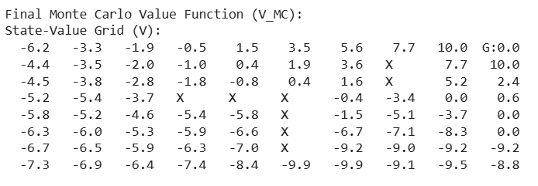
Explanation: The Monte Carlo value function is noisier than the DP V* table because MC relies on sampled episodes instead of full backups. However, high values still cluster near the goal, and the overall gradient roughly matches the DP solution.
Final Monte Carlo Policy Grid (greedy w.r.t Q_MC):
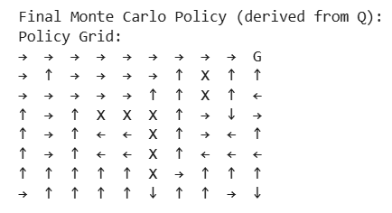
Explanation: The Monte Carlo policy also routes the agent toward the goal, but the arrow directions show more variation, especially in lower rows. This reflects exploration noise and the fact that Monte Carlo learns from a finite number of episodes.

3.4 Learning Curves and Error Analysis
Step‑to‑Goal Curve for Monte Carlo:
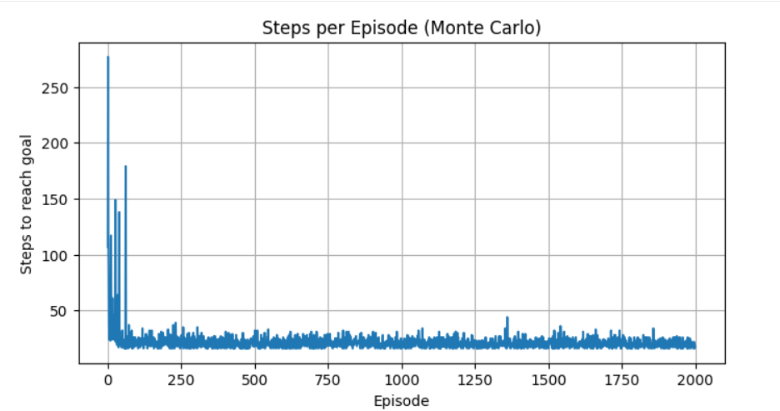
Explanation: At the beginning of training, the agent sometimes takes more than 200 steps to finish an episode. After a short learning period, the number of steps quickly drops and stabilizes around 20–35 steps per episode, indicating successful learning of an efficient route to the goal.
SSE between V_MC and V_DP per Episode:
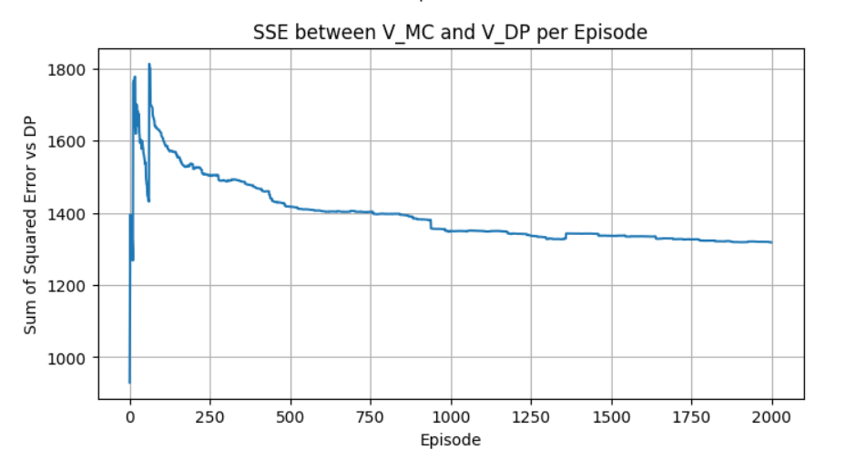
Explanation: The sum of squared error (SSE) between the Monte Carlo value function and the DP V* table starts high but steadily decreases as training proceeds. The curve flattens around 1300–1400, showing that V_MC moves closer to the theoretical V* while still retaining some noise due to sampling.

4. Summary and Conclusions
This project compared Dynamic Programming and Monte Carlo Control on a 9×10 grid world goal‑search task. Dynamic Programming, using full knowledge of the environment, produced a clean and stable optimal value table V* and a deterministic greedy policy. Monte Carlo Control, implemented with ε‑greedy exploration, approached these values over many episodes but showed more variance in both the value function and the learned policy.
The step‑to‑goal curve demonstrated that Monte Carlo quickly reduced the number of steps required to reach the goal, stabilizing at a relatively small number of steps per episode. The SSE curve confirmed convergence toward the DP solution, even though Monte Carlo remained slightly noisy. Overall, both algorithms successfully solved the grid world, and the comparison highlighted the strengths of model‑based DP versus sample‑based MC methods.

5. References
Sutton, R. S., & Barto, A. G. (2018). Reinforcement Learning: An Introduction (2nd ed.).
CAP 6629 course lecture slides and provided project instructions.

6. Appendix: AI Usage Declaration
I used AI tools for this project and provide the required details below.
A1. How was AI used?
AI (ChatGPT, GPT‑5.1) was used only for writing assistance, explanation, and document formatting. It helped me rephrase technical explanations, structure the report sections, generate pseudocode formatting, and design a clean Word layout. AI did not execute any code, compute any value tables, generate policies, or produce numerical results. All experiments were implemented and run by me in Google Colab.
A2. What commands/prompts were employed?
Examples of prompts I used include:
• “Explain Dynamic Programming and Monte Carlo Control in simple terms for my report.”
• “Help me format pseudocode for value iteration and Monte Carlo control.”
• “Give a short caption for my step‑to‑goal graph.”
• “Rewrite this paragraph to be clearer and more concise.”
• “Generate a formal AI usage statement that answers all required questions.”
• “Help me structure a reinforcement learning project report with sections 1–5.”
A3. Comparison with human work: what did AI bring?
AI made the process faster by suggesting structured code outlines, cleaner explanations, and well‑formatted text. This reduced the time I spent on rewriting descriptions and formatting the document, allowing me to focus on writing the Python code, running experiments in Google Colab, and interpreting the results. AI contributed convenience and polish, but not technical correctness.
A4. Human judgments/revisions retained to compensate for disadvantages
I manually verified that all AI‑generated explanations matched my actual outputs (value tables, policies, and graphs). Whenever AI text did not exactly fit my results, I edited or replaced it. I designed the grid world, implemented and debugged the algorithms, chose hyperparameters, decided which results to present, and drew all final conclusions. Thus, the technical content and experimental findings are my own work, with AI only supporting presentation.
A5. Main tool name and version/date, internet status
Tool: ChatGPT (GPT‑5.1). Date of use: November 2025. The model was used without direct internet browsing; all reinforcement‑learning code execution and experimentation were performed locally in Google Colab by me.

Google Colab sourcecode: https://colab.research.google.com/drive/11JsTdw74ZQNlHaqBgW5t5UE4VOBpQCCb?usp=sharing

