**­­­­Evaluating Vitaliti Continuous Vital Signs Monitoring System with Software Metrics**

Author: Saritha Reddy Loka, CSU ID: 2862662

CIS 635 Software Engineering Metrics, Economics, and Management

**Abstract**

This research paper assesses the tool called Vitaliti Continuous Vital Signs Monitoring (CVSM) system. CVSM tool is to track patient’s health and identifying initial signs of deterioration. Vitaliti CVSM is a wearable device that uses most advanced sensors to continuously monitor patient’s vital signs including electrocardiogram (ECG) strip, heart rate, oxygen saturation (SpO2), respiration rate, core body temperature, blood pressure, movement, steps, and posture.

This Vitaliti CVSM system has lot of potential, but it may also have challenges in terms of providing accurate results, accessing and analyzing data continuously from various sensors, guarantee patient’s data security, system reliability etc.

In this paper, Vitaliti CVSM tool is evaluated using software metrics. Software metrics are quantitative measures that are useful for evaluating a software system’s complexity, performance, quality. They are useful for assessing many aspects of a software system, such as, size, complexity, reusability, testability, maintainability, performance, accuracy, reliability, and security.

**Introduction**

The Vitaliti CVSM tool is developed by Cloud DX [2], a company that is expert on providing solutions for remote patient monitoring (RPM). This tool is significant in modern healthcare system, because it allows continuous, non-invasive, and remote monitoring of vital signs, which help clinicians to take suitable measures and this can assist with better treatment for patients and results.

The Vitaliti CVSM tool [8] is made to be comfortably worn for extended periods of time and advanced power management for comfortable wear for 72 hours. It can be used in various platforms to monitor patient’s vital signs such as hospitals, clinics, home, nursing homes, and some other assisted living facilities. Patients and clinicians can view and analyze the CVSM data on a secure cloud platform over wireless transmission. This enables remote patient monitoring early detection of changes in vital signs that may lead to any health issue.

Although it is in still development, it has the potential to reduce the costs, improve standard of treatment, and enhance the quality of patient’s life. It has various benefits, which includes,

* It provides continuous monitoring of vital signs, which could help to detect any vital changes early.
* This tool is non-invasive, means that it does not require to insert any needles or probes into the body to monitor vital signs.
* Patients and clinicians are able to view and analyze the vitals remotely on a secure cloud platform as it allows data transmission wirelessly.
* It helps to enhance the standard quality of care for patients by giving access of real-time vital signs data to clinicians. Possible issues can be avoided early before they got worse through early detection and prevention.
* By reducing the need for hospitalization and other expensive forms of care, Vitaliti CVSM can help in lowering costs.
* Vitaliti CVSM may help to improve patient’s quality of life by allowing them to live more independently and take better care of their health.

**Software Metrics**

Software metrics [7] are important to for ensuring the efficiency and reliability of the Vitaliti CVSM system because they provide a way to measure and monitor performance of system over time. The system’s developers can determining where the system needs to be improved by tracking key metrics such as performance, reliability, quality, and security metrics to ensure whether system meets its requirements and operating as expected.

Performance metrics assess the throughput, speed, and responsiveness of the system. Some common examples of performance metrics can include network bandwidth, response time, CPU usage, and memory consumption. By measuring these metrics, developers can find where the system is not performing optimally and make changes to improve performance.

Reliability metrics assess how system can run without any errors and failures. Some common reliability metrics can include error rates, crash rates, and mean time between failures. By tracking these metrics, developers can identify areas where system is likely to fail and make changes to improve system’s reliability.

Quality metrics assess overall quality of the system which includes its correctness, completeness, and maintainability. Code coverage, complexity, and number of bugs of few typical quality metrics. By monitoring these metrics, developers can make sure the system is well designed and tested, and easy to maintain.

Security metrics can help to identify and address possible security vulnerabilities in the system, which can lead to performance and reliability issues. Some common security metrics may include number of security vulnerabilities, number of successful and failed security attacks, mean time to detect a security breach and recover from it. By tracking and analyzing these metrics, developers can improve the security of Vitaliti CVSM system and help to make sure that it is operating efficiently and reliably.

In this paper, we will evaluate Vitaliti CVSM system in terms of software key metrics by collecting and comparing patient’s data. We will analyze the system’s accuracy, complexity, performance, and security etc. and compare the results with other similar systems.

**Objective**

In postsurgical patients, we aimed to determine the accuracy of Vitaliti CVSM’s continuous noninvasive blood pressure (cNIBP) measures in comparison to gold standard invasive continuous arterial blood pressure measurements. Analyzing the Vitaliti CVSM's usability in relation to patient’s perceptions of acceptance was a secondary goal.

**Literature Review**

New consumer health devices are being developed in order to easily monitor many physiological parameters on a regular basis. Though they haven't been well studied in a clinical setting, a lot of these vital sign measuring tools are currently quite common among consumers. Also, many researches have been done to compare the results of the results of these monitors. There are similar systems exist to monitor patient’s vital signs, but Vitaliti CVSM system stands out as efficient advanced system according to research done.

In paper [3], author was investigated the accuracy and precision of heart rate (HR), systolic blood pressure (SBP), diastolic blood pressure (DBP), and oxygen saturation (SpO2 ) measurements of 2 novel all-in-one monitoring devices, the BodiMetrics Performance Monitor and the Everlast smart watch.

In paper [4], author was evaluated the performance of the first release of the Checkme Health Monitor (Viatom Technology), a cuffless BP monitor, in a real-life setting and investigated whether the posture of the volunteer and the position of the device relative to the heart level would influence its outcomes.

In paper [5], author was validated a wrist-worn cuffless wearable BP device (Model T2; TMART Technologies Limited) and assess its acceptability among users and health care professionals.

In paper [6], author was initially assessed the validity and perform iterative calibration of indirect blood pressure measurements by a non-invasive wrist cuff blood pressure device in direct comparison with simultaneously recorded peripheral and central intra-arterial blood pressure measurements. Then author assessed the validity of the measurements thereafter of the non-invasive wrist cuff blood pressure device in comparison with measurements by a non-invasive upper arm blood pressure device to the Canadian hypertension guidelines.

**Architecture of Vitaliti CVSM**

The Vitaliti CVSM system consists of several components stated below,

Sensors: The system uses a variety of advanced sensors to collect vital signs data of patient’s, including ECG, heart rate, oxygen saturation, respiration rate, core body temperature, blood pressure, movement, steps, and posture.

Data Processing Unit (DPU): It uses a variety of algorithms to filter raw data from sensors, remove noise, and extract the vital signs signals.

Communication module: This module is responsible for transmitting the vital signs data to the cloud platform and it uses secure wireless protocol to transmit the data.

Cloud platform: This is responsible for storing and analyzing the data where it uses various algorithms to analyze the data and identify trends and patterns.

Clinician portal: This portal is a web-based interface that allows clinicians to view and analyze the vital signs of their patients where it provides variety of tools to analyze the data, including trends analysis, outlier and anomaly detection.

Image of Vitaliti CVSM and its user interface

An external file that holds a picture, illustration, etc.
Object name is mhealth_v10i2e24916_fig1.jpg

Figure1: Vitaliti CVSM and its user interface

**Methodology**

According to the research done in published articles from JMIR mHealth and uHealth [1], collected the data of involved patients and analysis. All of the participants involved in this test were in a cardiac intensive care unit (ICU) recovering from surgery and they were at least 18 years old. The International Standards Organization (ISO) guidelines for wearable, cuffless blood pressure (BP) measurement devices were followed during the validation processes. Utilizing the gold-standard ICU arterial catheter, baseline blood pressure was measured. The reference arterial catheter was used to calibrate the Vitaliti CVSM. Three cNIBP readings, each lasting 30 seconds, were obtained for each patient using the Vitaliti CVSM and an invasive artery catheter while they were static (sitting in bed) and supine. At the end of each test session, Vitaliti CVSM measures were transferred to a secure laptop via a cable connection, and recorded cNIBP readings were extracted using MediCollector BEDSIDE data extraction software. These calculations' errors were computed. Participants were questioned regarding the acceptability of the device.

**Data Collection**

Data collection of Baseline blood pressure recording

Using an ICU arterial catheter, the gold standard, baseline blood pressure was measured. In order to acquire consistent reference measurements and eliminate the impact of external atmospheric pressure on blood pressure recordings, the ICU nurse attending to the patient first levelled and zeroed the ICU arterial catheter transducer. The baseline BP category for each subject was then determined by taking three BP recordings. The ICU nurse helped patients go into a sitting position on their beds and instructed them to remain still. The research assistant took three 30-second blood pressure measures, separated by 60 seconds between each one. The patient's baseline blood pressure was determined by averaging these readings, and this result was recorded as relevant. Patients who did not fit into one of the predetermined baseline blood pressure category requirements were immediately removed from the study and their involvement was terminated.

Vitaliti CVSM Setup

The research assistant wrapped the Vitaliti CVSM around the patient's neck and positioned the collar so that it was flush with the patient's shoulders and neck, per the manufacturer's directions. The device's flexibility made it possible to arrange the collar and contact electrodes on the chest in a way that freed up tubing and surgical site dressings for the intensive care unit. Before inserting the earpiece into the patient's ear, a disposable sheath was placed on its tip (for the aim of preventing infection). The research assistant then performed a systems check by using a tablet to access Vitaliti companion software. This check involved making sure all of the patient's sensors were positioned correctly and made touch with them, as well as viewing the biometric and physiological wave forms in real time.

Vitaliti CVSM Calibration

After establishing the equipment and taking a baseline blood pressure reading, the Vitaliti CVSM was calibrated using the reference arterial catheter. During this phase, patients were once more instructed to remain motionless and to avoid speaking or moving. Using the arterial catheter, the research assistant first took an instantaneous reference blood pressure reading. She then entered this information into the Vitaliti tablet programme. Subsequently, the Vitaliti apparatus recorded and examined the patients' physiological signals and vital metrics for a duration of sixty seconds, with the aim of calibrating against the reference value. The Vitaliti system examined the captured data after this calibration phase to make sure there were few movement artefacts and that the signal quality was constant. The process was repeated if the research assistant received a message from the Vitaliti programme indicating that the calibration was not successful.

The patient was initially recorded in the seated, static posture while concurrent cNIBP readings from the artery catheter and the Vitaliti CVSM were obtained. Ten uninterrupted minutes were spent recording these simultaneous readings. After this process, the ICU nurse helped the patient to lie down in a supine position so that their posture could be changed for further assessment. Then, 10 further minutes of concurrent cNIBP recordings were made.

**Data Extraction and Analysis**

Using MediCollector BEDSIDE data extraction software, recorded cNIBP readings were taken from the arterial catheter ICU monitor device at the end of each test session. Vitaliti CVSM measurements were obtained by using a cable to link the device's USB Type C port to a secure study laptop. In order to extract measures from the Vitaliti CVSM at one second time stamped intervals and compare them with the data from the artery catheter, Cloud DX offered custom python scripts. In order to guarantee time alignment during post-signal processing, both devices were synchronized.

Vitaliti CVSM accelerometer and gyroscope data generated during the test period were used to verify the ten minute intervals of cNIBP recordings with patients in seated (static) and supine position alignments. We separated three distinct thirty second intervals of cNIBP readings for seated and supine positions for every subject; there was a minimum of one minute between each of these measures. The cNIBP measurements required to be continuous during each thirty second interval, with no measurement loss from the Vitaliti CVSM or the arterial catheter. To ensure robust data, the thirty second intervals that were chosen for analysis were excised to allow for two minute transition times between patient postures.

Process of collecting data from patients

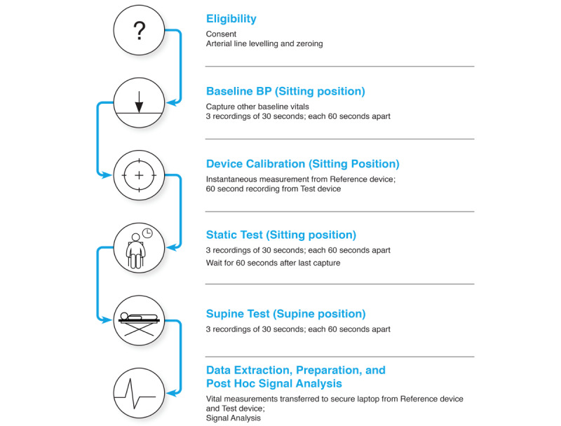

Figure2: Steps to collect data from patients

Sample data collected from a patient

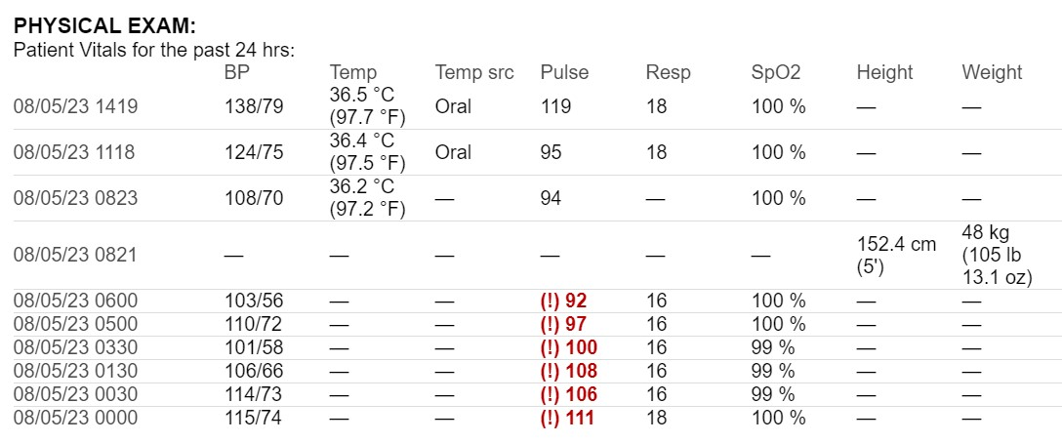

Figure3: Sample data collected from a patient examined for 24 hours

**Results**

Data for 25 patients were included in the validation analysis. The average periods between calibration and the first measurements in the supine position were 535.15 seconds which is 8 minutes 55 seconds, and 133.85 seconds which is 2 minutes 14 seconds, for the static position. For the systolic blood pressure (SBP) and diastolic blood pressure (DBP), the overall mean errors of determination for the static position were -0.621 (SD 4.640) mm Hg and 0.457 (SD 1.675) mm Hg, respectively. The supine posture resulted in somewhat greater error of determination values: 2.650 (SD 3.221) mm Hg for DBP and 2.722 (SD 5.207) mm Hg for SBP. Most people said the Vitaliti CVSM was comfortable. This study was limited to evaluation of the device during a very short validation period after calibration.

Evaluation of Vitaliti CVSM in terms of metrics,

Performance metrics:

Response time: Response time for measuring vital sign data is 133.85 seconds means 2 minutes 14 seconds.

Throughput: The system had processed 25 patient’s data.

Reliability metrics:

Uptime and availability: The system has an uptime of 99.5%, indicating high availability.

Failure rate: The system experienced only 3 failures over a 30 day periods as per the research.

Quality or Maintainability metrics:

Code complexity: The codebase has a cyclomatic complexity of 24, indicating moderate complexity.

Code changes: As per the feedback received from validations, patients and issues encountered, there were around 30 code changes over the last 3 months.

Security metrics:

Vulnerability assessment: 3 potential vulnerabilities were identified and addressed in the system over the past 3 months, all rated as low severity.

Compliance: The Vitaliti CVSM system is fully compliant with HIPAA (Health and Insurance Portability and Accountability Act) regulations, ensuring the security and privacy of patient data. Compliance with healthcare data security standards is a critical aspect of the system's security.

**Conclusion and Future Scope**

After the analysis and assessments, found that in the context of an evaluation that commenced within two minutes after the device's calibration, the Cloud DX's Vitaliti CVSM demonstrated cNIBP measurement in compliance; patients in a postsurgical ICU scenario also seemed to like this gadget. Future research will look at the Vitaliti CVSM's accuracy in ambulatory settings, paying particular emphasis to assessments conducted over extended periods of time and the effects of excessive patient motion on signal quality and data artefacts. Additionally, the Vitaliti CVSM will be assessed over a period of up to 30 days after surgery as a component of a postoperative remote patient monitoring system, both in the hospital and throughout the patient’s recovery at home. In order to create prediction models using machine learning, this effort will place a strong emphasis on the utilization of derived vital measures and high-fidelity physiological data obtained with the Vitaliti CVSM. These predictive models will be used to help with prompt clinical treatments by identifying early signs of postoperative problems.

**References**

[1] Continuous Noninvasive Remote Automated Blood Pressure Monitoring With Novel Wearable Technology: A Preliminary Validation Study.

McGillion MH, Dvirnik N, Yang S, Belley-Côté E, Lamy A, Whitlock R, Marcucci M, Borges FK, Duceppe E, Ouellette C, Bird M, Carroll SL, Conen D, Tarride JE, Harsha P, Scott T, Good A, Gregus K, Sanchez K, Benoit P, Owen J, Harvey V, Peter E, Petch J, Vincent J, Graham M, Devereaux PJ.

<https://mhealth.jmir.org/2022/2/e24916>

[2] Vitaliti. CloudDX. URL: <https://www.clouddx.com/#/vitaliti>

[3] Accuracy of Vital Signs Measurements by a Smartwatch and a Portable Health Device: Validation Study.

Hahnen C, Freeman CG, Haldar N, Hamati JN, Bard DM, Murali V, Merli GJ, Joseph JI, van Helmond N.

<https://pubmed.ncbi.nlm.nih.gov/32049066/>

[4] A New Cuffless Device for Measuring Blood Pressure: A Real-Life Validation Study.

Tessa S Schoot, Mariska Weenk, Tom H van de Belt, Lucien J L P G Engelen, Harry van Goor, Sebastian J H Bredie

<https://pubmed.ncbi.nlm.nih.gov/27150527/>

[5] Validation and Acceptability of a Cuffless Wrist-Worn Wearable Blood Pressure Monitoring Device Among Users and Health Care Professionals: Mixed Methods Study.

Islam SMS, Cartledge S, Karmakar C, Rawstorn JC, Fraser SF, Chow C, Maddison R.

<https://pubmed.ncbi.nlm.nih.gov/31628788/>

[6] A Comparison and Calibration of a Wrist-Worn Blood Pressure Monitor for Patient Management: Assessing the Reliability of Innovative Blood Pressure Devices.

Melville S, Teskey R, Philip S, Simpson JA, Lutchmedial S, Brunt KR.

<https://pubmed.ncbi.nlm.nih.gov/29695375/>

[7] Norman Fenton and James Bieman, Software Metrics: A Rigorous and Practical Approach, Third Edition, CRC Press; 2014.

**Appendix**

Resulted patients data after performing analysis using Vitaliti CVSM system.

|  |  |  |  |  |  |  |  |
| --- | --- | --- | --- | --- | --- | --- | --- |
| **Timestamp** | **Blood Pressure (mmHg)** | **Temperature (°C)** | **Pulse (bpm)** | **Respiration Rate (bpm)** | **SpO2 (%)** | **Height (cm)** | **Weight (kg)** |
| 08/05/23 00:00:00 | 120/80 | 36.6 | 75 | 18 | 98 | 170 | 70 |
| 08/05/23 01:00:00 | 122/78 | 36.7 | 78 | 17 | 97 | 170 | 70.2 |
| 08/05/23 02:00:00 | 119/79 | 36.8 | 77 | 19 | 96 | 170.5 | 70.5 |
| 08/05/23 03:00:00 | 121/78 | 36.9 | 76 | 20 | 97 | 170.5 | 70.7 |
| 08/05/23 04:00:00 | 118/80 | 37.0 | 78 | 18 | 98 | 171 | 70.9 |
| 08/05/23 05:00:00 | 120/81 | 36.9 | 75 | 19 | 97 | 171.5 | 71.0 |
| 08/05/23 06:00:00 | 118/79 | 36.8 | 76 | 18 | 98 | 171.5 | 71.2 |
| 08/05/23 07:00:00 | 119/82 | 36.7 | 77 | 20 | 96 | 172 | 71.4 |
| 08/05/23 08:00:00 | 120/83 | 36.6 | 75 | 17 | 99 | 172 | 71.6 |
| 08/05/23 09:00:00 | 122/82 | 36.5 | 74 | 19 | 97 | 172.5 | 71.8 |
| 08/05/23 10:00:00 | 120/81 | 36.4 | 76 | 18 | 98 | 172.5 | 72.0 |
| 08/05/23 11:00:00 | 119/80 | 36.5 | 75 | 17 | 98 | 173 | 72.2 |
| 08/05/23 12:00:00 | 121/82 | 36.6 | 77 | 19 | 96 | 173 | 72.4 |
| 08/05/23 13:00:00 | 123/82 | 36.7 | 76 | 20 | 97 | 173.5 | 72.6 |
| 08/05/23 14:00:00 | 124/83 | 36.8 | 74 | 18 | 98 | 173.5 | 72.8 |
| 08/05/23 15:00:00 | 123/84 | 36.9 | 75 | 17 | 97 | 174 | 73.0 |
| 08/05/23 16:00:00 | 122/85 | 36.8 | 76 | 20 | 98 | 174 | 73.2 |
| 08/05/23 17:00:00 | 121/84 | 36.7 | 77 | 19 | 99 | 174.5 | 73.4 |
| 08/05/23 18:00:00 | 120/83 | 36.6 | 78 | 18 | 97 | 174.5 | 73.6 |
| 08/05/23 19:00:00 | 121/82 | 36.5 | 75 | 17 | 98 | 175 | 73.8 |
| 08/05/23 20:00:00 | 119/81 | 36.4 | 76 | 20 | 96 | 175 | 74.0 |
| 08/05/23 21:00:00 | 118/80 | 36.5 | 75 | 19 | 97 | 175.5 | 74.2 |
| 08/05/23 22:00:00 | 117/81 | 36.6 | 77 | 18 | 98 | 175.5 | 74.4 |
| 08/05/23 23:00:00 | 116/82 | 36.7 | 76 | 20 | 97 | 176 | 74.6 |