Batch Evaluation vs Fair Comparison Report
Token-Overlap Metrics vs LLM-Judged Metrics (Groq 70B)

1. Overview
This report compares two different evaluation approaches applied to the same RAG pipeline:
 | Batch Evaluation | Fair Comparison
File | batch_evaluation.py | evaluation_fair_comparison.py
Evaluation Method | Token-overlap (algorithmic) | LLM-as-judge (Groq 70B)
Answer Generator | Ollama (llama3.2, 3B) | Ollama + Groq (both evaluated)
Faithfulness | Token overlap between answer & context | LLM judges if answer is grounded in context
Coverage / Recall | Token overlap (context → answer) | LLM judges if context covers reference
Relevance / BLEU | Query-answer token overlap | Word overlap with reference answer

The batch evaluation uses simple token-overlap metrics — fast and deterministic but shallow. The fair comparison uses an LLM (Groq 70B) as a judge — slower but captures semantic meaning.

2. Batch Evaluation Results (Token-Overlap)
The batch evaluation uses Ollama (llama3.2) to generate answers and scores them using simple token-overlap metrics. No LLM is involved in scoring.

2.1 Overall Averages
Metric | Average Score
Faithfulness (answer ∩ context / answer) | 76.6%
Coverage (answer ∩ context / context) | 29.4%
Relevance (query ∩ answer / query) | 57.6%

2.2 Per-Question Scores
Question | Faithfulness | Coverage | Relevance
Symptoms of bacterial vaginosis | 95.0% | 26.6% | 57.1%
Causes of varicose veins | 93.5% | 21.8% | 25.0%
Preventing melanoma | 96.0% | 28.9% | 71.4%
Living with type 1 diabetes | 31.9% | 34.4% | 80.0%
MRSA | 66.7% | 35.2% | 54.5%

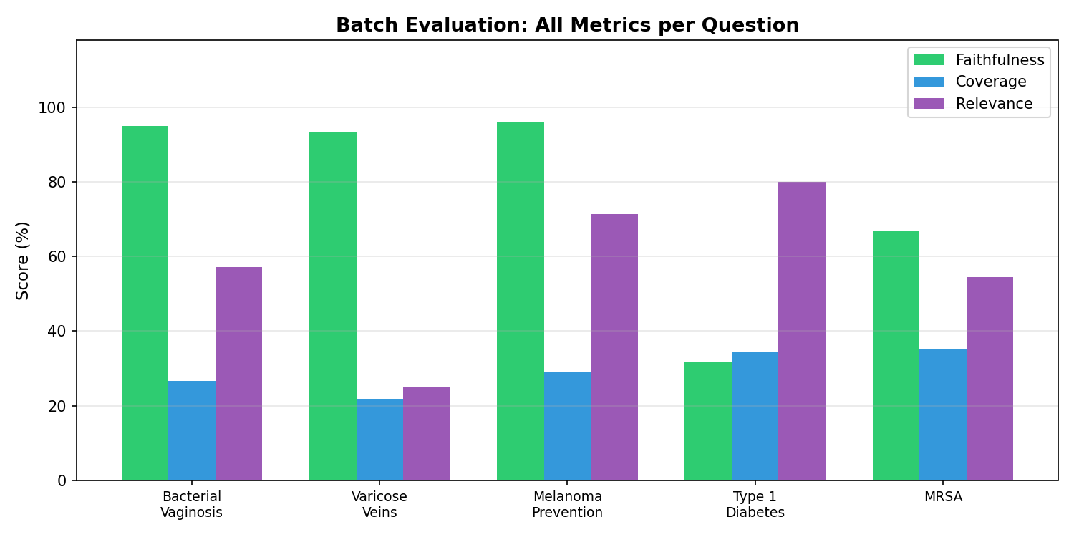

3. Fair Comparison Results (LLM-Judged)
The fair comparison re-evaluates both Ollama and Groq generated answers using the same Groq 70B judge. This provides semantic evaluation rather than surface-level token matching.

3.1 Overall Averages
Metric | Ollama Answers | Groq Answers
Faithfulness | 88.0% | 100.0%
Context Recall | 100.0% | 100.0%
BLEU Score | 51.9% | 63.7%

3.2 Per-Question Scores
Question | Ollama Faith. | Groq Faith. | Ollama BLEU | Groq BLEU
Symptoms of bacterial vaginosis | 100.0% | 100.0% | 91.1% | 86.8%
Causes of varicose veins | 100.0% | 100.0% | 45.9% | 36.1%
Preventing melanoma | 100.0% | 100.0% | 78.5% | 96.9%
Living with type 1 diabetes | 80.0% | 100.0% | 9.6% | 20.0%
MRSA | 60.0% | 100.0% | 34.2% | 78.6%

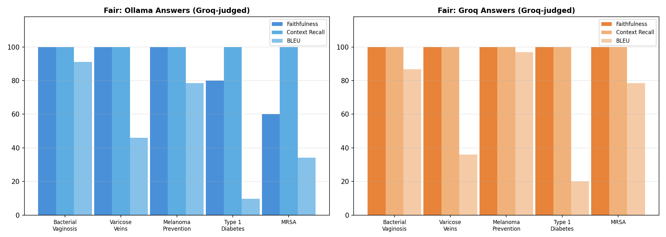

4. Direct Comparison: Faithfulness
Faithfulness is the one metric both approaches share (though measured differently). This section compares them directly.

4.1 Faithfulness: All Three Variants
Question | Batch  (token-overlap) | Fair: Ollama  (Groq-judged) | Fair: Groq  (Groq-judged)
Symptoms of bacterial vaginosis | 95.0% | 100.0% | 100.0%
Causes of varicose veins | 93.5% | 100.0% | 100.0%
Preventing melanoma | 96.0% | 100.0% | 100.0%
Living with type 1 diabetes | 31.9% | 80.0% | 100.0%
MRSA | 66.7% | 60.0% | 100.0%

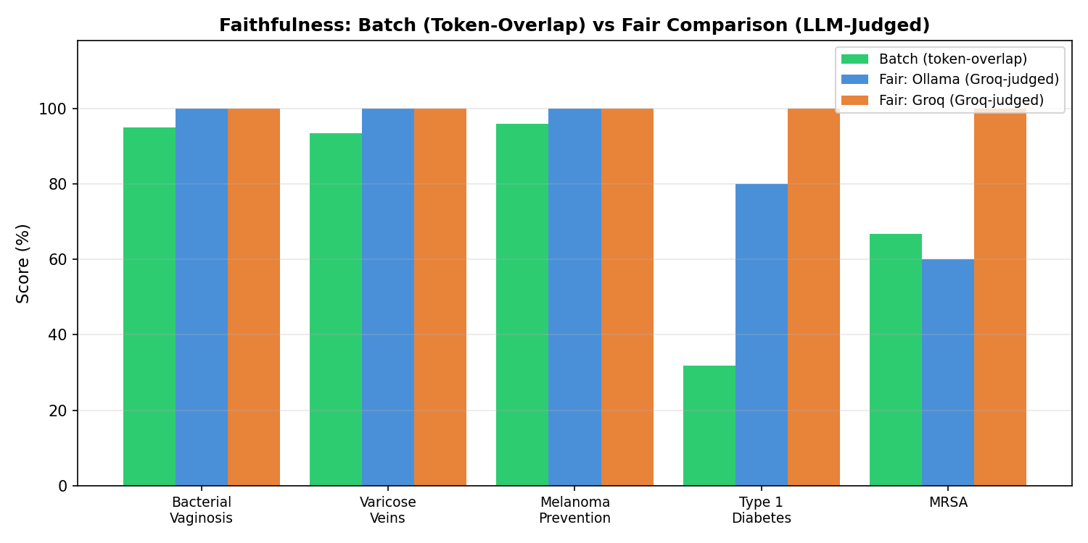

4.2 Overall Comparison: All Metrics
Metric | Batch (Ollama) | Fair: Ollama  (Groq-judged) | Fair: Groq  (Groq-judged)
Faithfulness | 76.6% | 88.0% | 100.0%
Coverage / Context Recall | 29.4% | 100.0% | 100.0%
Relevance / BLEU | 57.6% | 51.9% | 63.7%

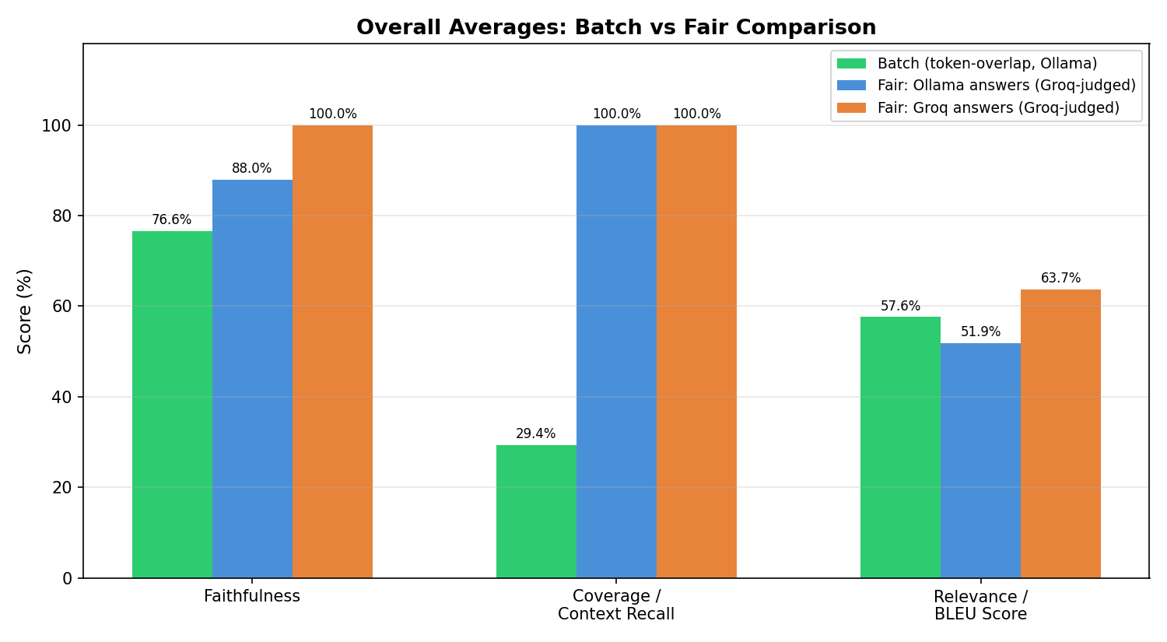

5. Analysis: Why the Approaches Differ

5.1 Token-Overlap vs Semantic Understanding
The batch evaluation measures faithfulness by counting how many answer tokens appear in the context. This is fast and deterministic, but it misses semantic meaning. For example, if the answer says "varicose veins are caused by valve problems" and the context says "valves stop working properly", token overlap may score this lower than an LLM judge that understands they mean the same thing.

5.2 Coverage vs Context Recall
Batch coverage (29.4%) is much lower than fair context recall (100%). This is because coverage measures what fraction of context tokens appear in the answer — but the context is much longer than the answer, so most context tokens naturally won't appear. The LLM judge evaluates whether the context semantically covers the reference answer, which is a more meaningful question.

5.3 Relevance vs BLEU
Batch relevance (57.6%) measures query-answer token overlap — does the answer contain the question's words? BLEU (51.9% Ollama, 63.7% Groq) measures answer-reference word overlap. These measure different things: relevance checks if the answer addresses the question, while BLEU checks if the answer matches the ground truth.

5.4 Type 1 Diabetes — Consistently Weak
Both approaches flagged this question as problematic. Batch faithfulness was 31.9% (the answer contained many words not in the context), and fair faithfulness was 80% (the LLM judge noted the answer added unsupported advice). The underlying issue is thin reference data for this topic.

5.5 MRSA — Divergent Scores
Batch faithfulness for MRSA was 66.7% while fair comparison gave 60%. Both flagged that the Ollama answer drifted into treatment details beyond the "how you get MRSA" question. The token-overlap approach caught this because treatment-related tokens weren't in the primary context chunk.

6. Key Takeaways
- Token-overlap metrics (batch) are fast, deterministic, and free — but they only capture surface-level word matching. They work well as a quick sanity check.
- LLM-judged metrics (fair comparison) capture semantic meaning and nuance, but depend on the quality of the judge model and cost API calls.
- Both approaches agreed on the weak spots: Type 1 Diabetes (thin data) and MRSA (answer drift). When both methods flag the same issue, it's a reliable signal.
- The ideal evaluation combines both: token-overlap for fast iteration during development, and LLM-judged metrics for thorough evaluation before deployment.
- Coverage (29.4%) should not be compared directly to context recall (100%) — they measure fundamentally different things despite sounding similar.

