Chunking Methods — RAGAS Evaluation Report
QA-Pair vs Recursive Character vs Semantic Chunking

1. Overview
This report compares three chunking strategies evaluated using the RAGAS framework. All methods use Groq's llama-3.3-70b-versatile for both answer generation and RAGAS evaluation. The same 5 questions and ground-truth references are used across all methods.
 | QA-Pair (Original) | Recursive Character | Semantic Chunking
Ingestion File | ingest.py | ingest_recursive.py | ingest_semantic.py
Method | Split by ## Question blocks | 800 chars, 200 overlap | Embedding similarity splits
Chunks Created | ~1,950 | 2,801 | 4,248
Vector Store | db/chroma_db | db/chroma_db_recursive | db/chroma_db_semantic

1.1 RAGAS Metrics
Metric | What RAGAS Measures | How It Works
Faithfulness | Is the answer grounded in context? | Extracts claims from answer,  verifies each against context
Context Recall | Does context cover the reference? | Checks each reference sentence  against retrieved context
Context Precision | Were retrieved chunks useful? | Checks if each context chunk  helped answer the question

2. Overall Results
Metric | QA-Pair | Recursive | Semantic | Best
Faithfulness | 98.0% | 98.0% | 97.1% | QA-Pair
Context Recall | 100.0% | 80.0% | 66.0% | QA-Pair
Context Precision | 90.0% | 78.3% | 71.7% | QA-Pair

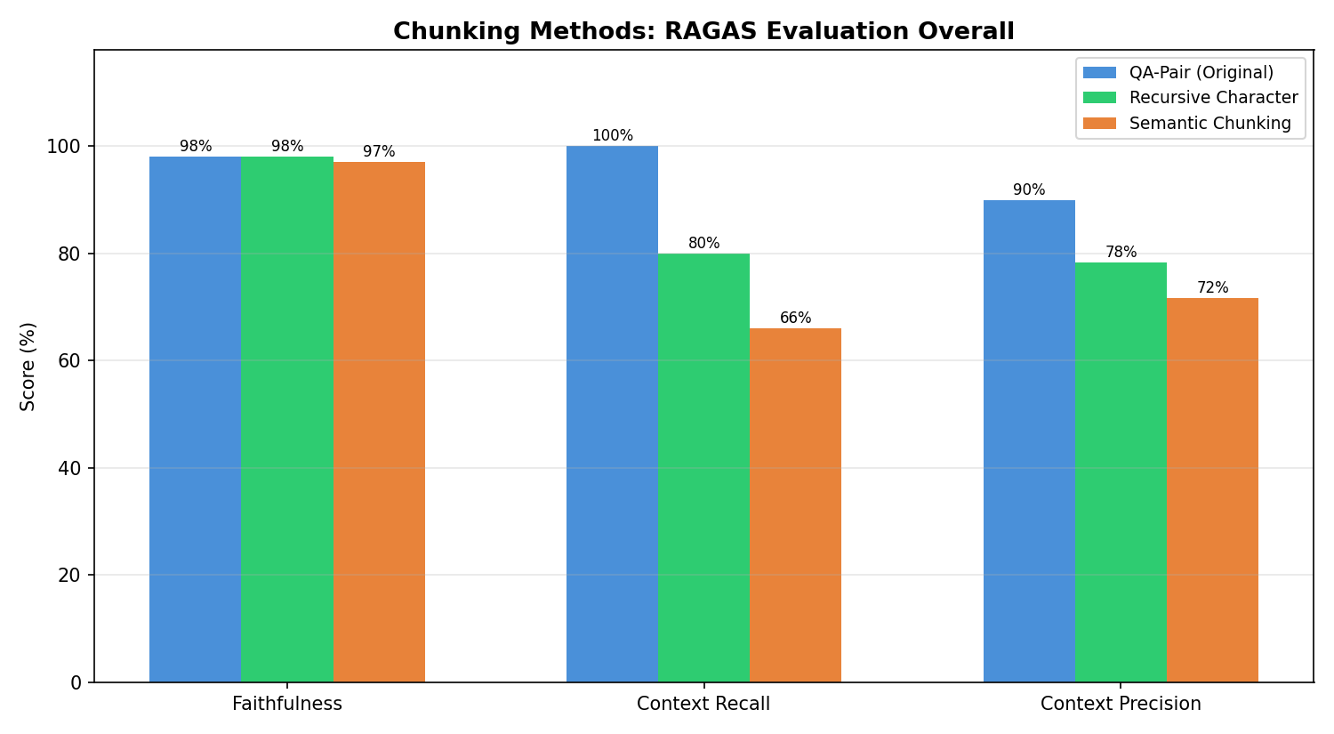

3. Per-Question Breakdown

3.1 Faithfulness
Question | QA-Pair | Recursive | Semantic
Symptoms of bacterial vaginosis | 100% | 100% | 100%
Causes of varicose veins | 90% | 90% | 86%
Preventing melanoma | 100% | 100% | 100%
Living with type 1 diabetes | 100% | 100% | 100%
MRSA | 100% | 100% | 100%

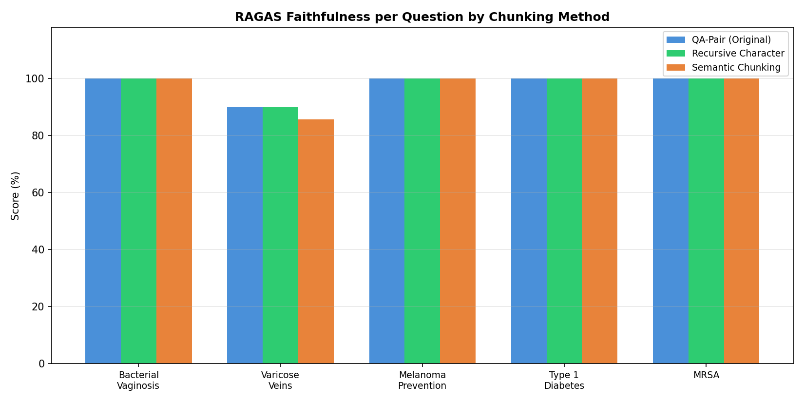

3.2 Context Recall
Question | QA-Pair | Recursive | Semantic
Symptoms of bacterial vaginosis | 100% | 100% | 100%
Causes of varicose veins | 100% | 100% | 50%
Preventing melanoma | 100% | 100% | 100%
Living with type 1 diabetes | 100% | 0% | 0%
MRSA | 100% | 100% | 80%

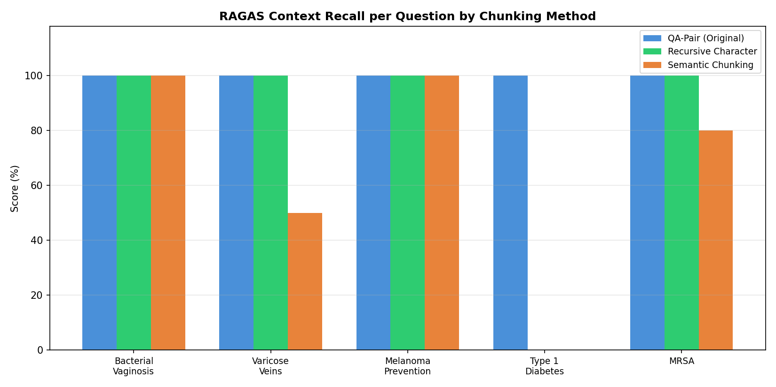

3.3 Context Precision
Question | QA-Pair | Recursive | Semantic
Symptoms of bacterial vaginosis | 100% | 100% | 100%
Causes of varicose veins | 100% | 100% | 100%
Preventing melanoma | 92% | 100% | 83%
Living with type 1 diabetes | 75% | 0% | 0%
MRSA | 83% | 92% | 75%

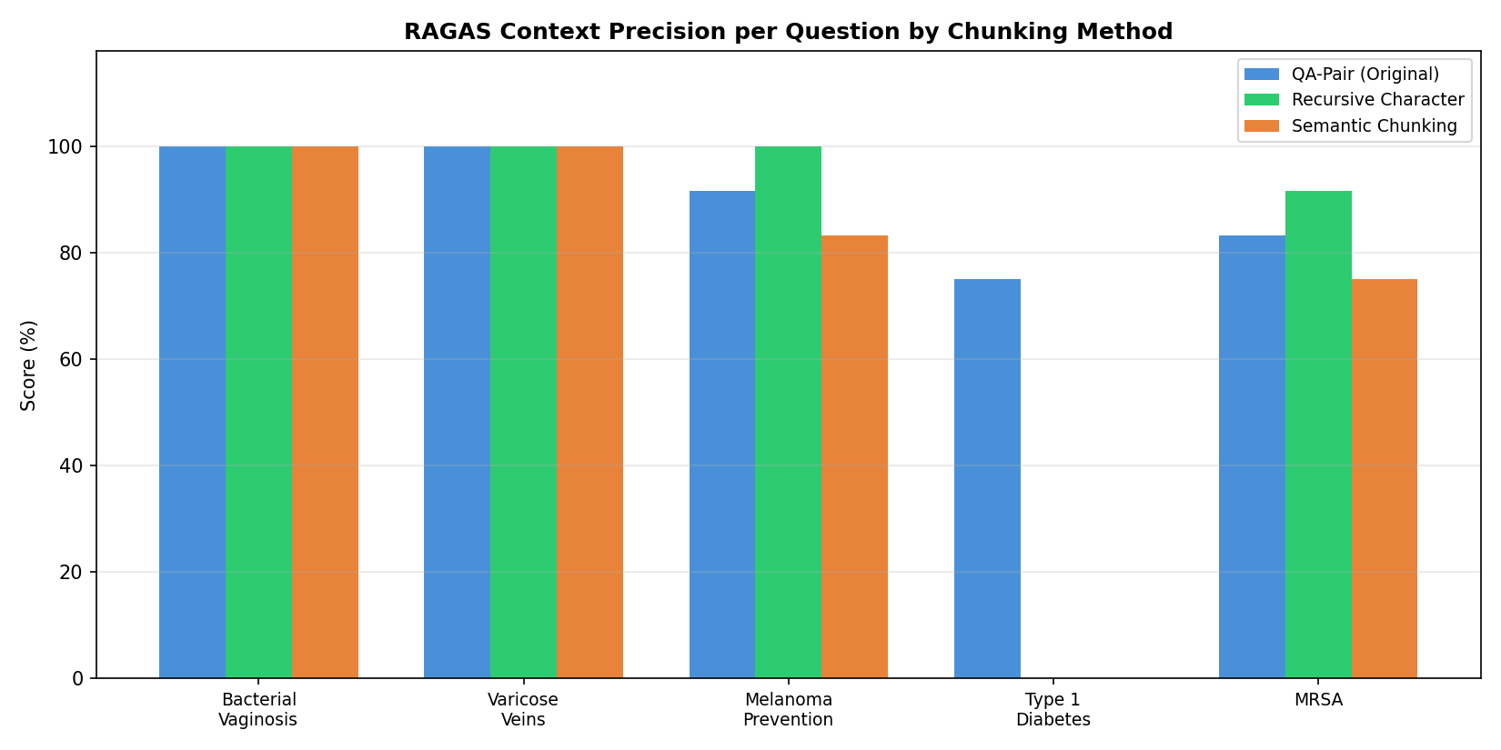

4. Analysis

4.1 QA-Pair Chunking Wins Across All RAGAS Metrics
QA-Pair chunking scored highest on all three RAGAS metrics: 98% faithfulness, 100% context recall, and 90% context precision. This confirms what our earlier custom evaluation found — when documents are structured as question-answer pairs, chunking by those natural boundaries preserves the semantic completeness that retrieval needs.

4.2 Context Recall: The Biggest Differentiator
Context recall dropped significantly with alternative chunking: 100% (QA-Pair) → 80% (Recursive) → 66% (Semantic). RAGAS verified this by checking each sentence in the reference answer against the retrieved context. Recursive and semantic splitting fragment QA pairs, so the retriever can't find complete answers — parts of the reference information are missing from the retrieved chunks.

4.3 Context Precision: Retrieval Noise
Context precision measures whether retrieved chunks were actually useful. QA-Pair scored 90%, while Recursive (78.3%) and Semantic (71.7%) scored lower. This means the alternative methods retrieved more irrelevant chunks — noise that doesn't help answer the question. More chunks doesn't mean better retrieval.

4.4 Faithfulness: Similar Across Methods
All three methods scored similarly on faithfulness (97-98%). This makes sense — faithfulness measures whether the answer stays grounded in whatever context was retrieved. Even with worse retrieval, the LLM was disciplined about not hallucinating beyond the provided context.

4.5 RAGAS vs Custom Evaluation Agreement
Both RAGAS and our earlier custom evaluation reached the same conclusion: QA-Pair chunking is best for this dataset. However, RAGAS provides more granular insights — the context precision metric revealed retrieval noise that the custom evaluation couldn't detect.

5. Conclusion
- QA-Pair chunking is the clear winner for structured FAQ-style medical documents. RAGAS evaluation confirms this with rigorous, decomposed metrics that go beyond simple scoring.
- Chunking strategy primarily affects retrieval quality (context recall and precision), not generation quality (faithfulness). The LLM generates faithful answers regardless — the bottleneck is whether the right documents are retrieved.
- RAGAS's context precision metric adds value over custom evaluation by detecting retrieval noise — an important signal for optimising the retrieval pipeline.

