Fair Comparison Report
Both answer sets judged by the same model: Groq llama-3.3-70b-versatile

1. Approach
The original evaluation used each model as both generator and judge, making comparison unfair. In this fair comparison, we keep the original generated answers from both Ollama and Groq, but re-evaluate ALL answers using the same judge: Groq's llama-3.3-70b-versatile (70B parameters). This isolates the answer quality from the judge quality.

2. Overall Results (Same Judge)
Metric | Ollama Answers | Groq Answers | Difference
Faithfulness | 88.0% | 100.0% | +12.0%
Context Recall | 100.0% | 100.0% | +0.0%
BLEU Score | 51.9% | 63.7% | +11.8%

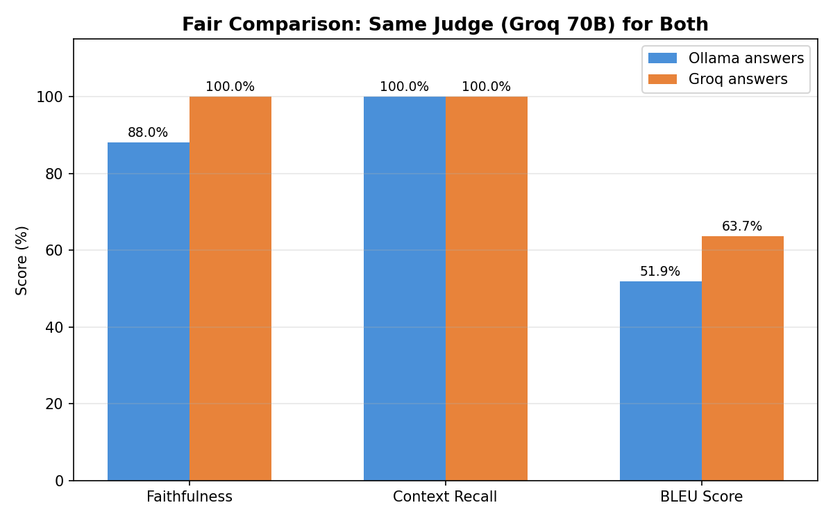

3. Per-Question Breakdown

3.1 Faithfulness
Question | Ollama | Groq | Diff
Symptoms of bacterial vaginosis | 100.0% | 100.0% | +0.0%
Causes of varicose veins | 100.0% | 100.0% | +0.0%
Preventing melanoma | 100.0% | 100.0% | +0.0%
Living with type 1 diabetes | 80.0% | 100.0% | +20.0%
MRSA | 60.0% | 100.0% | +40.0%

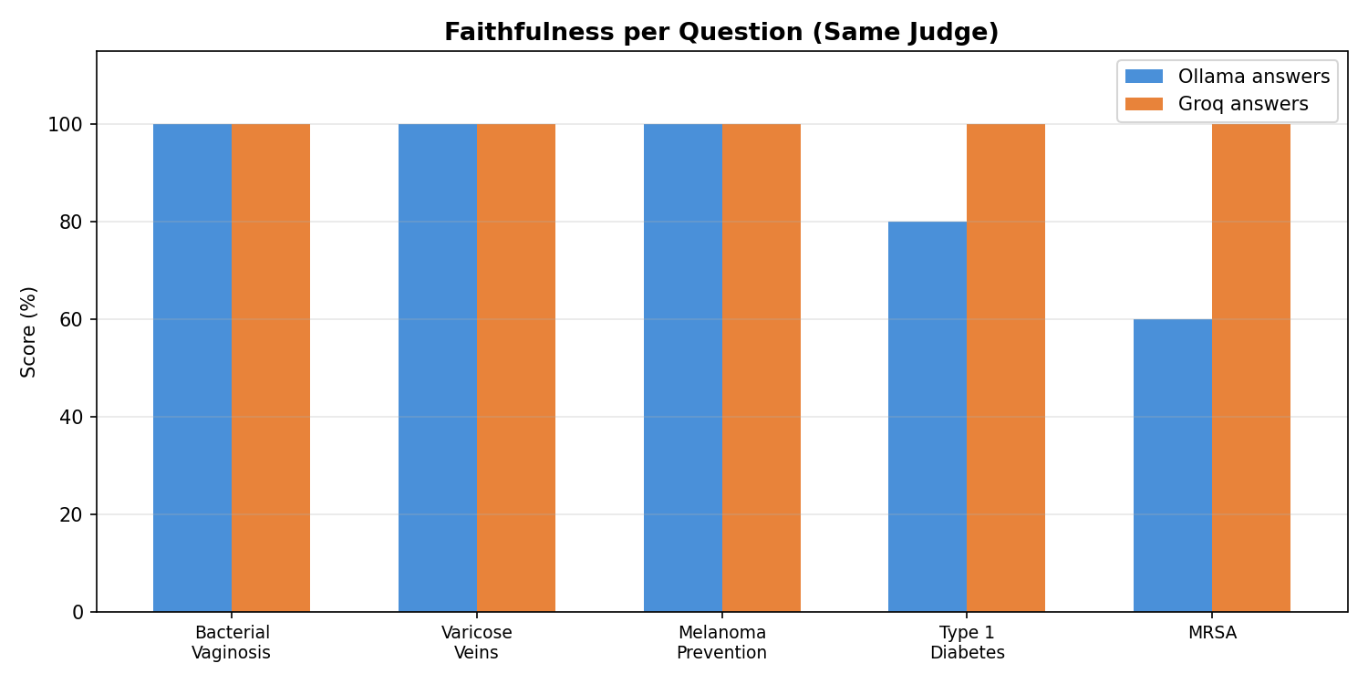

3.2 Context Recall
Question | Ollama | Groq | Diff
Symptoms of bacterial vaginosis | 100.0% | 100.0% | +0.0%
Causes of varicose veins | 100.0% | 100.0% | +0.0%
Preventing melanoma | 100.0% | 100.0% | +0.0%
Living with type 1 diabetes | 100.0% | 100.0% | +0.0%
MRSA | 100.0% | 100.0% | +0.0%

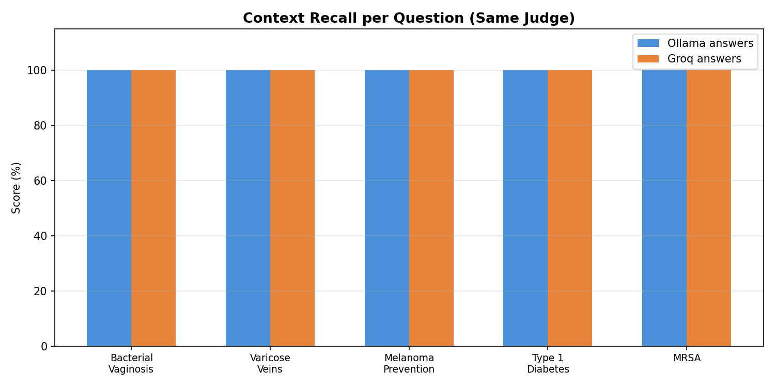

3.3 BLEU Score
Question | Ollama | Groq | Diff
Symptoms of bacterial vaginosis | 91.1% | 86.8% | -4.3%
Causes of varicose veins | 45.9% | 36.1% | -9.8%
Preventing melanoma | 78.5% | 96.9% | +18.5%
Living with type 1 diabetes | 9.6% | 20.0% | +10.4%
MRSA | 34.2% | 78.6% | +44.3%

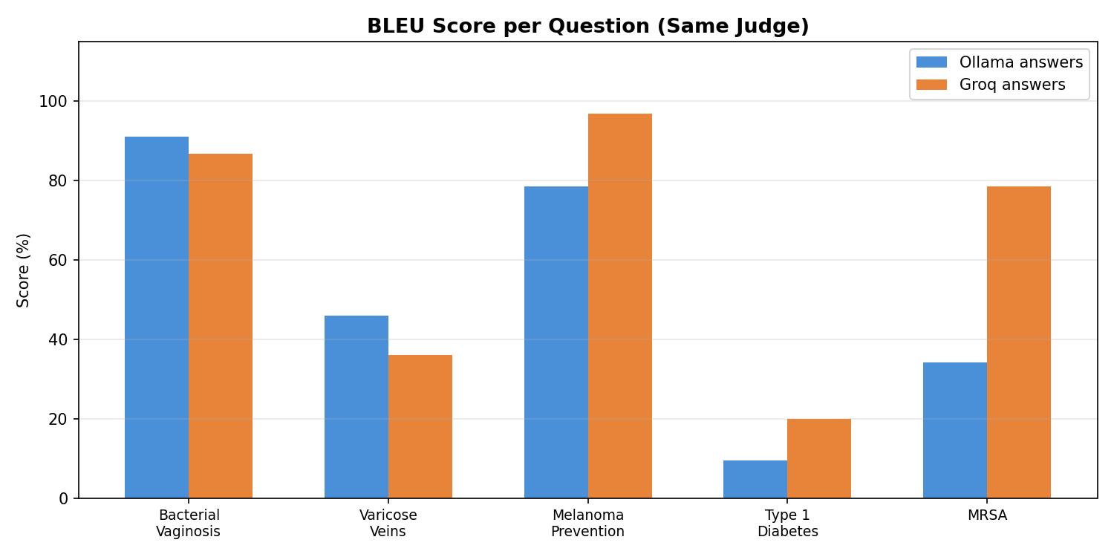

4. What This Tells Us
With the same judge model evaluating both sets of answers, we can now see the true difference in answer quality between the 3B and 70B generation models, free from judge bias.
The BLEU scores remain unchanged since they are purely algorithmic. The faithfulness and context recall scores now reflect actual answer quality differences rather than judge capability differences.

5. Original vs Fair Comparison
Metric | Ollama (self-judged) | Ollama (Groq-judged) | Change
Faithfulness | 56.6% | 88.0% | +31.4%
Context Recall | 38.6% | 100.0% | +61.4%
BLEU Score | 51.9% | 51.9% | -0.0%

This table shows how much the Ollama scores change when judged by a better model. The difference highlights how unreliable the small 3B model was as an evaluator.

