RAG Evaluation Comparison Report
Ollama (llama3.2 — 3B, Local) vs Groq (llama-3.3-70b — API)
Includes original evaluation and fair comparison with same judge model

1. Overview
This report compares the evaluation results of the same RAG (Retrieval-Augmented Generation) pipeline using two different LLM backends. Both runs used the same retrieval pipeline (ChromaDB + sentence-transformers embeddings + cross-encoder reranker), the same 5 questions, and the same reference documents from HSE medical conditions.
 | Ollama (Local) | Groq (API)
Model | llama3.2 (3B params) | llama-3.3-70b-versatile (70B params)
Hosting | Local (on-device) | Cloud API (free tier)
Role | RAG generation + evaluation judge | RAG generation + evaluation judge
Questions | 5 | 5

The evaluation uses three metrics: Faithfulness (is the answer grounded in context?), Context Recall (does the context cover the reference answer?), and BLEU Score (algorithmic word overlap between answer and reference).

2. Original Evaluation Results
In the original evaluation, each model served as both the answer generator and the evaluation judge. Ollama's llama3.2 (3B) judged its own answers, and Groq's llama-3.3-70b (70B) judged its own answers.

2.1 Overall Averages
Metric | Ollama (llama3.2) | Groq (llama-3.3-70b) | Difference
Faithfulness | 56.6% | 100.0% | +43.4%
Context Recall | 38.6% | 100.0% | +61.4%
BLEU Score | 51.9% | 63.7% | +11.8%

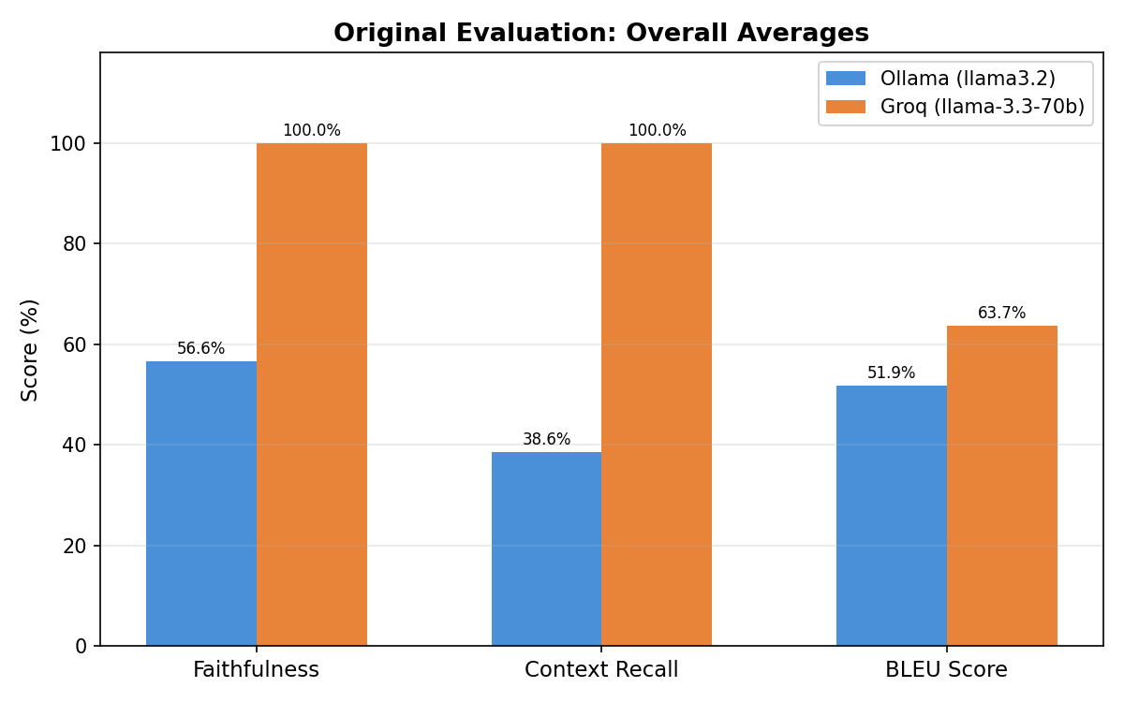

2.2 Faithfulness per Question
Question | Ollama | Groq | Diff
Symptoms of bacterial vaginosis | 80.0% | 100.0% | +20.0%
Causes of varicose veins | 80.0% | 100.0% | +20.0%
Preventing melanoma | 33.0% | 100.0% | +67.0%
Living with type 1 diabetes | 50.0% | 100.0% | +50.0%
MRSA | 40.0% | 100.0% | +60.0%

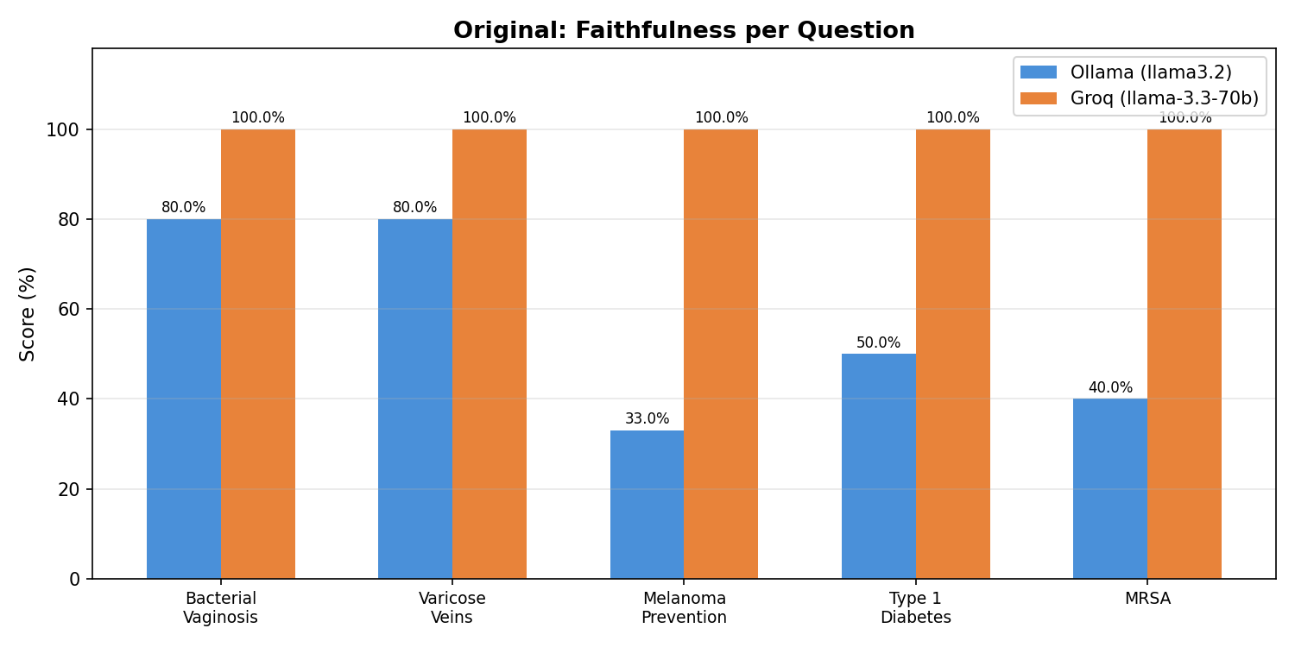

2.3 Context Recall per Question
Question | Ollama | Groq | Diff
Symptoms of bacterial vaginosis | 40.0% | 100.0% | +60.0%
Causes of varicose veins | 40.0% | 100.0% | +60.0%
Preventing melanoma | 40.0% | 100.0% | +60.0%
Living with type 1 diabetes | 33.0% | 100.0% | +67.0%
MRSA | 40.0% | 100.0% | +60.0%

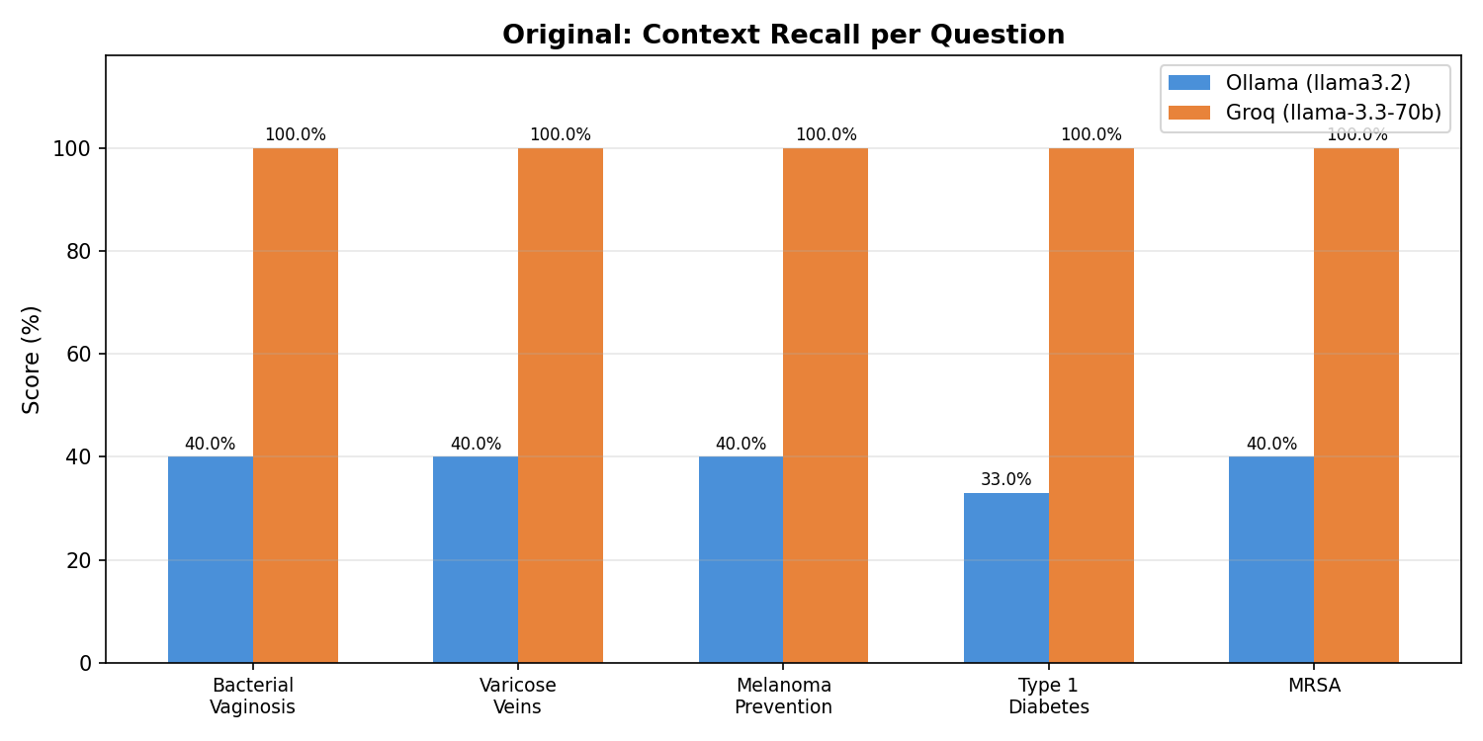

2.4 BLEU Score per Question
Question | Ollama | Groq | Diff
Symptoms of bacterial vaginosis | 91.1% | 86.8% | -4.3%
Causes of varicose veins | 45.9% | 36.1% | -9.8%
Preventing melanoma | 78.5% | 96.9% | +18.4%
Living with type 1 diabetes | 9.6% | 20.0% | +10.4%
MRSA | 34.2% | 78.6% | +44.4%

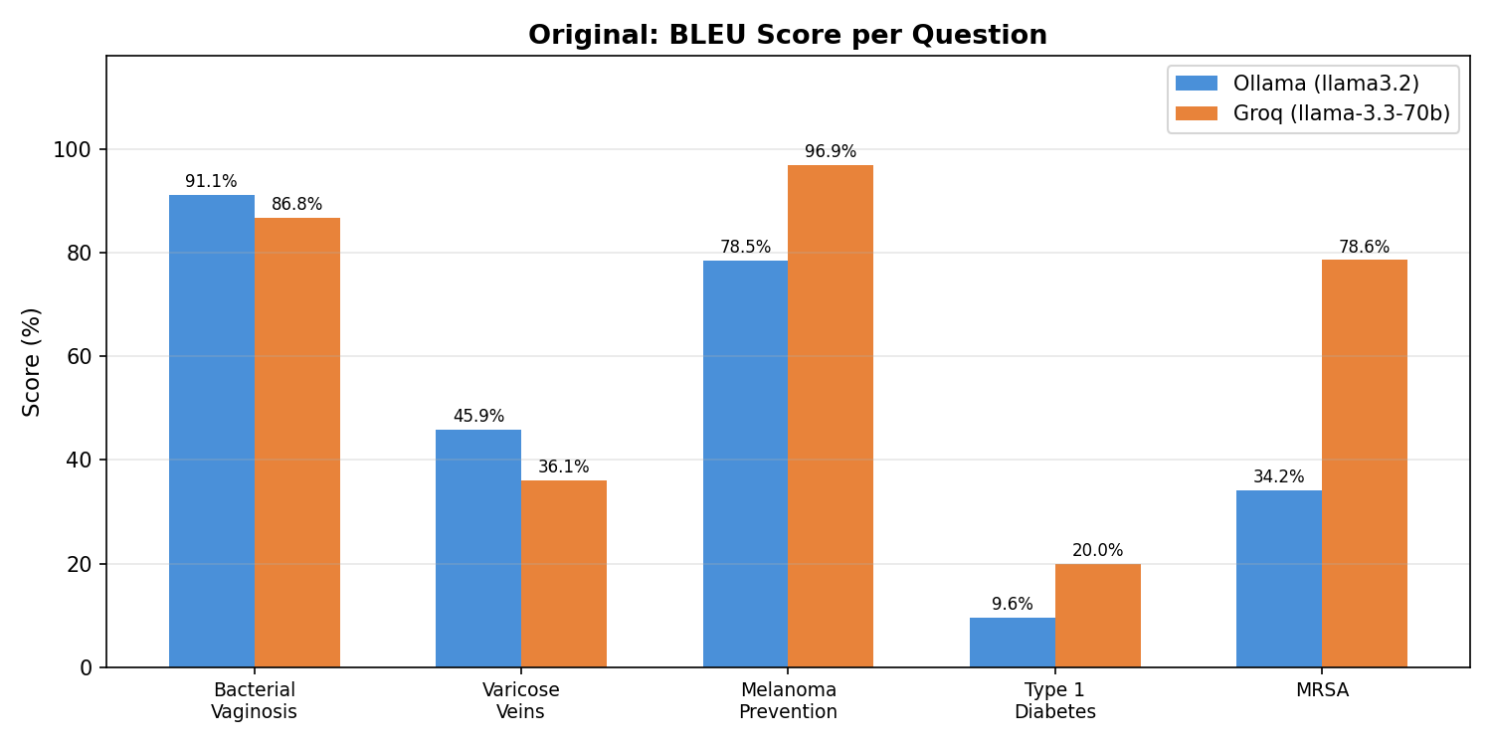

3. Fair Comparison (Same Judge: Groq 70B)
To isolate answer quality from judge quality, we re-evaluated both sets of answers using the same judge model: Groq's llama-3.3-70b-versatile (70B parameters). The original generated answers from both Ollama and Groq were kept unchanged — only the evaluation judge was standardised.

3.1 Overall Averages (Same Judge)
Metric | Ollama Answers | Groq Answers | Difference
Faithfulness | 88.0% | 100.0% | +12.0%
Context Recall | 100.0% | 100.0% | +0.0%
BLEU Score | 51.9% | 63.7% | +11.8%

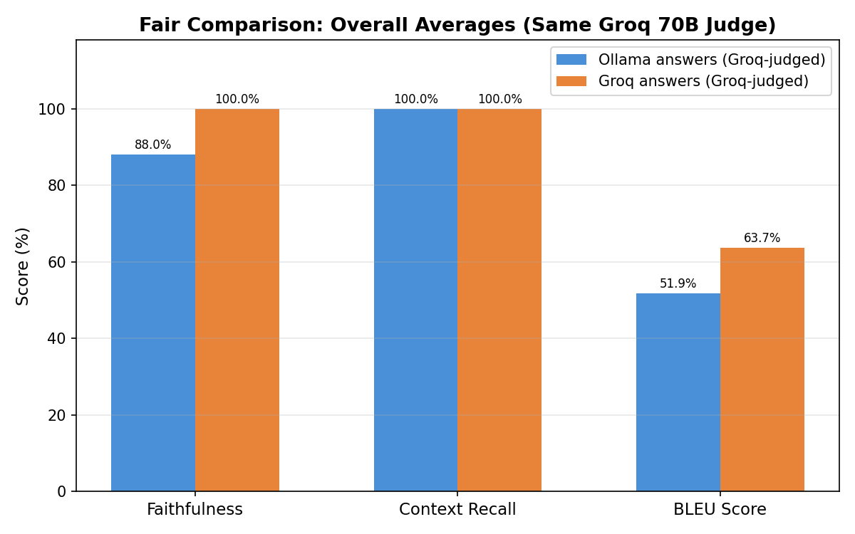

3.2 Faithfulness per Question (Same Judge)
Question | Ollama | Groq | Diff
Symptoms of bacterial vaginosis | 100.0% | 100.0% | +0.0%
Causes of varicose veins | 100.0% | 100.0% | +0.0%
Preventing melanoma | 100.0% | 100.0% | +0.0%
Living with type 1 diabetes | 80.0% | 100.0% | +20.0%
MRSA | 60.0% | 100.0% | +40.0%

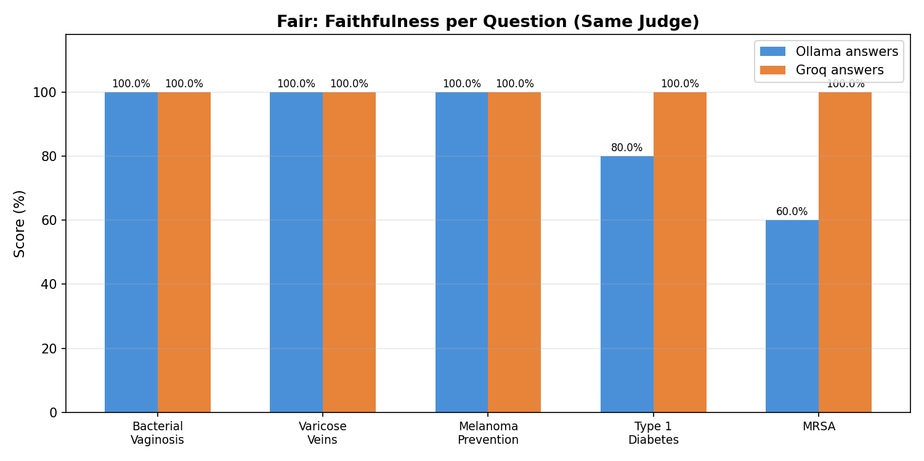

3.3 Context Recall per Question (Same Judge)
Question | Ollama | Groq | Diff
Symptoms of bacterial vaginosis | 100.0% | 100.0% | +0.0%
Causes of varicose veins | 100.0% | 100.0% | +0.0%
Preventing melanoma | 100.0% | 100.0% | +0.0%
Living with type 1 diabetes | 100.0% | 100.0% | +0.0%
MRSA | 100.0% | 100.0% | +0.0%

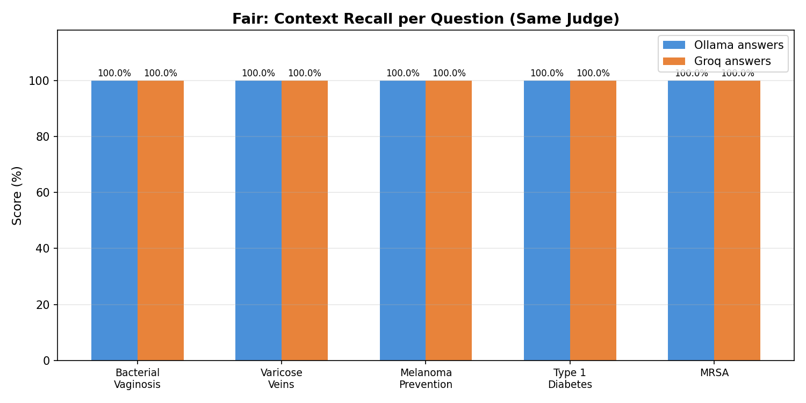

3.4 BLEU Score per Question (Same Judge)
Question | Ollama | Groq | Diff
Symptoms of bacterial vaginosis | 91.1% | 86.8% | -4.3%
Causes of varicose veins | 45.9% | 36.1% | -9.8%
Preventing melanoma | 78.5% | 96.9% | +18.4%
Living with type 1 diabetes | 9.6% | 20.0% | +10.4%
MRSA | 34.2% | 78.6% | +44.4%

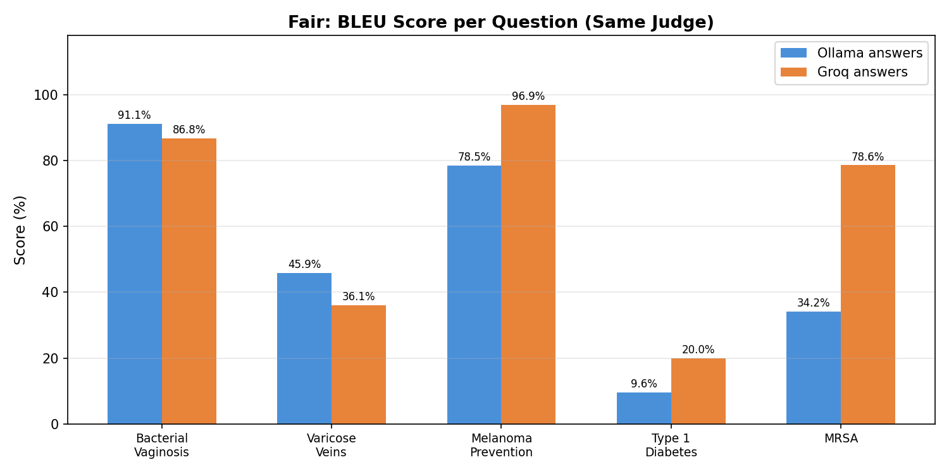

4. Original vs Fair: Side-by-Side
These charts show all four score variants per question — original self-judged scores alongside the fair Groq-judged scores — making the impact of judge quality immediately visible.

4.1 Faithfulness: Original vs Fair
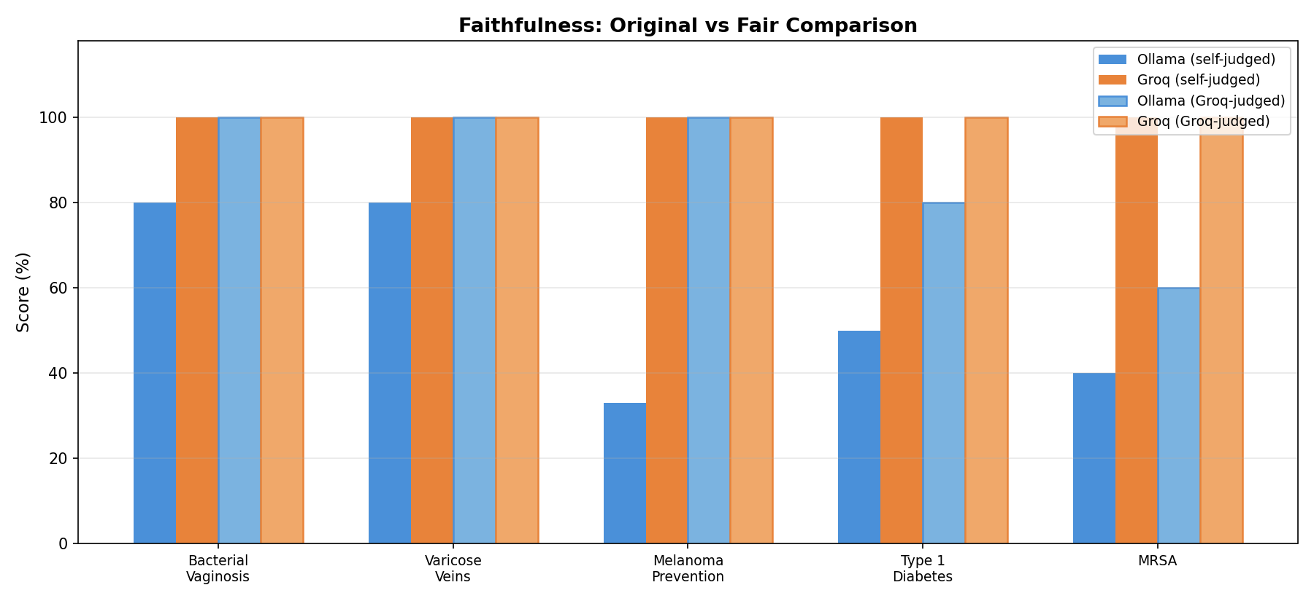

4.2 Context Recall: Original vs Fair
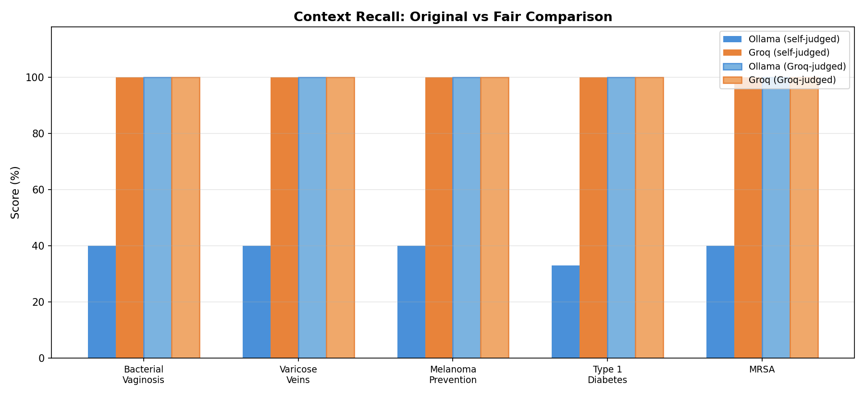

4.3 Impact of Judge Change on Ollama Scores
This table shows how Ollama's scores changed when re-evaluated by the Groq 70B judge instead of its own 3B judge.
Metric | Ollama (self-judged) | Ollama (Groq-judged) | Change
Faithfulness | 56.6% | 88.0% | +31.4%
Context Recall | 38.6% | 100.0% | +61.4%
BLEU Score | 51.9% | 51.9% | -0.0%

5. Analysis: Why the Results Differ

5.1 Judge Model Quality — The Main Factor
Faithfulness and context recall are scored by an LLM acting as a judge. In the original evaluation, Ollama used its own llama3.2 (3B parameters) as the judge, while Groq used llama-3.3-70b (70B parameters).
The 3B model is a weak evaluator. It struggles to properly assess whether a response is grounded in the provided context, often giving inconsistent and lower scores even when the answer is clearly faithful. The 70B model understands the evaluation task much better and scores more accurately.
Evidence: When we re-judged Ollama's answers with the Groq 70B judge, faithfulness jumped from 56.6% to 88.0% and context recall from 38.6% to 100.0%. The answers didn't change — only the judge got smarter.

5.2 Generation Quality — A Secondary Factor
The 70B model also generates slightly better RAG answers than the 3B model. Examples:
- Melanoma: Groq's answer included "Melanoma is not always preventable, but..." which closely matches the reference. Ollama's version said "Melanoma can be prevented by..." — a subtle but meaningful inaccuracy that omits the nuance from the source material.
- MRSA: Groq's answer stayed focused on "how you get MRSA" (the actual question), while Ollama's answer drifted into treatment details from other context chunks, reducing faithfulness.
- Type 1 Diabetes: Both models acknowledged the thin context, but Groq's response was more concise and cited the source, while Ollama added unsupported advice about "exploring additional resources."

5.3 BLEU Tells the Objective Story
BLEU is computed algorithmically with no LLM involvement, making it the most objective metric. The BLEU improvement was moderate (51.9% → 63.7%), confirming that the 70B model generates better answers, but not as dramatically as the original LLM-judged metrics suggested.
BLEU scores are identical in both the original and fair comparison because they don't depend on the judge model at all.

5.4 Type 1 Diabetes — Low for Both
Both models scored low on BLEU for this question because the reference answer is extremely short: "Advice on avoiding complications of type 1 diabetes." There simply isn't enough ground-truth content for either model to match against. This is a data quality issue, not a model quality issue.

6. Key Takeaways
- Using a small model (3B) as both generator and judge produces unreliable evaluation scores. The 3B judge underscored Ollama's answers by over 30 percentage points on faithfulness.
- The 70B model via Groq API provides better generation quality and much more reliable evaluation. The fair comparison shows the actual generation gap is modest (~12% on faithfulness, ~12% on BLEU).
- BLEU scores are the most objective metric since they don't depend on LLM judgment. They should be used alongside LLM-judged metrics to cross-validate results.
- For reliable evaluation, always use a strong model as the judge — ideally separate from the generation model. This avoids self-evaluation bias.
- Both models performed well on context recall when fairly judged (100%), indicating the retrieval pipeline itself is working effectively.

