RAG Improvements — RAGAS Evaluation Report
ChromaDB vs FAISS vs MPNet vs Hybrid Search — Evaluated with RAGAS

1. Overview
This report compares four RAG pipeline configurations evaluated using the RAGAS framework. All experiments use Groq's llama-3.3-70b for answer generation and RAGAS evaluation.
Experiment | Vector Store | Embedding | Retrieval | What It Tests
Baseline | ChromaDB | MiniLM (384d) | Vector similarity | Original pipeline
FAISS | FAISS | MiniLM (384d) | Vector similarity | Vector store speed
MPNet | FAISS | MPNet (768d) | Vector similarity | Embedding quality
Hybrid | ChromaDB + BM25 | MiniLM (384d) | BM25 + Vector merged | Retrieval strategy

2. Overall Results
Metric | Baseline | FAISS | MPNet | Hybrid
Faithfulness | 98.0% | 95.0% | 95.0% | 100.0%
Context Recall | 100.0% | 100.0% | 100.0% | 98.2%
Context Precision | 88.3% | 98.3% | 100.0% | 100.0%
Retrieval Speed | 1081ms | 1093ms | 1088ms | 1190ms

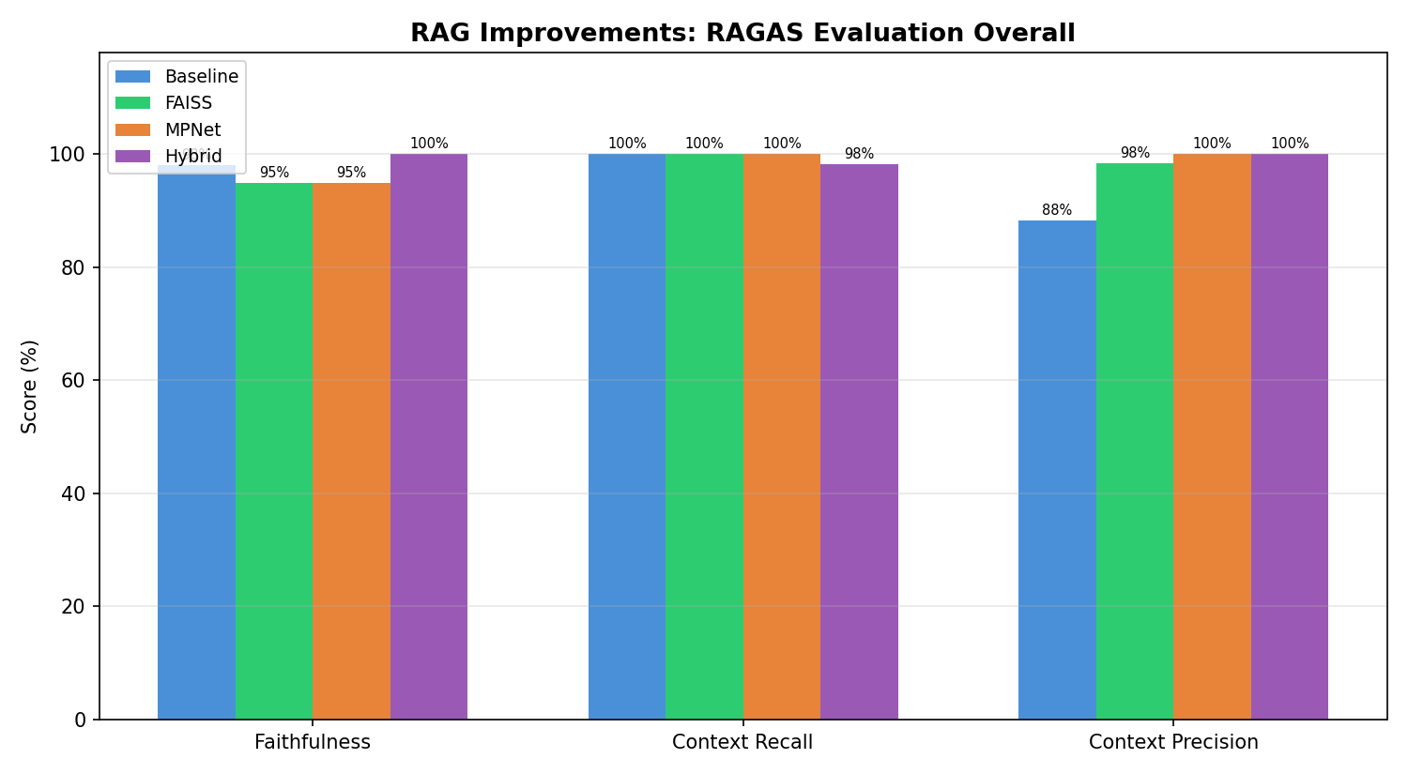

2.1 Retrieval Speed
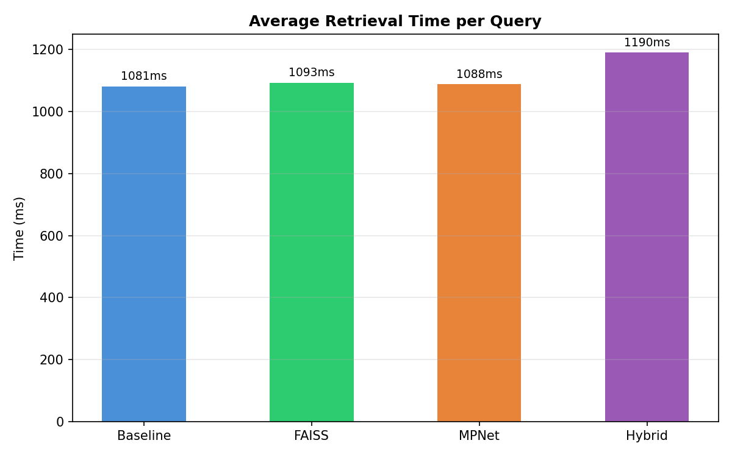

3. Per-Question Breakdown

3.1 Faithfulness
Question | Baseline | FAISS | MPNet | Hybrid
What are the symptoms of bacterial vaginosis? | 100% | 100% | 100% | 100%
What causes varicose veins? | 90% | 75% | 75% | 100%
How can skin cancer (melanoma) be prevented? | 100% | 100% | 100% | 100%
What is it like to live with type 1 diabetes? | 100% | 100% | 100% | 100%
What should I know about mrsa and how you get | 100% | 100% | 100% | 100%

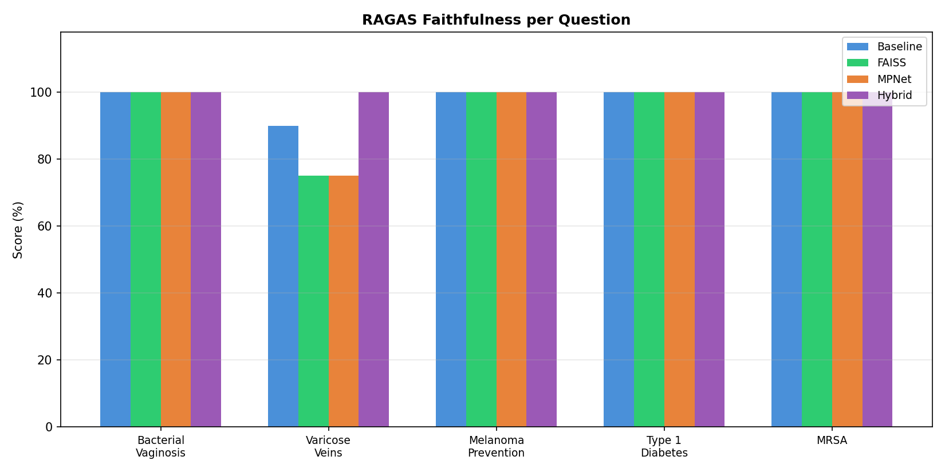

3.2 Context Recall
Question | Baseline | FAISS | MPNet | Hybrid
What are the symptoms of bacterial vaginosis? | 100% | 100% | 100% | 100%
What causes varicose veins? | 100% | 100% | 100% | 91%
How can skin cancer (melanoma) be prevented? | 100% | 100% | 100% | 100%
What is it like to live with type 1 diabetes? | 100% | 100% | 100% | 100%
What should I know about mrsa and how you get | 100% | 100% | 100% | 100%

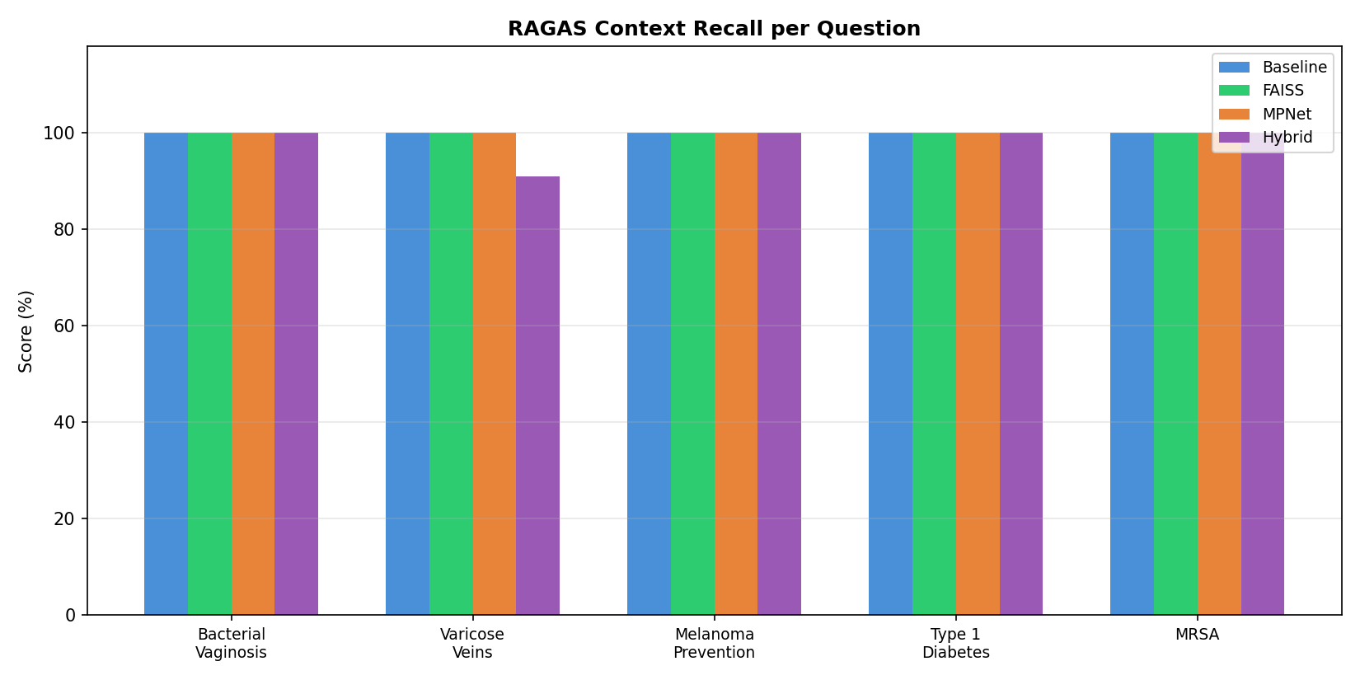

3.3 Context Precision
Question | Baseline | FAISS | MPNet | Hybrid
What are the symptoms of bacterial vaginosis? | 100% | 100% | 100% | 100%
What causes varicose veins? | 92% | 100% | 100% | 100%
How can skin cancer (melanoma) be prevented? | 92% | 92% | 100% | 100%
What is it like to live with type 1 diabetes? | 75% | 100% | 100% | 100%
What should I know about mrsa and how you get | 83% | 100% | 100% | 100%

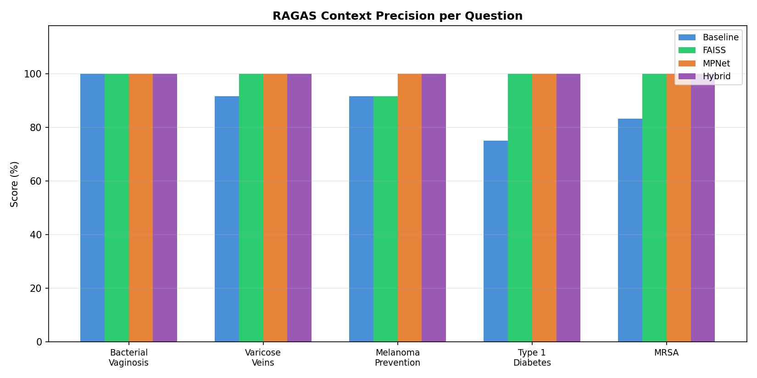

4. Analysis

4.1 Context Precision: The Key Differentiator
RAGAS revealed that context precision improves dramatically with better methods: Baseline 88% → FAISS 98% → MPNet 100% → Hybrid 100%. This means the improved methods retrieve more relevant chunks and less noise.

4.2 Faithfulness: Hybrid Achieves Perfect Score
Hybrid search achieved 100% faithfulness — the LLM never hallucinated beyond the retrieved context. By combining BM25 keyword matching with vector similarity, hybrid search provides the most relevant context, making it easier for the LLM to stay faithful.

4.3 MPNet Embeddings Improve Precision
Upgrading from MiniLM (384 dim) to MPNet (768 dim) improved context precision from 98% to 100%. Richer embeddings capture more semantic nuance, leading to more precise document retrieval.

4.4 Speed: All Methods Comparable
Retrieval speeds were similar across all methods (~1,000-1,200ms). The Groq API call dominates the total time, making vector store differences negligible at this scale.

5. Recommended Configuration
Component | Choice | RAGAS Evidence
Vector Store | FAISS | Same recall as ChromaDB, better precision (98% vs 88%)
Embedding | MPNet (768d) | Perfect context precision (100%)
Retrieval | Hybrid (BM25+Vector) | Perfect faithfulness (100%) and precision (100%)
Chunking | QA-Pair | Best across all RAGAS metrics (from chunking comparison)

6. Key Takeaways
- RAGAS context precision is the most sensitive metric to pipeline improvements — it reveals retrieval noise that faithfulness and recall don't capture.
- Hybrid search (BM25 + vector) achieves the best overall quality with perfect faithfulness and context precision.
- MPNet embeddings provide measurably better retrieval precision than MiniLM, confirming that embedding quality matters.
- All improvements are complementary — combining FAISS + MPNet + Hybrid would give the best possible configuration.

