RAG Pipeline — Master Evaluation Report
Complete evaluation across models, judges, metrics, and chunking strategies

1. Project Overview
This report consolidates all evaluations performed on the Medical RAG pipeline. The pipeline retrieves information from 423 HSE medical condition documents and generates answers using an LLM. Five test questions from questions.txt are used throughout.

1.1 Data Sources
Component | Source | Details
Questions | questions.txt | 5 medical questions
Ground Truth | docs/ folder (423 .md files) | 1,942 QA pairs extracted from markdown
Vector Store | db/chroma_db (+ variants) | ChromaDB with sentence-transformer embeddings

1.2 Evaluation Files
Five separate evaluation scripts were created, each serving a different purpose:
File | Purpose | Answer Generator | Evaluation Judge | Metrics
evaluation.py | Original baseline evaluation | Ollama  (llama3.2, 3B) | Ollama  (llama3.2, 3B) | LLM-judged Faithfulness  LLM-judged Context Recall  BLEU Score
evaluation_groq.py | API-based evaluation | Groq API  (llama-3.3-70b, 70B) | Groq API  (llama-3.3-70b, 70B) | LLM-judged Faithfulness  LLM-judged Context Recall  BLEU Score
evaluation_fair_comparison.py | Fair comparison with  same judge for both | N/A  (uses saved answers) | Groq API  (llama-3.3-70b, 70B) | LLM-judged Faithfulness  LLM-judged Context Recall  BLEU Score
batch_evaluation.py | Fast algorithmic evaluation | Ollama  (llama3.2, 3B) | None  (algorithmic only) | Token-overlap Faithfulness  Token-overlap Coverage  Token-overlap Relevance
evaluation_chunking_comparison.py | Compare 3 chunking methods | Groq API  (llama-3.3-70b, 70B) | Groq API  (llama-3.3-70b, 70B) | LLM-judged Faithfulness  LLM-judged Context Recall  BLEU Score

1.3 Metrics Explained
Metric | Type | What It Measures
Faithfulness  (LLM-judged) | LLM as judge | Is the answer grounded in the retrieved context?  Scored 0.0–1.0 by the judge LLM
Context Recall  (LLM-judged) | LLM as judge | Does the retrieved context cover the ground-truth reference?  Scored 0.0–1.0 by the judge LLM
BLEU Score | Algorithmic | Word overlap between generated answer and reference answer.  No LLM involved — purely deterministic
Faithfulness  (token-overlap) | Algorithmic | Fraction of answer tokens found in context.  Used in batch_evaluation.py only
Coverage  (token-overlap) | Algorithmic | Fraction of context tokens found in answer.  Used in batch_evaluation.py only
Relevance  (token-overlap) | Algorithmic | Fraction of query tokens found in answer.  Used in batch_evaluation.py only

2. Original Evaluation: Ollama vs Groq (Self-Judged)
In this evaluation, each model served as both the answer generator and the evaluation judge. Ollama's llama3.2 (3B) judged its own answers, and Groq's llama-3.3-70b (70B) judged its own.
Metric | Ollama (llama3.2) | Groq (llama-3.3-70b) | Difference
Faithfulness | 56.6% | 100.0% | +43.4%
Context Recall | 38.6% | 100.0% | +61.4%
BLEU Score | 51.9% | 63.7% | +11.8%

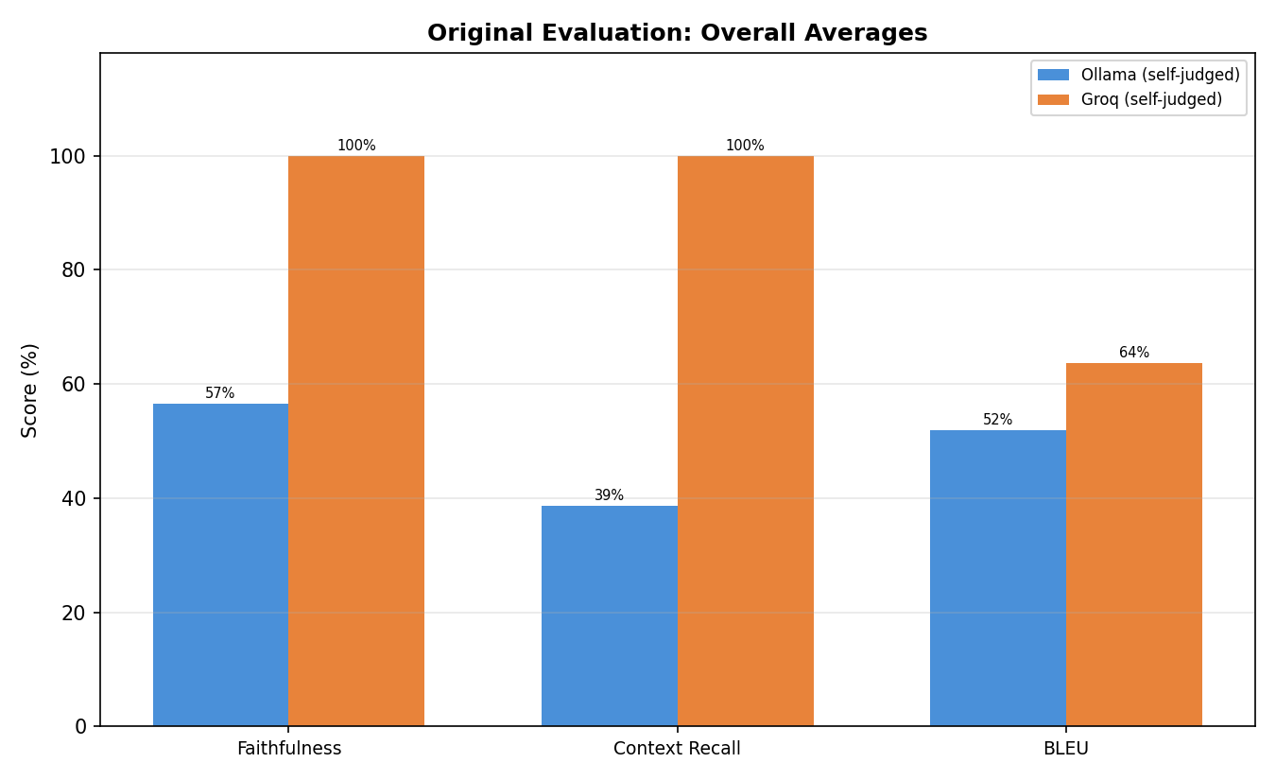

2.1 Per-Question Scores
Question | Ollama Faith. | Groq Faith. | Ollama Recall | Groq Recall | Ollama BLEU | Groq BLEU
Symptoms of bacterial vaginosis | 80% | 100% | 40% | 100% | 91.1% | 86.8%
Causes of varicose veins | 80% | 100% | 40% | 100% | 45.9% | 36.1%
Preventing melanoma | 33% | 100% | 40% | 100% | 78.5% | 96.9%
Living with type 1 diabetes | 50% | 100% | 33% | 100% | 9.6% | 20.0%
MRSA | 40% | 100% | 40% | 100% | 34.2% | 78.6%

3. Fair Comparison: Same Judge (Groq 70B) for Both
To isolate answer quality from judge quality, both sets of answers were re-evaluated using the same Groq 70B judge. The original generated answers were kept unchanged.
Metric | Ollama Answers | Groq Answers | Difference
Faithfulness | 88.0% | 100.0% | +12.0%
Context Recall | 100.0% | 100.0% | +0.0%
BLEU Score | 51.9% | 63.7% | +11.8%

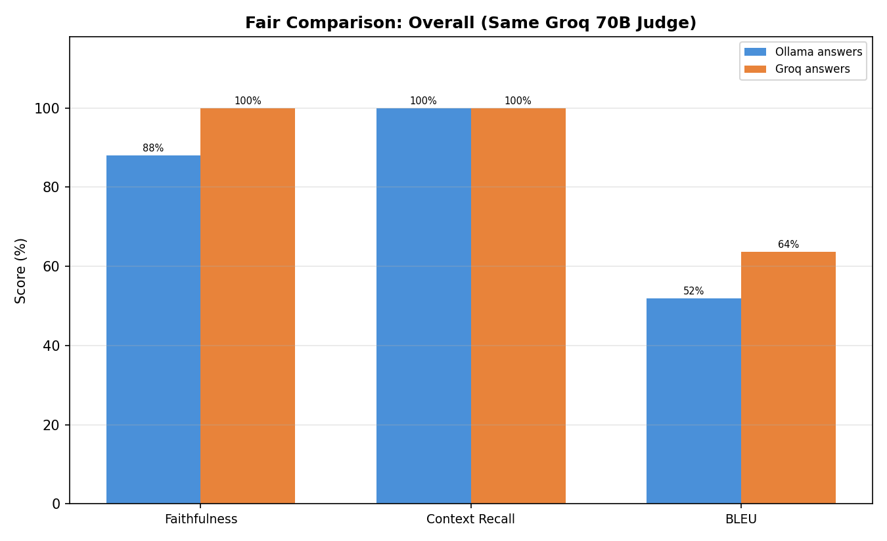

3.1 Impact of Judge Quality
This table shows how Ollama's scores changed when re-evaluated by the Groq 70B judge:
Metric | Ollama (self-judged by 3B) | Ollama (judged by Groq 70B) | Change
Faithfulness | 56.6% | 88.0% | +31.4%
Context Recall | 38.6% | 100.0% | +61.4%
BLEU Score | 51.9% | 51.9% | 0.0% (algorithmic)

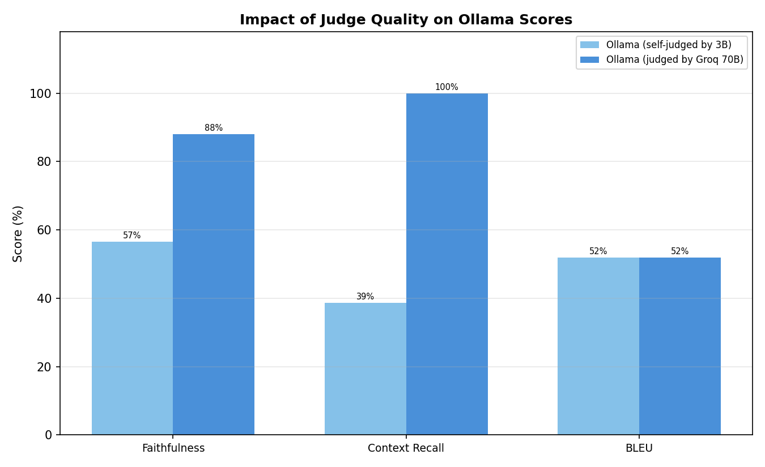

4. Batch Evaluation: Token-Overlap Metrics
The batch evaluation uses simple token-overlap metrics — no LLM is involved in scoring. This provides fast, deterministic, and free evaluation but only captures surface-level matching.
Metric | Average Score | How It Works
Faithfulness | 76.6% | answer tokens ∩ context tokens / answer tokens
Coverage | 29.4% | answer tokens ∩ context tokens / context tokens
Relevance | 57.6% | query tokens ∩ answer tokens / query tokens

4.1 Batch vs LLM-Judged Faithfulness
Comparing the same Ollama-generated answers scored by token-overlap vs LLM judge:
Question | Batch  (token-overlap) | Fair  (Groq 70B judge)
Symptoms of bacterial vaginosis | 95.0% | 100.0%
Causes of varicose veins | 93.5% | 100.0%
Preventing melanoma | 96.0% | 100.0%
Living with type 1 diabetes | 31.9% | 80.0%
MRSA | 66.7% | 60.0%

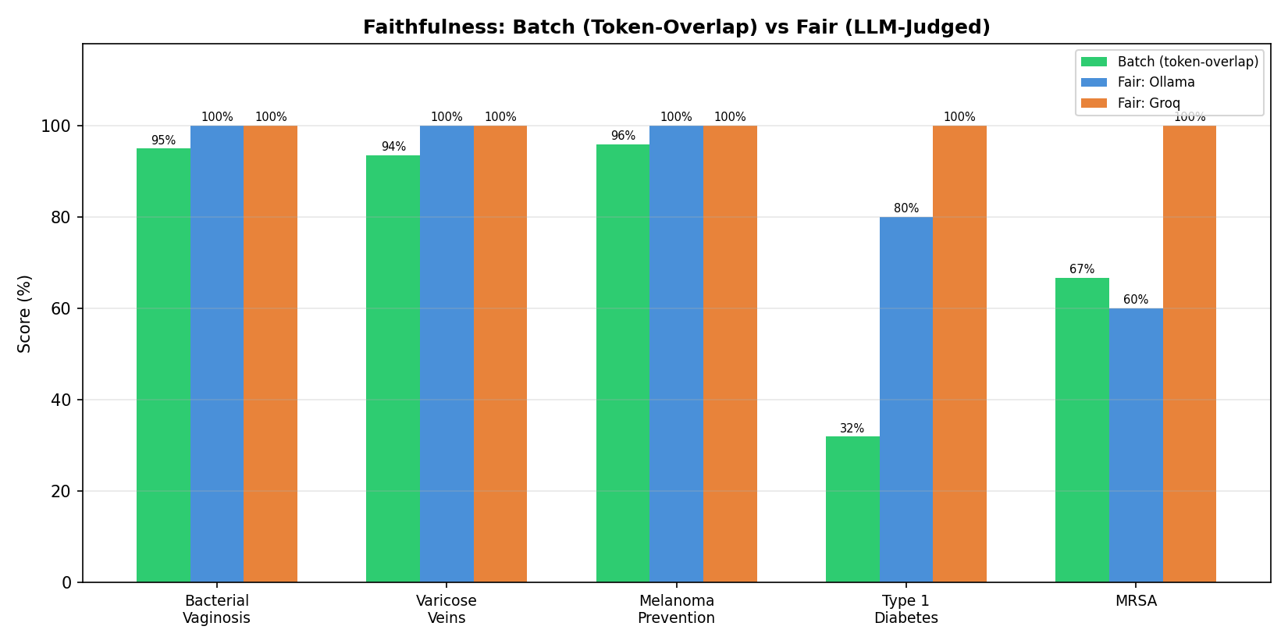

5. Chunking Method Comparison
Three chunking strategies were tested. All used Groq 70B as both generator and judge. Each method writes to its own vector store — the original DB was not modified.

5.1 Chunking Methods
 | QA-Pair (Original) | Recursive Character | Semantic Chunking
File | ingest.py | ingest_recursive.py | ingest_semantic.py
Method | Split by ## Question blocks | RecursiveCharacterTextSplitter  800 chars, 200 overlap | SemanticChunker  (embedding similarity)
Chunks | ~1,950 | 2,801 | 4,248
Overlap | None | 200 characters | None
DB Path | db/chroma_db | db/chroma_db_recursive | db/chroma_db_semantic

5.2 Overall Results
Metric | QA-Pair | Recursive | Semantic
Faithfulness | 90.0% | 76.0% | 76.0%
Context Recall | 100.0% | 84.0% | 60.0%
BLEU Score | 75.4% | 58.8% | 55.9%

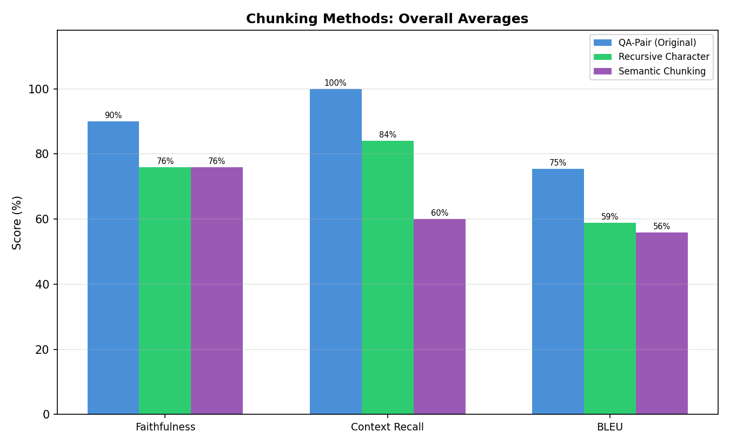

5.3 Per-Question: Faithfulness
Question | QA-Pair | Recursive | Semantic
Symptoms of bacterial vaginosis | 100% | 100% | 100%
Causes of varicose veins | 100% | 100% | 0%
Preventing melanoma | 100% | 80% | 100%
Living with type 1 diabetes | 50% | 0% | 80%
MRSA | 100% | 100% | 100%

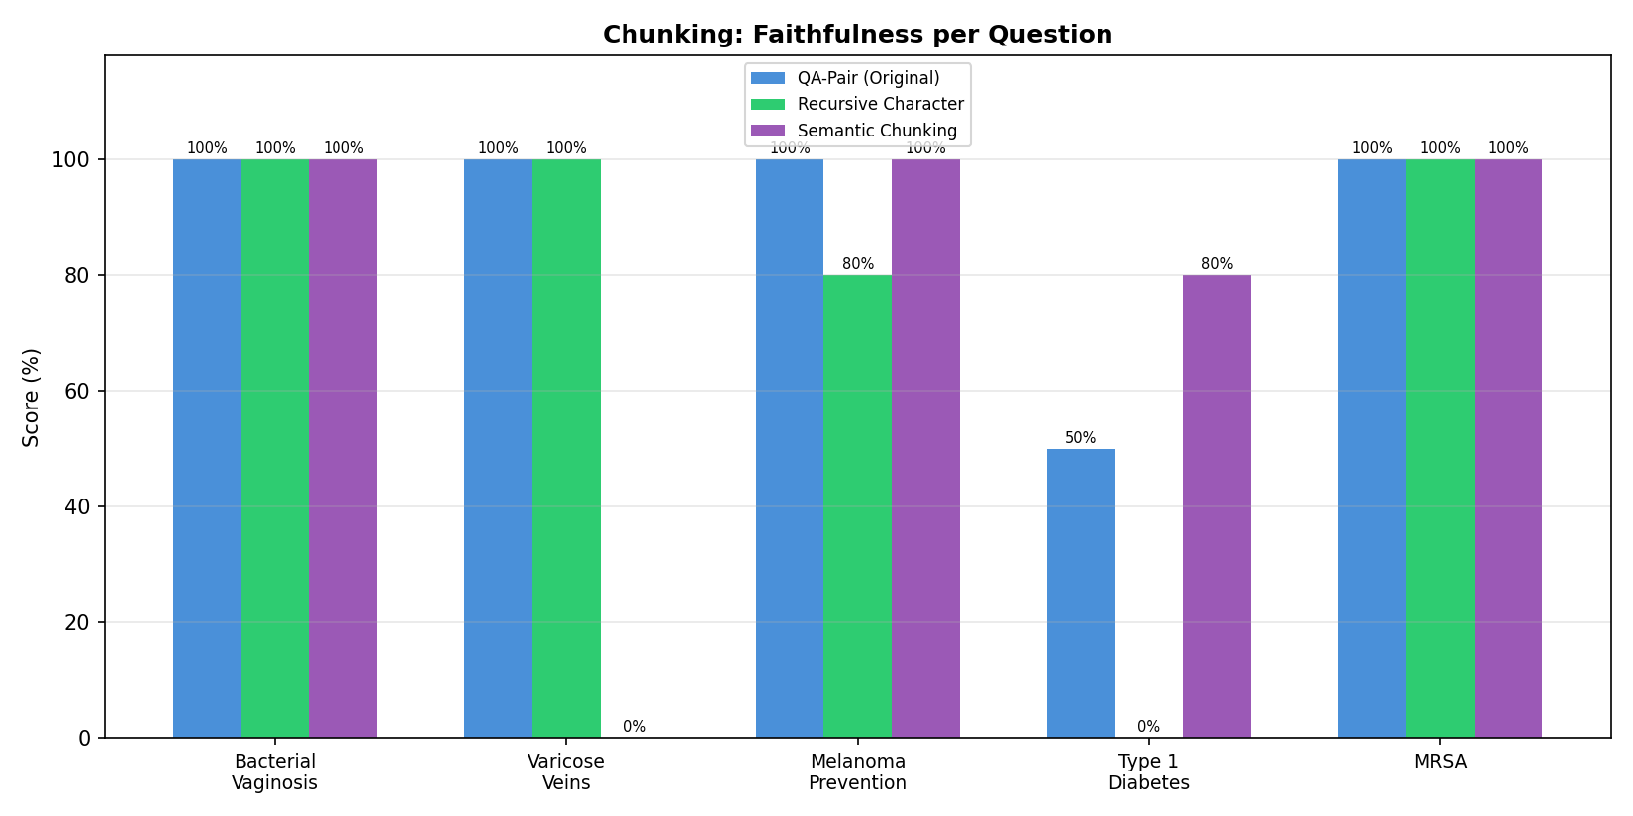

5.4 Per-Question: Context Recall
Question | QA-Pair | Recursive | Semantic
Symptoms of bacterial vaginosis | 100% | 100% | 100%
Causes of varicose veins | 100% | 100% | 20%
Preventing melanoma | 100% | 100% | 100%
Living with type 1 diabetes | 100% | 20% | 20%
MRSA | 100% | 100% | 60%

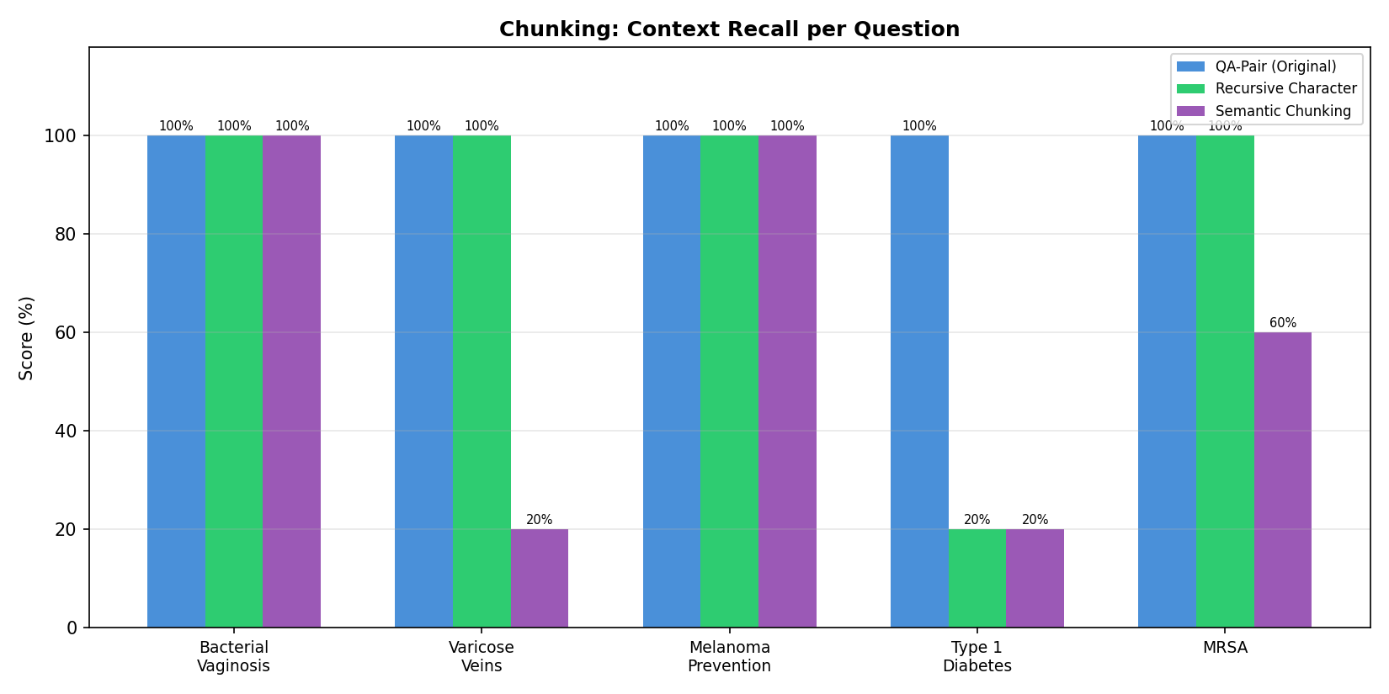

5.5 Per-Question: BLEU Score
Question | QA-Pair | Recursive | Semantic
Symptoms of bacterial vaginosis | 100.0% | 100.0% | 100.0%
Causes of varicose veins | 36.1% | 32.8% | 23.8%
Preventing melanoma | 80.0% | 55.9% | 96.9%
Living with type 1 diabetes | 87.5% | 5.3% | 7.5%
MRSA | 73.5% | 100.0% | 51.0%

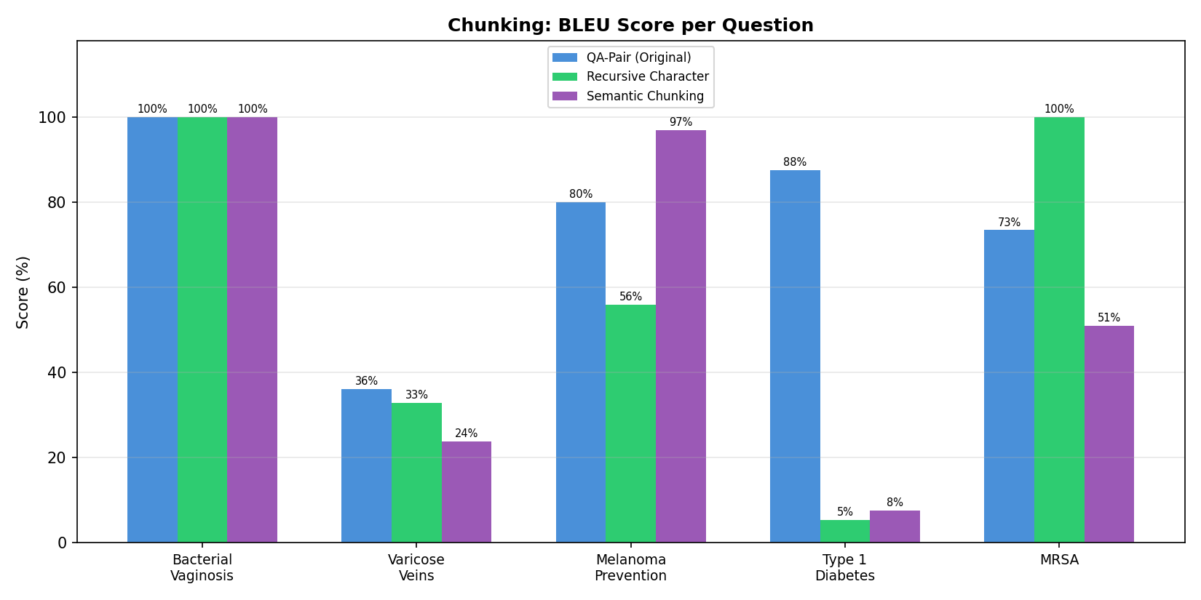

6. Analysis

6.1 Judge Model Quality Is the Biggest Variable
The 3B Ollama model underscored its own answers by over 30% on faithfulness. When the same answers were re-judged by Groq 70B, faithfulness jumped from 56.6% to 88.0% and context recall from 38.6% to 100%. The answers didn't change — only the judge improved. This confirms that small models are unreliable evaluators.

6.2 Generation Quality: 70B Is Modestly Better
With the same Groq 70B judge, the actual generation gap is modest: 12% on faithfulness (88% vs 100%) and 11.8% on BLEU (51.9% vs 63.7%). The 70B model generates more precise answers that stay closer to the source material.

6.3 Token-Overlap vs LLM-Judged Metrics
Batch token-overlap faithfulness (76.6%) and LLM-judged faithfulness (88.0%) broadly agree but diverge on nuanced cases. Token-overlap is fast and free but misses semantic equivalence. LLM-judged metrics capture meaning but depend on judge quality. Both flagged the same weak spots (Type 1 Diabetes, MRSA).

6.4 QA-Pair Chunking Is Best for This Dataset
The original QA-pair chunking outperformed both alternatives across all metrics. This is because the documents are already structured as question-answer pairs — chunking by QA boundaries preserves complete semantic units. Recursive splitting (84% recall) and semantic chunking (60% recall) both fragment these natural units, hurting retrieval quality.

6.5 More Chunks ≠ Better Retrieval
Semantic chunking created 4,248 chunks (2x more than QA-pair) but scored lowest on every metric. Fragmentation increases noise in retrieval results.

7. Key Takeaways
- Use a strong model (70B+) as the evaluation judge. Small models (3B) produce unreliable scores that can mislead evaluation by 30+ percentage points.
- Separate the judge from the generator to avoid self-evaluation bias. The fair comparison approach gives the most trustworthy results.
- BLEU scores are the most objective metric — use them alongside LLM-judged metrics to cross-validate results.
- Match chunking strategy to document structure. QA-pair chunking is ideal for structured FAQ-style documents. Use recursive splitting for unstructured prose.
- Token-overlap metrics are useful for fast iteration during development. Use LLM-judged metrics for thorough evaluation before deployment.
- The Groq free tier (llama-3.3-70b) provides excellent evaluation quality with generous daily quotas — a practical choice for projects without budget for paid APIs.

8. Project Files Reference

8.1 Evaluation Scripts
File | Purpose | Generator | Judge
evaluation.py | Original baseline | Ollama (3B) | Ollama (3B)
evaluation_groq.py | API-based evaluation | Groq (70B) | Groq (70B)
evaluation_fair_comparison.py | Fair comparison (same judge) | Saved answers | Groq (70B)
batch_evaluation.py | Fast algorithmic eval | Ollama (3B) | Token-overlap
evaluation_chunking_comparison.py | Chunking method comparison | Groq (70B) | Groq (70B)

8.2 Ingestion Scripts
File | Chunking Method | DB Path
ingest.py | QA-Pair (original) | db/chroma_db
ingest_recursive.py | Recursive Character Splitting | db/chroma_db_recursive
ingest_semantic.py | Semantic Chunking | db/chroma_db_semantic

8.3 Core Pipeline
File | Purpose
retrieval.py | RAG retrieval + reranking + answer generation
generation.py | Interactive question-answering interface
app.py | Streamlit web application
questions.txt | 5 test questions
docs/ | 423 HSE medical condition markdown files

8.4 Results & Reports
File | Contents
ragas_results.csv | Ollama evaluation results
ragas_results_groq.csv | Groq evaluation results
ragas_details.json | Ollama detailed results with contexts
ragas_details_groq.json | Groq detailed results with contexts
ragas_results_fair_comparison.csv | Fair comparison results
batch_results.csv | Batch token-overlap results
chunking_comparison_results.json | Chunking method comparison results

