RAGAS vs Custom Evaluation Comparison
Industry-Standard RAGAS Framework vs Custom Prompt-Based Evaluation

1. Overview
This report compares two evaluation approaches applied to the same set of Ollama-generated answers. The answers were generated once using the local Ollama llama3.2 (3B) model and saved. Both evaluation methods then scored these identical answers.
 | Custom Evaluation | RAGAS Library
File | evaluation.py | evaluation_ragas_compare.py
Judge Model | Ollama llama3.2 (3B, local) | Groq llama-3.3-70b (70B, API)
Method | Single prompt: 'Rate 0-1' | Claim decomposition + verification
Faithfulness | LLM gives one holistic score | Extracts claims, verifies each against context
Context Recall | LLM gives one holistic score | Checks each reference sentence against context
Context Precision | Not available | Checks if each context chunk was useful
BLEU Score | Algorithmic word overlap | Not included

2. Overall Results
Metric | RAGAS  (Groq 70B judge) | Custom  (Ollama 3B judge) | Difference
Faithfulness | 92.5% | 56.6% | +35.9%
Context Recall | 100.0% | 38.6% | +61.4%
Context Precision | 93.3% | N/A | —
BLEU Score | N/A | 51.9% | —

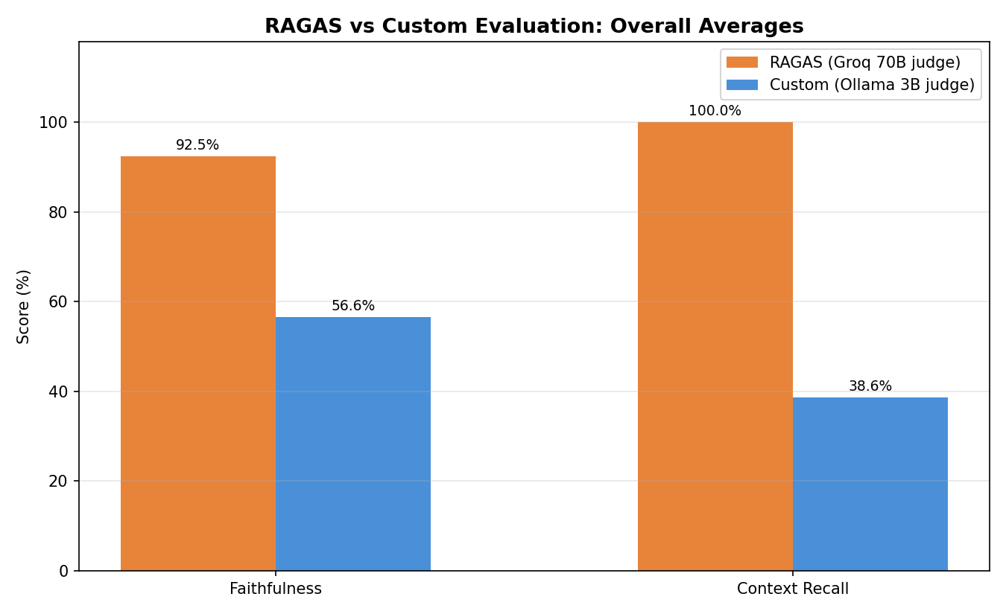

3. Per-Question Breakdown

3.1 Faithfulness
Question | RAGAS | Custom | Diff
What are the symptoms of bacterial vaginosis? | 100% | 80% | +20%
What causes varicose veins? | 100% | 80% | +20%
How can skin cancer (melanoma) be prevented? | 91% | 33% | +58%
What is it like to live with type 1 diabetes? | 71% | 50% | +21%
What should I know about mrsa and how you get | 100% | 40% | +60%

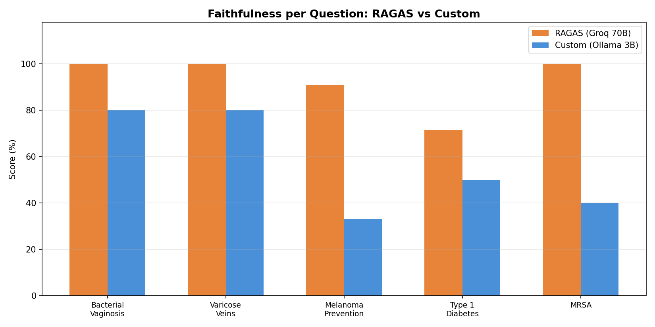

3.2 Context Recall
Question | RAGAS | Custom | Diff
What are the symptoms of bacterial vaginosis? | 100% | 40% | +60%
What causes varicose veins? | 100% | 40% | +60%
How can skin cancer (melanoma) be prevented? | 100% | 40% | +60%
What is it like to live with type 1 diabetes? | 100% | 33% | +67%
What should I know about mrsa and how you get | 100% | 40% | +60%

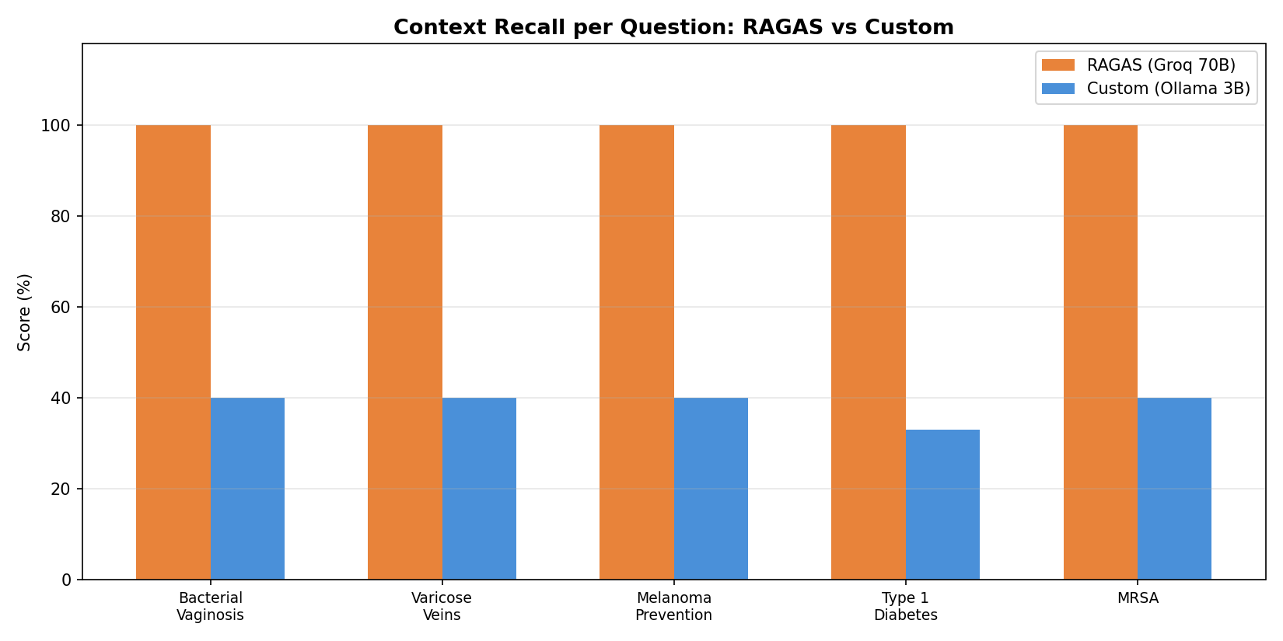

3.3 RAGAS: All Three Metrics
Question | Faithfulness | Context Recall | Context Precision
What are the symptoms of bacterial vaginosis? | 100% | 100% | 100%
What causes varicose veins? | 100% | 100% | 100%
How can skin cancer (melanoma) be prevented? | 91% | 100% | 83%
What is it like to live with type 1 diabetes? | 71% | 100% | 100%
What should I know about mrsa and how you get | 100% | 100% | 83%

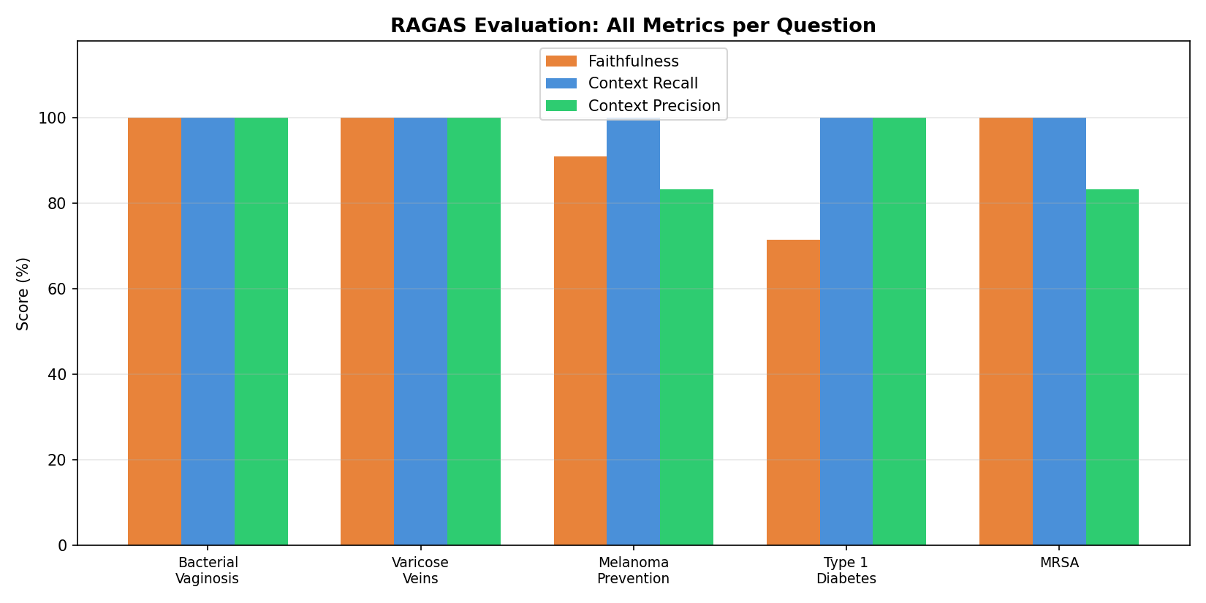

4. Analysis: Why the Scores Differ

4.1 Two Factors at Play
The difference between RAGAS and custom scores comes from two factors working together:
- Judge quality: The custom evaluation used Ollama's 3B model as judge, which is too small to reliably assess faithfulness and context recall. RAGAS used Groq's 70B model, which understands the evaluation task much better.
- Evaluation methodology: The custom approach asks for a single holistic score with one prompt. RAGAS decomposes the evaluation into atomic checks — extracting individual claims and verifying each one separately. This structured approach is more rigorous and less prone to inconsistency.

4.2 Faithfulness: 92.5% (RAGAS) vs 56.6% (Custom)
The custom evaluation underscored the answers by ~36 percentage points. The 3B judge often gave low scores even when the answer was clearly grounded in the context. RAGAS's claim-by-claim verification found that most claims in the answers were actually supported — the answers were better than the small judge thought.
RAGAS scored 92.5% rather than 100% because it found some answers contained claims that went slightly beyond the context (e.g., the melanoma answer at 91% and diabetes answer at 71%). This granularity is a strength of the decomposition approach.

4.3 Context Recall: 100% (RAGAS) vs 38.6% (Custom)
This is the biggest gap. RAGAS found that the retrieved context covered 100% of the reference information for all questions. The custom evaluation's 38.6% was almost entirely due to the weak 3B judge — it couldn't properly assess whether the context covered the reference.

4.4 Context Precision: 93.3% (RAGAS only)
This metric is unique to RAGAS. It measures whether the retrieved context chunks were actually useful for answering the question. At 93.3%, most retrieved chunks were relevant. The melanoma and MRSA questions scored 83% — some retrieved chunks about treatment and diagnosis weren't directly useful for the specific questions asked.

4.5 BLEU: 51.9% (Custom only)
BLEU is purely algorithmic and not part of RAGAS. It provides an objective baseline that doesn't depend on any LLM judge. The moderate score reflects that the Ollama answers captured the right information but used different wording than the reference.

5. Key Takeaways
- RAGAS provides more reliable and granular evaluation than simple prompt-based scoring. Its claim decomposition approach catches nuances that a single-prompt judge misses.
- The 3B Ollama judge severely underscored the answers — by 36% on faithfulness and 61% on context recall. Small models should not be used as evaluation judges.
- RAGAS adds Context Precision as a bonus metric, helping identify when the retrieval pipeline returns irrelevant documents.
- Combining RAGAS (structured LLM evaluation) with BLEU (algorithmic baseline) gives the most complete picture of RAG pipeline quality.
- For production RAG systems, RAGAS is the recommended evaluation framework due to its rigour, reproducibility, and industry adoption.

