PROJECT REPORT
Destiny Travels API
Destination management with Express.js, MongoDB and Mongoose
Item | Detail
Database | destiny_travels
Collection | destinations
Architecture | MVC (config, models, controllers, routes)
Stack | Node.js, Express.js, MongoDB, Mongoose, Postman
Endpoints | 13 functional + 5 error-handling checks
Mongoose methods | 15 distinct (requirement: at least 10)
Date | November 2026

Contents
1. Problem Statement
2. Architecture and Project Structure
3. Database Connection and Setup
4. Implementation Highlights
5. API Testing with Postman
6. Error Handling and Status Codes
7. Conclusion

1. Problem Statement
A travel company needs a back-end service to store and manage its destinations. Staff must be able to add destinations, look them up, correct their details, remove outdated ones, and help customers discover trips that fit their budget and interests.
This project builds the Destiny Travels API: a REST service using Express.js, MongoDB and Mongoose, organised in the MVC pattern, that provides CRUD operations and advanced queries on a destinations collection.

1.1 Objectives
- Add Destinations (Intermediate): add destinations with create() and insertMany().
- Retrieve Destinations (Intermediate): fetch all destinations with find(), one by ID with findById(), one by name with findOne().
- Update Destinations (Intermediate): update by ID with findByIdAndUpdate() and by name with findOneAndUpdate().
- Smart Destination Discovery (Advanced): filter by category and price range, sort with sort(), paginate with skip() and limit(), list unique categories with distinct(), count with countDocuments().
- Destination Cleanup (Advanced): delete by ID with findByIdAndDelete(), by name with findOneAndDelete(), and by condition with deleteMany().

1.2 Technical requirements
- MongoDB database destiny_travels, collection destinations.
- MVC structure with separate config, models, controllers and routes folders.
- At least 10 distinct Mongoose methods (this project uses 15).
- All endpoints tested with Postman.
- Proper error handling and HTTP status codes.

2. Architecture and Project Structure
A request enters server.js, is matched by a route, handled by a controller, and reaches MongoDB through the Mongoose model. Errors from any controller go to one central error handler that returns a consistent JSON body and the correct status code.
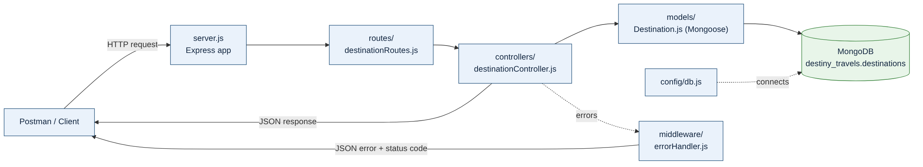
Figure 1: Request flow through the MVC layers

2.1 Folder structure
destiny-travels-api/
├── config/
│ └── db.js MongoDB connection
├── models/
│ └── Destination.js Mongoose schema + indexes
├── controllers/
│ └── destinationController.js Business logic for every endpoint
├── routes/
│ └── destinationRoutes.js URL -> controller mapping
├── middleware/
│ └── errorHandler.js 404 + central error handler
├── utils/
│ └── ApiError.js Error class carrying an HTTP status
├── data/
│ └── destinations.js Sample data (11 destinations)
├── postman/
│ └── Destiny_Travels_API.postman_collection.json
├── docs/ Report generator, API spec, diagrams, screenshots
├── seeder.js npm run seed
├── server.js App entry point
└── .env.example

Layer | Responsibility
config/db.js | Connects to MongoDB using MONGO_URI.
models/Destination.js | Schema, validation rules and indexes.
controllers/ | One handler per endpoint; calls Mongoose methods.
routes/ | Maps HTTP method and URL to a controller.
middleware/errorHandler.js | 404 handler and central error handler.
seeder.js, data/ | Loads 11 sample destinations.

2.2 Data model
Field | Type | Rules
name | String | Required, 2-100 characters, unique (case-insensitive)
location | String | Required
category | String | Required; Beach, Hill Station, Heritage, Adventure, Wildlife, Spiritual or City
price | Number | Required, 0 or more
rating | Number | 0 to 5, default 0
duration | Number | Days, 1 or more, default 3
bestSeason, description | String | Optional text
createdAt, updatedAt | Date | Added automatically (timestamps)

2.3 Mongoose methods used
Method | Purpose | Endpoint
create() | Insert one document | POST /api/destinations
insertMany() | Insert an array of documents | POST /api/destinations/bulk
find() | Fetch all / filtered documents | GET /api/destinations, /discover
findById() | Fetch by _id | GET /api/destinations/:id
findOne() | Fetch first match by name | GET /api/destinations/name/:name
findByIdAndUpdate() | Update by _id | PUT /api/destinations/:id
findOneAndUpdate() | Update by name | PUT /api/destinations/name/:name
sort() | Order by price / rating | GET /api/destinations/discover
skip() | Skip documents for pagination | GET /api/destinations/discover
limit() | Cap documents per page | GET /api/destinations/discover
distinct() | Unique category values | GET /api/destinations/categories
countDocuments() | Count matching documents | GET /count, /discover
findByIdAndDelete() | Delete by _id | DELETE /api/destinations/:id
findOneAndDelete() | Delete by name | DELETE /api/destinations/name/:name
deleteMany() | Delete by condition | DELETE /api/destinations/bulk

3. Database Connection and Setup
config/db.js reads MONGO_URI from the .env file and connects with Mongoose. If the connection fails the process exits with a clear message.
const mongoose = require('mongoose');

/**
* Connects to MongoDB (database: destiny_travels).
* The connection string is read from the MONGO_URI environment variable.
*/
const connectDB = async () => {
const uri = process.env.MONGO_URI || 'mongodb://127.0.0.1:27017/destiny_travels';

try {
const conn = await mongoose.connect(uri, {
serverSelectionTimeoutMS: 8000,
});
console.log(`MongoDB connected: ${conn.connection.host}/${conn.connection.name}`);
return conn;
} catch (error) {
console.error(`MongoDB connection failed: ${error.message}`);
process.exit(1);
}
};

module.exports = connectDB;

3.1 Running the project
npm install
cp .env.example .env # MONGO_URI=mongodb://127.0.0.1:27017/destiny_travels
npm run dev # http://localhost:5000
npm run seed # optional: load 11 sample destinations

Expected console output on a successful start:
MongoDB connected: 127.0.0.1/destiny_travels
Server running on http://localhost:5000

4. Implementation Highlights

4.1 Model
const mongoose = require('mongoose');

const CATEGORIES = [
'Beach',
'Hill Station',
'Heritage',
'Adventure',
'Wildlife',
'Spiritual',
'City',
];

const destinationSchema = new mongoose.Schema(
{
name: {
type: String,
required: [true, 'Destination name is required'],
trim: true,
minlength: [2, 'Name must be at least 2 characters'],
maxlength: [100, 'Name cannot exceed 100 characters'],
},
location: {
type: String,
required: [true, 'Location is required'],
trim: true,
},
category: {
type: String,
required: [true, 'Category is required'],
enum: {
values: CATEGORIES,
message: `Category must be one of: ${CATEGORIES.join(', ')}`,
},
},
price: {
type: Number,
required: [true, 'Price is required'],
min: [0, 'Price cannot be negative'],
},
rating: {
type: Number,
min: [0, 'Rating cannot be below 0'],
max: [5, 'Rating cannot exceed 5'],
default: 0,
},
duration: {
type: Number,
min: [1, 'Duration must be at least 1 day'],
default: 3,
},
bestSeason: {
type: String,
trim: true,
},
description: {
type: String,
trim: true,
maxlength: [1000, 'Description cannot exceed 1000 characters'],
},
},
{
timestamps: true,
collection: 'destinations',
}
);

// Case-insensitive unique destination names ("goa" and "Goa" are the same).
destinationSchema.index(
{ name: 1 },
{ unique: true, collation: { locale: 'en', strength: 2 } }
);
// Speeds up the filter + sort queries used by Smart Destination Discovery.
destinationSchema.index({ category: 1, price: 1 });

const Destination = mongoose.model('Destination', destinationSchema);

module.exports = Destination;
module.exports.CATEGORIES = CATEGORIES;

4.2 Routes
const express = require('express');
const controller = require('../controllers/destinationController');

const router = express.Router();

// NOTE: fixed paths (/bulk, /discover, /categories, /count, /name/:name)
// must be declared BEFORE "/:id", otherwise Express would treat them as an id.

router
.route('/')
.get(controller.getAllDestinations) // Challenge 02 - find()
.post(controller.createDestination); // Challenge 01 - create()

router
.route('/bulk')
.post(controller.createManyDestinations) // Challenge 01 - insertMany()
.delete(controller.deleteManyDestinations); // Challenge 05 - deleteMany()

router.get('/discover', controller.discoverDestinations); // Challenge 04 - filter, sort, skip, limit
router.get('/categories', controller.getCategories); // Challenge 04 - distinct()
router.get('/count', controller.countDestinations); // Challenge 04 - countDocuments()

router
.route('/name/:name')
.get(controller.getDestinationByName) // Challenge 02 - findOne()
.put(controller.updateDestinationByName) // Challenge 03 - findOneAndUpdate()
.delete(controller.deleteDestinationByName); // Challenge 05 - findOneAndDelete()

router
.route('/:id')
.get(controller.getDestinationById) // Challenge 02 - findById()
.put(controller.updateDestinationById) // Challenge 03 - findByIdAndUpdate()
.delete(controller.deleteDestinationById); // Challenge 05 - findByIdAndDelete()

module.exports = router;

Fixed paths such as /bulk, /discover and /categories are declared before /:id, otherwise Express would read them as an ID.

4.3 Smart discovery controller
// GET /api/destinations/discover?category=Beach&minPrice=5000&maxPrice=20000&sort=price,-rating&page=1&limit=5
exports.discoverDestinations = asyncHandler(async (req, res) => {
const filter = buildFilter(req.query);
const sort = buildSort(req.query.sort);
const { page, limit, skip } = buildPagination(req.query);

const [destinations, total] = await Promise.all([
Destination.find(filter).sort(sort).skip(skip).limit(limit), // sort(), skip(), limit()
Destination.countDocuments(filter), // countDocuments()
]);

res.json({
success: true,
page,
limit,
total,
totalPages: Math.ceil(total / limit),
count: destinations.length,
data: destinations,
});
});

Sorting always ends with _id so two documents with equal price never swap places between pages. The list query and countDocuments() run in parallel with the same filter, so total and totalPages match the data.

5. API Testing with Postman
The collection postman/Destiny_Travels_API.postman_collection.json holds 19 requests in six folders. Each has a test script that checks the status code and the success flag. Request 01 stores the new _id in the destinationId variable for requests 04, 06 and 12.
Run the requests in order, starting from an empty collection (npm run seed:destroy).

5.1 Add Destinations
01. Add a single destination
Item | Detail
Request | POST /api/destinations
Mongoose | create()
Expected status | 201
Purpose | Creates one destination and returns the saved document.

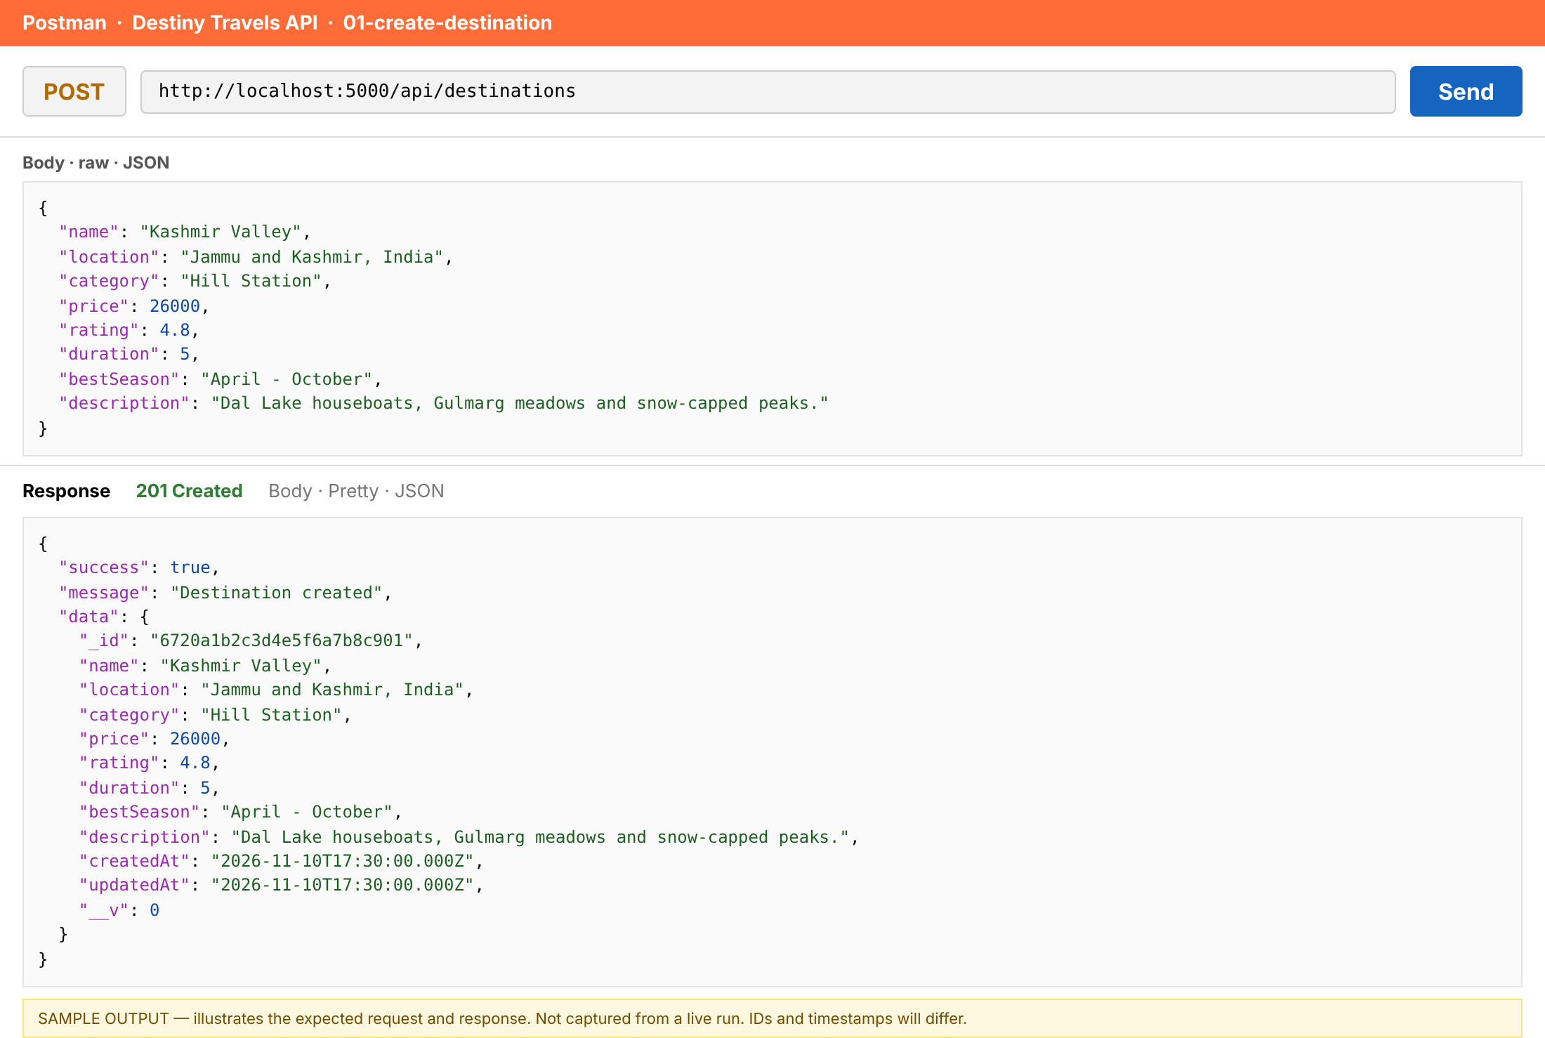
Figure: 01-create-destination (sample output, not a live capture)
02. Add many destinations at once
Item | Detail
Request | POST /api/destinations/bulk
Mongoose | insertMany()
Expected status | 201
Purpose | Inserts an array of destinations in one database call.

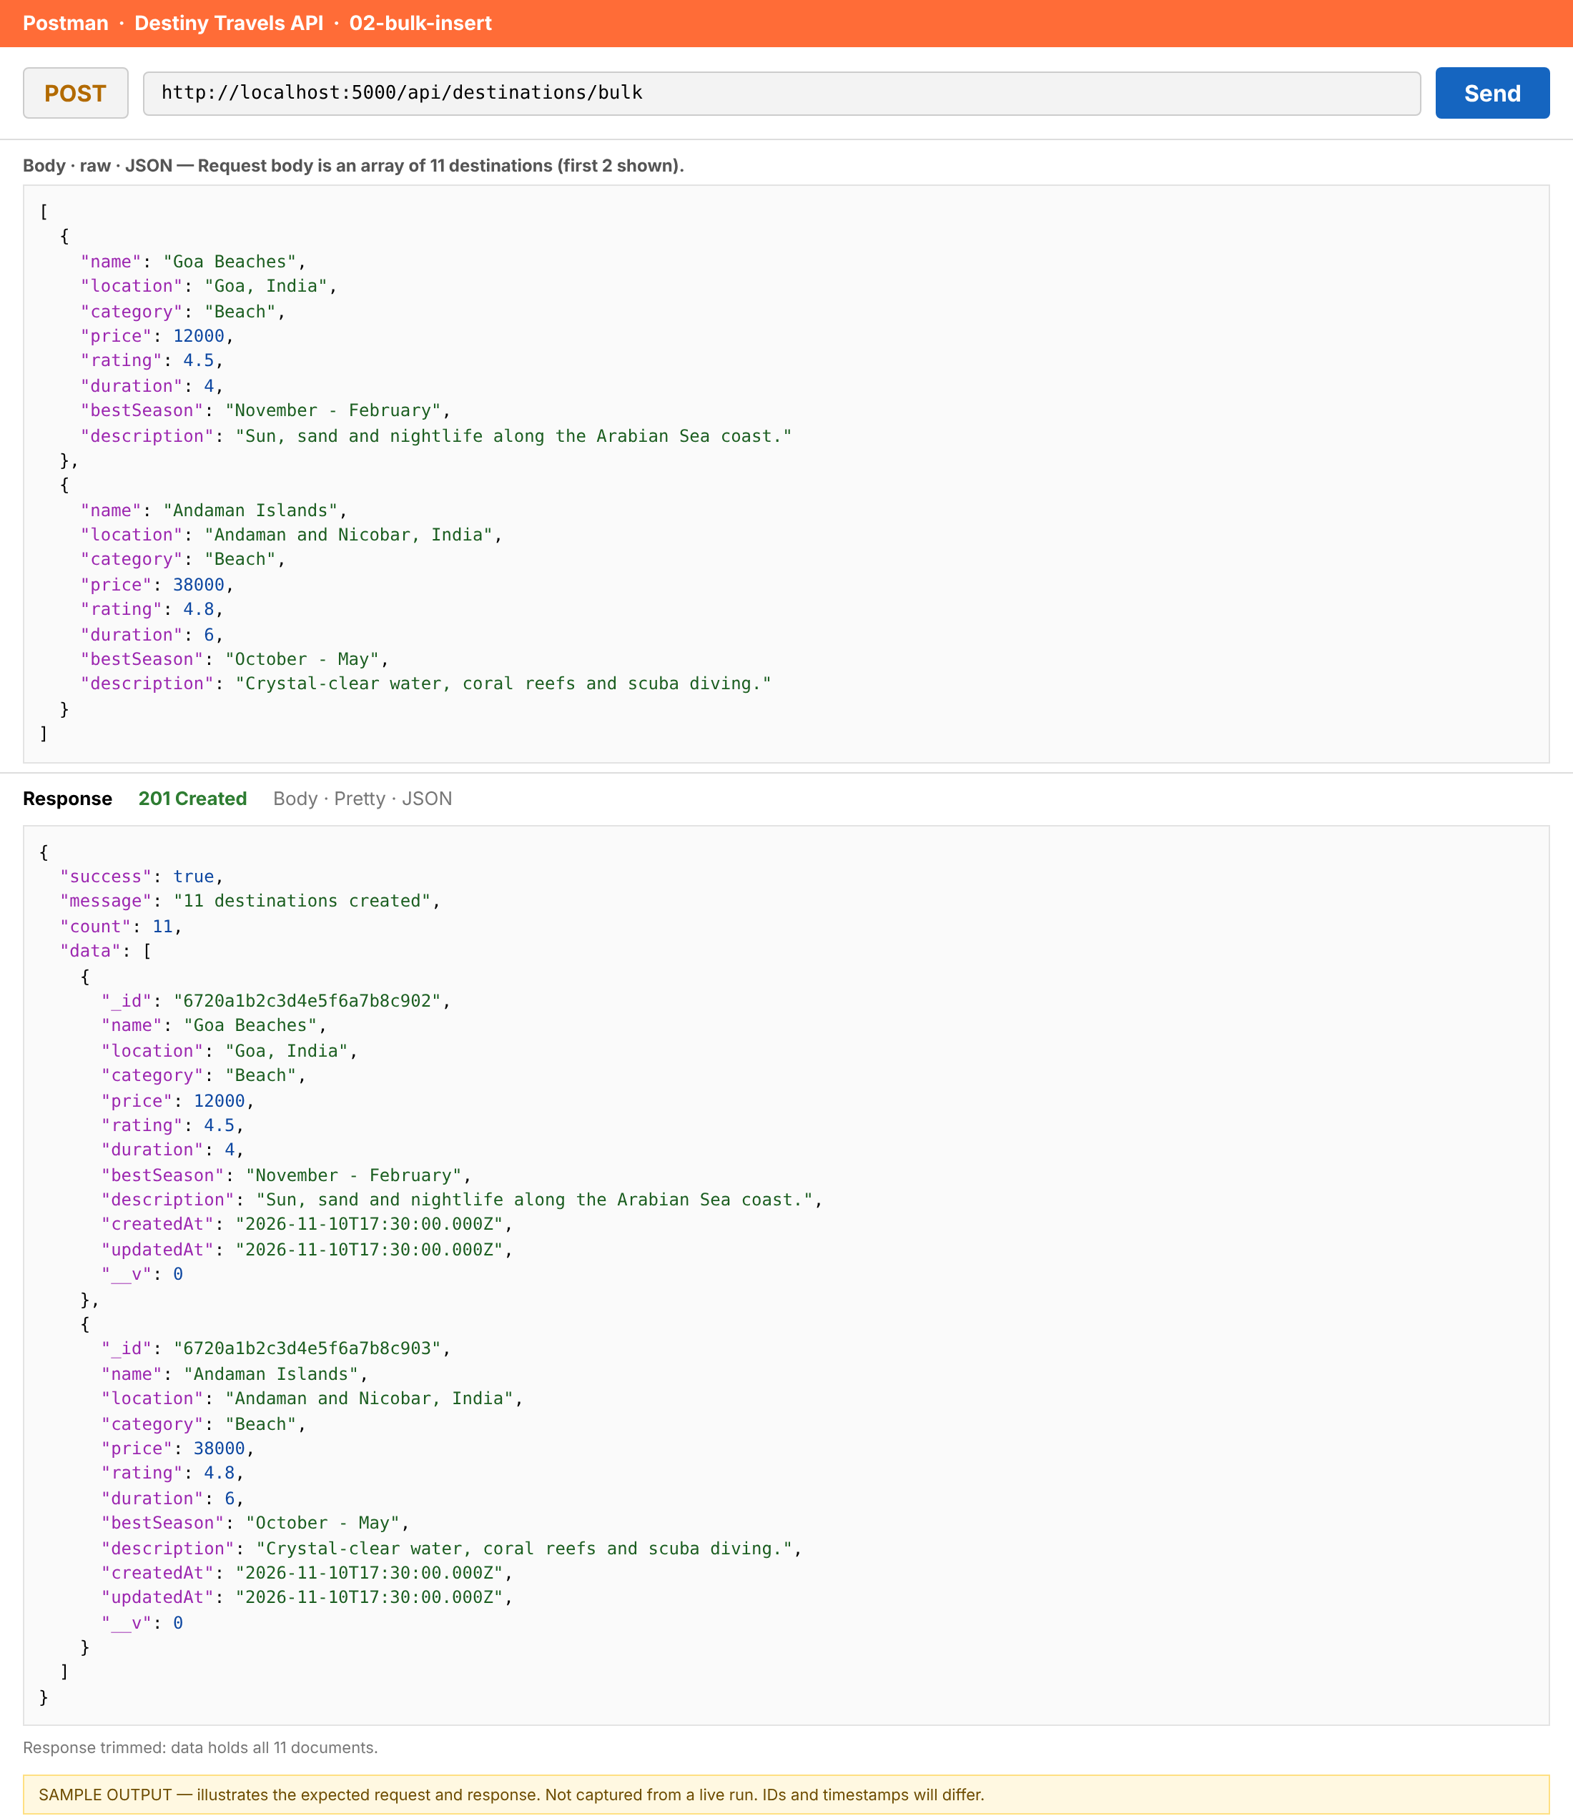
Figure: 02-bulk-insert (sample output, not a live capture)

5.2 Retrieve Destinations
03. Retrieve all destinations
Item | Detail
Request | GET /api/destinations
Mongoose | find()
Expected status | 200
Purpose | Returns every document in the destinations collection.

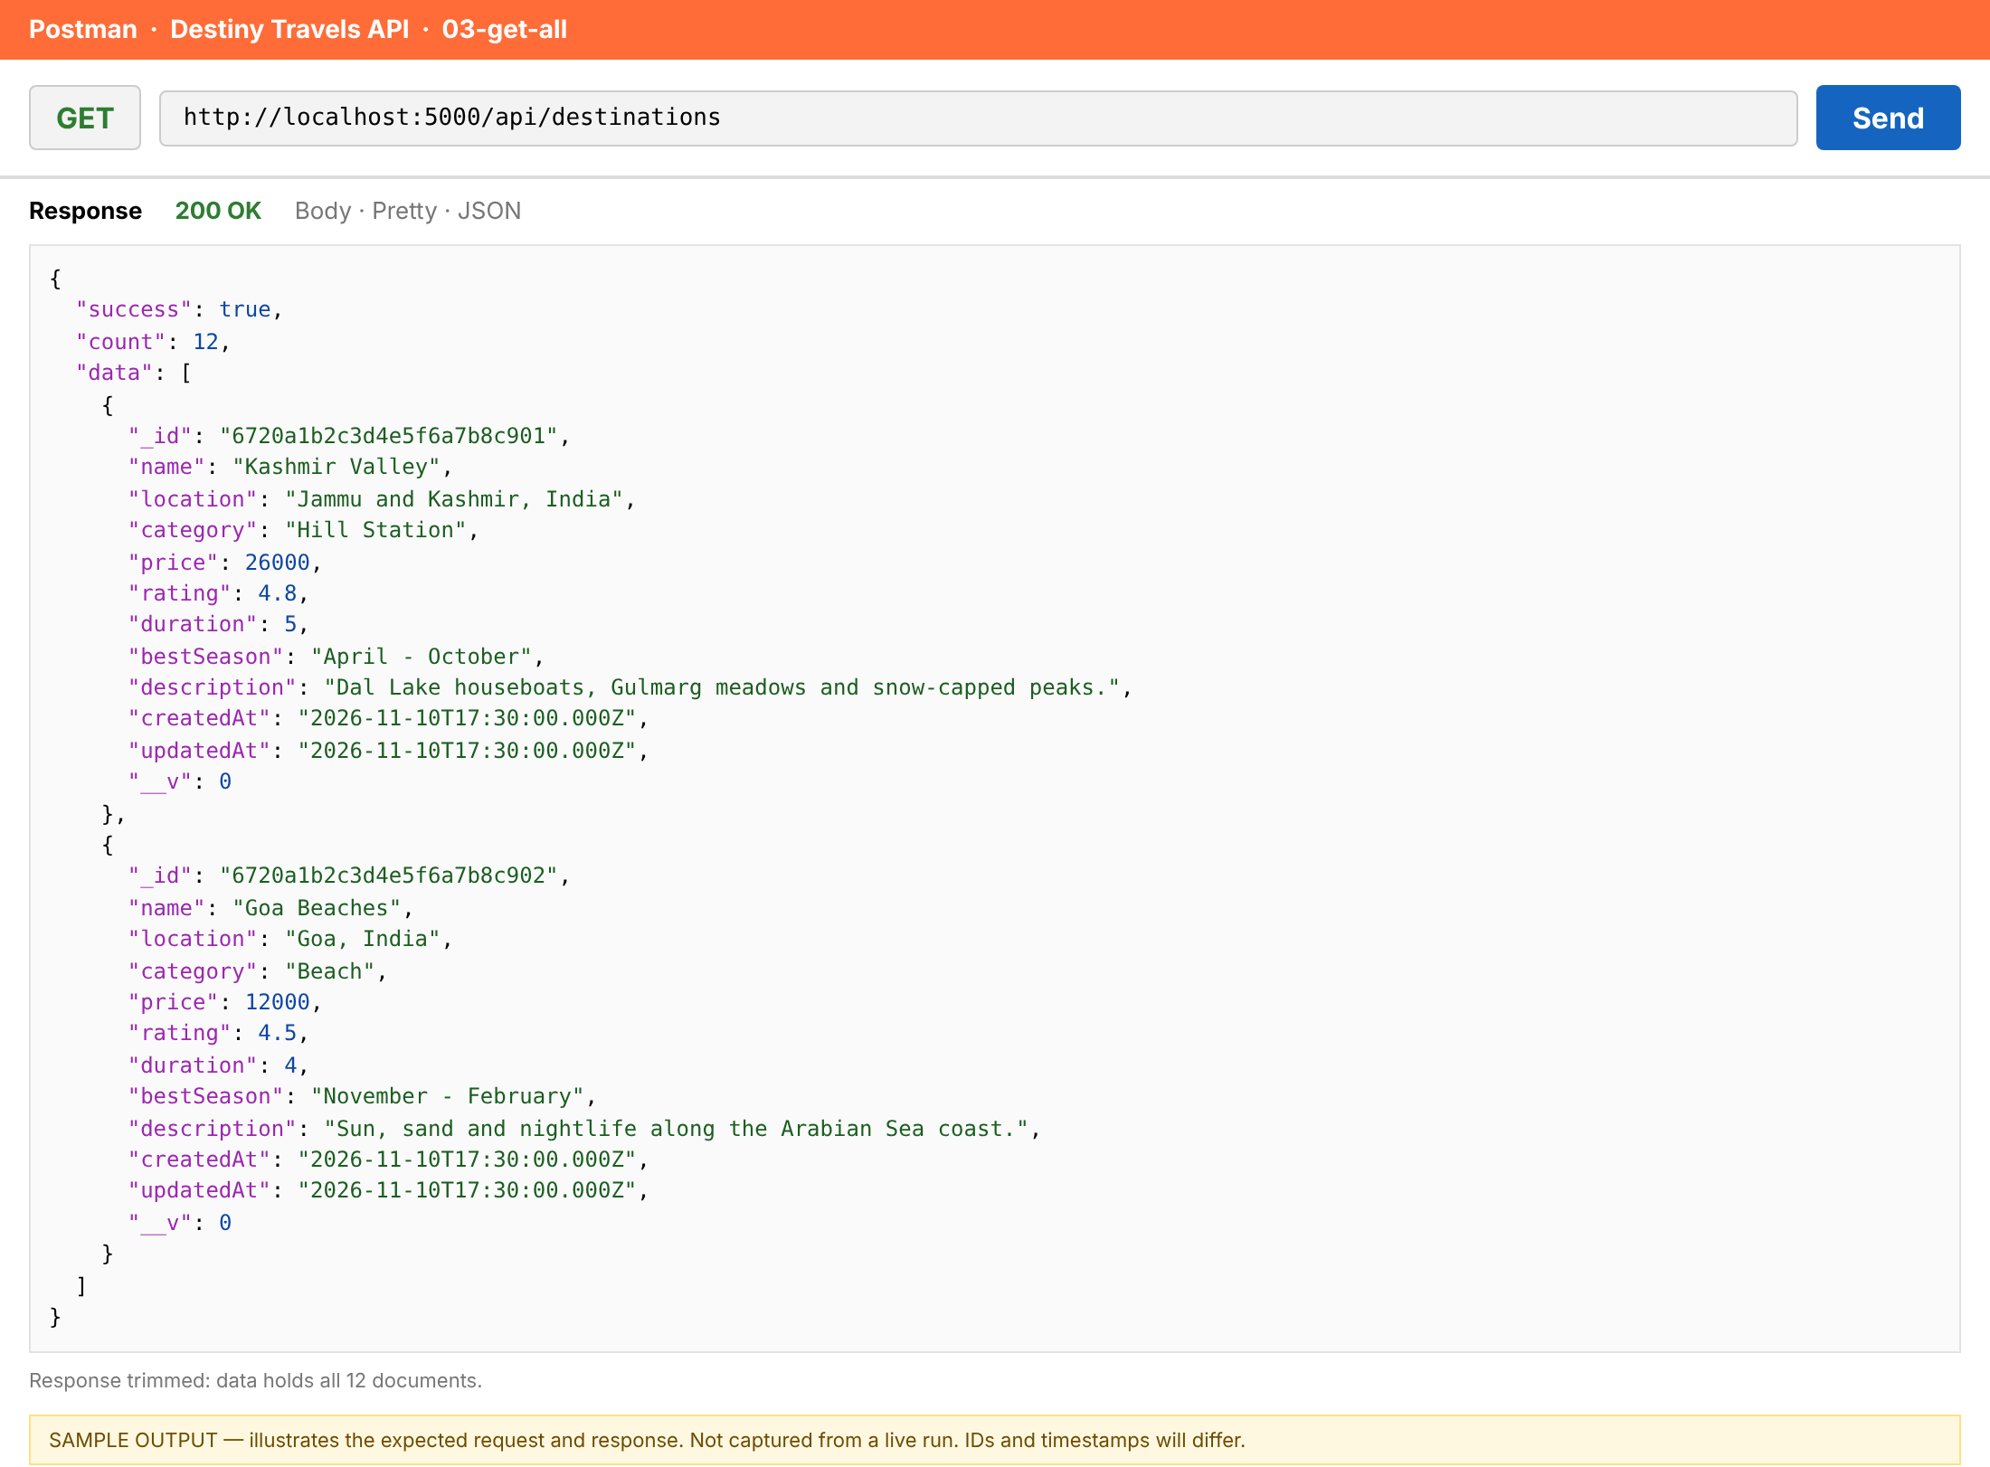
Figure: 03-get-all (sample output, not a live capture)
04. Retrieve a destination by ID
Item | Detail
Request | GET /api/destinations/:id
Mongoose | findById()
Expected status | 200
Purpose | Looks up one destination by its MongoDB _id.

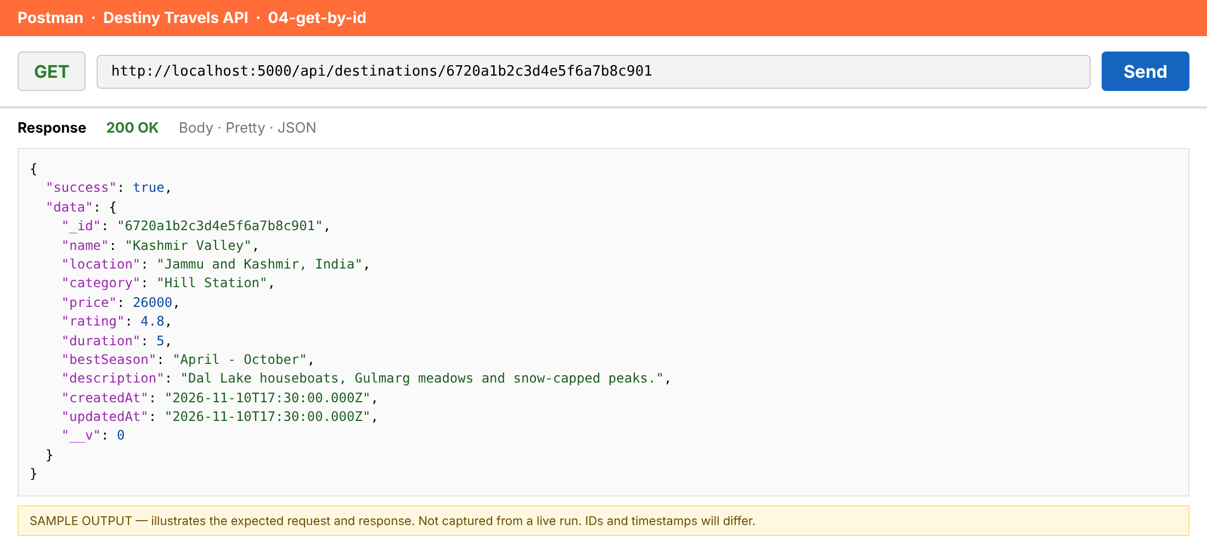
Figure: 04-get-by-id (sample output, not a live capture)
05. Retrieve a destination by name
Item | Detail
Request | GET /api/destinations/name/:name
Mongoose | findOne()
Expected status | 200
Purpose | Finds the first destination whose name matches (case-insensitive).

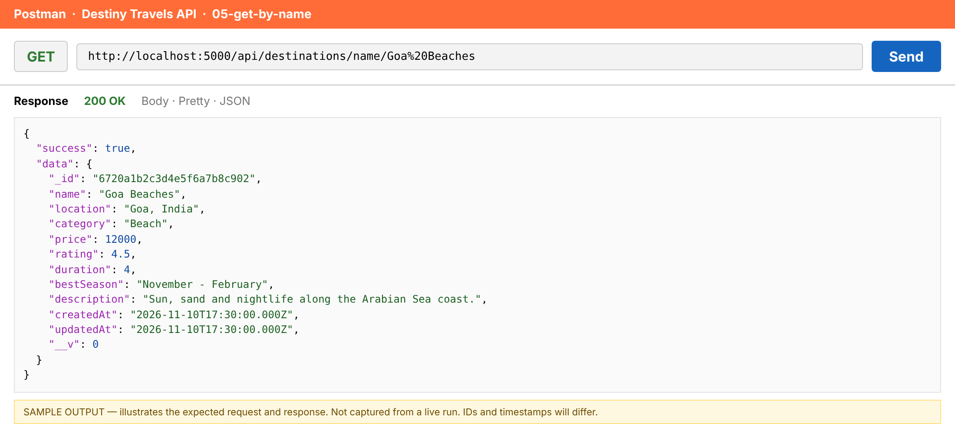
Figure: 05-get-by-name (sample output, not a live capture)

5.3 Update Destinations
06. Update a destination by ID
Item | Detail
Request | PUT /api/destinations/:id
Mongoose | findByIdAndUpdate()
Expected status | 200
Purpose | Changes only the fields sent and returns the updated document.

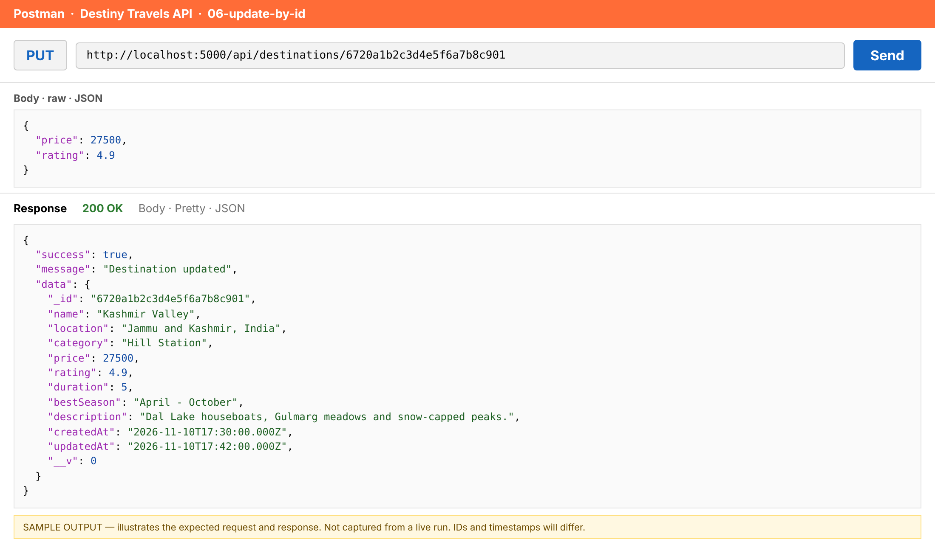
Figure: 06-update-by-id (sample output, not a live capture)
07. Update a destination by name
Item | Detail
Request | PUT /api/destinations/name/:name
Mongoose | findOneAndUpdate()
Expected status | 200
Purpose | Updates the destination that matches the name in the URL.

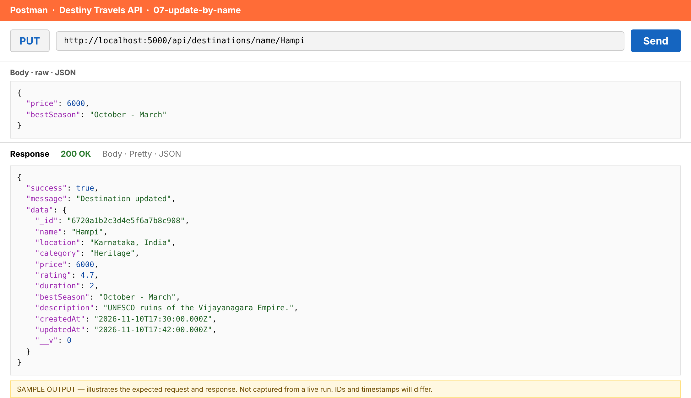
Figure: 07-update-by-name (sample output, not a live capture)

5.4 Smart Destination Discovery
08. Smart discovery: filter, sort and paginate (page 1)
Item | Detail
Request | GET /api/destinations/discover?category=Beach&minPrice=5000&maxPrice=40000&sort=price,-rating&page=1&limit=2
Mongoose | find().sort().skip().limit() + countDocuments()
Expected status | 200
Purpose | Beach destinations priced 5,000-40,000, cheapest first (ties by best rating), 2 per page.

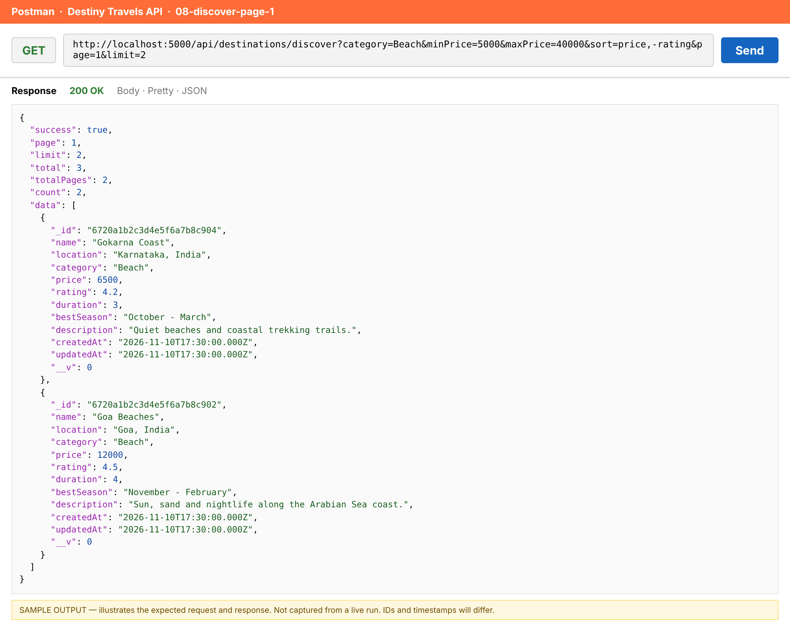
Figure: 08-discover-page-1 (sample output, not a live capture)
09. Smart discovery: page 2
Item | Detail
Request | GET /api/destinations/discover?category=Beach&minPrice=5000&maxPrice=40000&sort=price,-rating&page=2&limit=2
Mongoose | skip() + limit()
Expected status | 200
Purpose | skip((page - 1) x limit) moves to the next page of the same result set.

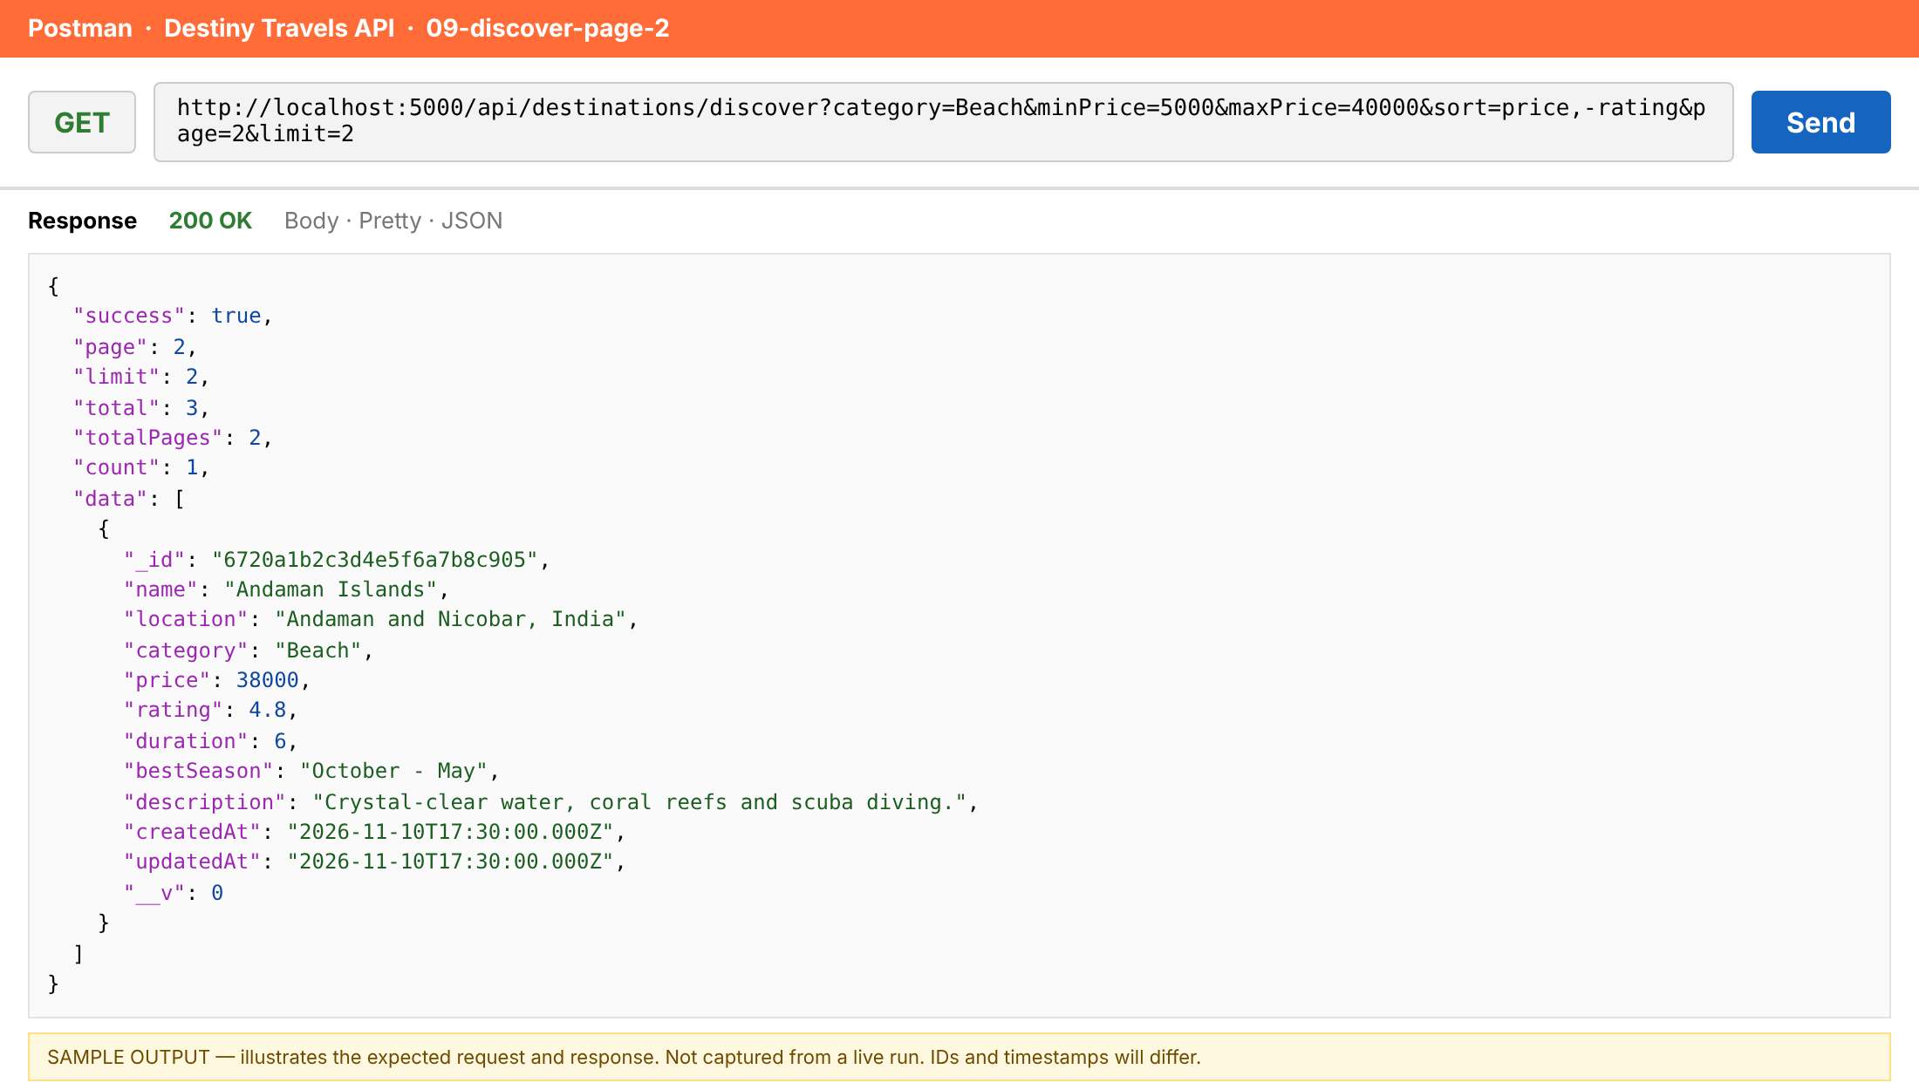
Figure: 09-discover-page-2 (sample output, not a live capture)
10. Retrieve unique categories
Item | Detail
Request | GET /api/destinations/categories
Mongoose | distinct()
Expected status | 200
Purpose | Returns each category once, sorted alphabetically.

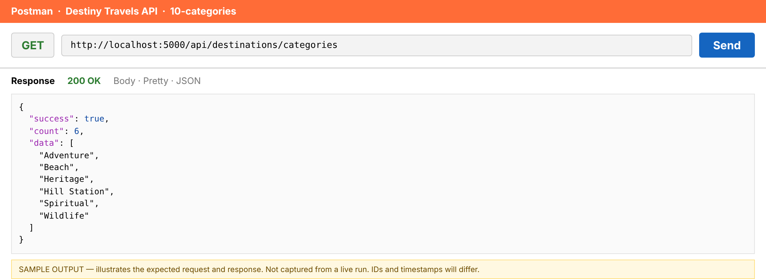
Figure: 10-categories (sample output, not a live capture)
11. Count destinations
Item | Detail
Request | GET /api/destinations/count?category=Beach
Mongoose | countDocuments()
Expected status | 200
Purpose | Counts documents that match the optional filters (here: category = Beach).

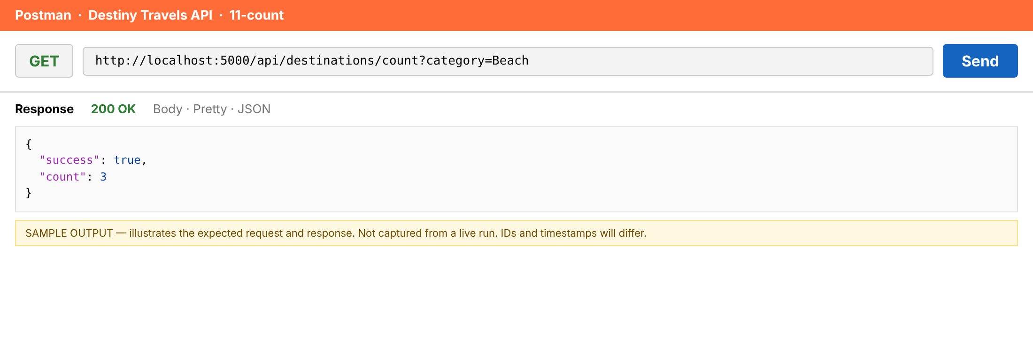
Figure: 11-count (sample output, not a live capture)

5.5 Destination Cleanup
12. Delete a destination by ID
Item | Detail
Request | DELETE /api/destinations/:id
Mongoose | findByIdAndDelete()
Expected status | 200
Purpose | Removes one destination and returns the document that was deleted.

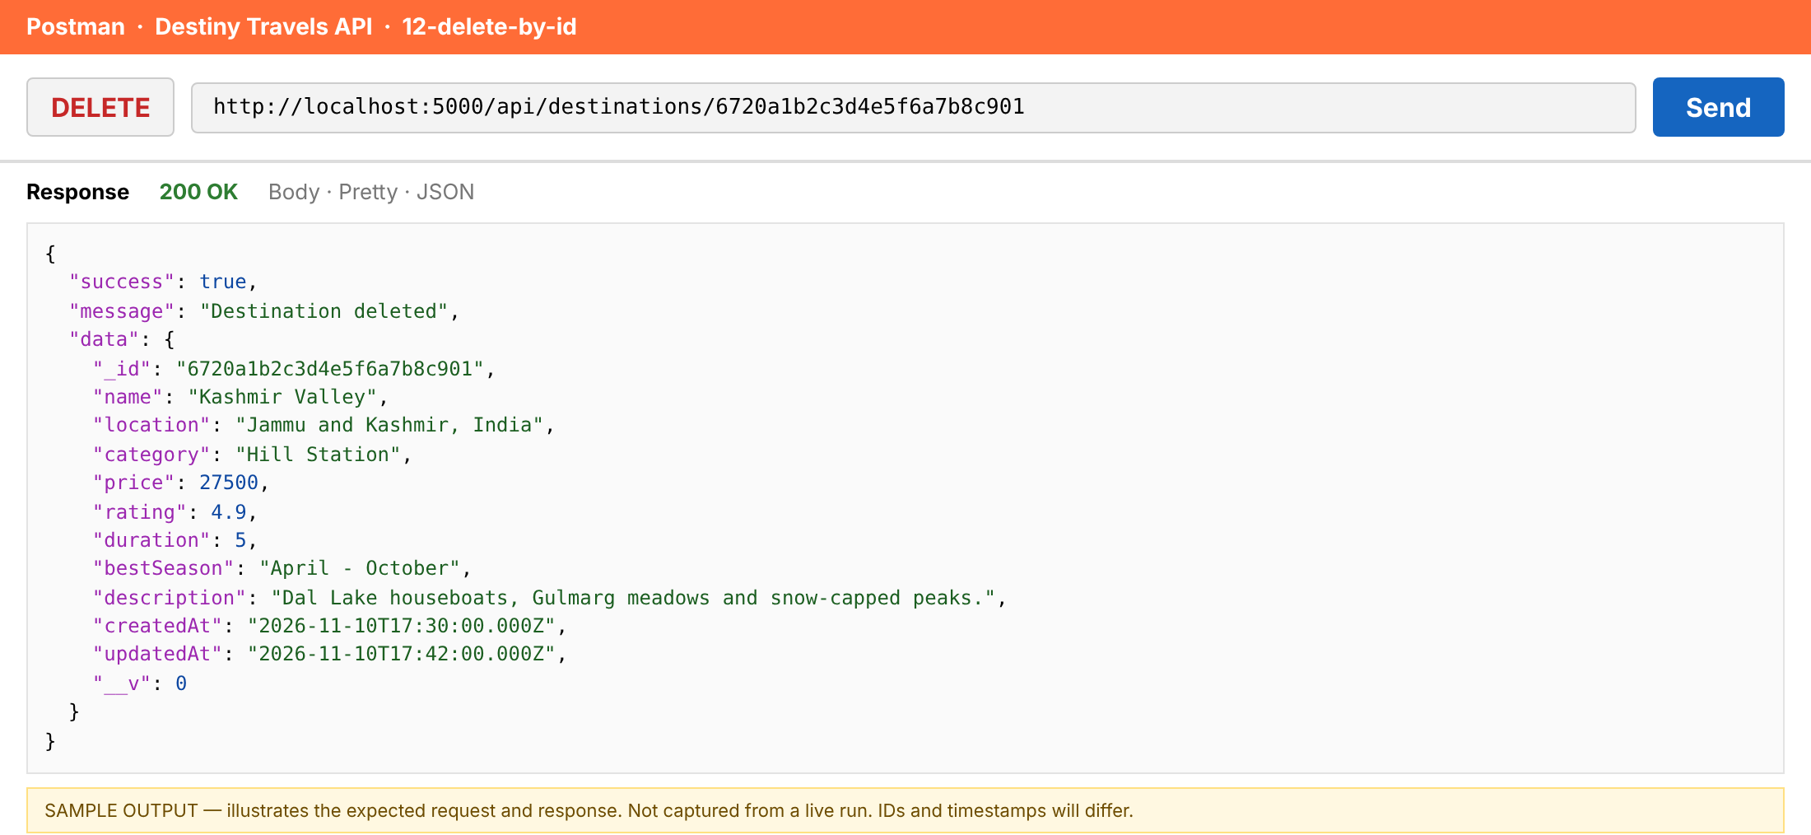
Figure: 12-delete-by-id (sample output, not a live capture)
13. Delete a destination by name
Item | Detail
Request | DELETE /api/destinations/name/:name
Mongoose | findOneAndDelete()
Expected status | 200
Purpose | Removes the destination whose name matches and returns it.

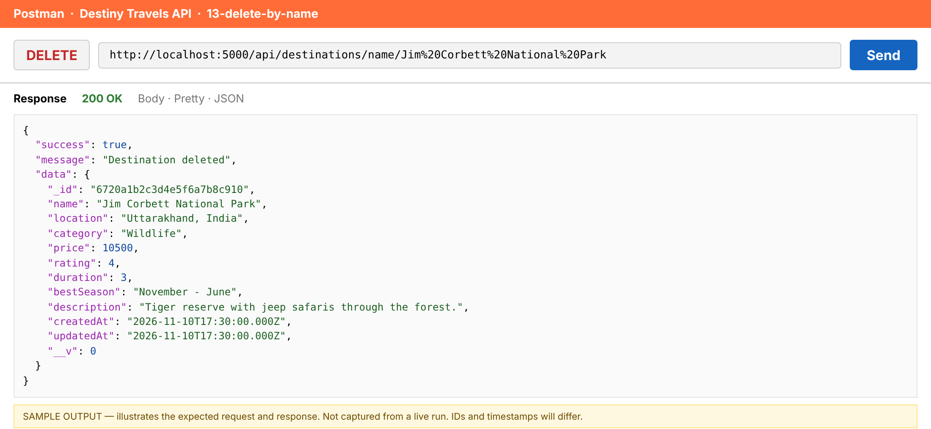
Figure: 13-delete-by-name (sample output, not a live capture)
14. Delete multiple destinations by condition
Item | Detail
Request | DELETE /api/destinations/bulk?maxPrice=6500
Mongoose | deleteMany()
Expected status | 200
Purpose | Deletes every destination priced at 6,500 or less (Gokarna Coast and Hampi in the sample data).

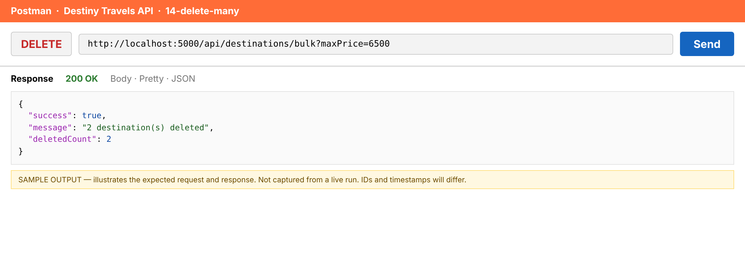
Figure: 14-delete-many (sample output, not a live capture)

5.6 Error Handling Checks
15. Invalid ID format returns 400
Item | Detail
Request | GET /api/destinations/:id
Expected status | 400
Purpose | A malformed ObjectId is rejected before the database is queried.

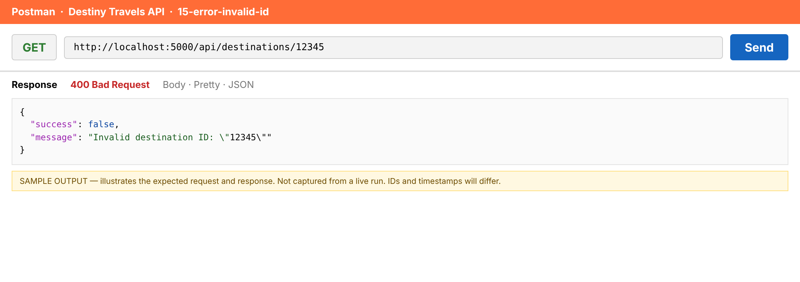
Figure: 15-error-invalid-id (sample output, not a live capture)
16. Unknown ID returns 404
Item | Detail
Request | GET /api/destinations/:id
Expected status | 404
Purpose | A well-formed ID that matches no document.

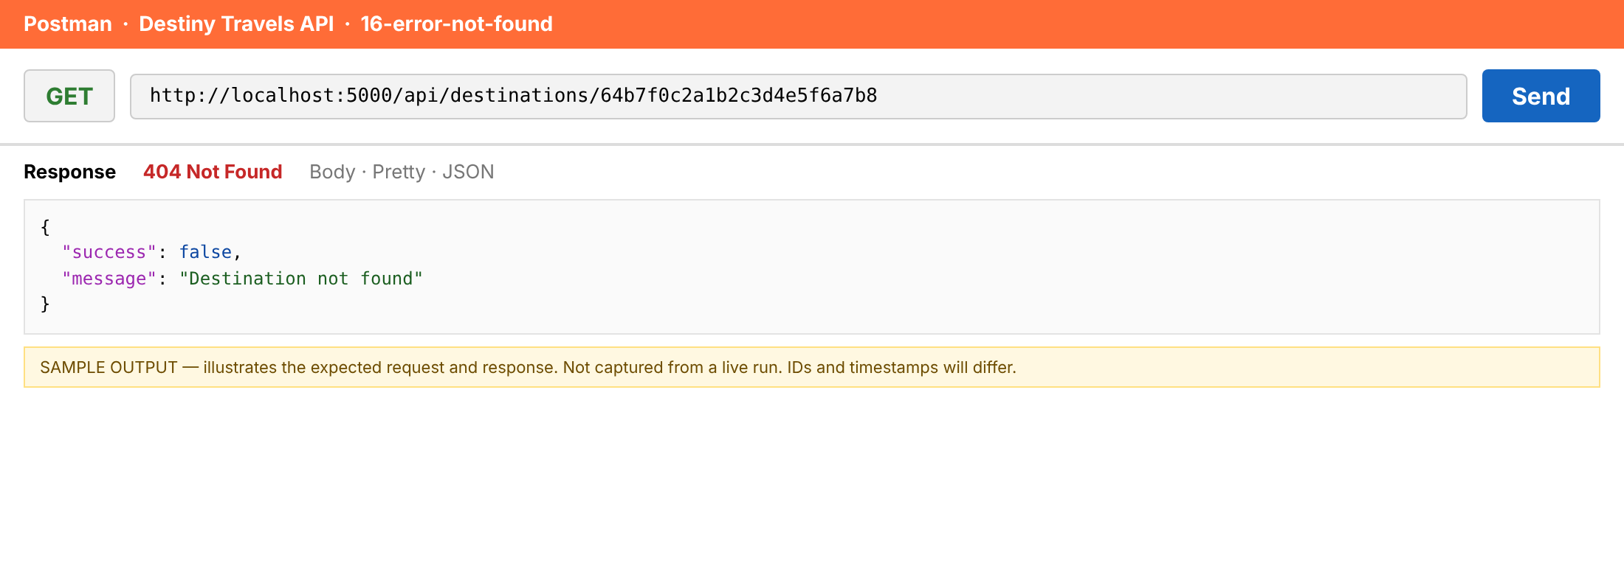
Figure: 16-error-not-found (sample output, not a live capture)
17. Invalid data returns 400 with details
Item | Detail
Request | POST /api/destinations
Expected status | 400
Purpose | Schema validation lists every problem found in the body.

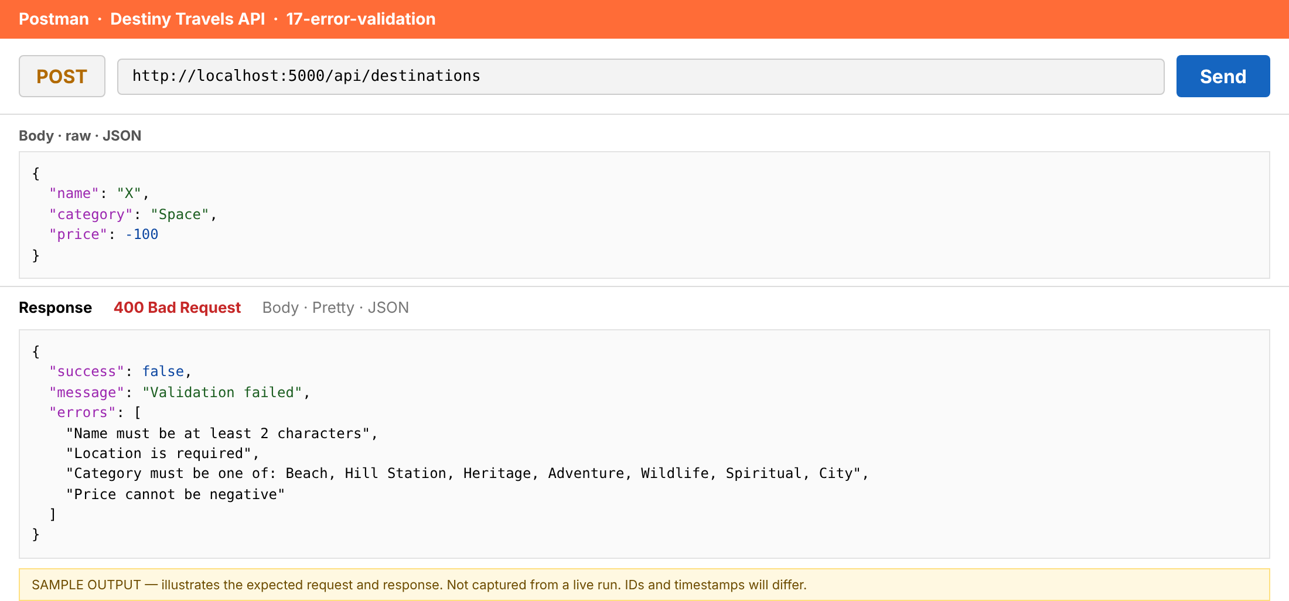
Figure: 17-error-validation (sample output, not a live capture)
18. Duplicate name returns 409
Item | Detail
Request | POST /api/destinations
Expected status | 409
Purpose | The unique index on name blocks a second "Goa Beaches".

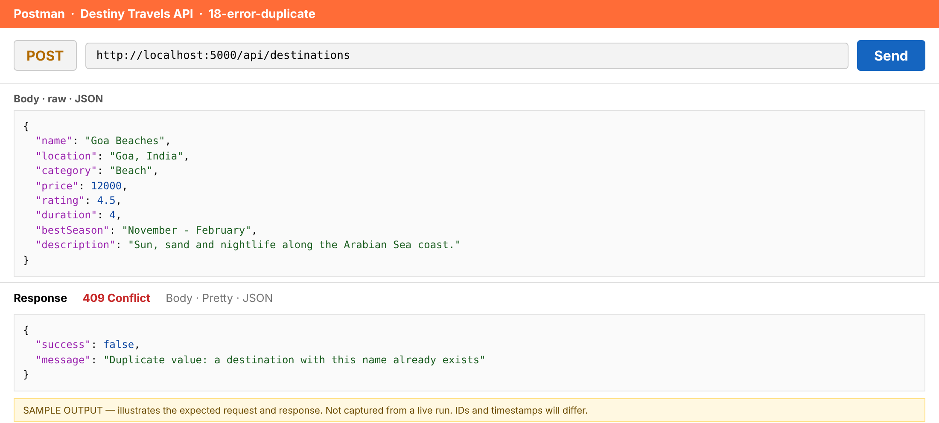
Figure: 18-error-duplicate (sample output, not a live capture)
19. Bulk delete without a condition returns 400
Item | Detail
Request | DELETE /api/destinations/bulk
Expected status | 400
Purpose | Protects the collection from an accidental "delete everything" call.

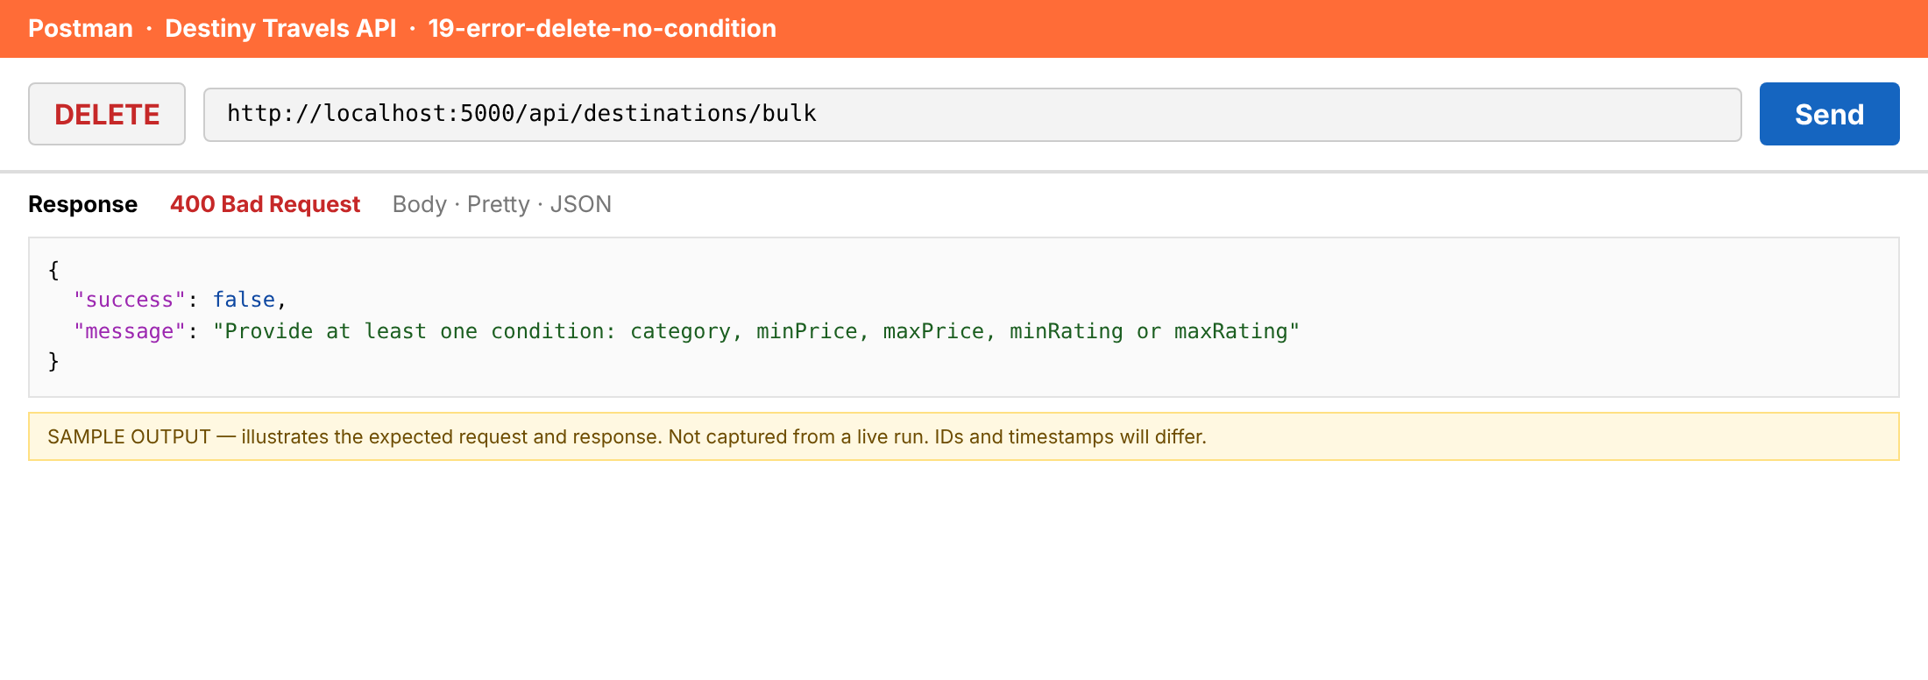
Figure: 19-error-delete-no-condition (sample output, not a live capture)

6. Error Handling and Status Codes
Status | Meaning | Triggered by
200 | OK | Successful read, update or delete
201 | Created | create() or insertMany() succeeded
400 | Bad Request | Malformed ID, validation failure, bad query value, empty update, bulk delete with no condition
404 | Not Found | No document matches, or unknown route
409 | Conflict | Duplicate destination name (unique index)
500 | Server Error | Unexpected failure; details hidden in production

const ApiError = require('../utils/ApiError');

// 404 for any route that does not exist.
const notFound = (req, res, next) => {
next(new ApiError(404, `Route not found: ${req.method} ${req.originalUrl}`));
};

// Central error handler: always answers with { success: false, message }.
// eslint-disable-next-line no-unused-vars
const errorHandler = (err, req, res, next) => {
let statusCode = err.statusCode || 500;
let message = err.message || 'Internal server error';
let errors;

// Mongoose validation failed (required field, enum, min/max ...)
if (err.name === 'ValidationError' && err.errors) {
statusCode = 400;
errors = Object.values(err.errors).map((e) => e.message);
message = 'Validation failed';
}

// Malformed ObjectId or wrong data type
if (err.name === 'CastError') {
statusCode = 400;
message = `Invalid value for "${err.path}": ${err.value}`;
}

// Duplicate key (unique index on name)
if (err.code === 11000) {
statusCode = 409;
const field = Object.keys(err.keyValue || {})[0] || 'field';
message = `Duplicate value: a destination with this ${field} already exists`;
}

// Invalid JSON body
if (err.type === 'entity.parse.failed') {
statusCode = 400;
message = 'Invalid JSON in request body';
}

if (statusCode >= 500) {
console.error(err);
if (process.env.NODE_ENV === 'production') {
message = 'Internal server error';
}
}

const body = { success: false, message };
if (errors) body.errors = errors;
res.status(statusCode).json(body);
};

module.exports = { notFound, errorHandler };

7. Conclusion
The Destiny Travels API covers all five challenges: adding, retrieving, updating, discovering and deleting destinations. It uses 15 distinct Mongoose methods, a clean MVC layout, input validation, safe bulk delete, and consistent JSON errors with correct HTTP status codes.

Possible next steps
- Add user authentication and role-based access for write operations.
- Add text search on name and description.
- Add automated tests with Jest and Supertest.

